> # R example of logistic regression
>
> # The data set is the TIF data from Table 11.8 and from class
>
> # Entering the data and defining the variables:
>
>
> ##########
> ##
> # Reading the data into R:
>
> my.datafile <- tempfile()
> cat(file=my.datafile, "
+ 0 9.2
+ 0 12.9
…
+ 0 12.5
+ 1 13.5
+ ", sep=" ")
>
> options(scipen=999) # suppressing scientific notation
>
> citydata <- read.table(my.datafile, header=FALSE, col.names=c("Y", "income"))
>
> # Note we could also save the data columns into a file and use a command such as:
> # citydata <- read.table(file = "z:/stat_516/filename.txt", header=FALSE, col.names = c("Y", "income"))
>
> attach(citydata)
>
> # The data frame called citydata is now created,
> # with two variables, "Y", "income".
> ##
> #########
> ####################################################################
>
> # attaching the data frame:
>
> attach(citydata)

The following object(s) are masked from citydata ( position 3 ) :

income Y

>
> # A simple plot of the data:
>
> plot(income, Y)

> # A simple plot of the data:
>
> plot(income, Y)
>
> # fitting the regression model:
>
> city.reg <- glm(Y ~ income, family=binomial)
>
> # Note that the logit link is the default for the binomial family
>
> # getting the summary regression output:
>
> summary(city.reg)

Call:
glm(formula = Y ~ income, family = binomial)

Deviance Residuals:
Min 1Q Median 3Q Max
-1.8781 -0.8021 -0.4736 0.8097 1.9461

Coefficients:
Estimate Std. Error z value Pr(>|z|)
(Intercept) -11.3487 3.3511 -3.387 0.000708 ***
income 1.0019 0.2954 3.392 0.000695 ***
---
Signif. codes: 0 '***' 0.001 '**' 0.01 '*' 0.05 '.' 0.1 ' ' 1

(Dispersion parameter for binomial family taken to be 1)

Null deviance: 69.235 on 49 degrees of freedom
Residual deviance: 53.666 on 48 degrees of freedom
AIC: 57.666

Number of Fisher Scoring iterations: 3

>
> # the fitted values:
>
> # fitted(city.reg)
>
> # The sample X values along with the corresponding fitted values:
>
> # cbind(income, fitted(city.reg))
>
> # A plot of the data with the estimated logistic curve on top:
>
> library(boot);
> xrange <- seq(from=min(income), to=max(income), length=100)
> lines(xrange, inv.logit(city.reg$coef[1]+ city.reg$coef[2]*xrange))
>
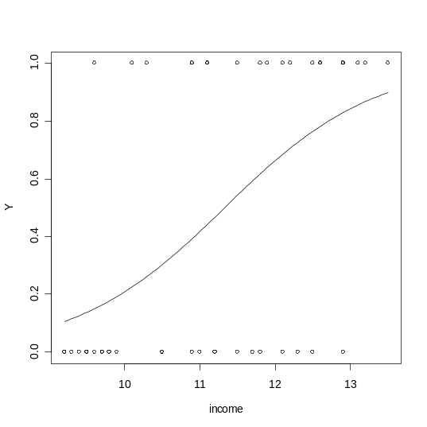
>
> ############### INFERENCE IN LOGISTIC REGRESSION ######################
>
>
>
>
> # Getting the LR test statistic and P-value in R (simple logistic regression):
> anova(city.reg)
Analysis of Deviance Table

Model: binomial, link: logit

Response: Y

Terms added sequentially (first to last)

Df Deviance Resid. Df Resid. Dev
NULL 49 69.235
income 1 15.569 48 53.666
> LR.test.stat <- anova(city.reg)[2,2]; LR.test.stat
[1] 15.56875
> LR.test.df <- anova(city.reg)[2,1]
>
> LR.test.Pvalue <- 1 - pchisq(LR.test.stat, df=LR.test.df); LR.test.Pvalue
[1] 0.00007955886
>
> # Output: R provides a likelihood-ratio test of H0: beta_1 = 0. Since the P-value
> # is very small ( < .0001), we reject H0, conclude beta_1 is not zero, and conclude
> # that income has a significant effect on the probability a city uses TIF.
>
> est.odds.ratio <- exp(summary(city.reg)$coef["income","Estimate"])
> print(est.odds.ratio)
[1] 2.723401
>
> # getting an approximate 95% CI for the odds ratio
> # associated with Y (an indirect way):
>
> conf.level <- 0.95
> alpha <- 1 - conf.level
> b1 <- summary(city.reg)$coef["income","Estimate"]
> s.b1 <- summary(city.reg)$coef["income","Std. Error"]
> lower <- exp(b1 - qnorm(1-alpha/2)*s.b1)
> upper <- exp(b1 + qnorm(1-alpha/2)*s.b1)
> print(paste(100*(1-alpha), "percent CI for odds ratio:", lower, upper))
[1] "95 percent CI for odds ratio: 1.52642800228199 4.85899894744525"
>
> # The estimates beta_0-hat and beta_1-hat are -11.347 and 1.002.
> # Estimated odds ratio = 2.723, and 95% CI for odds ratio is (1.526, 4.858).
>
>
> # To get, say, a 99% CI, just change the specified conf.level to 0.99.
>
> #################################################################################
>
>
> ############ Goodness of Fit: ##############
>
> ####
> # A function to do the Hosmer-Lemeshow test in R.
> # R Function is due to Peter D. M. Macdonald, McMaster University.
> #
> hosmerlem <-
+ function (y, yhat, g = 10)
+ {
+ cutyhat <- cut(yhat, breaks = quantile(yhat, probs = seq(0,
+ 1, 1/g)), include.lowest = T)
+ obs <- xtabs(cbind(1 - y, y) ~ cutyhat)
+ expect <- xtabs(cbind(1 - yhat, yhat) ~ cutyhat)
+ chisq <- sum((obs - expect)^2/expect)
+ P <- 1 - pchisq(chisq, g - 2)
+ c("X^2" = chisq, Df = g - 2, "P(>Chi)" = P)
+ }
> #
> ######
>
> # Doing the Hosmer-Lemeshow test
> # (after copying the above function into R):
>
> hosmerlem(Y, fitted(city.reg))
X^2 Df P(>Chi)
6.262964 8.000000 0.617802
>
> # The P-value will not match SAS's P-value perfectly but should be close.

