From Single Hepatocytes to Whole Liver Function:
A Multi-Scale Model of Human Hepatic Galactose Metabolism
König M.¹ and Holzhütter HG.¹
¹Institute of Biochemistry, Department of Computational Systems Biochemistry, University Medicine Charité Berlin, Germany
Running Title: Model of Liver Galactose Metabolism
Keywords: Virtual Liver, Hepatic Galactose Metabolism, Leloir pathway, Sinusoid, Perfusion, Galactosemia

To whom correspondence should be addressed: Matthias König, Institute of Biochemistry, University Medicine Charité Berlin, Virchowweg 6, 10117 Berlin; Tel: (0049) 30450528197; Email: matthias.koenig@charite.de

Abbreviations
GEC – galactose elimination capacity
ODE – ordinary differential equations
RBC – red blood cells
Abbreviations for metabolites, reactions and transporters in Figure 1.

Abstract
We present a multi-scale model of galactose metabolism in the liver bridging the scales from single-cell metabolism over the tissue level to the whole-organ. The model combines a detailed kinetic model of the cellular galactose metabolism with a tissue-scale perfusion model of the sinusoid. The metabolic capacity of the whole liver is modelled by integrating the heterogeneous contributions of sinusoids differing in blood-flow rates and tissue-architecture. The model was applied to the normal physiological state and the different variants of galactosemia caused by deficiency of the galactokinase (GALK), galactose-1-phosphate uridyl transferase (GALT) or UDP-galactose 4´-epimerase (GALE). The presented multi-scale model reproduces a wide range of experimental data ranging from multiple-indicator dilution and galactose elimination curves on organ and tissue scale, to alterations in key metabolites observed in galactosemia.

Introduction

Liver architecture
The liver plays a central role in maintaining the homeostasis of numerous plasma metabolites, clearance of substances and detoxification of xenobiotics. The liver architecture is unique within the body in that hepatic functionality is parallelized across a multitude of structural similar hexagonal subunits, the lobuli. Within a single lobule a network of capillaries, the so-called liver sinusoids, connect periportal regions, supplied via portal vein and hepatic artery, with the perivenous region, drained by the central vein . Sinusoids, separated from the surrounding hepatocytes via the space of Disse, form the smallest functional unit of the liver (Figure 1).

Hepatic Galactose Metabolism
The liver is the most important organ for the whole-body metabolism and clearance of galactose . Galactose metabolism consists of three main enzymatic steps (Figure 2), often referred to as Leloir pathway: i) the phosphorylation of galactose (gal) to galactose 1-phosphate (gal1p) catalysed by galactokinase (GALK, EC 2.7.1.6); ii) the conversion of gal1p to UDP-galactose (udpgal) by galactose-1-phosphate uridyl transferase (GALT, EC 2.7.7.10) and iii) the interconversion of udpgal and UDP-glucose (udpglc) by UDP-galactose 4´-epimerase (GALE, EC 5.1.3.2) . Galactose can enter glycolysis as glucose-1 phosphate (glc1p), one of the GALT reaction products, or can be incorporated as udpgal, the substrate donor of all galactosylation reactions, in glycoproteins and glycolipids .
The galactose elimination capacity (GEC) is an established test of liver function reflecting the functional hepatic mass and liver volume . Impairment of the liver and hepatocytes by diseases like cirrhosis or intoxication is commonly associated with impaired galactose clearance.

Galactosemias
Galactosemias, rare Mendelian metabolic disorders, are caused by deficiencies in either GALK (OMIM 230200), GALT (OMIM 230400) or GALE (OMIM 230350) . The underlying basis of most pathophysiology in galactosemia is unclear , but untreated as well as treated patients with galactosemia show accumulation and/or depletion of specific metabolites, and often abnormalities of glycosylation . As a consequence of intracellular accumulation of galactose or gal1p , alternative metabolic pathways may become active in galactosemias, which under normal conditions only metabolize trace quantities of galactose : i) reduction of galactose by aldolase reductase (ALDR) to galactitol, which is not further metabolized and accumulates; ii) oxidation of galactose to galactonate, presumably by galactose dehydrogenase (GALDH) ; iii) the formation of udpgal by UDP-glucose pyrphosphorylase (UGP) .

Model of galactose metabolism
Surprisingly, despite the importance of the hepatic galactose metabolism for the systemic galactose clearance and formation of precursors for glycosylation reactions no detailed mathematical model of this pathway is available hitherto. This work closes this gap by presenting a kinetic model of the galactose metabolism in human hepatocytes. On top, in order to understand how the successive dilution or concentration of metabolites along the sinusoidal blood flow from the periportal to the perivenous site influences the cellular metabolism requires a tissue-scale model that combines spatial gradients of metabolite concentrations with the cellular metabolism of individual liver cells. Finally, for the correct interpretation of results obtained in the galactose tolerance test it is necessary to take into account regional variations of the blood flow and in the architecture of sinusoids. For example, in certain liver diseases like fibrosis or fatty liver diseases larger spatial regions with strongly aberrant blood flow may coexist with regions of virtually normal perfusion and organ architecture. In contrast, intoxication of the liver, for example by carbon tetrachloride (CCl4), impairs primarily the function of perivenous hepatocytes in virtually all sinusoids across the whole organ. Thus, for fully understanding the metabolic input-output relationship of the liver it needs to bridge the spatial scales from single hepatocyte metabolism over tissue-scale functional units of sinusoids to the whole-organ level. Here, we present such a multi-scale model of the hepatic galactose metabolism. The grounding of this model is a detailed kinetic model of the cellular galactose metabolism. This cellular model is integrated into a realistic tissue-scale model of the sinusoidal liver unit based on known histological parameters (geometry, cell numbers, architecture, perfusion rates). Finally, liver metabolism was modelled as weighted average across the contribution of tissue-scale models with differing blood flow, tissue geometry and cellular metabolic capacity.

Relevance
Interplay tissue and organ perfusion and metabolism. Alterations in structure and perfusion in disease and age.

Methods
The presented model of hepatic metabolism is a hierarchical model consisting of cellular scale on the level of single hepatocytes (Figure 1A), tissue scale on level of the sinusoidal unit (Figure 1B) and organ scale on level of the whole liver (Figure 1C).

Cellular scale - galactose metabolism & galactosemias
The hepatocyte galactose metabolism is described by a kinetic model based on ordinary differential equations (ODEs). The model comprises the Leloir-Pathway with the main reactions GALK, GALT and GALE as well as the alternative processes important in galactosemias (Figure 1A). The ODEs are provided in the Supplementary Information with enzymatic parameters and metabolite concentrations listed in Supplementary Table 1 and Supplementary Table 2, respectively. The maximal enzyme activities (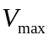) were chosen to achieve a good correspondence of model simulations with reported galactose elimination rates in healthy young human subjects Table 2 and Table 3 and observed changes in metabolite concentrations after galactose loads [REF, Figure?]. The mathematical models on cellular scale and tissue-scale are available as SBML from Biomodels.org (biomodels.org/?) and JWS Online (http://jjj.mib.ac.uk/database?l.). The kinetic parameters of the model were stored in SABIO-RK and are accessible via SBML annotations or from the Supplementary Information.
GALK, GALT and GALE deficiencies were implemented by changing the kinetic parameters for the respective enzyme from wildtype to values for the impaired enzyme variants (Table 1) with all other model parameters unchanged.

Tissue scale - sinusoidal unit
The tissue-scale model of the sinusoidal unit (Figure 1B) consists of a central blood vessel (sinusoid) surrounded by the space of Disse and adjacent hepatocytes in cylindrical geometry with parameters in Supplementary Table 3 and Supplementary Table 4. In the sinusoid substances are transported by blood flow and diffusion, in the space of Disse solely by diffusion. Red blood cells (RBC) are constricted to the sinusoid, whereas all other model substances (<200µm), namely galactose (gal), water (h2o), albumin (alb) and sucrose (suc), can pass in the space of Disse owing to the fenestration of the endothelial cells . Galactose and water can enter the hepatocytes, whereas sucrose and albumin are restricted to the space of Disse and the sinusoid.
Diffusion and blood flow are modelled by discretizing the sinusoid and Disse space in small volumes with the transport between neighbouring volumes governed by one-dimensional diffusion and convection equations (analogue to ). The periportal (pp) and perivenous (pv) blood compartment are located adjacent to the first and last sinusoidal volume, respectively. A single sinusoidal unit consists of 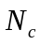 hepatocytes with each cell having a single associated sinusoid and Disse volume (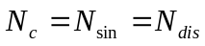). Concentrations of the modelled compounds 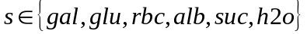 in pp and pv are denoted 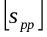 and 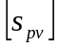, the concentrations in the sinusoidal and Disse space 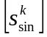 and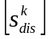 (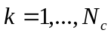). The diffusion coefficients are denoted 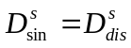within the sinusoid and space of Disse and 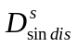between sinusoid and space of Disse (Supplementary Table 5). With the sinusoidal blood flow velocity 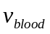, the sinusoidal radius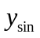, the width of space of Disse 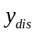 and the discretization along the sinusoidal axis 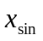and the exchange areas 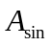between adjacent space sinusoidal volumes, 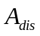between adjacent space of Disse volumes and 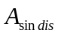 between adjacent sinusoid and space of Disse volumes, the rates of transport are given by

Blood flow in sinusoid (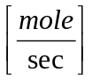)
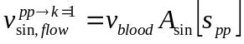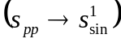
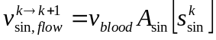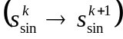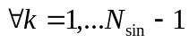
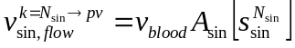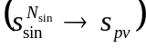
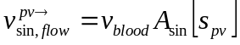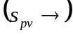

Diffusion in sinusoid and space of Disse ()
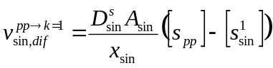
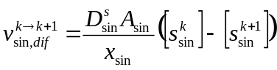
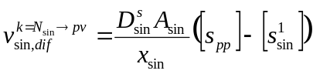
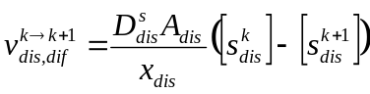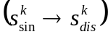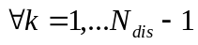
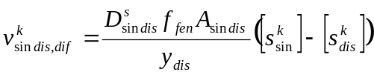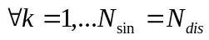
The model was integrated using COPASI with absolute and relative tolerances of 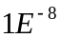. The complete source code is available from https://sourceforge.net/projects/multiscale-galactose.

Lobulus and liver scale
To account for the heterogeneity of the sinusoidal units within the single liver lobules and the liver a distribution of sinusoidal units based on the reported values in blood flow 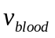, sinusoidal length 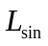, sinusoidal radius 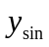, width of Disse space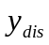 and hepatocyte sheet thickness 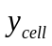 were simulated. The individual parameters were assumed statistically independent for the simulations.
Parameters for the log-normal distributions were fitted to experimental data based on a maximum-likelihood method for univariate distributions. The fit was performed with fitdistr from package MASS in R with estimate and estimate error given in (Supplementary Table 4)
For 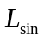and 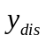 no experimental histograms could be found in the literature, so the parmters were calculated from reported mean and standard deviation 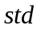based on the transformation
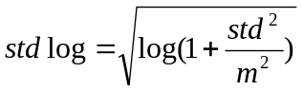
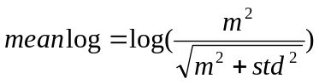
To simulate the model a sample of sinusoidal geometries and blood flows (N=1000 for dilution curves; N=250 for galactose simulations) was simulated. Calculation of whole-liver output was performed by scaling the simulated volume (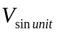) and flow (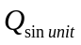) to total liver blood flow (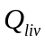) and liver volume (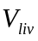) based on literature values for the whole organ (Supplementary Table 6).

Analysis dilution curves
The area under the curve (AUC), mean transit time (MTT), and variance of the transit time (VTT) were calculated directly from the dilution curves using the following equations {Warren, 2008 #137}:
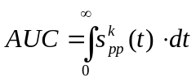
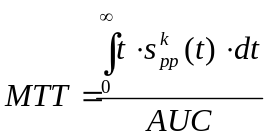
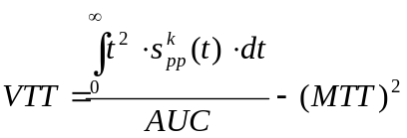
The catheter and nonexchangable vessel transit time () was estimated from the time of first appearance of radioactivity above background levels in the experimental dilution curves.

Analysis galactose elimination and clearance
The galactose elimination (GE), the removal rate (R), the extraction ratio (ER) and the clearance (CL) were calculated from the blood flow 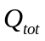 and the arterial and venous concentrations of galactose 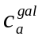and 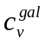using the following equations :
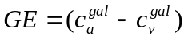
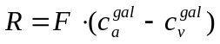
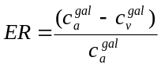
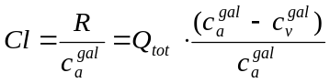

Results

Multiple Dilution-Indicator Curves
The model was validated on the basis of in vivo measured multiple indicator-dilution curves in dog and human und PET-data (human) of galactose metabolism.
Multiple indicator dilution curves for a multitude of substances could be replicated (Figure 3). Very interestingly the shift of the dilution-indicator curves observed and explained by Goresky as different free volumes of the substances are a consequence of the different diffusion coefficients for the substances, resulting in a delayed appearance of the substances perivenious.
The single-injection, multiple-indicator dilution approach provides a method to determine the composition of the liver and the rates of hepatic processes . Labeled red blood cells (RBC) are used as vascular reference. Larger materials are excluded from the space of Disse. The model of Goresky provides a realistic alternative to the too simple lumped compartmental descriptions of the liver classically utilized in pharmacokinetics. It provides a framework such that each curve can be directly compared with each other, the outflow concentration of each tracer is divided by the total injected, providing a normalized value, an outflow fraction per ml.

Relationship vascular tree and sinusoid transit times ?
It is assumed that no displacement occurs between reference intravascular and diffusible tracers in the large vessels: all displacement occurs in the exchanging vessels (sinusoids). The interrelations between whole-organ outflow reference and diffusible tracer curves will depend not only on the phenomena occurring within each sinusoid but also on the way the transit times in larger vessels and sinusoids are interrelated. Various combinations are possible, depending on the structure of the network and the kind of flow coupling in the system. The pattern corresponding to the liver was found to lie at a simple extreme in this possible spectrum [Rose1976, Goresky1970]. The distribution of out-flow transit times was found to correspond to the distribution transit of sinusoidal times in large transit times; the distribution of vessels was so compact that a single value could be assumed. Thus it was possible to derive a test for the single-sinusoid modeling. If, after a common transit time in large vessels, the sinusoidal transit time for each diffusible label in the liver is increased by the ratio of its total-to-accessible sinusoidal vascular space, then it should be possible to reverse this flow-limited delay effect in the curve for each diffusible label.
Goresky et al.1 previously have considered two models representing the extreme cases, i.e., no heterogeneity, and maximum heterogeneity in capillary transit times. Multiple indicator-dilution data from the liver fit the latter model very well [Rose1976].

Galactose Elimination Capacity (GEC)
“Quantitation of liver function is necessary to assess the degree of liver impairment, to objectively evaluate response to treatment and to select transplant recipients (1). Most of the commonly used quantitative tests, such as galactose-elimination capacity (2), sulfobromophthalein clearance (3) or antipyrine clearance (4) measure the disappearance of a test compound from blood. From these measurements, clearance is calculated and functional capacities are inferred without knowledge of details of the hepatic metabolism.” {Dufour, 1992 #160}
“Since all hepatocytes are thought to participate maximally in the removal of galactose, the test has been regarded as a measure of the functioning liver cell mass (Lm) (28). This concept has been supported by the proportional reductions in galactose elimination capacity and BSP elimination in patients with liver diseases (7,20)” {Ducry, 1979 #161}
The galactose elimination capacity (GEC) is defined as the rate with which a given plasma load of galactose is cleared. The GEC depends on the amount of metabolically active liver cell mass and the liver perfusion : The GEC is an accepted test of liver function and has been measured in numerous studies [Schirmer -> 5, 9, 17, 22, 41, 78, 79, 82, 83, 88, 96]. [Schirmer1986 -> 17,82, 83, 88, 96].
Galactose Clearance at low concentrations (GCLC) has proven to be as near ideal a method for estimating the effective hepatic blood flow (EBHF) because most of the plasma galactose entering the liver also leaves the liver without being metabolized [Schirmer1986]. The dependence of the hepatic galactose elimination rate follows a Michaelis-Menten saturation kinetics [43, 50, 70]; with a quasi-linear concentration-dependent (first-order) elimination phase followed by a clearance maximum (GEC) at higher concentrations (zero-order phase).
Numerous studies about liver galactose elimination capacity (GEC) [5, 9, 17, 22, 41, 78, 79, 82, 83, 88, 96]
Hepatic vein catheterization at high concentrations revealed a constant hepatic arterial-hepatic venous concentration difference [87,88].
Henderson et al. confirmed the near complete extraction of galactose across the liver (ER = 0.94) in subjects without hepatic disease by performing hepatic vein catheterization [35].
The most extensive work on galactose elimination kinetics was done by Keiding and co-workers [43-45, 48, 50, 85, 99]. The “sinusoidal perfusion model” they developed provides a sound theoretical justification for using galactose clearance at low concentrations to estimate EHBF [44, 45, 48, 50, 99].
Hepatic galactose elimination follows Michaelis-Menten saturation kinetics [43, 50, 70]; Its hallmarks are an early, concentration-dependent (first-order) elimination phase followed by a definable clearance maximum (GEC) at higher concentrations (zero-order phase).
Definition of velocity as amount of galactose removed per unit time per 100g of body weight (as opposed to rate per individual man [82, 96] or rate per g of liver weight [43, 50].
Blood flows unidirectionally through the sinusoids at prescribed rates [4, 26, 27]. The inflow concentration exceeds the outflow concentration with a gradient through the liver.
Apparent Km for galactose elimination in rat with sinusoidal perfusion model is 30.1 mcg/ml ~ 0.167mM, which is in close agreement with values reported by others [18 27, 43, 48, 50];

The Vmax for galactose elimination is much higher in humans than in rats [47,82,96], with the Km being similar [47].

“These kinetic studies on the clearance of galactose at concentrations of 0 to 10 mg/dl (0 to 0.555 mmol/l) show that it approaches the ideal test substance for measuring effective liver blood flow (a) it is kineticially simple simple to analyse at steady state during continuous infusion (b) it is avidly removed by the liver, with minimal extrahepatic clearance and c) there is indirect evidence supporting virtually complete extraction by functional liver tissue on each pass.

The model of hepatic galactose metabolism integrated within the sinusoidal units was validated on the basis of measured GEC curves under normal conditions. The model reproduced the observed saturation kinetics for galactose elimination (low/high

For the galactose metabolism it is sufficient to model the liver, due to its main role in galactose clearance. The model only describes the one-time pass through the liver without recirculation of uncleared galactose. Herefore, it would be necessary to model the systemic circulation.
Multiple galactose peaks

GEC in Galactosemias
Comparison of measeared plasma profiles of galactose (GEC) and cellular concentrations of intermediates of galactose metabolism (gal1p, udpgal, …) with model values for the GALK, GALT and GALE deficiencies.

In a first step the model was validated multiple-indicator dilution curves. None of the data was used for model fitting, all model parameters result from the geometric constraints of the system and the physic-chemical properties of the substances transported within the sinusoid and the space of Disse. The model performance was validated based on published multiple-indicator dilution curves in human [REF] and dog [REF].

“With the reports that there is a large daily endogenous production of galactose [10–12] which provides a galactose burden in addition to that imposed by food intake, it is apparent that patients with galactosemia with little or no GALT must have mechanisms for disposal of the sugar. Otherwise, they would continue toaccumulate galactose metabolites such as galactose-1-phosphate (Gal-1-P), galactitol and galactonate. This, however, is not the case: most patients manifest their own relatively unique steady-state levels of plasma galactose[13], RBC galactose-1-phosphate [14], galactitol and galactonate [15], and urinary galactitol [16] and galactonate[17] excretion. Estimates are that urinary excretion of metabolites account for about 30% of the daily burden [7,12]. [Berry2004]
“Specific metabolites known to reach abnormal levels in the hemolysates and/or tissues of untreated patients with classic galactosemia (GALT deficiency) include galactose, gal1p, galactitol, and inositol. Abnormal galactonate also forms but is excreted in the urine and does not accumulate in tissues (revied in Holten et al 2000, Tyfield and Walter 2002). Patients with classic galactosemia may also experience a partial depletion of UDP-gal, at least in their red blood cells.
“Following dietary restriction of galactose, patients with GALT deficiency demonstrate marked normalization of their metabolic profiles, although gal1p often remains outside the normal range (>5mM untreated, ~0.1mM treated, undetectable in normal (Gitzelmann 1995). Indeed, a number of studies have correlated the presence of elevated gal1p in patients on dietary galactose restriction with severity of clinical outcome (Kaufman 1988, Ng1991, Xu1995b).”
Untreated GALE deficiency also accumulate abnormal high levels of RBC galactose and gal1p. In addition these pationes also accumulate very high levels of UDP-gal (Holton et al, 1981; Walter et al., 1999, Openo et al, 2006). Considering that gal-1P is a substrate of GALT but not GALE, the fact that it accumulates to abnormal high levels in GALE-impaired cells demonstrates the interdependence of enzymes in the pathway. Presumably, gal1p accumulates in these cells secondary to the accumulation of UDP-gal, which exerts product inhibition on GALT.”
“In GALT-deficient mice created by Ning2000, gal1p accumulated in liver, kidney and brain, with very high levels of gal1p in red blood cells, comparable to findings in GALT-deficient humans. Surprisingly, these mice showed no evidence of galactose toxicity. However, the concentrations of galactitol in these GALT-defcient mice were significantly lower than observed in humans. This is probably caused by the low levels of aldose reductase in normal mouse tissues (Ai et al 2000). .”

“In galactosemic infants on an unrestricted lactose intake, a potentially lethal organ toxicity syndrome develops, presumably because D-galactose-derived metabolites (D-galactose-1-phosphate and D-galactitol) accumulate within the cells. ”

Alterations in Galactosemias
- Differences in GALK, GALT and GALE deficiencies
- Metabolic control analysis as predictor of alterations (which parameters have the largest impact on metabolic levels (especially byproducts galactitol, galactose and galactose-1p
- Simulation of multitude of “real-world” changes in enzyme activity based on characterization of typical mutants

Role of Alternative Galactose Pathways
Alternative pathways of galactose metabolism become important under impaired GALK, GALT or GALE.
“Overexpression of human IMP was found to overcome galactose toxicity in GALT deficient yeast cells” [Lai2009->95]

UDP-galactose pyrophosphorylase
“The formation of UDP-glucose is believed to be the major physiological function of the pyrophosphorylase (I). However, at a slower rate, the enzyme also catalyzed the pyrophosphorolysis of UDP-galactose. The saturating concentration for UDP-galactose is 10 times that of UDP-glucose. Under normal physiological conditions, this may not be significant, but, in a galactosemic patient, in which the normal galactose metabolism is impaired, the pyrophosphorylase may participate in an abnormal role. Isselbacher has suggested that a pyrophosphorylase is responsible for the increased ability of some galactosemics to metabolize galactose by synthesizing UDP-galactose from galactose-1-P and UTP (3). Gitzelmann, on the other hand, has suggested that a pyrophosphorylase may be responsible for the elevated galactose-1-P levels found in the blood of some galactosemics on supposedly galactose-free diets (11). Thus, a pyrophosphorylase has been suggested to catalyze both the biosynthesis and the pyrophosphorolysis of UDP-galactose in galactosemics”.
Abraham and Howell (12) extracted UDP-galactose pyrophosphorylase activity from human liver and, without purification, the catalytic properties were elaborated upon. The specificity of their extract for substrate was not reported”

Accumulation of Byproducts of galactose metabolism
“Galactitol accumulation has been demonstrated in the brain of toxic neonates with classical galactosemia [Leslie2003 -> 3, 46, 59]. The amounts of galactitol measured directly in GALT-deficient mice are lower (2mM) than levels detected by magnetic resonance spectroscopy in human subjects (8mM) [Leslie2003 -> 3, 57].
A high galactitol content in the lens was detected in a GALT-defiecnt patient with cataract”[Wang2001->8]
Galactitol has been isolated from tissues and urine of galactosemic patients [Segal1968 - > 19,20] and from tissues of rats fed high galactose diet [Segal1986 -> 21,22]
Accumulation of galactitol lens (cataracts)

“Cataract caused by galactitol accumulation seems to be the only consistent abnormality in galactokinase deficiency and this can be prevented with a galactose-restricted diet ->Holton2001.” “This relatively benign course of the disease is in strong contrast with high percentage of late complications that have been reported in the more common disorder of galactose metabolism, GALT deficiency. ”
Indeed excretion of abnormal quantities of galactitol in the urine of galactosemic patients is characteristic of the disorder [Wang2001-> 6].”[Wang2001]. “

For example,patients with significant GALE-deficiency accumulate strikingly elevated levels of UDPgal in response to galactose exposure (Walter1999, Openo2006). In contrast, patients with GALT deficiency may experience abnormal depletion of UDPgal and/or UDPglc (Xu1995a, Holton et al2000, Lai et al., 2003).

“In GALT-deficient mice created by Ning2000, gal1p accumulated in liver, kidney and brain, with very high levels of gal1p in red blood cells, comparable to findings in GALT-deficient humans. .”
“Accumulation of gal1p is regarded one of the most important pathogenic factors in GALT deficiency ->Gitzelmann1995, Gitzelmann1967
“In humans, deficiency of GALT activity caused by deleterious
variations of the GALT gene can result in a potentially lethal disorder
called classic galactosemia (MIM# 230400) [Isselbacher et al.,
1956; Segal and Berry, 1995]. If the affected neonates are not treated
in time, they will suffer fromsevere hepatic and renal failure, bleeding
diatheses, and E. coli sepsis, which can lead to death within days
of birth [Goppert, 1917; Isselbacher et al., 1956; Mason et al., 1935;
Segal and Berry, 1995]. The exact pathophysiology of these acute
symptoms remains uncertain, partially because of the lack of experimental
animal model for this disease [Leslie et al., 1996], but the accumulation of gal-1P is regarded as one of the most important
pathogenic factors [Gitzelmann, 1995; Gitzelmann et al., 1967]. “

GEC in aging
“A significant negative correlation as observed between age and both liver volume and apparent liver blood flow. The reduction in liver volume, apparent liver blood flow and perfusion may at least partly account for the decline in the clearance of many drugs undergoing liver metabolism, which has been noted to occur with aging in man” {Wynne, 1989 #144}
“Schnegg1986{Schnegg, 1986 #145}

Wynne1989 {Wynne, 1989 #144}
Abnormalities in gal-Metabolism and liver disease: “Some patients with hepatic disease have increased Gal in their blood [Yamaguchi1989 -> 4], as shown by our patient with peliosis hepatitis, and also glycogen storage disease type XI. Also, liver dysfunction is an early clinical complication of galactosemia” [Yamaguchi1989]

Discussion
“The removal of substances from blood by hepatic clearance is influenced by three factors: the intrinsic elminimation capacity (hepatocyte function), hepatic extraction and liver blood flow. Galactose clearance in the blood concentration range of 0 to 0,55mmol/l measures clearance at infusion rates one fith to one thenth of intrinsic elimination capacity, is virtually independent of hepatic extraction and is thus a flow-dependent clearance.”{Henderson, 1983 #86}
Quantitative assessment of liver function.

Hypothesis of Pathophysiology in Galactosemias
“The more we learn of the ‘single gene’ metabolic disorders, the more it becomes clear that intricate cascades of regulation and combinatorial control operate here as well, overseeing the interplay of enzymes and metabolic pathways under normal conditions, and mediating pathophysiology and the severity of patient outcome under abnormal conditions. Identifying the players and inter-relationships not only teaches us about normal metabolism, it further empowers a rational approach to the development of novel and potentially more effective treatments.”
“Multiple mechanism resulting in the pathophysiology in galactosemia were proposed [Lai2009] (reviewed in Tyfield and Walter 2002, Leslie 2003):
- Accumulation of toxic metabolites in the blocked Leloir Pathway
- accumulation of toxic products of alternate galactose metabolism
- Alterations of absolute UDP-galactose, UDP-glucose and relative UDP-glucose/UDP-galactose levels with implications in protein glycosylation and galactosylation, Lebea2005 have proposed that depletion of UDP-gal in GALT deficiency may impede the function of cerebroside galactosyl transferase, responsible for the galactosylation of cerebrosides. Considering that both UDPgal and UDP-glc serve as important activated sugar donors for glycosyltransferases, the connection to pathophysiology may involve defects in the biosynthesis of glycoproteins and/or glycolipids in the cells and tissues of galactosemic patients (Segal, 1995, Tyfeld and Walter 2002). Indeed such abnormalities have been found.”
With both levels and approximate 1:3 ratio of UDP-gal and UDP-glc are very tightly controlled in normal cells (Segal1995), these levels and ratio may be disturbed in both GALT and GALE-deficiency galactosemia
- Perturbation in inositol metabolism, with reports suggesting that increased gal1p could inhibit myoinositol monophosphatase (IMP) [Fridovich-Keil2006 ->Wells1965].
- Futile cycles of phosphorylation/dephosphorylation in galactose metabolism might result in ATP depletion [Fridovich-Keil2006 -> Miller1973]
- Elevated intracellular gal1p might inhibit a number of important enzymes, including glucose-6-phosphatase, phosphoglucomutase, … [Fridovich-Keil2006 -> Gitzelmann]
Trapping of uridine phosphate with galactose (similar to galactosamine induced hepatitis) could explain the neonatal liver failure, …. [Keppler1969, 1970]. Similar effects, in case of certain mutations, the galactose production of the body could be sufficient to lower the UDP levels. “The decrease in UTP is considered to be the most essential primary mechanism of galactosamine-induced liver damage [Keppler1970->18,19] and is proposed to explain the increased toxicity of galactose by ethanol. ” [Discuss]

Galactose metabolism and GEC are quit constant. Adult rats fed a 40% galactose diet for 5 days did not show an increase in GEC although 20 days on the diet resulted in a 20% increase in V_{max} suggesting that adaptive mechanisms are slow [Schirmer1986 ->18]. This lack of inducability and relatively constant V_{max} is desirable in clearance methodology as a fluctuating V_{max}/FK_{m} would certainly complicate clearance interpretations.

Comparison to current multiscale models of liver
Höhme (no detailed blood flow, no metabolism)
Chaloubh (missing parameter distributions, only briding the gap to the sinusoidal unit, not possible to simulate the different effects of heterogenous variations of parameters.
Galactose-Clearance Modelle – no detailed description of metabolism, no bridging to whole liver function
Ricken, porous media,

Towards a virtual liver
Bridging the scales from cellular processes over the coupling of single cells within the tissue-architecture towards whole-organ models is a crucial step in understand physiological function of organs in the normal state and in pathophysiologies. Only by modelling the different scales explicitly the emerging behaviour on a liver scale can be properly understood.

Acknowledgement
This work was supported by the Federal Ministry of Education and Research (BMBF, Germany) within the Virtual Liver Network (VLN grant number 0315741). I thank the SABIO-RK Team for their effort to integrate the kinetic parameters in their database, especially Martin Golebiewski, Renate Kenia and Ulrike Wittig. I thank Tobias Czauderna for the support with SBGN as well as Lucian Smith with libAntimony.
The authors declare no commercial or financial conflict of interest.

References
Bernstein, L.M., et al. (1960) The blood galactose disappearance curve as a test of liver function, Gastroenterology, 39, 293-304.
Berry, G.T., et al. (2000) Galactose breath testing distinguishes variant and severe galactose-1-phosphate uridyltransferase genotypes, Pediatric research, 48, 323-328.
Bosch, A.M., et al. (2002) Clinical features of galactokinase deficiency: a review of the literature, Journal of inherited metabolic disease, 25, 629-634.
Czauderna, T., Klukas, C. and Schreiber, F. (2010) Editing, validating and translating of SBGN maps, Bioinformatics, 26, 2340-2341.
Fridovich-Keil, J.L. (2006) Galactosemia: the good, the bad, and the unknown, Journal of cellular physiology, 209, 701-705.
Goresky, C.A., Bach, G.G. and Nadeau, B.E. (1973) On the uptake of materials by the intact liver. The transport and net removal of galactose, The Journal of clinical investigation, 52, 991-1009.
Henderson, J.M., Kutner, M.H. and Bain, R.P. (1982) First-order clearance of plasma galactose: the effect of liver disease, Gastroenterology, 83, 1090-1096.
Hoops, S., et al. (2006) COPASI--a COmplex PAthway SImulator, Bioinformatics, 22, 3067-3074.
Jepsen, P., et al. (2009) The galactose elimination capacity and mortality in 781 Danish patients with newly-diagnosed liver cirrhosis: a cohort study, BMC gastroenterology, 9, 50.
Keppler, D., Rudigier, J. and Decker, K. (1970) Trapping of uridine phosphates by D-galactose in ethanol-treated liver, FEBS letters, 11, 193-196.
Knop, J.K. and Hansen, R.G. (1970) Uridine diphosphate glucose pyrophosphorylase. IV. Crystallization and properties of the enzyme from human liver, The Journal of biological chemistry, 245, 2499-2504.
Konig, M., Holzhutter, H.G. and Berndt, N. (2013) Metabolic gradients as key regulators in zonation of tumor energy metabolism: A tissue-scale model-based study, Biotechnology journal, 8, 1058-1069.
Le Novere, N., et al. (2009) The Systems Biology Graphical Notation, Nature biotechnology, 27, 735-741.
Leslie, N.D. (2003) Insights into the pathogenesis of galactosemia, Annual review of nutrition, 23, 59-80.
Marchesini, G., et al. (1988) Galactose elimination capacity and liver volume in aging man, Hepatology, 8, 1079-1083.
Novelli, G. and Reichardt, J.K. (2000) Molecular basis of disorders of human galactose metabolism: past, present, and future, Molecular genetics and metabolism, 71, 62-65.
Petry, K.G. and Reichardt, J.K. (1998) The fundamental importance of human galactose metabolism: lessons from genetics and biochemistry, Trends in genetics : TIG, 14, 98-102.
Sasse, D., Spornitz, U.M. and Maly, I.P. (1992) Liver architecture, Enzyme, 46, 8-32.
Schadewaldt, P., et al. (2000) Analysis of concentration and (13)C enrichment of D-galactose in human plasma, Clinical chemistry, 46, 612-619.
Schirmer, W.J., et al. (1986) Galactose clearance as an estimate of effective hepatic blood flow: validation and limitations, The Journal of surgical research, 41, 543-556.
Segal, S. and Rogers, S. (1971) Nucleotide inhibition of mammalian liver galactose-I-phosphate uridylyltransferase, Biochimica et biophysica acta, 250, 351-360.
Tang, M., et al. (2012) Correlation assessment among clinical phenotypes, expression analysis and molecular modeling of 14 novel variations in the human galactose-1-phosphate uridylyltransferase gene, Human mutation, 33, 1107-1115.
Timson, D.J. (2005) Functional analysis of disease-causing mutations in human UDP-galactose 4-epimerase, The FEBS journal, 272, 6170-6177.
Timson, D.J. and Reece, R.J. (2003) Functional analysis of disease-causing mutations in human galactokinase, European journal of biochemistry / FEBS, 270, 1767-1774.
Timson, D.J. and Reece, R.J. (2003) Sugar recognition by human galactokinase, BMC biochemistry, 4, 16.
Tyfield, L. and Walter, J. (2002) Galactosemia. In Scriver, C., et al. (eds), The Metabolic and Molecular Bases of Inherited Disease. McGraw-Hill, New York.
Tygstrup, N. (1966) Determination of the hepatic elimination capacity (Lm) of galactose by single injection, Scandinavian journal of clinical and laboratory investigation. Supplementum, 18, 118-125.
Villeneuve, J.P., et al. (1996) The hepatic microcirculation in the isolated perfused human liver, Hepatology, 23, 24-31.
Vilstrup, H. (1983) Effects of acute carbon tetrachloride intoxication on kinetics of galactose elimination by perfused rat livers, Scandinavian journal of clinical and laboratory investigation, 43, 127-131.
Walter, J.H., et al. (1999) Generalised uridine diphosphate galactose-4-epimerase deficiency, Archives of disease in childhood, 80, 374-376.
Wisse, E., et al. (1985) The liver sieve: considerations concerning the structure and function of endothelial fenestrae, the sinusoidal wall and the space of Disse, Hepatology, 5, 683-692.
Wittig, U., et al. (2012) SABIO-RK--database for biochemical reaction kinetics, Nucleic Acids Res, 40, D790-796.

Figures

Figure 1 – Model of hepatic galactose metabolism on cellular, tissue- and organ-scale
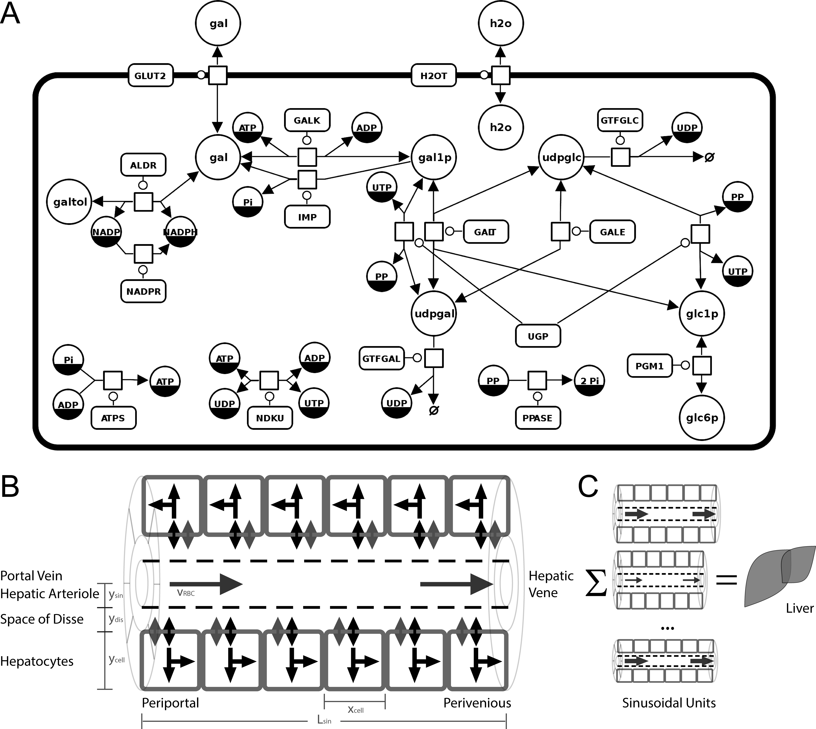
A) Metabolic model of hepatic galactose metabolism in SBGN created with SBGN-ED . The processes ATPS and NADPR were added for cofactor regeneration. Detailed information on metabolites, initial concentrations, rate equations and parameters is provided in the method section and the supplementary information.
Reactions: (ALDR) Aldose reductase (galactitol NAD 1-oxidoreductase); (ATPS) ATP synthesis; (GALDH) Galactose 1-dehydrogenase; (GALE) UDP-glucose 4-epimerase; (GALK) Galactokinase; (GALT) Galactose-1-phosphate uridyl transferase; (GLUT2) Facilitated glucose transporter member 2; (GTFGAL) Glycosyltransferase galactose; (GTFGLC) Glycosyltransferase glucose; (NADPR) NADP reductase; (NDKU) Nucleoside diphosphokinase, ATP:UDP phosphotransferase; (IMP) Inositol monophosphatase; (PGM1) Phosphoglucomutase-1; (PPASE) Pyrophosphatase; (UGALP) UDP-galactose pyrophosphorylase; (UGP) UDP-glucose pyrophosphorylase;
Metabolites: (adp) ADP; (atp) ATP; (gal) D-galactose; (gal1p) D-galactose 1-phosphate; (galnat) D-galactonate; (galtol) D-galactitol; (glc) D-glucose; (glc1p) D-glucose 1-phosphate; (glc6p) D-glucose 6-phosphate; (nadp) NADP; (nadph) NADPH; (pi) phosphate; (pp) pyrophosphate; (udp) UDP; (udpgal) UDP-D-galactose; (udpglc) UDP-D-glucose; (utp) UTP;
B) Tissue-scale model of the sinusoidal unit comprising diffusion and convection based transport of substances in the sinusoid, diffusion-based transport of substances in the space of Disse and description of cellular metabolism via kinetic models of individual hepatocytes.
C) Modeling the liver via integration of heterogenous models of the sinusoidal unit varying in blood flow and structural parameters.

Figure 2 – Parameter distributions and resulting multiple-indicator dilution curves
A
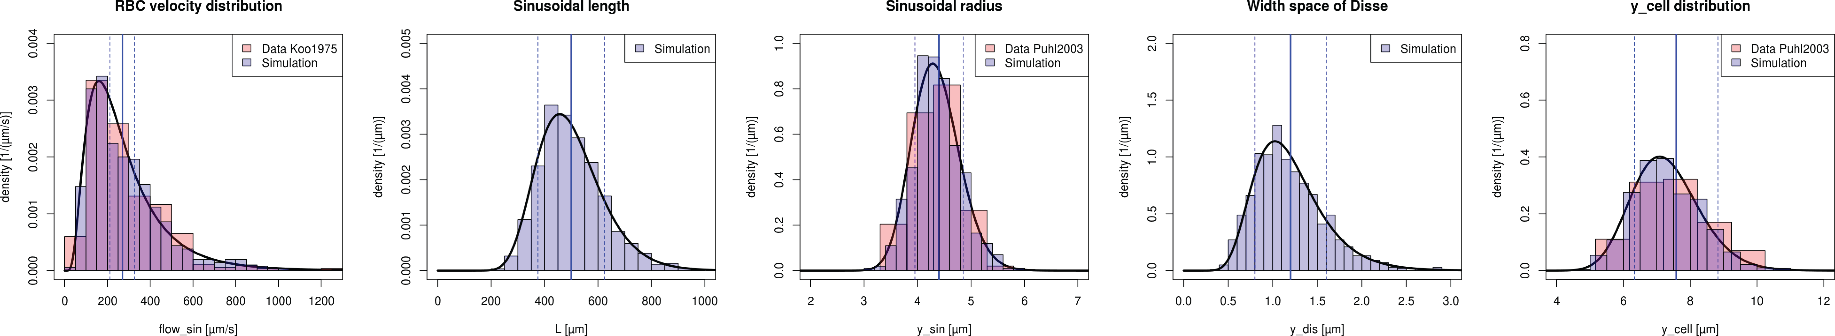
B
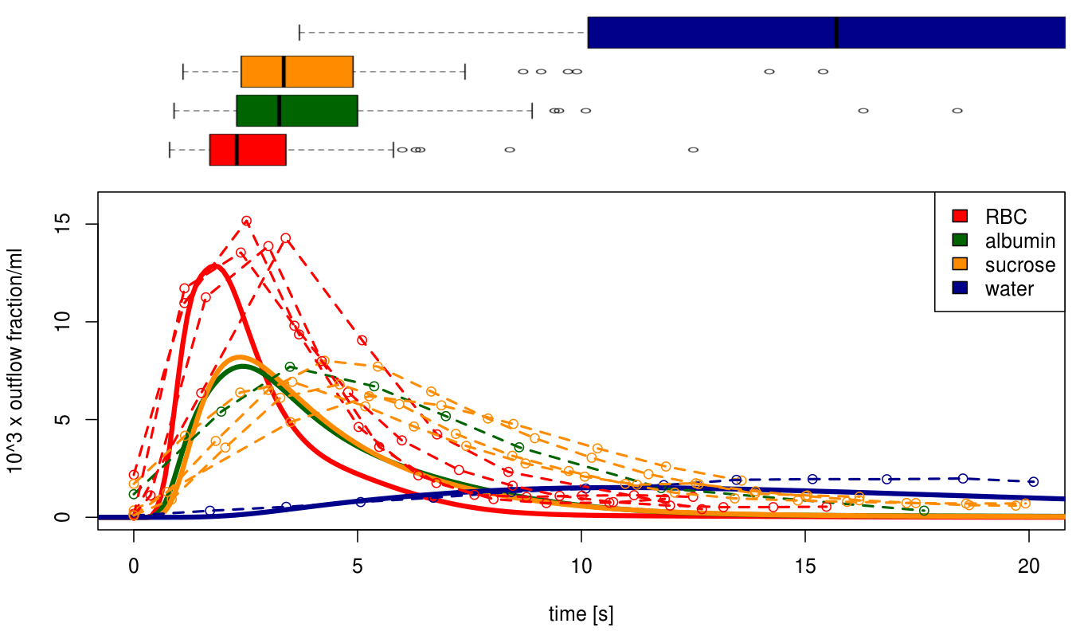
C
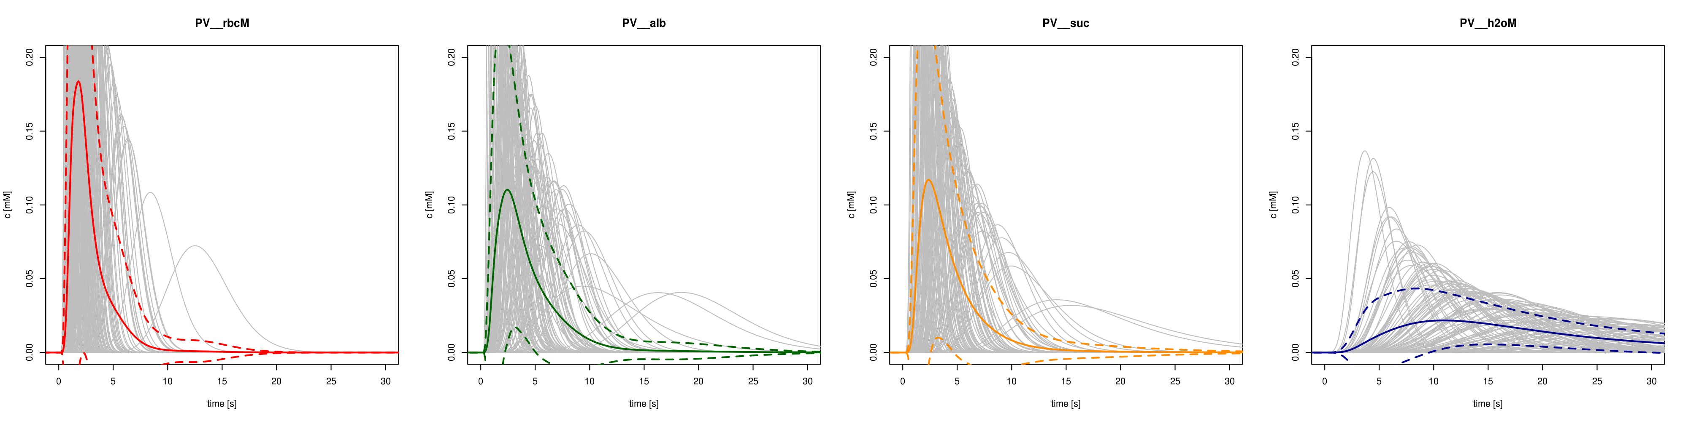
A) Parameter distributions underlying the model simulations. For every simulation a multitude of structural different sinusoidal units is simulated and the results are integrated. Shown are the parameter distributions based on fitting with the experimental data and the sample for the simulation (N=1000).
B) Predicted multiple-indicator diluation curves based on fixed paramterization of model with literature data. Input peak is rectangle peak with duration of 0.5s. top) Boxplot of simulated peak times of dilution curves for RBC, albumin, sucrose and water. botton) mean Experimental data from dogs dashes [Goresky1983].
C) Individual curves for the sampled geometries with mean (solid) and mean+-std (dashed)
With and without galactose.
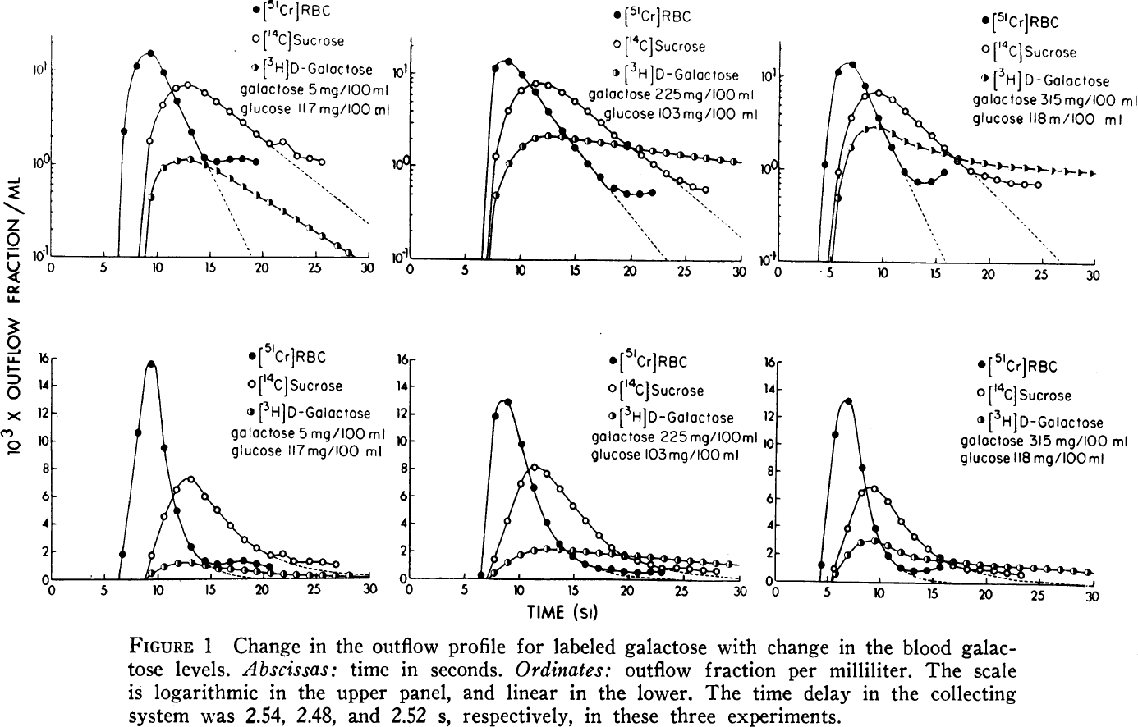

Figure 3 – Hepatic galactose elimination, extraction ratio, and flow-dependent clearance and extraction ratio.
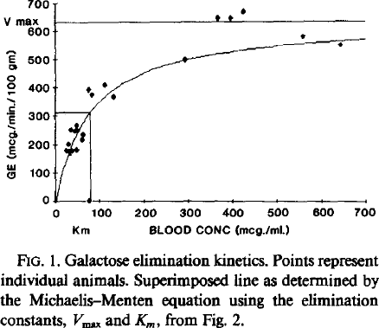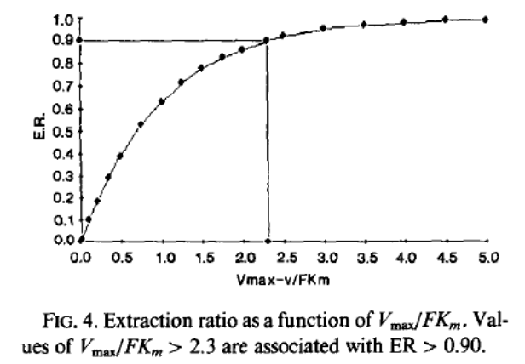
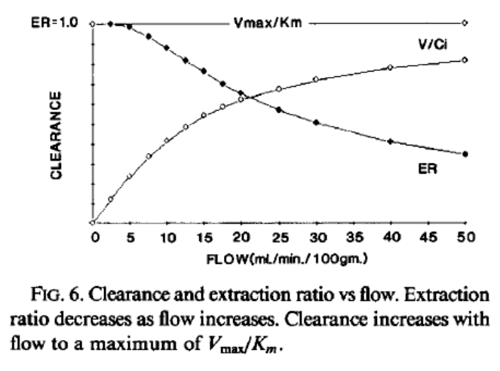

Figure 4 – Effect of metabolic deficiencies (galactosemias) on cellular, tissue and organ level (metabolic control analysis single cell level & altered steady state values)
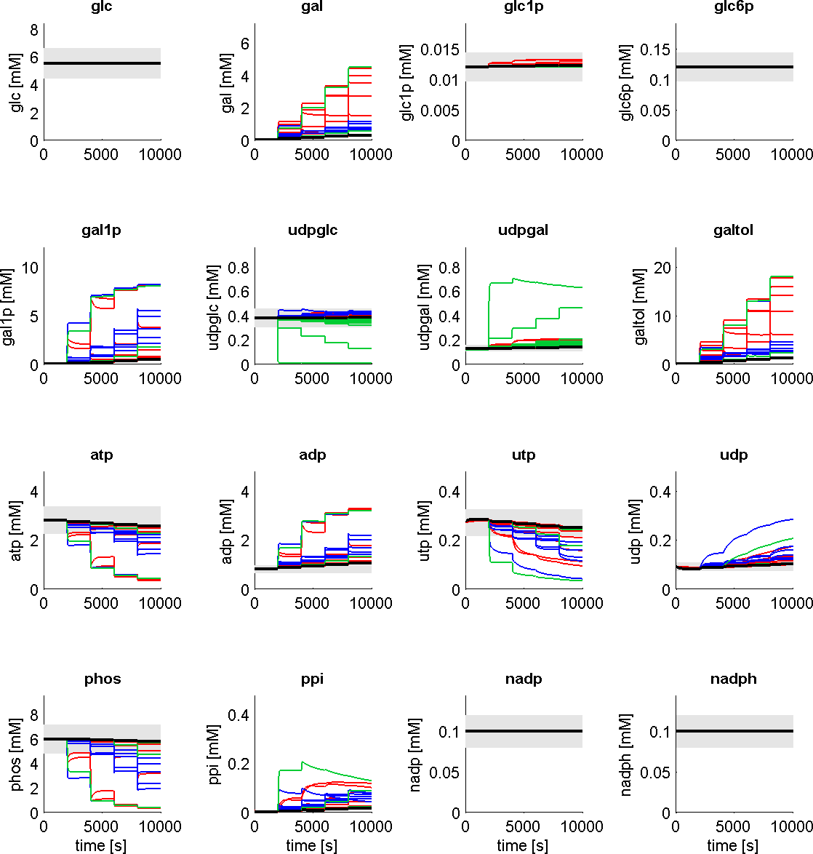 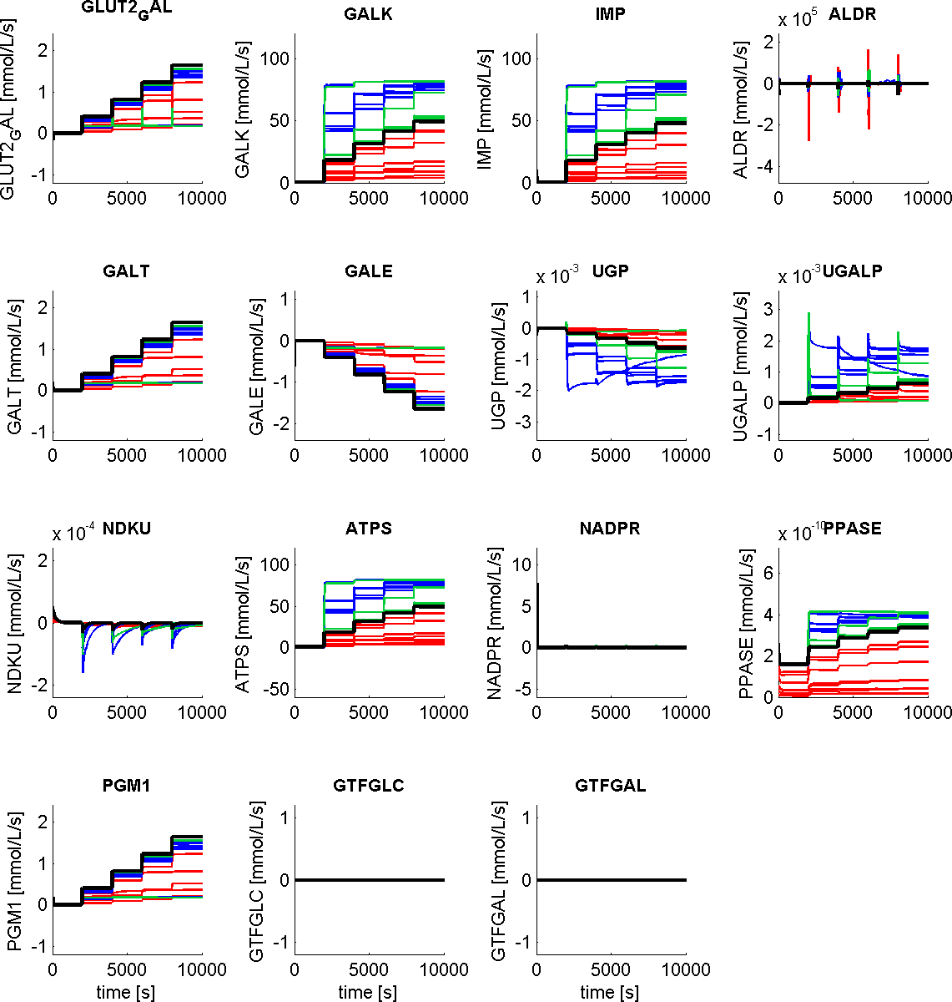Concentrations
Fluxes
Alterations in metabolite levels and fluxes in GALK, GALT and GALE deficiencies (Table 1) compared to normal hepatic galactose metabolism. Galactose and galactitol accumulate in the deficiencies. The absolute udpglc and udpgal concentrations as well as the normal relative value of ~udpglc/udpgal are altered. Some of the deficiencies result in a marked decrease of energy state (ATP/ADP) due to the high futile cycles in the GALK/IMP system.

Figure 5 –GEC in aging
Display the experimental observed changes in galactose clearance.

Tables

Table 1 –Alterations in kinetic properties in galactosemias.
 | Enzyme | Variant | k_{cat} [1/s] (%wt) | K_{m}(gal) [mM] (%wt) | K_{m}(atp) [mM] (%wt) | Reference
 | GALK | Wild Type | 8.7±0.5 (100) | 0.97±0.22 (100) | 0.034±0.004 (100)
1 | GALK | H44Y | 2.0±0.1 (23) | 7.70±4.40 (794) | 0.130±0.009 (382)
2 | GALK | R68C | 3.9±0.8 (45) | 0.43±0.15 (44) | 0.110±0.035 (324)
3 | GALK | A198V | 5.9±0.1 (68) | 0.66±0.22 (68) | 0.026±0.001 (76)
4 | GALK | G346S | 0.4±0.04 (5) | 1.10±0.16 (113) | 0.005±0.002 (15)
5 | GALK | G347S | 1.1±0.2 (13) | 13.0±2.0 (1340) | 0.089±0.034 (262)
6 | GALK | G349S | 1.8±0.1 (21) | 1.70±0.48 (175) | 0.039±0.004 (115)
7 | GALK | E43A | 6.7±0.02 (77) | 1.90±0.50 (196) | 0.035±0.0003 (103)
8 | GALK | E43G | 0.9±0.02 (10) | 0.14±0.01 (14) | 0.0039±0.0006 (11)
 | Enzyme | Variant | V_{max} [nmol/mg/s] (% wt) | K_{m}(gal1p) [mM] (%wt) | K_{m}(udpglc) [mM] (%wt) | Reference
 | GALT | Wild Type | 804±65 (100) | 1.25±0.36 (100) | 0.43±0.09 (100)
9 | GALT | R201C | 396±59 (49) | 1.89±0.62 (151) | 0.58±0.13 (135)
10 | GALT | E220K | 253±53 (31) | 2.34±0.42 (187) | 0.69±0.16 (160)
11 | GALT | R223S | 297±25 (37) | 1.12±0.31 (90) | 0.76±0.09 (177)
12 | GALT | I278N | 45±3 (6) | 1.98±0.35 (158) | 1.23±0.28 (286)
13 | GALT | L289F | 306±23 (38) | 2.14±0.21 (171) | 0.48±0.13 (112)
14 | GALT | E291V | 385±18 (48) | 2.68±0.16 (214) | 0.95±0.43 (221)
 | Enzyme | Variant | k_{cat} [1/s] (%wt) | K_{m}(udpglc) [mM] (%wt) |  | Reference
 | GALE | Wild Type | 36±1.4 (100) | 0.069±0.012 (100)
15 | GALE | N34S | 32±1.3 (89) | 0.082±0.015 (119)
16 | GALE | G90E | 0.046±0.0028 (0) | 0.093±0.024 (135)
17 | GALE | V94M | 1.1±0.088 (3) | 0.160±0.038 (232)
18 | GALE | D103G | 5.0±0.23 (14) | 0.140±0.021 (203)
19 | GALE | L183P | 11±1.2 (31) | 0.097±0.040 (141)
20 | GALE | K257R | 5.1±0.29 (14) | 0.066±0.015 (96)
21 | GALE | L313M | 5.8±0.36 (16) | 0.035±0.011 (51)
22 | GALE | G319E | 30±1.3 (83) | 0.078±0.013 (113)
23 | GALE | R335H | 15±0.48 (42) | 0.099±0.012 (143)

Table 2 –Galactose elimination in normal state and disease
 | Human | Dog | Rat
Endogeneous galactose production | Rate of endogenous D-galactose appearance in plasma in humans:  R = 0.17 µmol/kg_{BW}/h (low when compared to Berry)  R = 2.9-5.4µmol/kgBW/h
Hepatic galactose elimination / galactose clearance  (liver) | Saturation of hepatic galactose elimination  The hepatic galactose elimination (HGE) rate is assumed to be independent at high blood galactose levels which are easily obtained in clinical galactose tolerance tests . The HGE rate usually falls at concentration below 500mg/l (=2.78mM)  “Several observations indicate that the hepatic elimination rate of galactose is independent of the concentration at levels which are easily obtained in clinical galactose tests. [Stenstam1956] demonstrated that continuous infusions of galactose, exceeding about 400mg/min, resulted in rectilinearly rising plasma concentrations. Liver-vein catheterization studies have shown that the arterio-hepatic venous concentration difference is constant in a wide concentration interval [Tygstrup & Winkler 1954, Nakamura1961]. [Waldstein1960] demonstrated that the extrarenal elimination of galactose from the body would reach a maximum during galactose infusions, and [Segal1961] found that the conversion of 14C-galactose to 14CO2 was delayed by injection of 20g of carrier galactose.  Single injection results in galactose elimination of GE=341–609 mg(galactose)/min (1.89-3.38mmol/min), whereas continuous infusion gives GE=295-509mg(galactose/min) (1.63-2.83mmol/min)“Single injection and infusion experiments will give different figures for the hepatic galactose elimination capacity and volume of distribution, depending on the degree of displacement of the arterial curve.  “Galactose elimination progressively decreased from GE=3.05±0.58 (SD)mmol/min in younger subjects to GE=1.83±0.24 (SD)mmol/min in subjects over 81. ”. Standard method of calculation of galactose elimination capacity is Tystrups procedure , here assuming a urinary loss of galactose of 10% of the injected dose.  GE 1.89- 3.58mmol/min (n=17, healthy, single injection method) {Tygstrup, 1963  #78}  Experiments with continuous infusions at different rates indicated that on the average the curve of the mean concentrations in the body was delayed 7min in relation to the arterial curve. {Tygstrup, 1963 #78}  GE 0.8- 2.2mmol/min (n=20){Tygstrup, 1977 #148}  In healthy people, plasma galactose clearance was 1366±172 ml/min and hepatic extraction was 95% (during continuous infusion of 5% D-galactose at a rate of 50mg/min) {Henderson, 1983 #86}  GEC 7.48±0.94mg/min/kgbw (SD, n=70, <40 years, normal) {Schnegg, 1986 #145} ~2.91±0.37mmole/min GEC (with 70kgbw)  GEC 7.08±0.68mg/min/kgbw (SD, n=11, 40-70 years, normal) {Schnegg, 1986 #145} ~2.75±0.26mmole/min GEC (with 70kgbw)  GEC 6.08±1.30mg/min/kgbw (SD, n=13, >70years, normal) {Schnegg, 1986 #145} ~2.36±0.51mmole/min GEC (with 70kgbw)  The galactose utilization rate of human liver slices is twice as great as that of rat liver slices. {Tygstrup, 1971 #159}  Galactose utilization is almost constant throughout the incubation period.  Galactose uptake:  5.64±0.41µmol/g (SD, n=11, human liver tissue slices, medium 1.7mM galactose)  1.25±0.14µmol/g (SD, n=11, human liver tissue slices, medium 1.7mM galactose + ethanol 10mM)  2.47±0.16µmol/g (SD, n=16, rat liver tissue slices, medium 1.7mM galactose, Wistar rats ~200g bw)  0.82±0.11µmol/g (SD, n=16, rat liver tissue slices, medium 1.7mM galactose + ethanol 10mM, Wistar rats ~200g bw)  3.18±0.64mmole/min [2.26-4.07] GEC (SD, n=9, normal subjects) {Tygstrup, 1961 #98}  1.98±0.25mmole/min [1.69-2.53] GEC (SD, n=11, cirrhotics, total elimination rate >300mg/min) {Tygstrup, 1961 #98}  1.37±0.16mmole/min [1.19-1.66] GEC (SD, n=10, cirrhotics, total elimination rate >210 & <300mg/min) {Tygstrup, 1961 #98}  0.61±0.11mmole/min [0.87-1.16] GEC (SD, n=11, cirrhotics, total elimination rate <210) {Tygstrup, 1961 #98}  6.94±0.88mg/min/kg (SD, n=20 healthy controls) [Wernze1973]  ~2.70±0.34mmole/min GEC (with 70kgbw)  5.17±0.83mg/min/kg (SD, n=14, patients with renal insufficiency) [Wernze1973]  ~2.01±0.32mmole/min GEC (with 70kgbw)  Normal maximal hepatic galactose elimination rate GEC of ~500mg/min=2.78mmole/min {Tygstrup, 1961 #98} | <
Km values clearance
Kidney Clearance | In human subjects only small amounts are excreted by the kidneys. {Salaspuro, 1968 #70} |  | . In rats, however, the urinary excretion of galactose rises to from 60 to 80 % (unpublished observation). {Salaspuro, 1968 #70}
Renal galactose extraction | “An exponential component might be attributed to renal extraction, which is known to be proportional to concentration [Gammeltoft, Kjerluf-Jensen1943, Dominguez1944]. The total renal extraction averages 8.8% of the amount given.” {Tygstrup, 1954 #85}  Urinary excretion of galactose is unimportant in relation to hepatic elimination at plasma concentrations below about 500mg/l=2.78mM (~3% of total elimination){Tygstrup, 1961 #98}  11.7±1.7% (range 9.2 – 15.2) of dose urinary excretion (SD, n=9, human, normal subjects) {Tygstrup, 1961 #98}  The dat a agree with the concept of reabsorption of galactose in the renal tubulus with a low and incomplete threshold at a concentration in the body of 100 -200 mg/l. The relatively slow rise in clearance at higher concentrations indicates that Tm of the process is very high, unless the reabsorption of these high concentrations is mainly passive, i.e. by diffusion. {Tygstrup, 1961 #98}
RBC galactose extraction

