From Single Hepatocytes to Whole Liver Function:
A Multi-Scale Model of Human Hepatic Galactose Metabolism
König M.¹ and Holzhütter HG.¹
¹Institute of Biochemistry, Department of Computational Systems Biochemistry, University Medicine Charité Berlin, Germany
Running Title: Model of Liver Galactose Metabolism
Keywords: Virtual Liver, Hepatic Galactose Metabolism, Leloir pathway, Sinusoid, Perfusion, Galactosemia

To whom correspondence should be addressed: Matthias König, Institute of Biochemistry, University Medicine Charité Berlin, Virchowweg 6, 10117 Berlin; Tel: (0049) 30450528197; Email: matthias.koenig@charite.de

Abbreviations
GEC – galactose elimination capacity
ODE – ordinary differential equations
RBC – red blood cells
Abbreviations for metabolites, reactions and transporters in Figure 1.

Abstract
We present a multi-scale model of galactose metabolism in the liver bridging the scales from single-cell metabolism over the tissue level to the whole-organ. The model combines a detailed kinetic model of the cellular galactose metabolism with a tissue-scale perfusion model of the sinusoid. The metabolic capacity of the whole liver is modelled by integrating the heterogeneous contributions of sinusoids differing in blood-flow rates and tissue-architecture. The model was applied to the normal physiological state and the different variants of galactosemia caused by deficiency of the galactokinase (GALK), galactose-1-phosphate uridyl transferase (GALT), or UDP-galactose 4´-epimerase (GALE). The presented multi-scale model reproduces a wide range of experimental data ranging from multiple-indicator dilution and galactose elimination curves on organ and tissue scale, to alterations in key metabolites observed in galactosemia.

Introduction

Liver architecture
The liver plays a central role in maintaining the homeostasis of numerous plasma metabolites, clearance of substances and detoxification of xenobiotics. The liver architecture is unique within the body in that hepatic functionality is parallelized across a multitude of structural similar hexagonal subunits, the lobuli. Within a single lobule a network of capillaries, the so-called liver sinusoids, connect periportal regions, supplied via portal vein and hepatic artery, with the perivenous region, drained by the central vein . Sinusoids, separated from the surrounding hepatocytes via the space of Disse, form the smallest functional unit of the liver (Figure 1).

Hepatic Galactose Metabolism
The liver is the most important organ for the whole-body metabolism and clearance of galactose . Galactose metabolism consists of three main enzymatic steps (Figure 2), often referred to as Leloir pathway: i) the phosphorylation of galactose (gal) to galactose 1-phosphate (gal1p) catalysed by galactokinase (GALK, EC 2.7.1.6); ii) the conversion of gal1p to UDP-galactose (udpgal) by galactose-1-phosphate uridyl transferase (GALT, EC 2.7.7.10) and iii) the interconversion of udpgal and UDP-glucose (udpglc) by UDP-galactose 4´-epimerase (GALE, EC 5.1.3.2) . Galactose can enter glycolysis as glucose-1 phosphate (glc1p), one of the GALT reaction products, or can be incorporated as udpgal, the substrate donor of all galactosylation reactions, in glycoproteins and glycolipids .
The galactose elimination capacity (GEC) is an established test of liver function reflecting the functional hepatic mass and liver volume . Impairment of the liver and hepatocytes by diseases like cirrhosis or intoxication is commonly associated with impaired galactose clearance.

Galactosemias
Galactosemias, rare Mendelian metabolic disorders, are caused by deficiencies in either GALK (OMIM 230200), GALT (OMIM 230400) or GALE (OMIM 230350) . The underlying basis of most pathophysiology in galactosemia is unclear , but untreated as well as treated patients with galactosemia show accumulation and/or depletion of specific metabolites, and often abnormalities of glycosylation . As a consequence of intracellular accumulation of galactose or gal1p , alternative metabolic pathways may become active in galactosemias, which under normal conditions only metabolize trace quantities of galactose : i) reduction of galactose by aldolase reductase (ALDR) to galactitol, which is not further metabolized and accumulates; ii) oxidation of galactose to galactonate, presumably by galactose dehydrogenase (GALDH) ; iii) the formation of udpgal by UDP-glucose pyrphosphorylase (UGP) .

Model of galactose metabolism
Surprisingly, despite the importance of the hepatic galactose metabolism for the systemic galactose clearance and formation of precursors for glycosylation reactions no detailed mathematical model of this pathway is available hitherto. This work closes this gap by presenting a kinetic model of the galactose metabolism in human hepatocytes. On top, in order to understand how the successive dilution or concentration of metabolites along the sinusoidal blood flow from the periportal to the perivenous site influences the cellular metabolism requires a tissue-scale model that combines spatial gradients of metabolite concentrations with the cellular metabolism of individual liver cells. Finally, for the correct interpretation of results obtained in the galactose tolerance test it is necessary to take into account regional variations of the blood flow and in the architecture of sinusoids. For example, in certain liver diseases like fibrosis or fatty liver diseases larger spatial regions with strongly aberrant blood flow may coexist with regions of virtually normal perfusion and organ architecture. In contrast, intoxication of the liver, for example by carbon tetrachloride (CCl4), impairs primarily the function of perivenous hepatocytes in virtually all sinusoids across the whole organ. Thus, for fully understanding the metabolic input-output relationship of the liver it needs to bridge the spatial scales from single hepatocyte metabolism over tissue-scale functional units of sinusoids to the whole-organ level. Here, we present such a multi-scale model of the hepatic galactose metabolism. The grounding of this model is a detailed kinetic model of the cellular galactose metabolism. This cellular model is integrated into a realistic tissue-scale model of the sinusoidal liver unit based on known histological parameters (geometry, cell numbers, architecture, perfusion rates). Finally, liver metabolism was modelled as weighted average across the contribution of tissue-scale models with differing blood flow, tissue geometry and cellular metabolic capacity.

Methods
The presented model of hepatic metabolism is a hierarchical model consisting of cellular scale on the level of single hepatocytes (Figure 1A), tissue scale on level of the sinusoidal unit (Figure 1B) and organ scale on level of the whole liver (Figure 1C).

Cellular scale - galactose metabolism & galactosemias
The hepatocyte galactose metabolism is described by a kinetic model based on ordinary differential equations (ODEs). The model comprises the Leloir-Pathway with the main reactions GALK, GALT and GALE as well as the alternative processes important in galactosemias (Figure 1A). The ODEs are provided in the Supplementary Information with enzymatic parameters and metabolite concentrations listed in Table 1 and Table 2, respectively. The maximal enzyme activities (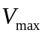) were chosen to achieve a good correspondence of model simulations with reported galactose elimination rates [REF, Figure?] and observed changes in metabolite concentrations after galactose loads [REF, Figure ?]. The mathematical models on cellular scale and tissue-scale are available as SBML from Biomodels.org (biomodels.org/?) and JWS Online (http://jjj.mib.ac.uk/database?l.). The kinetic parameters of the model were stored in SABIO-RK and made accessible via SBML annotations.
GALK, GALT and GALE deficiencies were implemented by changing the kinetic parameters for the respective enzyme from wildtype to values for the impaired enzyme variants (Table 3) with all other model parameters unchanged.

Tissue scale - sinusoidal unit
The tissue-scale model of the sinusoidal unit (Figure 1B) consists of a central blood vessel (sinusoid) surrounded by the space of Disse and adjacent hepatocytes in cylindrical geometry with parameters in Table 4. In the sinusoid substances are transported by blood flow and diffusion, in the space of Disse solely by diffusion. Red blood cells (RBC) are constricted to the sinusoid, whereas all other model substances (<200µm), namely galactose (gal), water (h2o), albumin (alb) and sucrose (suc), can pass in the space of Disse owing to the fenestration of the endothelial cells . Galactose and water can enter the hepatocytes, whereas sucrose and albumin are restricted to the space of Disse and the sinusoid.
Diffusion and blood flow are modelled by discretizing the sinusoid and Disse space in small volumes with the transport between neighbouring volumes governed by one-dimensional diffusion and convection equations (similar to ). The periportal (pp) and perivenous (pv) blood compartment are located adjacent to the first periportal and last perivenous sinusoidal volume, respectively. A sinusoidal unit consists of 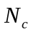 hepatocytes from periportal to perivenous with each cell having a single associated sinusoid and Disse volume (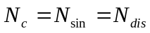). The concentrations of 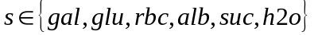 in pp and pv are given by 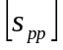 and 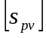 the concentrations in the sinusoidal and Disse space as 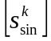 and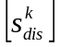 (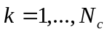). The respective diffusion coefficients within the sinusoid and space of Disse are given by 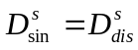, the diffusion through the fenestraetion between sinusoid and space of Disse by 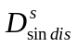.With the blood flow velocity in the sinusoid 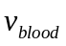, the sinusoidal radius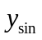, the width of space of Disse 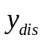 and the discretization along the sinusoid 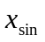the rates of transport between the compartments are given as

Blood flow in sinusoid (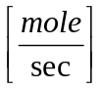)
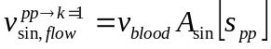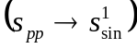
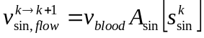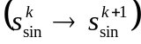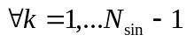
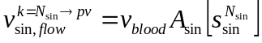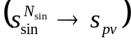
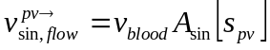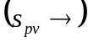

Diffusion in sinusoid and space of Disse ()
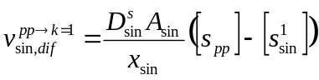
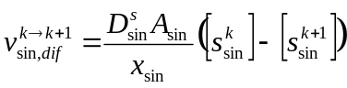
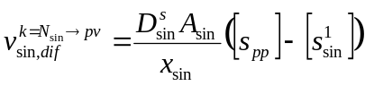
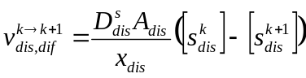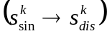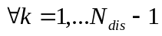
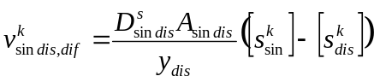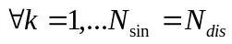
The model was solved using COPASI with absolute and relative tolerances of 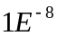. All source code is available at https://sourceforge.net/projects/multiscale-galactose.

Organ scale- liver
To account for the heterogeneity of the sinusoidal units within the liver a distribution of sinusoidal units differing in blood flow 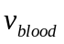, sinusoidal length 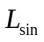, sinusoidal radius 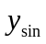, width of Disse space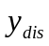 and hepatocyte sheet thickness 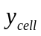 were simulated. The individual parameter distributions were assumed lognormal distributed with mean and variance based on experimental values. The various tissue parameters were assumed to be statistically independent. The resulting combined output of the distribution of sinusoidal units was scaled to account for the whole liver capacity.
Parameter |  | mean  | standard deviation
Sinusoidal length | 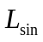 | 500µm | 70µm
Sinusoidal radius |  | 4.4µm | 0.45µm
Width of Disse space |  | 0.8µm | 0.3µm
Hepatocyte sheet thickness |  | 1/4*25µm | ¼*5µm
Blood flow velocity |  | 60µm/s | 50µm/s

Results
- Validierung des Gewebe-Modells auf der Basis von in vivo gemessenen multiple indicator-dilution curves (Hund) und PET-data (Mensch); das ohne Galaktosestoffwechsel
- Validierung des zellulären Stoffwechselmodells + Gewebe-Modells auf der Bsasis von gemessenen GEC-Kurven unter Normalbedingungen – Vergleich low/high Galaktose-Last (Rekonstruktion der Sättigungskinetik)
Müßte in die Simulationen des Plasmaverlauf von Galaktose nicht die systemische Zirkulation einbezogen werden:
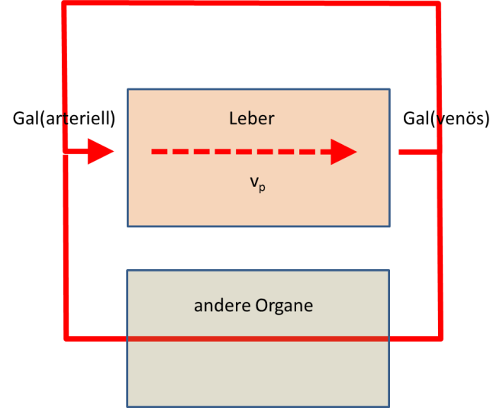
Und wäre es denkbar, aus dem gemessen Zeitverlauf der Plasma-Galaktose bei zweimaliger, zeitlich versetzter Galaktosegabe den Perfusionsanteil vom metabolischen Anteil zu separieren?
- Galaktosämie: Vergleich von gemessenen Plasmaprofilen von Galaktose (GEC) und zellulären Konzentrationen von Intermediaten (Gal-1P, UDP-Gal etc.) mit Modellwerten für die 3 Varianten der Galaktosämie – jeweils Kommentare zur pathophysiologischen Bedeutung dieser Veränderungen (Galactitol etc.)
- Simulationen: GEC bei verschiedenen Lebererkrankungen – Fibrose, Okklusion der A. Hepatica, CCl4-Intoxikation

Die interessanteste Frage ist die nach der medizinischen Relevanz des Modells: Welche Aussagen gestattet das Model nach Anpassung an gemessene Plasmaverläufe. Differences in homogeneous and heterogenous disturbances of the model.
In allen Teilabschnitten 1-4 vorneweg eine knappe Darstellung des biologischen und medizinischen Hintergrundes (bisher viel zu viel Details im Results-Teil). Wie besprochen, wenn möglich zum Vergleich immer eine Simulation für das „homogene“ Modell (alle Zellen sehen die gleiche Plasmaverhältnisse; alle Sinusoid-Einheiten haben die gleichen Flüsse und Geometrie) mitführen

Liver Galactose Elimination Capacity (GEC)
The galactose elimination capacity (GEC) is defined as the rate with which a given plasma load of galactose is cleared. The GEC depends on the amount of metabolically active liver cell mass and the liver perfusion : The GEC is an accepted test of liver function and has been measured in numerous studies [Schirmer -> 5, 9, 17, 22, 41, 78, 79, 82, 83, 88, 96]. [Schirmer1986 -> 17,82, 83, 88, 96]. Galactose Clearance at low concentrations (GCLC) has proven to be as near ideal a method for estimating the effective hepatic blood flow (EBHF) because most of the plasma galactose entering the liver also leaves the liver without being metabolized [Schirmer1986]. The dependence of the hepatic galactose elimination rate follows a Michaelis-Menten saturation kinetics [43, 50, 70]; with a quasi-linear concentration-dependent (first-order) elimination phase followed by aclearance maximum (GEC) at higher concentrations (zero-order phase).

Changes in Hepatic Galactose Metabolism
Galactose metabolism and GEC are quit constant. Adult rats fed a 40% galactose diet for 5 days did not show an increase in GEC although 20 days on the diet resulted in a 20% increase in V_{max} suggesting that adaptive mechanisms are slow [Schirmer1986 ->18]. This lack of inducability and relatively constant V_{max} is desirable in clearance methodology as a fluctuating V_{max}/FK_{m} would certainly complicate clearance interpretations.

In a first step the model was validated multiple-indicator dilution curves. None of the data was used for model fitting, all model parameters result from the geometric constraints of the system and the physic-chemical properties of the substances transported within the sinusoid and the space of Disse. The model performance was validated based on published multiple-indicator dilution curves in human [REF] and dog [REF].

Validation on Tissue and Organ Scale
Validierung des Gewebe-Modells auf der Basis von in vivo gemessenen multiple indicator-dilution curves (Hund) und PET-data (Mensch); das ohne Galaktosestoffwechsel
Multiple indicator dilution curves for a multitude of substances could be replicated (Figure 3). Very interestingly the shift of the dilution-indicator curves observed and explained by Goresky as different free volumes of the substances are a consequence of the different diffusion coefficients for the substances, resulting in a delayed appearance of the substances perivenious.
Normal hepatic galactose metabolism
Hepatic galactose metabolism was simulated. Data from multiple indicator-dilution curves in dogs as well as PET data from humans could be reproduced.
Deficiencies in hepatic galactose metabolism
Various deficiencies in hepatic galactose metabolism were simulated.

“With the reports that there is a large daily endogenous production of galactose [10–12] which provides a galactose burden in addition to that imposed by food intake, it is apparent that patients with galactosemia with little or no GALT must have mechanisms for disposal of the sugar. Otherwise, they would continue toaccumulate galactose metabolites such as galactose-1-phosphate (Gal-1-P), galactitol and galactonate. This, however, is not the case: most patients manifest their own relatively unique steady-state levels of plasma galactose[13], RBC galactose-1-phosphate [14], galactitol and galactonate [15], and urinary galactitol [16] and galactonate[17] excretion. Estimates are that urinary excretion of metabolites account for about 30% of the daily burden [7,12]. [Berry2004]
“Specific metabolites known to reach abnormal levels in the hemolysates and/or tissues of untreated patients with classic galactosemia (GALT deficiency) include galactose, gal1p, galactitol, and inositol. Abnormal galactonate also forms but is excreted in the urine and does not accumulate in tissues (revied in Holten et al 2000, Tyfield and Walter 2002). Patients with classic galactosemia may also experience a partial depletion of UDP-gal, at least in their red blood cells.
“Following dietary restriction of galactose, patients with GALT deficiency demonstrate marked normalization of their metabolic profiles, although gal1p often remains outside the normal range (>5mM untreated, ~0.1mM treated, undetectable in normal (Gitzelmann 1995). Indeed, a number of studies have correlated the presence of elevated gal1p in patients on dietary galactose restriction with severity of clinical outcome (Kaufman 1988, Ng1991, Xu1995b).”
Untreated GALE deficiency also accumulate abnormal high levels of RBC galactose and gal1p. In addition these pationes also accumulate very high levels of UDP-gal (Holton et al, 1981; Walter et al., 1999, Openo et al, 2006). Considering that gal-1P is a substrate of GALT but not GALE, the fact that it accumulates to abnormal high levels in GALE-impaired cells demonstrates the interdependence of enzymes in the pathway. Presumably, gal1p accumulates in these cells secondary to the accumulation of UDP-gal, which exerts product inhibition on GALT.”
“In GALT-deficient mice created by Ning2000, gal1p accumulated in liver, kidney and brain, with very high levels of gal1p in red blood cells, comparable to findings in GALT-deficient humans. Surprisingly, these mice showed no evidence of galactose toxicity. However, the concentrations of galactitol in these GALT-defcient mice were significantly lower than observed in humans. This is probably caused by the low levels of aldose reductase in normal mouse tissues (Ai et al 2000). .”

“In galactosemic infants on an unrestricted lactose intake, a potentially lethal organ toxicity syndrome develops, presumably because D-galactose-derived metabolites (D-galactose-1-phosphate and D-galactitol) accumulate within the cells. ”

Alterations in Galactosemias
- Differences in GALK, GALT and GALE deficiencies
- Metabolic control analysis as predictor of alterations (which parameters have the largest impact on metabolic levels (especially byproducts galactitol, galactose and galactose-1p
- Simulation of multitude of “real-world” changes in enzyme activity based on characterization of typical mutants

Role of Alternative Galactose Pathways
Alternative pathways of galactose metabolism become important under impaired GALK, GALT or GALE.
“Overexpression of human IMP was found to overcome galactose toxicity in GALT deficient yeast cells” [Lai2009->95]

UDP-galactose pyrophosphorylase
“The formation of UDP-glucose is believed to be the major physiological function of the pyrophosphorylase (I). However, at a slower rate, the enzyme also catalyzed the pyrophosphorolysis of UDP-galactose. The saturating concentration for UDP-galactose is 10 times that of UDP-glucose. Under normal physiological conditions, this may not be significant, but, in a galactosemic patient, in which the normal galactose metabolism is impaired, the pyrophosphorylase may participate in an abnormal role. Isselbacher has suggested that a pyrophosphorylase is responsible for the increased ability of some galactosemics to metabolize galactose by synthesizing UDP-galactose from galactose-1-P and UTP (3). Gitzelmann, on the other hand, has suggested that a pyrophosphorylase may be responsible for the elevated galactose-1-P levels found in the blood of some galactosemics on supposedly galactose-free diets (11). Thus, a pyrophosphorylase has been suggested to catalyze both the biosynthesis and the pyrophosphorolysis of UDP-galactose in galactosemics”.
Abraham and Howell (12) extracted UDP-galactose pyrophosphorylase activity from human liver and, without purification, the catalytic properties were elaborated upon. The specificity of their extract for substrate was not reported”

Accumulation of Byproducts of galactose metabolism
“Galactitol accumulation has been demonstrated in the brain of toxic neonates with classical galactosemia [Leslie2003 -> 3, 46, 59]. The amounts of galactitol measured directly in GALT-deficient mice are lower (2mM) than levels detected by magnetic resonance spectroscopy in human subjects (8mM) [Leslie2003 -> 3, 57].
A high galactitol content in the lens was detected in a GALT-defiecnt patient with cataract”[Wang2001->8]
Galactitol has been isolated from tissues and urine of galactosemic patients [Segal1968 - > 19,20] and from tissues of rats fed high galactose diet [Segal1986 -> 21,22]
Accumulation of galactitol lens (cataracts)

“Cataract caused by galactitol accumulation seems to be the only consistent abnormality in galactokinase deficiency and this can be prevented with a galactose-restricted diet ->Holton2001.” “This relatively benign course of the disease is in strong contrast with high percentage of late complications that have been reported in the more common disorder of galactose metabolism, GALT deficiency. ”
Indeed excretion of abnormal quantities of galactitol in the urine of galactosemic patients is characteristic of the disorder [Wang2001-> 6].”[Wang2001]. “

For example,patients with significant GALE-deficiency accumulate strikingly elevated levels of UDPgal in response to galactose exposure (Walter1999, Openo2006). In contrast, patients with GALT deficiency may experience abnormal depletion of UDPgal and/or UDPglc (Xu1995a, Holton et al2000, Lai et al., 2003).

“In GALT-deficient mice created by Ning2000, gal1p accumulated in liver, kidney and brain, with very high levels of gal1p in red blood cells, comparable to findings in GALT-deficient humans. .”
“Accumulation of gal1p is regarded one of the most important pathogenic factors in GALT deficiency ->Gitzelmann1995, Gitzelmann1967

“In humans, deficiency of GALT activity caused by deleterious
variations of the GALT gene can result in a potentially lethal disorder
called classic galactosemia (MIM# 230400) [Isselbacher et al.,
1956; Segal and Berry, 1995]. If the affected neonates are not treated
in time, they will suffer fromsevere hepatic and renal failure, bleeding
diatheses, and E. coli sepsis, which can lead to death within days
of birth [Goppert, 1917; Isselbacher et al., 1956; Mason et al., 1935;
Segal and Berry, 1995]. The exact pathophysiology of these acute
symptoms remains uncertain, partially because of the lack of experimental
animal model for this disease [Leslie et al., 1996], but the accumulation of gal-1P is regarded as one of the most important
pathogenic factors [Gitzelmann, 1995; Gitzelmann et al., 1967]. “

Galactose metabolism as liver function test
Abnormalities in gal-Metabolism and liver disease: “Some patients with hepatic disease have increased Gal in their blood [Yamaguchi1989 -> 4], as shown by our patient with peliosis hepatitis, and also glycogen storage disease type XI. Also, liver dysfunction is an early clinical complication of galactosemia” [Yamaguchi1989]

Discussion

Hypothesis of Pathophysiology in Galactosemias
“The more we learn of the ‘single gene’ metabolic disorders, the more it becomes clear that intricate cascades of regulation and combinatorial control operate here as well, overseeing the interplay of enzymes and metabolic pathways under normal conditions, and mediating pathophysiology and the severity of patient outcome under abnormal conditions. Identifying the players and inter-relationships not only teaches us about normal metabolism, it further empowers a rational approach to the development of novel and potentially more effective treatments.”
“Multiple mechanism resulting in the pathophysiology in galactosemia were proposed [Lai2009] (reviewed in Tyfield and Walter 2002, Leslie 2003):
- Accumulation of toxic metabolites in the blocked Leloir Pathway
- accumulation of toxic products of alternate galactose metabolism
- Alterations of absolute UDP-galactose, UDP-glucose and relative UDP-glucose/UDP-galactose levels with implications in protein glycosylation and galactosylation, Lebea2005 have proposed that depletion of UDP-gal in GALT deficiency may impede the function of cerebroside galactosyl transferase, responsible for the galactosylation of cerebrosides. Considering that both UDPgal and UDP-glc serve as important activated sugar donors for glycosyltransferases, the connection to pathophysiology may involve defects in the biosynthesis of glycoproteins and/or glycolipids in the cells and tissues of galactosemic patients (Segal, 1995, Tyfeld and Walter 2002). Indeed such abnormalities have been found.”
With both levels and approximate 1:3 ratio of UDP-gal and UDP-glc are very tightly controlled in normal cells (Segal1995), these levels and ratio may be disturbed in both GALT and GALE-deficiency galactosemia
- Perturbation in inositol metabolism, with reports suggesting that increased gal1p could inhibit myoinositol monophosphatase (IMP) [Fridovich-Keil2006 ->Wells1965].
- Futile cycles of phosphorylation/dephosphorylation in galactose metabolism might result in ATP depletion [Fridovich-Keil2006 -> Miller1973]
- Elevated intracellular gal1p might inhibit a number of important enzymes, including glucose-6-phosphatase, phosphoglucomutase, … [Fridovich-Keil2006 -> Gitzelmann]
Trapping of uridine phosphate with galactose (similar to galactosamine induced hepatitis) could explain the neonatal liver failure, …. [Keppler1969, 1970]. Similar effects, in case of certain mutations, the galactose production of the body could be sufficient to lower the UDP levels. “The decrease in UTP is considered to be the most essential primary mechanism of galactosamine-induced liver damage [Keppler1970->18,19] and is proposed to explain the increased toxicity of galactose by ethanol. ” [Discuss]

Comparison to current multiscale models of liver
Höhme (no detailed blood flow, no metabolism)
Chaloubh (missing parameter distributions, only briding the gap to the sinusoidal unit, not possible to simulate the different effects of heterogenous variations of parameters.
Galactose-Clearance Modelle – no detailed description of metabolism, no bridging to whole liver function

Towards a virtual liver
Bridging the scales from cellular processes over the coupling of single cells within the tissue-architecture towards whole-organ models is a crucial step in understand physiological function of organs in the normal state and in pathophysiologies. Only by modelling the different scales explicitly the emerging behaviour on a liver scale can be properly understood.

Acknowledgement
This work was supported by the Federal Ministry of Education and Research (BMBF, Germany) within the Virtual Liver Network (VLN grant number 0315741). I thank the SABIO-RK Team for their effort to integrate the kinetic parameters in their database, especially Martin Golebiewski, Renate Kenia and Ulrike Wittig. I thank Tobias Czauderna for the support with SBGN as well as Lucian Smith with libAntimony.
The authors declare no commercial or financial conflict of interest.

References
Accorsi, A., et al. (1989) Isoenzymes of phosphoglucomutase from human red blood cells: isolation and kinetic properties, Preparative biochemistry, 19, 251-271.
Allen, T.H. and Reeve, E.B. (1953) Distribution of extra plasma in the blood of some tissues in the dog of measured with P32 and T-1824, The American journal of physiology, 175, 218-223.
Arbuckle, M.I., et al. (1996) Structure-function analysis of liver-type (GLUT2) and brain-type (GLUT3) glucose transporters: expression of chimeric transporters in Xenopus oocytes suggests an important role for putative transmembrane helix 7 in determining substrate selectivity, Biochemistry, 35, 16519-16527.
Bautista, J.M., Mason, P.J. and Luzzatto, L. (1992) Purification and properties of human glucose-6-phosphate dehydrogenase made in E. coli, Biochimica et biophysica acta, 1119, 74-80.
Bernstein, L.M., et al. (1960) The blood galactose disappearance curve as a test of liver function, Gastroenterology, 39, 293-304.
Berry, G.T., et al. (1995) Endogenous synthesis of galactose in normal men and patients with hereditary galactosaemia, Lancet, 346, 1073-1074.
Berry, G.T., et al. (2000) Galactose breath testing distinguishes variant and severe galactose-1-phosphate uridyltransferase genotypes, Pediatric research, 48, 323-328.
Blouin, A., Bolender, R.P. and Weibel, E.R. (1977) Distribution of organelles and membranes between hepatocytes and nonhepatocytes in the rat liver parenchyma. A stereological study, The Journal of cell biology, 72, 441-455.
Bosch, A.M., et al. (2002) Clinical features of galactokinase deficiency: a review of the literature, Journal of inherited metabolic disease, 25, 629-634.
Brauer, R.W., Holloway, R.J. and Leong, G.F. (1959) Changes in liver function and structure due to experimental passive congestion under controlled hepatic vein pressures, The American journal of physiology, 197, 681-692.
Brown, G.K. (2000) Glucose transporters: structure, function and consequences of deficiency, Journal of inherited metabolic disease, 23, 237-246.
Carlisle, K.M., et al. (1992) Estimation of total hepatic blood flow by duplex ultrasound, Gut, 33, 92-97.
Casciari, J.J., Sotirchos, S.V. and Sutherland, R.M. (1988) Glucose diffusivity in multicellular tumor spheroids, Cancer Res, 48, 3905-3909.
Chang, H.Y., et al. (1996) The importance of conserved residues in human liver UDPglucose pyrophosphorylase, European journal of biochemistry / FEBS, 236, 723-728.
Ciaraldi, T.P., Horuk, R. and Matthaei, S. (1986) Biochemical and functional characterization of the rat liver glucose-transport system. Comparisons with the adipocyte glucose-transport system, The Biochemical journal, 240, 115-123.
Colville, C.A., et al. (1993) Kinetic analysis of the liver-type (GLUT2) and brain-type (GLUT3) glucose transporters in Xenopus oocytes: substrate specificities and effects of transport inhibitors, The Biochemical journal, 290 ( Pt 3), 701-706.
Corpas, F.J., et al. (1995) Kinetic properties of hexose-monophosphate dehydrogenases. II. Isolation and partial purification of 6-phosphogluconate dehydrogenase from rat liver and kidney cortex, Molecular and cellular biochemistry, 144, 97-104.
Corpas, F.J., et al. (1995) Kinetic properties of hexose-monophosphate dehydrogenases. I. Isolation and partial purification of glucose-6-phosphate dehydrogenase from rat liver and kidney cortex, Life sciences, 56, 179-189.
Cuatrecasas, P. and Segal, S. (1965) Mammalian Galactokinase. Developmental and Adaptive Characteristics in the Rat Liver, The Journal of biological chemistry, 240, 2382-2388.
Czauderna, T., Klukas, C. and Schreiber, F. (2010) Editing, validating and translating of SBGN maps, Bioinformatics, 26, 2340-2341.
Diepenbrock, F., et al. (1992) Colorimetric determination of galactose and galactose-1-phosphate from dried blood, Clinical biochemistry, 25, 37-39.
Duggleby, R.G., et al. (1996) Sequence differences between human muscle and liver cDNAs for UDPglucose pyrophosphorylase and kinetic properties of the recombinant enzymes expressed in Escherichia coli, European journal of biochemistry / FEBS, 235, 173-179.
Elliott, K.R. and Craik, J.D. (1982) Sugar transport across the hepatocyte plasma membrane, Biochemical Society transactions, 10, 12-13.
Everett, N.B., Simmons, B. and Lasher, E.P. (1956) Distribution of blood (Fe 59) and plasma (I 131) volumes of rats determined by liquid nitrogen freezing, Circulation research, 4, 419-424.
Facchiano, A. and Marabotti, A. (2010) Analysis of galactosemia-linked mutations of GALT enzyme using a computational biology approach, Protein engineering, design & selection : PEDS, 23, 103-113.
Fridovich-Keil, J.L. (2006) Galactosemia: the good, the bad, and the unknown, Journal of cellular physiology, 209, 701-705.
Fukuchi, T., et al. (1994) Recombinant rat nucleoside diphosphate kinase isoforms (alpha and beta): purification, properties and application to immunological detection of native isoforms in rat tissues, Biochimica et biophysica acta, 1205, 113-122.
Gariepy, L., et al. (1993) Clearance by the liver in cirrhosis. II. Characterization of propranolol uptake with the multiple-indicator dilution technique, Hepatology, 18, 823-831.
Geeganage, S. and Frey, P.A. (1998) Transient kinetics of formation and reaction of the uridylyl-enzyme form of galactose-1-P uridylyltransferase and its Q168R-variant: insight into the molecular basis of galactosemia, Biochemistry, 37, 14500-14507.
Goresky, C.A. (1963) A linear method for determining liver sinusoidal and extravascular volumes, The American journal of physiology, 204, 626-640.
Goresky, C.A., Bach, G.G. and Nadeau, B.E. (1973) On the uptake of materials by the intact liver. The transport and net removal of galactose, The Journal of clinical investigation, 52, 991-1009.
Gould, G.W., et al. (1991) Expression of human glucose transporters in Xenopus oocytes: kinetic characterization and substrate specificities of the erythrocyte, liver, and brain isoforms, Biochemistry, 30, 5139-5145.
Groebe, K., Erz, S. and Mueller-Klieser, W. (1994) Glucose diffusion coefficients determined from concentration profiles in EMT6 tumor spheroids incubated in radioactively labeled L-glucose, Advances in experimental medicine and biology, 361, 619-625.
Gross, J.F. and Aroesty, J. (1972) Mathematical models of capillary flow: a critical review, Biorheology, 9, 225-264.
Guynn, R.W., et al. (1974) The concentration and control of cytoplasmic free inorganic pyrophosphate in rat liver in vivo, The Biochemical journal, 140, 369-375.
Henderson, J.M., Kutner, M.H. and Bain, R.P. (1982) First-order clearance of plasma galactose: the effect of liver disease, Gastroenterology, 83, 1090-1096.
Hoops, S., et al. (2006) COPASI--a COmplex PAthway SImulator, Bioinformatics, 22, 3067-3074.
Irie, M., et al. (1970) Distribution and properties of alkaline pyrophosphatases of rat liver, Journal of biochemistry, 67, 47-58.
Jakab, F., et al. (1995) The interaction between hepatic arterial and portal venous blood flows; simultaneous measurement by transit time ultrasonic volume flowmetry, Hepato-gastroenterology, 42, 18-21.
Jepsen, P., et al. (2009) The galactose elimination capacity and mortality in 781 Danish patients with newly-diagnosed liver cirrhosis: a cohort study, BMC gastroenterology, 9, 50.
Kashiwaya, Y., et al. (1994) Control of glucose utilization in working perfused rat heart, The Journal of biological chemistry, 269, 25502-25514.
Keppler, D. and Decker, K. (1969) Studies on the mechanism of galactosamine-1-phosphate and its inhibition of UDP-glucose pyrophosphorylase, European journal of biochemistry / FEBS, 10, 219-225.
Keppler, D., et al. (1969) Changes in uridine nucleotides during liver perfusion with D-galactosamine, FEBS letters, 4, 278-280.
Keppler, D., Rudigier, J. and Decker, K. (1970) Trapping of uridine phosphates by D-galactose in ethanol-treated liver, FEBS letters, 11, 193-196.
Keppler, D.O., et al. (1970) The trapping of uridine phosphates by D-galactosamine. D-glucosamine, and 2-deoxy-D-galactose. A study on the mechanism of galactosamine hepatitis, European journal of biochemistry / FEBS, 17, 246-253.
Kimura, N. and Shimada, N. (1988) Membrane-associated nucleoside diphosphate kinase from rat liver. Purification, characterization, and comparison with cytosolic enzyme, The Journal of biological chemistry, 263, 4647-4653.
Knop, J.K. and Hansen, R.G. (1970) Uridine diphosphate glucose pyrophosphorylase. IV. Crystallization and properties of the enzyme from human liver, The Journal of biological chemistry, 245, 2499-2504.
König, M., Bulik, S. and Holzhütter, H.G. (2012) Quantifying the contribution of the liver to glucose homeostasis: a detailed kinetic model of human hepatic glucose metabolism, PLoS computational biology, 8, e1002577.
Konig, M., Holzhutter, H.G. and Berndt, N. (2013) Metabolic gradients as key regulators in zonation of tumor energy metabolism: A tissue-scale model-based study, Biotechnology journal, 8, 1058-1069.
Koo, A. and Liang, I.Y. (1979) Microvascular filling pattern in rat liver sinusoids during vagal stimulation, J Physiol, 295, 191-199.
Kuntz, E. and Kuntz, H.D. (2006) Hepatology - Principles and Practice.
Lai, K., et al. (2003) GALT deficiency causes UDP-hexose deficit in human galactosemic cells, Glycobiology, 13, 285-294.
Lam, S.C. and Packham, M.A. (1986) Isolation and kinetic studies of nucleoside diphosphokinase from human platelets and effects of cAMP phosphodiesterase inhibitors, Biochemical pharmacology, 35, 4449-4455.
Lautt, W.W. (2009). In, Hepatic Circulation: Physiology and Pathophysiology. San Rafael (CA).
Le Novere, N., et al. (2009) The Systems Biology Graphical Notation, Nature biotechnology, 27, 735-741.
Leslie, N.D. (2003) Insights into the pathogenesis of galactosemia, Annual review of nutrition, 23, 59-80.
Loud, A.V. (1968) A quantitative stereological description of the ultrastructure of normal rat liver parenchymal cells, The Journal of cell biology, 37, 27-46.
MacPhee, P.J., et al. (1988) Microcirculatory changes in livers of mice infected with murine hepatitis virus. Evidence from microcorrosion casts and measurements of red cell velocity, Microvascular research, 36, 140-149.
Marchesini, G., et al. (1988) Galactose elimination capacity and liver volume in aging man, Hepatology, 8, 1079-1083.
Novelli, G. and Reichardt, J.K. (2000) Molecular basis of disorders of human galactose metabolism: past, present, and future, Molecular genetics and metabolism, 71, 62-65.
Orfanos, A.P., Jinks, D.C. and Guthrie, R. (1986) Microassay for estimation of galactose and galactose-1-phosphate in dried blood specimens, Clinical biochemistry, 19, 225-228.
Ozer, N., Aksoy, Y. and Ogus, I.H. (2001) Kinetic properties of human placental glucose-6-phosphate dehydrogenase, The international journal of biochemistry & cell biology, 33, 221-226.
Parthasarathy, R., Parthasarathy, L. and Vadnal, R. (1997) Brain inositol monophosphatase identified as a galactose 1-phosphatase, Brain research, 778, 99-106.
Petry, K.G. and Reichardt, J.K. (1998) The fundamental importance of human galactose metabolism: lessons from genetics and biochemistry, Trends in genetics : TIG, 14, 98-102.
Puhl, G., et al. (2003) Noninvasive in vivo analysis of the human hepatic microcirculation using orthogonal polorization spectral imaging, Transplantation, 75, 756-761.
Quan-Ma, R., et al. (1966) Galactitol in the tissues of a galactosemic child, Am J Dis Child, 112, 477-478.
Quick, C.B., Fisher, R.A. and Harris, H. (1974) A kinetic study of the isozymes determined by the three human phosphoglucomutase loci PGM1, PGM2, and PGM3, European journal of biochemistry / FEBS, 42, 511-517.
Quimby, B.B., et al. (1997) Characterization of two mutations associated with epimerase-deficiency galactosemia, by use of a yeast expression system for human UDP-galactose-4-epimerase, American journal of human genetics, 61, 590-598.
Quimby, B.B., et al. (1996) Functional requirements of the active site position 185 in the human enzyme galactose-1-phosphate uridylyltransferase, The Journal of biological chemistry, 271, 26835-26842.
Sangiuolo, F., et al. (2004) Biochemical characterization of two GALK1 mutations in patients with galactokinase deficiency, Human mutation, 23, 396.
Sasse, D., Spornitz, U.M. and Maly, I.P. (1992) Liver architecture, Enzyme, 46, 8-32.
Schadewaldt, P., et al. (2000) Analysis of concentration and (13)C enrichment of D-galactose in human plasma, Clinical chemistry, 46, 612-619.
Schirmer, W.J., et al. (1986) Galactose clearance as an estimate of effective hepatic blood flow: validation and limitations, The Journal of surgical research, 41, 543-556.
Segal, S. (1995) Defective galactosylation in galactosemia: is low cell UDPgalactose an explanation?, European journal of pediatrics, 154, S65-71.
Segal, S. and Rogers, S. (1971) Nucleotide inhibition of mammalian liver galactose-I-phosphate uridylyltransferase, Biochimica et biophysica acta, 250, 351-360.
Slepak, T.I., et al. (2007) Involvement of endoplasmic reticulum stress in a novel Classic Galactosemia model, Molecular genetics and metabolism, 92, 78-87.
Tang, M., et al. (2012) Correlation assessment among clinical phenotypes, expression analysis and molecular modeling of 14 novel variations in the human galactose-1-phosphate uridylyltransferase gene, Human mutation, 33, 1107-1115.
Thoden, J.B., et al. (2002) Structural analysis of the Y299C mutant of Escherichia coli UDP-galactose 4-epimerase. Teaching an old dog new tricks, The Journal of biological chemistry, 277, 27528-27534.
Thuillier, L. (1978) Purification and kinetic properties of human erythrocyte Mg2+-dependent inorganic pyrophosphatase, Biochimica et biophysica acta, 524, 198-206.
Timson, D.J. (2005) Functional analysis of disease-causing mutations in human UDP-galactose 4-epimerase, The FEBS journal, 272, 6170-6177.
Timson, D.J. and Reece, R.J. (2003) Functional analysis of disease-causing mutations in human galactokinase, European journal of biochemistry / FEBS, 270, 1767-1774.
Timson, D.J. and Reece, R.J. (2003) Sugar recognition by human galactokinase, BMC biochemistry, 4, 16.
Turnquist, R.L., et al. (1974) Uridine diphosphate glucose pyrophosphorylase: differential heat inactivation and further characterization of human liver enzyme, Biochimica et biophysica acta, 364, 59-67.
Tyfield, L. and Walter, J. (2002) Galactosemia. In Scriver, C., et al. (eds), The Metabolic and Molecular Bases of Inherited Disease. McGraw-Hill, New York.
Tygstrup, N. (1963) Determination of the hepatic galactose elimination capacity after a single intravenous injection in man: the reproducibility and the influence of uneven distribution, Acta physiologica Scandinavica, 58, 162-172.
Tygstrup, N. (1966) Determination of the hepatic elimination capacity (Lm) of galactose by single injection, Scandinavian journal of clinical and laboratory investigation. Supplementum, 18, 118-125.
Tygstrup, N. and Winkler, K. (1954) Kinetics of galactose elimination, Acta physiologica Scandinavica, 32, 354-362.
Tygstrup, N. and Winkler, K. (1958) Galactose blood clearance as a measure of hepatic blood flow, Clin Sci (Lond), 17, 1-9.
Villeneuve, J.P., et al. (1996) The hepatic microcirculation in the isolated perfused human liver, Hepatology, 23, 24-31.
Vilstrup, H. (1983) Effects of acute carbon tetrachloride intoxication on kinetics of galactose elimination by perfused rat livers, Scandinavian journal of clinical and laboratory investigation, 43, 127-131.
Walmsley, A.R., et al. (1998) Sugar transporters from bacteria, parasites and mammals: structure-activity relationships, Trends in biochemical sciences, 23, 476-481.
Walter, J.H., et al. (1999) Generalised uridine diphosphate galactose-4-epimerase deficiency, Archives of disease in childhood, 80, 374-376.
Wang, Z.J., et al. (2001) Proton magnetic resonance spectroscopy of brain metabolites in galactosemia, Annals of neurology, 50, 266-269.
Wasilenko, J., et al. (2005) Functional characterization of the K257R and G319E-hGALE alleles found in patients with ostensibly peripheral epimerase deficiency galactosemia, Molecular genetics and metabolism, 84, 32-38.
Wells, W.W., et al. (1965) The Isolation and Identification of Galactitol from the Brains of Galactosemia Patients, The Journal of biological chemistry, 240, 1002-1004.
Wermuth, B., et al. (1982) Purification and characterization of human-brain aldose reductase, European journal of biochemistry / FEBS, 127, 279-284.
Wermuth, B. and von Wartburg, J.P. (1982) Aldose reductase from human tissues, Methods in enzymology, 89 Pt D, 181-186.
Winans, K.A. and Bertozzi, C.R. (2002) An inhibitor of the human UDP-GlcNAc 4-epimerase identified from a uridine-based library: a strategy to inhibit O-linked glycosylation, Chemistry & biology, 9, 113-129.
Wisse, E., et al. (1985) The liver sieve: considerations concerning the structure and function of endothelial fenestrae, the sinusoidal wall and the space of Disse, Hepatology, 5, 683-692.
Wittig, U., et al. (2012) SABIO-RK--database for biochemical reaction kinetics, Nucleic Acids Res, 40, D790-796.
Wohlers, T.M. and Fridovich-Keil, J.L. (2000) Studies of the V94M-substituted human UDPgalactose-4-epimerase enzyme associated with generalized epimerase-deficiency galactosaemia, Journal of inherited metabolic disease, 23, 713-729.
Yamaguchi, A., et al. (1989) Microassay for screening newborns for galactosemia with use of a fluorometric microplate reader, Clinical chemistry, 35, 1962-1964.
Yoshida, C., Shah, H. and Weinhouse, S. (1982) Purification and properties of inorganic pyrophosphatase of rat liver and hepatoma 3924A, Cancer research, 42, 3526-3531.

Figures

Figure 1 – Model of hepatic galactose metabolism on cellular, tissue- and organ-scale
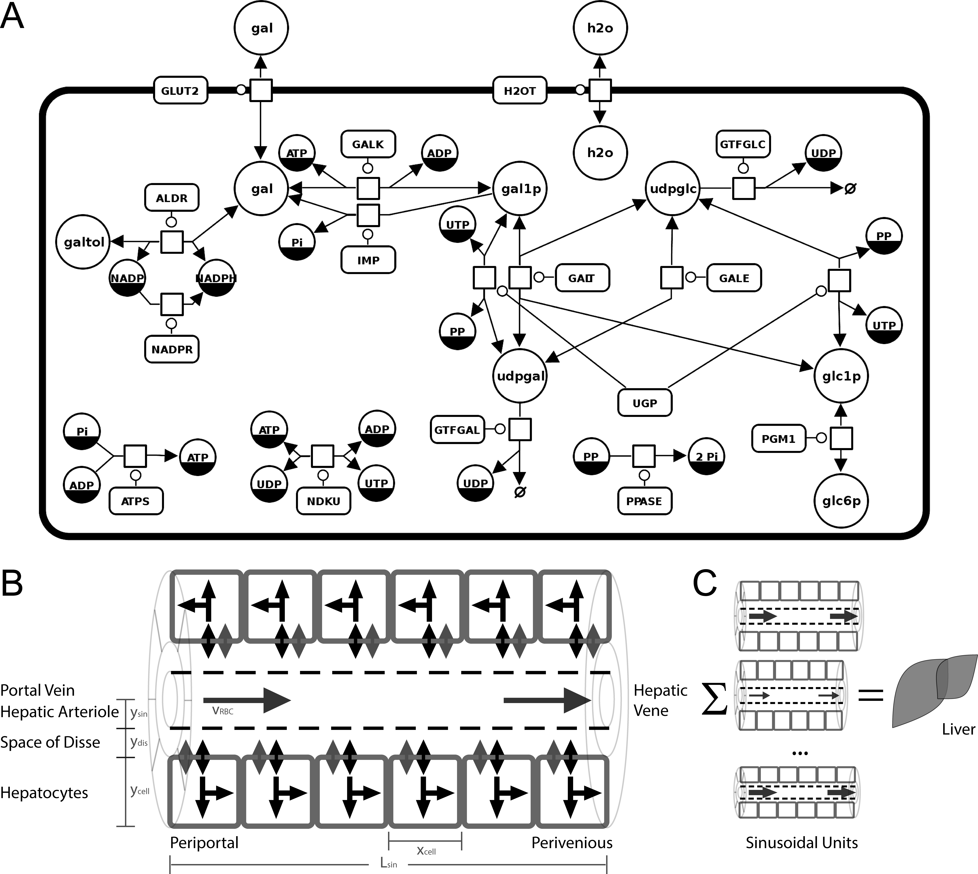
A) Metabolic model of hepatic galactose metabolism in SBGN created with SBGN-ED . The processes ATPS and NADPR were added for cofactor regeneration. Detailed information on metabolites, initial concentrations, rate equations and parameters is provided in the method section and the supplementary information.
Reactions: (ALDR) Aldose reductase (galactitol NAD 1-oxidoreductase); (ATPS) ATP synthesis; (GALDH) Galactose 1-dehydrogenase; (GALE) UDP-glucose 4-epimerase; (GALK) Galactokinase; (GALT) Galactose-1-phosphate uridyl transferase; (GLUT2) Facilitated glucose transporter member 2; (GTFGAL) Glycosyltransferase galactose; (GTFGLC) Glycosyltransferase glucose; (NADPR) NADP reductase; (NDKU) Nucleoside diphosphokinase, ATP:UDP phosphotransferase; (IMP) Inositol monophosphatase; (PGM1) Phosphoglucomutase-1; (PPASE) Pyrophosphatase; (UGALP) UDP-galactose pyrophosphorylase; (UGP) UDP-glucose pyrophosphorylase;
Metabolites: (adp) ADP; (atp) ATP; (gal) D-galactose; (gal1p) D-galactose 1-phosphate; (galnat) D-galactonate; (galtol) D-galactitol; (glc) D-glucose; (glc1p) D-glucose 1-phosphate; (glc6p) D-glucose 6-phosphate; (nadp) NADP; (nadph) NADPH; (pi) phosphate; (pp) pyrophosphate; (udp) UDP; (udpgal) UDP-D-galactose; (udpglc) UDP-D-glucose; (utp) UTP;
B) Tissue-scale model of the sinusoidal unit comprising diffusion and convection based transport of substances in the sinusoid, diffusion-based transport of substances in the space of Disse and description of cellular metabolism via kinetic models of individual hepatocytes.
C) Modeling the liver via integration of heterogenous models of the sinusoidal unit varying in blood flow and structural parameters.
Figure 2 – Validation of single cell model of galactose metabolism Time courses in GALE inhibition via ethanol.
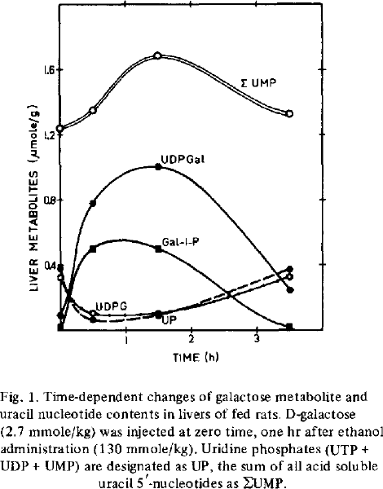
Typical effect of galactose challenge on the galactose metabolism of single cell model. Prediction of effects of GALE inhibition.
GALE is inhibited by ethanol ingestion, due to altered NAD/NADH quotient resulting in altered GALE activity due to NAD cofactor. Ethanol ingestion was simulated by altering the NAD levels. Experimental data from

Figure 3 – Hepatic multiple-indicator dilution curves
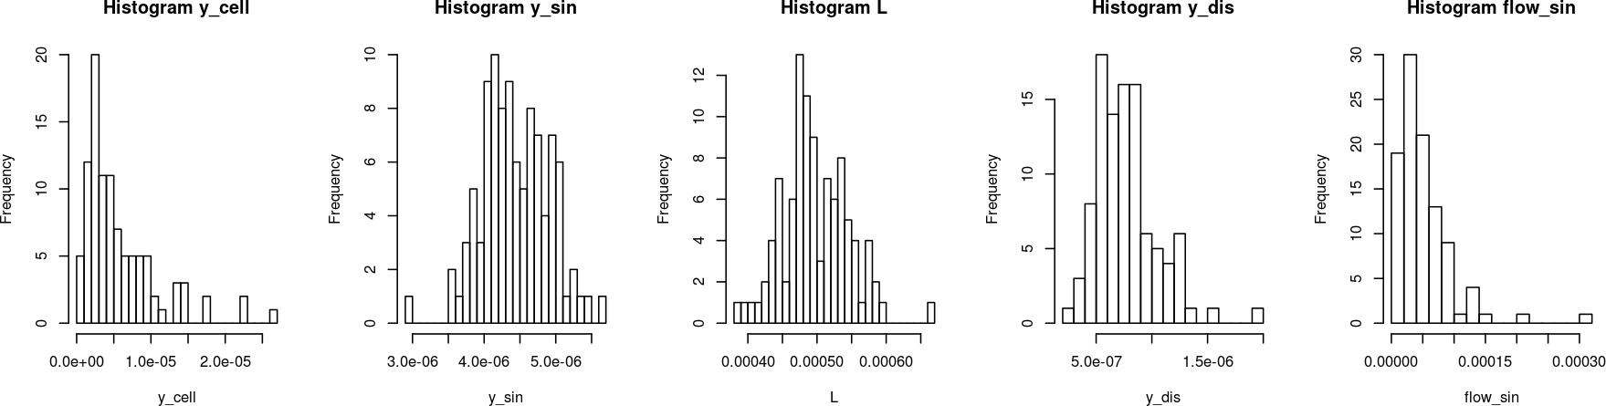
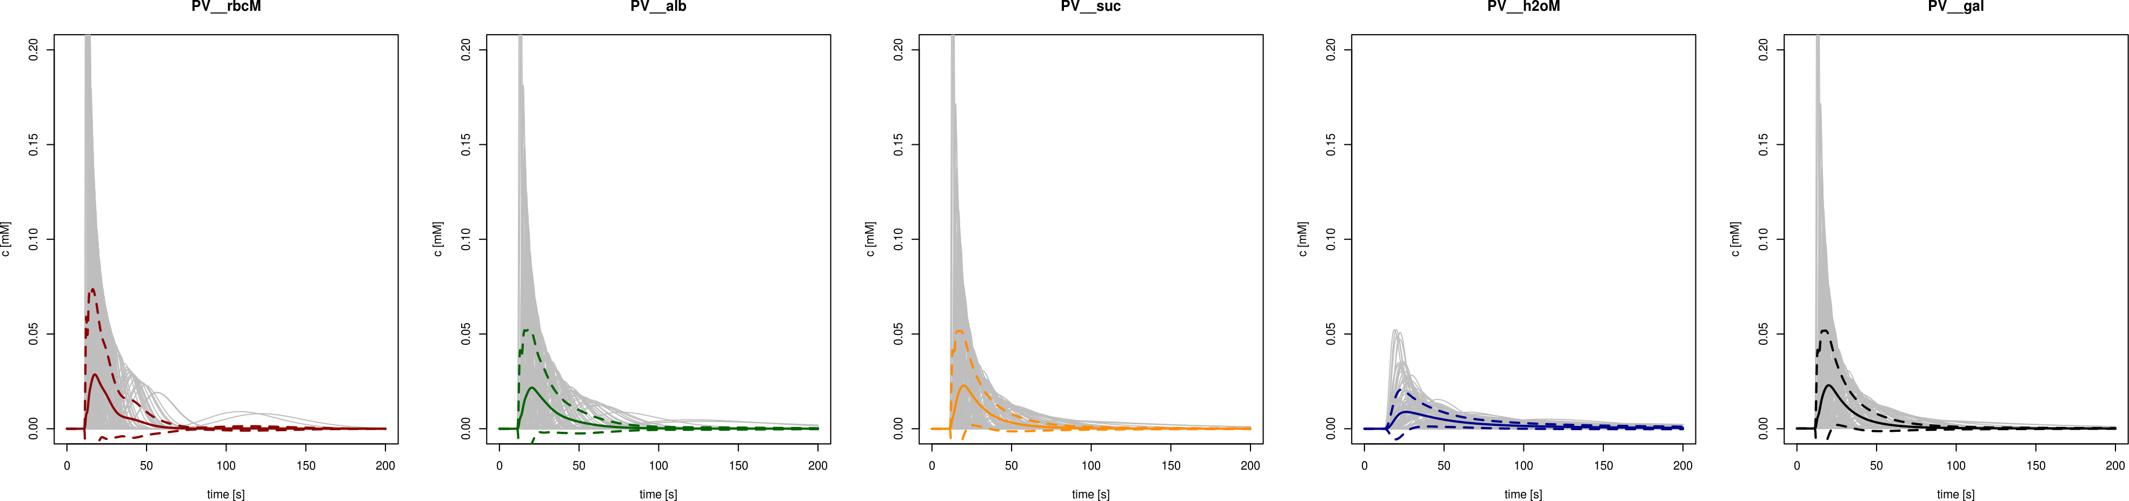
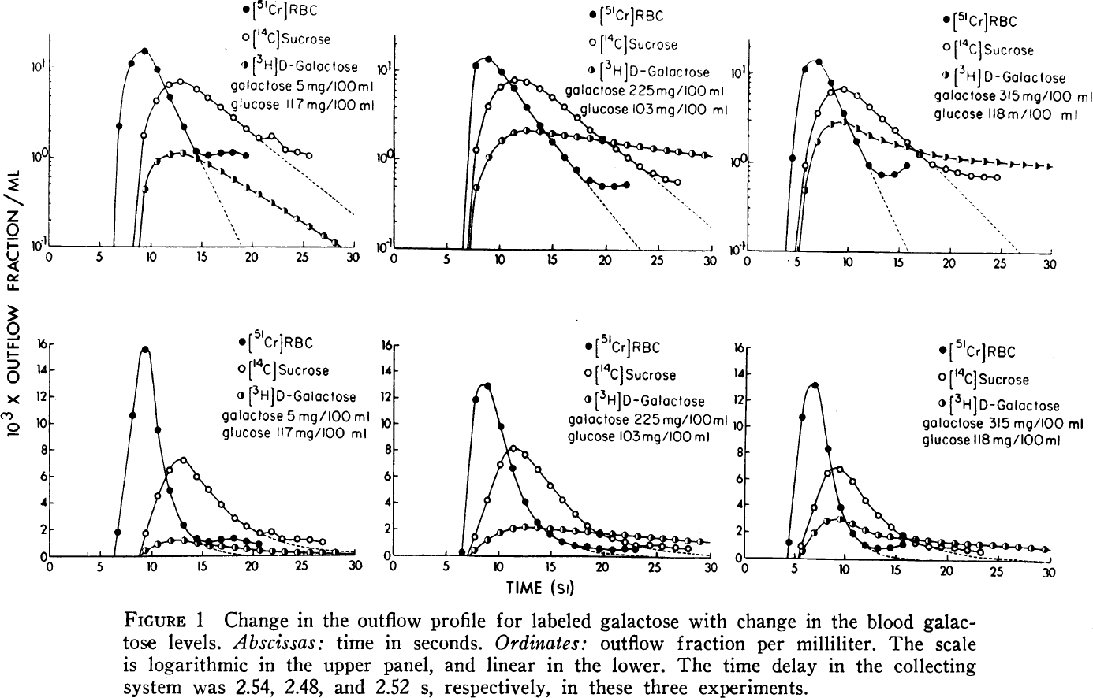
Simulated multiple-indicator diluation curves for given paramter distributions and corresponding experimental data from dogs and humans . For the simulation an indicator peak at time t=0sec with with 0.5sec is assumed.

Figure 4 – Hepatic galactose elimination, extraction ratio, and flow-dependent clearance and extraction ratio.
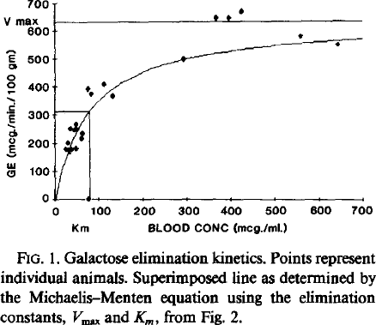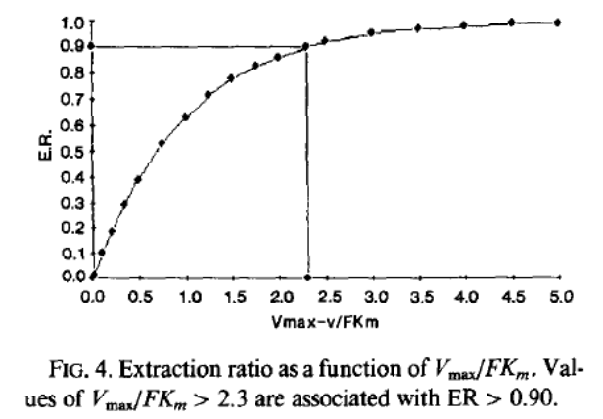
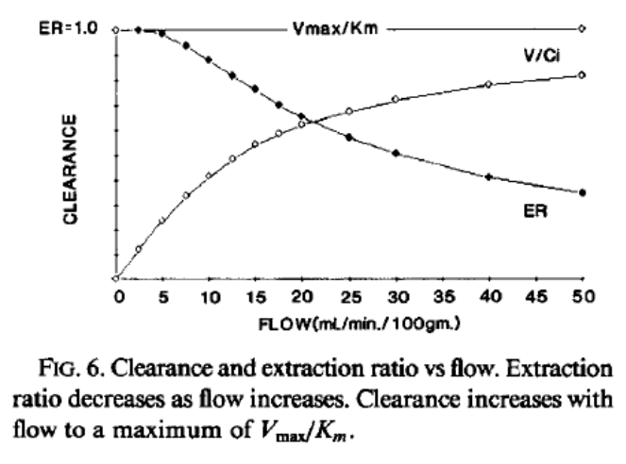
Whole organ clearance and extraction curves for galactose
Blood flow | 
Periportal galactose | 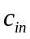
Perivenous galactose | 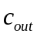
Removal rate | 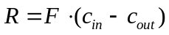
Extraction ratio | 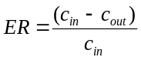
Clearance | 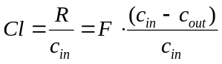

Figure 5 – Effect of metabolic deficiencies (galactosemias) on cellular, tissue and organ level
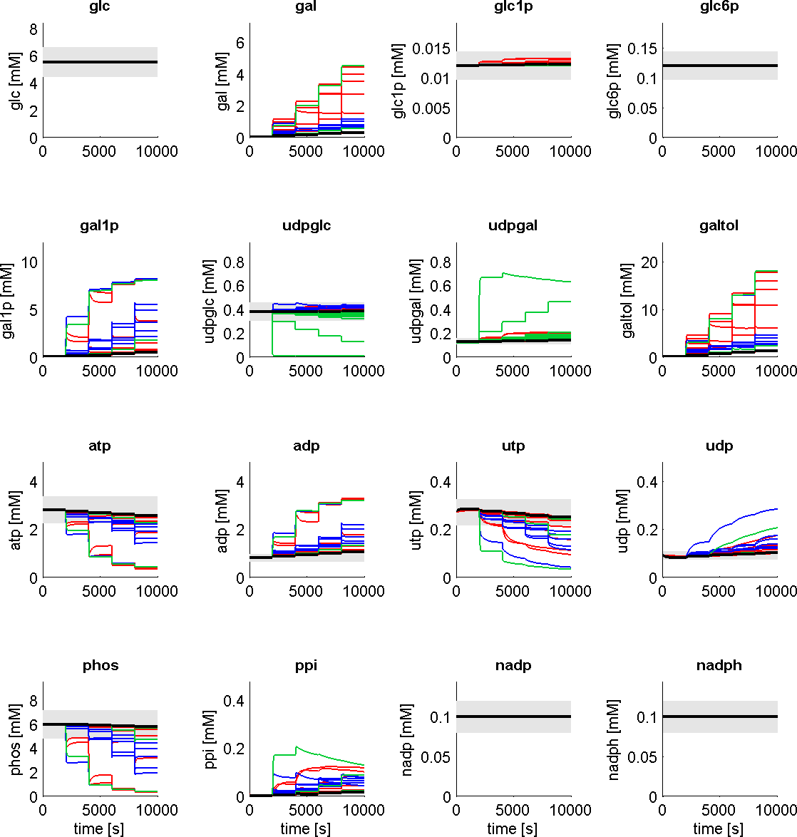 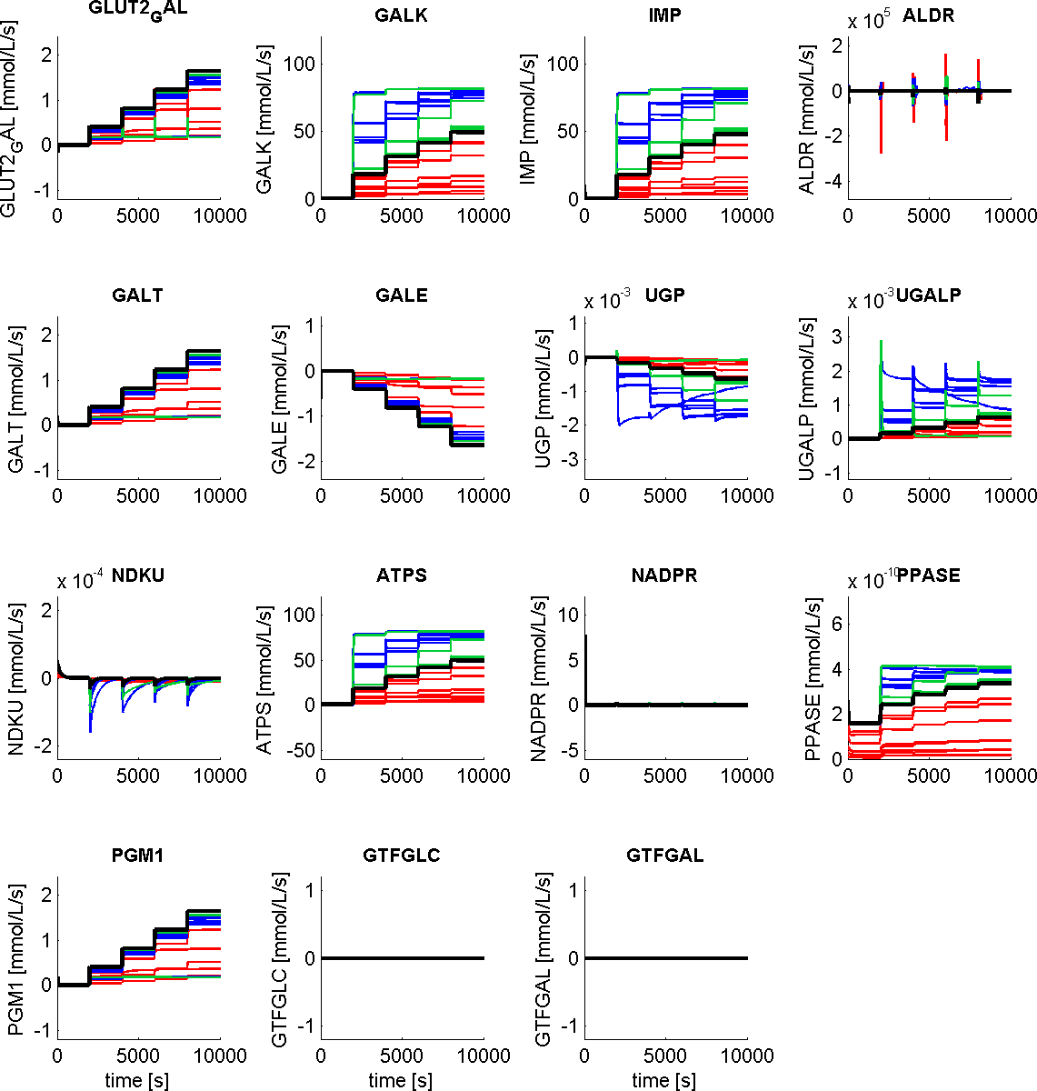Concentrations
Fluxes
Alterations in metabolite levels and fluxes in GALK, GALT and GALE deficiencies (Table 1) compared to normal hepatic galactose metabolism. Galactose and galactitol accumulate in the deficiencies. The absolute udpglc and udpgal concentrations as well as the normal relative value of ~udpglc/udpgal are altered. Some of the deficiencies result in a marked decrease of energy state (ATP/ADP) due to the high futile cycles in the GALK/IMP system.

Figure 6 – Effect of structural deficiencies – Cirrhosis, Sinusoidal obstruction, Arterial obstruction, …

Simulate the effects of some structural alterations of the parameters. What is the role of the individual parameters.

Supplementary Figures
Supplemental Figure 1 – Altered multiple indicator curves in galactosemias analogue to Figure 3.

Supplemental Figure 2 – Altered hepatic galactose clearance and dependency on flow in galactosemias analogue to Figure 4.

Supplemental Figure 3 – Metabolic Control Analysis
Role of the different parameters in controlling hepatic galactose metabolism.
[TODO] MCA of the single cell model

Tables

Table 4 - Tissue-scale model parameters (OPS – orthogonal polarization spectral imaging; QSD – quantitative stereological description; IVM – in vivo microscopy)
Parameter | Symbol |  | Model | Human | Dog | Rat
Tisse/Cell scale
number of hepatocytes along sinusoid | 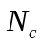 | 20 |  | 15-25 hepatocytes
sinusoid length |  | 500µm |  | 350–500µm (diameter of hepatic lobules 1.0 – 1.3mm )  500µm (diameter of acinus 1000µm) | 500µm
diameter hepatocytes in direction sinusoid | 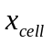 | 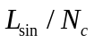 (25µm) |  | 20 – 40µm |  | 20.8±0.2µm (rat, periportal, QSD)  20.8±0.3µm (rat, midzonal, QSD)  21.0±0.3µm (rat, perivenious, QSD)
discretization along sinusoids
sinusoidal radius |  | 4.4µm |  | Sinusoidal diameter  8.8±0.9µm (human, OPS)  4-15µm (human) |  | Sinusoidal diameter  5.9±0.17µm (rat, Zone 1), 7.1±0.29µm (rat, Zone 3) [30?];  6.4±0.1µm (rat, Zone 1), 8.3±0.2µm (rat, Zone 3) [15?]
width space of Disse |  | 0.81µm (calculated from geometry) |  | 0.2–1µm [?images]
cell sheet thickness |  | 6.25 µm |  | 11.3µm from  intersinusoidal distance  22.6±2.5µm (human, OPS) |  | hepatocyte sheet thickness ~10µm (scanning electron microscopy, images)[Wisse1983]
Area between adjacent sinusoid compartments | 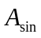 | 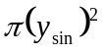
Area between adjacent Disse compartments | 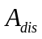 | 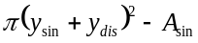
Area between adjacent sinusoid and Disse compartments | 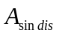 | 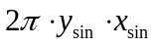
Volume sinusoid compartment | 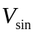 | 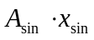
Volume Disse compartment | 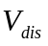 | 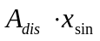
Volume cell | 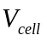
Volume fraction sinusoidal blood volume, % liver | 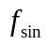 | 14.8% (calculated from geometry) |  | 15–25% (percent of liver volume)  9-15% ( n=6, isolated perfused human liver) | 15.2% (indicator dilution dog)  15.0% (dog) | 19.4% (rat)  11.6% (rat)  10.6% (morphological studies, % volume) ->Blouin1977?
Volume fraction extravascular volumes, % liver | 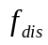 | 5.9% (calculated from geometry) |  | ~5% (percent of liver volume)  5-8% (n=6, isolated perfused human liver) | 6.2%(indicator dilution dog)  9.5±2.1%(±SD, indicator dilution dog, sucrose volume)  6.7% (dog) | 7.3% (rat)  6.0% (rat)  4.9% (morphological studies, % volume)
RBC velocity | 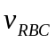 | 60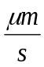 |  | 970±430 (±SD; human, OPS) | 93(dog, calculated from transit time of RBC, analog 53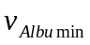15) | 180±20(±SE, rat)  250±3(±SE, rat, IVM)  150±6(±SE, rat, stated in )
volumetric blood flow sinusoid | 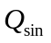 | 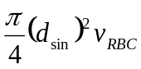  (58.4E-9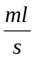 calculated from geometry) |  | analog to
Liver scale
total liver weight | 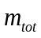 | 1500g |  | 1500-1800g (man), 1300-1500g (woman)  1697±171g (±SD, n=6) | 556g (400 – 800g) (dog) | 17.1±2.2g (±SD. N=13, in situ perfused rat livers)
total liver volume | 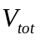 | 1.5L |  | 1.5L [?] [-> data Matrion]
total number of hepatic sinusoids | 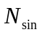 | 428E6 (calculated via blood flow)  2560E6 (calculated via volume) |  | Number of hepatic lobuli:  1.0E6–1.5E6
total hepatic blood flow (~75-80% portal vein partially deoxygenated, 20-25% hepatic artery well-oxygenated) | 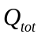 | 1.0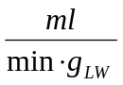= |  | 1800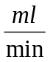(man) - 1200 (woman)  1067±160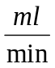(±SD, n=6, isolated perfused human liver)  992±276(n=14)  ~1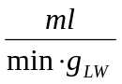  1.0-1.3  17.0±2.72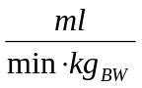(±SD, n=10 women, Doppler ultrasound)  30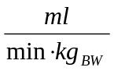 | 869(dog)  1.83±0.55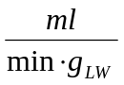(±SD, g liver weight, dog) | 20.9±1.3 (±SD. N=13, in situ perfused rat livers, perfusate blood flow)
Average mean transit time liver | 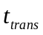 | 10-15s (correct for circular network) |  |  | 8.36±2.66sec RBC  15.11±4.82sec sucrose  42.22±12.96sec urea  (±SD, dog) | ~6.3±0.5sec RBC  ~12±1sec sucrose  ~9±1sec albumin
Diffusion coefficients
water | 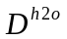 | 2100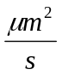 |  | 2100[http://bionumbers.hms.harvard.edu/bionumber.aspx?s=n&id=104087&ver=7]
sucrose | 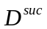 | 520 |  | 520 (sucrose in water)[http://bionumbers.hms.harvard.edu/bionumber.aspx?s=n&id=100614&ver=7]
glucose | 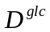 | 400 |  | 600(glucose in water) [http://bionumbers.hms.harvard.edu/bionumber.aspx?s=n&id=104089&ver=5]  670(glucose in water 25°C) [Longsworth, L. G. 1955. Diffusion in liquids and the Stokes-Einstein relation, p. 225-247. In T. Shedlovsky (ed.), Electrochemistry in biology and medicine. John Wiley & Sons, Inc., New York, N.Y.]
galactose | 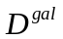 | 400
albumin | 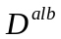 | 100

Table 1 - Reactions and transporters in human galactose metabolism and kinetic parameters.
Id | Information | Kinetics
GLUT2 | Facilitated glucose transporter member 2  D-glucose (disse) [glc_dis] ↔ D-glucose (cytosol) [glc]  D-galactose (disse) [gal_dis] ↔ D-galactose (cytosol) [gal]  Mechanism  TCDB:2.A.1.1 (glucose transporter subfamily)  Protein/Structure  UniProt:P11168 (GTR2_HUMAN)  Gene  SLC2A2, GLUT2  Disease  MIM:227810 (Fanconi-Bickel syndrome; FBS)  Galactose and glucose transported via GLUT2 (competitive inhibition kinetics)  Deficient transport of galactose into hepatocytes in human patients with defective GLUT2 transporters (Fanconi-Bickel syndrome) resulting in galactose malabsorption/intolerance . | km(D-glc)=21.7 ± 1.8mM (rat liver)  km(D-glc)=66±14mM (rat? hepatocytes)  km(3-O-MG)=42.3±4.1mM (human liver)  km(3-O-Methyl glc)=17.3 ± 4.3mM (rat liver)  km(D-gal)=174±48mM (rat? hepatocytes)  km(D-gal) > 50mM (GLUT2 enderocytes)  km(D-gal) = 85.5 ± 10.7mM (human, liver-type GLUT2)  km(D-gal) = 92 ± 8.4mM (human, liver-type GLUT2)  Km(D-fru) = 66mM  Km(D-fru)=212±32mM (rat? hepatocytes)  Accumulation rate (human GLUT2)  v(deoxy-D-glc) = 4.33±0.15 pmol/min/oocyte  v(D-gal) = 1.68±0.09 pmol/min/oocyte  v(D-fru) = 0.78±0.09 pmol/min/oocyte  v(D-glc)=220±19mmol/min/l of cell H2O (rat? hepatocytes)  v(D-gal)=288±48 mmol/min/l of cell H2O (rat? hepatocytes)  v(D-fru)=291±26 mmol/min/l of cell H2O (rat? hepatocytes)
GALK | Galactokinase  D-galactose [gal] + ATP [atp] ↔ D-galactose 1-phosphate [gal1p] + ADP [adp]  Reaction  EC:2.7.1.6  RHEA:13556  KEGG:R01092  Protein  UniProt:P51570 (GALK1_HUMAN)  homodimer P51570*2  Gene  GALK, GALK1  Disease  MIM:230200 (GALCT2 Galactosemia II)  Galactokinase being rate limiting for galactose clearance -> [27,28, 50] | Two-substrate ordered, ternary complex reaction  kcat(gal) = 8.7±5 1/s (SABIORK:14785)  km(atp) = 0.034±0.004mM (SABIORK:14792)  km(gal)=0.97±0.22 mM (SABIORK:14785)  km(gal) = 0.436mM (SABIORK:45367),  Uncompetitive product inhibition of GALK (adult rat liver) by gal1p with both 1mM and 5mM gal1p altering the Km for galactose from 0.150mM to 0.800mM (1mM gal1p caused 15% inhibition, 5mM gal1p 50% inhibition)  ki(gal1p) = 5.3mM (5.0-5.7mM) (adult rat liver)
IMP | Inositol monophosphatase  D-galactose 1-phosphate [gal1p] ↔ D-galactose [gal] + phosphate [pi]  Reaction  EC:3.1.3.25  Protein  UniProt:P29218 (IMPA1_HUMAN)  homodimer P29218*2  Gene  IMPA1, IMPA  Normal substrate inositol-1p (ino1p) | Competitive inhibition model  Kinetic analysis demonstrated that gal1p competitively inhibited human IMP1 by increasing Km for inositol-1p (ino1p) from 320±50µM to 980±70µM without changing the Vmax  km(ino1p) = 0.320±0.050mM  km(gal1p) = 0.35mM (similar kinetics gal1p to ino1p in vitro)
GALT | Galactose-1-phosphate uridyl transferase  UDP-D-glucose [udpglc] + D-galactose 1-phosphate [gal1p] ↔ D-glucose 1-phosphate [glc1p] + UDP-D-galactose [udpgal].  Reaction  EC:2.7.7.12  RHEA:13992  KEGG:R00955  Protein  UniProt:P07902 (GALT_HUMAN)  homodimer P07902*2  Gene  GALT  Disease  MIM:230400 (GALCT Galactosemia) | The catalytic mechanism of GALT is ping-pong kinetics with covalent intermediate UMP-enzyme .  Mutation analysis  km(gal1p) = 0.57±0.14mM (human, wildtype)  km(udpglc) = 0.21±0.04mM (human, wildtype)  Mutation analysis  km(gal1p) = 1.25±0.36mM (human, wildtype)  km(udpglc) = 0.43±0.09mM (human, wildtype)  (?species, 4°C)  km(udpglc) = 0.5±0.1mM  v(glc1p) = 281± 18 1/s  km(glc1p) = 0.37±0.18mM  v(glc1p) = 226± 10 1/s  km(gal1p) = 0.061±0.020mM  v(glc1p) = 166± 13 1/s  Potent linear competent inhibitors UTP and UDP of UDP-glucose :  Ki(UTP) = 0.13mM (rat, liver)  Ki(UDP) = 0.35mM (rat, liver)  Ki(UMP) = 2.3mM (rat, liver)  Ki(UDP-glucuronic acid)=0.40mM (rat, liver)
GALE | UDP-glucose 4-epimerase  UDP-D-glucose [udpglc] ↔ UDP-D-galactose [udpgal]  Reaction  EC:5.1.3.2  RHEA:22171  KEGG:R00291  Protein  UniProt:Q14376 (GALE_HUMAN)  homodimer Q14376*2  Gene  GALE  Disease  MIM:230350 (GALE deficiency)  Alternative activity with GlcNAc:  UDP-GalNAc ↔ UDP-GlcNAc  “Ethanol treatment increases the NADH/NAD ratio in liver -> [2-4] and by this inhibits the GALE ->[3,5]. Under these conditions oxidation and elimination ->[6-8] of galactose are impaired. Combined galactose+ethanol treatment results in accumulation of gal1p and udpgal in rat liver. The formation of high amounts of udpgal leads to a change in the distribution of liver uracil nucleotides. A marked decrease of udpglc, utp, udp and ump is followed by an increase of the sum of uracil nucleotides. ”  “The GALE reaction is indicated as the rate-limiting step of galactose metabolism in rat liver by the ratio of galactose metabolites “.  “The almost 4-fold increase of gal1p and updgal and the even stronger drop of the udpglc content in the ethanol treated liver avter a galactose load demonstrate the ethanol-induced inhibition of the GALE ”.  “Galactose provokes pronounced alterations of the uracil nucleotide contents in the liver, which are intensified by an inhibition of the GALE ” | Mutation analysis  km(udpgal)=0.069±0.012mM (human, wildtype)  kcat(udpgal) = 36±1.4 1/s (human, wildtype)  km(udpgal) = 0.15 ± 0.02mM (human, wildtype)  km(udpgal, V94M) = 0.27 ± 0.01mM (human, V94M)  km(udpgal)=0.140± 0.007mM (human, wildtype) (SABIORK:19823)  km(udpgal)=0.120± 0.04mM (human, wildtype) (SABIORK:46260)  kcat= 33.8±11.2 (human, wildtype) (SABIORK:16222)  km(udpgal) = 0.230±0.06mM (human, wildtype) (SABIORK:46263)
UGP  UGALP | UDP-glucose pyrophosphorylase  D-glucose 1-phosphate [glc1p] + UTP [utp] ↔ UDP-glucose [udglc]+ diphosphate [pp]  Reaction  EC:2.7.7.9  RHEA:19892  KEGG:R00289  Protein  UniProt:Q16851 (UGPA_HUMAN)  homooctamer Q16851*8  Gene  UGP2, UGP1  UDP-galactose pyrophosphorylase  D-galactose-1-phosphate [gal1p] + UTP [utp] + ↔ UDP-D-galactose [udpgal] pyrophosphate [pp]  Reaction  EC:2.7.7.10  RHEA:14212  KEGG:R00502  Protein  UniProt:Q16851 (UGPA_HUMAN)  homooctamer Q16851*8  Gene  UGP2, UGP1  The formation of UDP-glucose is the major physiological function of UGP, however at slow rates, the enzyme also catalyzes the phosphorylation of UDP-galactose [Segal1968].  Not significant in normal physiological conditions, but in galactosemic patients could circumvent GALT deficiency (Isselbacher ?).  Stable transfection of human UGP (hUGP2) rescued galactose GALT deficient yeast from “galactose toxicity [Lai2002]. | Enzyme displays simple Michaelis-Menten kinetics in both directions  MgUTP is a product inhibitor that shows competitive inhibition with respect to UDP-Glc  (human, liver, wildtype)  km(udpglc) = [0.031 - 0.051]mM  km(pp) = [0.172 - 0.210] mM  km(glc1p) = [0.172 - 0.174] mM  km(utp) = [0.563 - 0.692] mM  ki(utp) = 0.477± 41 mM (competitive inhibition with respect to UDP-glc)  V_{fwd}/V_{rev} = 0.260  (human, liver, wildtype)  km(udpglc) = 0.049±0.004mM  km(pp) = 0.166±0.013 mM  km(glc1p) = 0.172±0.010 mM  km(utp) = 0.563±0.115 mM  ki(utp) = 0.643± 0.047 mM (competitive inhibition with respect to UDP-glc)  ki(udpglc) = 0.013± 4 mM (competitive inhibition with respect to UTP?)  (human, liver, wildtype)  keq([udpglc][pp]/([UTP][glc1p])) = 0.15 – 0.16  km(udpglc) = 50mM  km(utp) = 48 mM  km(glc1p) = 95±10 mM  keq([UTP][glc1p]/([udpglc][pp])) = 4.55±0.1 (0.22)  The saturating concentration for UDP-galactose is 10 times that of UDP-glucose:  km(udpgal) = 10*km(udpglc) ~ 0.5mM (human, liver, wildtype)  km(udpgal) = 0.420mM (rabbit, liver, wildtype)  udpgal was an adequate substrate at 10 times the concentration of udpglc, showing 14.3% of udpglc (Calf) and 12.0% (Human).  activity with udpgal 2-12% of udpglc (12% with 3mM udpgal) (human liver)  “The activity of UDPG:galactose-1-phosphate uridylyltransferase from rat liver under optimal conditions in vitro is less than 5% of the UDPG pyrophosphorylase activity [Keppler1970 ->39,40]”  gal1p as competitive inhibitor of glc1p  “Previously, we showed that galactose-1-phosphate competitively inhibited UDP-glucose pyrophosphorylase, leading to 66% reduction in UDP-glucose/galactose contents in GALT-deficient cells under galactose challenge [Slepak2007->Lai2002].”
ALDR | Aldose reductase (galactitol NAD 1-oxidoreductase)  D-galactose [gal] + NADPH [nadph] + H ↔ galactitol [galtol] + NADP [nadp]  Reaction  EC:1.1.1.21  RHEA:12792 -> RHEA:37967  KEGG:R01095  Protein  UniProt:P15121 (ALDR_HUMAN)  monomer P15121*1  Gene  AKR1B1, ALDR1  Aldolase reductase is specific for NADPH as cofactor (NADH ~10% of NADPH-dependent activity) .  “Aldolase reductase catalyzes the conversion of aldoses and a number of other aldehydes to the corresponding alcohol metabolites. It is one of several cytosolic, monomeric, NADPH-dependent aldehyde and ketone reductases of wide substrate specificity ”. | km(gal) = 40.0mM (human brain) (SABIORK:22893)  kcat(gal) = 0.40 1/s (human brain) (SABIORK:22893)  km(gal) = 110.0mM (human brain) (SABIORK:15695)
PGM1 | Phosphoglucomutase-1  D-glucose 1-phosphate [glc1p] ↔ D-glucose 6-phosphate [glc6p]  Reaction  EC:5.4.2.2  KEGG:R00959  RHEA:23539  Protein (multiple isoforms PGM1, PGM2)  UniProt:P36871 (PGM1_HUMAN)  monomer P36871*1  main isoform for glc1p ↔ glc6p reaction  Gene  PGM1  Disease  MIM:612934 (Glycogen storage disease 14)  MIM:614921 (Congenital disorder of glycosylation 1T CDG1T)  Protein  UniProt:Q96G03 (PGM2_HUMAN)  Gene  PGM2  CDG1T - A multisystem disorder caused by a defect in glycoprotein biosynthesis and characterized by under-glycosylated serum glycoproteins. | The equilibrium lies strongly toward glc6p and reaction proceeds through ping-pong mechanism  The kinetic properties of PGM1 and PGM2 are essentially the same. PGM1 is specific for mutation of glucose, whereas PGM2 also has phosphoribomutase activities. (human, RBC)  [glc6p]/[glc1p] ~10-12  DeltaG =-7.1 kJ/mol  km(glc1p) = 0.049mM (human, RBC)  km(glc1p) = 0.045mM (rat, heart)  km(glc6p) = 0.67mM (rat, heart)  km(glc1p) = 0.083mM (human, RBC, PGM1)  ki(fru16bp) = 0.092mM (human, RBC, PGM1)
PPASE | Pyrophosphatase  Pyrophosphate [pp] + H2O → 2 phosphate [pi]  Reaction  EC:3.6.1.1  RHEA:24579  KEGG:R00004  Protein  UniProt:Q15181 (IPYR_HUMAN)  homodimer Q15181*2  Gene  PPA1, IOPPP, PP | km(pp) = 0.005mM (rat liver)  km(pp) = 0.14mM (human erythrocyte)  km(pp) = 0.07mM (rat liver)  Delta G0 = -23.56 kJ/mol  Delta G0 = -19.2 kJ/mol
NDKU | Nucleoside diphosphokinase (ATP:UDP phosphotransferase)  ATP [atp] + UDP [udp] ↔ ADP [adp] + UTP [udp]  Reaction  EC: 2.7.4.6  RHEA:25101  KEGG:R00156  Multitude of isoforms | Compulsory-order substituted-enzyme (Ping Pong Bi Bi) mechanism  km(atp) = 0.38mM (human, platelets)  km(adp) = 0.024mM (human, platelets)  km(gtp) = 0.12mM (human, platelets)  km(atp) = 1.33mM (rat, liver)  km(adp) = 0.042mM (rat, liver)  km(udp) = 0.19mM(rat, liver)  km(atp) = 1.80 mM (rat, liver)  km(adp) = 0.066 mM (rat, liver)  km(utp) = 27.00mM (rat, liver)  km(gtp) = 0.15mM (rat, liver)  km(gdp) = 0.049mM (rat, liver)
NADPR | NADP reductase  NADP [nadp] + H2→NADPH [nadph]  Modeled via glucose-6-phosphate dehydrogenase in pentose phosphate pathway  D-glucose 6-phosphate [glc6p] + NADP [nadp] → 6-phospho-D-glucono-1,5-lactone + NADPH [nadph] + H  Reaction  EC: 1.1.1.49  RHEA:15844  KEGG:R00835  Protein  UniProt:P11413 (G6PD_HUMAN)  homotetramer (dimer of dimer) P11413*4  Gene  G6PD | Delta G0 = -19.6 kJ/mol [Schuster1995]  km(glc6p) = 0.040±0.008 mM (human, placenta)  km(nadp) = 0.020±0.010 mM (human, placenta)  ki(nadph) = 0.0171±0.0032 mM (human, placenta)  km(glc6p) = 0.072 mM (human, RBC)  km(glc6p) = 0.069±0.003 mM (human, recombinant)  km(nadp) = 0.013 mM (human, RBC)  km(nadp) = 0.012±0.002 mM (human, recombinant)  km(nadph) = 0.015±0.002 mM (human, RBC)  km(nadph) = 0.014±0.003 mM (human, recombinant)  km(glc6p) = 0.326mM (rat, liver)  km(glc6p) = 0.157mM (rat, liver)  km(nadp) = 0.108 mM (rat, liver)  km(nadp) = 0.258 mM (rat, liver)  ki(nadhp) = 0.010 mM(rat, liver)  ki(nadhp) = 0.021 mM(rat, liver)
ATPS | ATP synthesis  ADP [adp] + phosphate [pi] → ATP [atp]  Modeled via general ATP producing reaction representative for ATP production via glycolysis and oxidative phosphorylation
GTF  GTFGAL  GTFGLC | Glycosyltransferase  Aceptor [gac] + UDP-glucose [udpglc] -> Acceptor-glucose[gacglc] + UDP [udp]  Aceptor [gac] + UDP-glucose [udpgal] -> Acceptor-glucose[gacgal] + UDP [udp]  Enzymes that transfer mono- or oligosaccharides from donor molecules to growing oligosaccharide chains or proteins are called glycosyltransferases (Gtfs)
GALDH | Galactose 1-dehydrogenase  D-galactose + NAD⁺ ↔D-galactono-1,4-lactone + NADH + H⁺  EC.1.1.1.48 (Brenda only bacteria)  D-galactose -> galactonate  (first enzyme in oxidative pathway)  [Segal1968 -> Cuatrecasas1966,15]  Alternative pathway to xylulose.  D-Galactose + Oxygen + H2O <=> D-Galactonate + Hydrogen peroxide  EC:1.1.3.9  KEGG:R01098  (only bacteria)
GALP | Galactose Production | Rate of endogenous D-galactose appearance in plasma in humans:  R = 0.17 µmol/kg_{BW}/h (low when compared to Berry)  R = 2.9-5.4µmol/kgBW/h
GE | Hepatic Galactose Elimination / Galactose Clearance | Saturation of hepatic galactose elimination  The hepatic galactose elimination (HGE) rate is assumed to be independent at high blood galactose levels which are easily obtained in clinical galactose tolerance tests . The HGE rate usually falls at concentration below 500mg/l (=2.78mM)  “Several observations indicate that the hepatic elimination rate of galactose is independent of the concentration at levels which are easily obtained in clinical galactose tests. [Stenstam1956] demonstrated that continuous infusions of galactose, exceeding about 400mg/min, resulted in rectilinearly rising plasma concentrations. Liver-vein catheterization studies have shown that the arterio-hepatic venous concentration difference is constant in a wide concentration interval [Tygstrup & Winkler 1954, Nakamura1961]. [Waldstein1960] demonstrated that the extrarenal elimination of galactose from the body would reach a maximum during galactose infusions, and [Segal1961] found that the conversion of 14C-galactose to 14CO2 was delayed by injection of 20g of carrier galactose.  Single injection results in galactose elimination of GE=341–609 mg(galactose)/min (1.89-3.38mmol/min), whereas continuous infusion gives GE=295-509mg(galactose/min) (1.63-2.83mmol/min)“Single injection and infusion experiments will give different figures for the hepatic galactose elimination capacity and volume of distribution, depending on the degree of displacement of the arterial curve.  “Galactose elimination progressively decreased from GE=3.05±0.58 (SD)mmol/min in younger subjects to GE=1.83±0.24 (SD)mmol/min in subjects over 81. ”. Standard method of calculation of galactose elimination capacity is Tystrups procedure , here assuming a urinary loss of galactose of 10% of the injected dose.

Table 2 - Metabolites in hepatic galactose metabolism.
Id | Name (mass)  Annotation | Initial Concentration | Comments
glc | D-glucose  (M_{w} 180.2)  CHEBI:4167  KEGG:C00031 | 5.5mM | [glc] = 5.5mM  3-10mM (depending on physiological state)
gal | D-galactose  (M_{w} 180.2)  CHEBI:4139  KEGG:C00124 | 0.00012mM  (no galactose)  0.00144mM  (GALT deficient)  0.0013-0.0027mM  (GALE deficient) | plasma of post-absorptive humans (data considerable lower (3-18-fold) than conventional enzymatic assay)  [gal] = 0.12±0.03µM (n=16) healthy subjects  [gal] = 1.44±0.54µM (n=10) classical galactosemia (GALT deficiency)  [gal] = 0.17±0.07µM (n=5) obligate heterozygous parents of classical galactosemia  [gal] = 0.11±0.04µM (n=15) diabetic patients  GALE deficient patients (blood)  [gal]=24-29mg/L (0.013-0.016mM)  [gal]= 48mg/L (0.027mM)  Neonatal control (blood):  [gal]=13±6 mg/L (0.0072±0.0033mM)  normal values:  [gal]=0.015±0.009mM (range 0-0.044mM)  Cut-off values for newborn screening blood for galactosemias: “If gal > 60mg/L (0.033mM) or gal1P > 150mg/L (0.058mM).”
glc1p | D-glucose 1-phosphate  (M_{w} 258.1)  CHEBI:58601  KEGG:C00103 | 0.012mM  (no galactose)  0.011mM  (1h galactose)  0.012mM  (1h galactose, GALE inhibition) | [glc1p] = 0.012mM  [glc1p] =0.010 ±0.004µmol/g_{ww} (~0.011mM) (starved + galactose 1h, rat, liver)  [glc1p] =0.011 ±0.005µmol/g_{ww} (~0.012mM) (ethanol, starved + galactose 1h, rat, liver)  [glc1p] = 0.0075±0.0010 µmol/g_{WW} (~0.0083mM) (rat liver, starved)  [glc1p] = 0.0115±0.008 µmol/g_{WW} (~0.0127mM) (rat liver, fed ad libitum)  [glc1p] = 0.0132±0.0007 µmol/g_{WW} (~0.0146mM) (rat liver, meal fed)  [glc6p]/[glc1p] ~10-12
glc6p | D-glucose 6-phosphate  (M_{w} 258.1)  CHEBI:58225  KEGG:C00668 | 0.12mM  (no galactose)  0.29mM  (1h galactose)  0.30mM  (1h galactose, GALE inhibition) | [glc6p] = 0.12mM  [glc6p] = 0.078±0.011 µmol/g_{WW} (~0.086mM) (rat liver, starved)  [glc6p] = 0.147±0.012 µmol/g_{WW} (~0.163mM) (rat liver, fed ad libitum)  [glc6p] = 0.157±0.007 µmol/g_{WW} (~0.174mM) (rat liver, meal fed)  [glc6p]/[glc1p] ~10-12  [glc6p] =0.26 ±0.06µmol/g_{ww} (~0.29mM) (starved + galactose 1h, rat, liver)  [glc6p] =0.30 ±0.13µmol/g_{ww} (~0.33mM) (ethanol, starved + galactose 1h, rat, liver)  [glc6p]/[glc1p] =22.2 ±5.9 (starved + galactose 1h, rat, liver)  [glc6p]/[glc1p] =22.8 ±5.9 (ethanol, starved + galactose 1h, rat, liver)
gal1p | D-galactose 1-phosphate  (M_{w} 258.1)  CHEBI:58336  KEGG:C00446 | 0.001mM  (no galactose)  0.20mM  (1h galactose)  0.77mM  (1h galactose, GALE inhibition)  1.2mM  (GALT deficient, glucose)  5.2mM  (GALT deficient, galactose) | (human cells)  [gal1p] = ND (not detectable) (Control glucose medium)  [gal1p] = 0.2±0.01mM (Control galactose medium)  [gal1p] =0.18 ±0.04µmol/g_{ww} (~0.2mM)(starved + galactose 1h, rat, liver)  [gal1p] =0.69 ±0.11µmol/g_{ww} (~0.77mM) (ethanol, starved + galactose 1h, rat, liver)  (human cells)  [gal1p] = 1.2±0.4mM (GALT-deficient glucose medium)  [gal1p] = 5.2±0.02mM (GALT-deficient galactose medium)  GALT deficiency detected (blood)  [gal1p] > 3.0mM (human cells)  GALE deficient patients (blood)  [gal1p]=330-360mg/L (1.28-1.39mM)  [gal1p]=474 mg/L (1.84mM)  Neonatal control (blood):  gal1P=15±11 mg/L (0.058±0.042mM)  normal values:  gal1P = 0.038±0.027 mM (range 0-0.096µM)  Mean concentration of gal1p (blood) was 0.15mM in cases below the cut-off of 0.74mM
udpglc | UDP-D-glucose  (M_{w} 564.3)  CHEBI:58885  KEGG:C00029 | 0.34mM  (no galactose)  0.27mM  (1h galactose)  0.17mM  (1h galactose, GALE inhibition) | [udpglc] = 0.38mM  [udpglc] = 0.32±0.05 µmol/g_{WW} (~0.36mM) (rat liver)  [udpglc] = 0.26±0.07 µmol/g_{WW} (~0.29mM) (rat liver)  [udpglc] =0.32 ±0.04µmol/g_{ww} (~0.36mM) (fed, rat, liver)  [udpglc] =0.29 ±0.05µmol/g_{ww} (~0.32mM) (starved, rat, liver)  [udpglc] =0.24 ±0.09µmol/g_{ww} (~0.27mM) (starved + galactose 1h, rat, liver)  [udpglc] =0.15 ±0.03µmol/g_{ww} (~0.17mM) (ethanol, starved + galactose 1h, rat, liver)  [udpglc] = 0.342±0.024 µmol/g_{WW} (~0.38mM) (rat liver, starved)  [udpglc] = 0.433±0.023 µmol/g_{WW} (~0.48mM) (rat liver, fed ad libitum)  [udpglc] = 0.347±0.027 µmol/g_{WW} (~0.39mM) (rat liver, meal fed)  (human cells, in µmol/100g(cell protein))  [udpglc] = 236±25 (Control glucose medium)  [udpglc] = 179±24 (76% glucose) (Control galactose medium)  (human cells, in µmol/100g(cell protein))  [udpglc] = 157±10 (GALT-deficient glucose medium)  [udpglc] = 110±10 (70% glucose) (GALT-deficient galactose medium)
udpgal | UDP-D-galactose  (M_{w} 564.3)  CHEBI:66914  KEGG:C00052 | 0.11mM  (no galactose)  0.36mM  (1h galactose)  1.39mM  (1h galactose, GALE inhibition) | Both the levels and approximate ratio of 1:3 of udpgal and udpglc are very tightly controlled in normal human cells. (1:3 rule udpglc)  [udpgal] =0.09 ±0.01µmol/g_{ww} (~0.10mM) (fed, rat, liver)  [udpgal] =0.09 ±0.01µmol/g_{ww} (~0.10mM) (starved, rat, liver)  [udpgal] =0.32 ±0.07µmol/g_{ww} (~0.36mM) (starved + galactose 1h, rat, liver)  [udpgal] =1.25 ±0.16µmol/g_{ww} (~1.39mM) (ethanol, starved + galactose 1h, rat, liver)  [udpgal]/[udpglc] =3.4 ±0.3 (fed, rat, liver)  [udpgal]/[udpglc] =3.3 ±0.3 (starved, rat, liver)  [udpgal]/[udpglc] =0.78 ±0.39 (starved + galactose 1h, rat, liver)  [udpgal]/[udpglc] =0.11 ±0.02 (ethanol, starved + galactose 1h, rat, liver)  [udpgal]/[gal1p] =1.94 ±0.35 (starved + galactose 1h, rat, liver)  [udpgal]/[gal1p] =1.85 ±0.27 (ethanol, starved + galactose 1h, rat, liver)  (human cells, in µmol/100g(cell protein))  [udpgal] = 82±10 (Control glucose medium)  [udpgal] = 46±4 (56% glucose) (Control galactose medium 24h)  (human cells, in µmol/100g(cell protein))  [udpgal] = 25±5 (GALT-deficient glucose medium)  [udpgal] = 17±3 (68% glucose) (GALT-deficient galactose medium 24h)
galtol | D-galactitol  (M_{w} 182.2)  CHEBI:16813  KEGG:C01697 | 0.001mM  (no galactose)  ~8mM  (GALT deficiency) | [galtol]=4.8-40µmol/g (~5.3-44mM) (occupational gray matter, human) [galtol]=17.6µmol/g (~)(basal ganglia, human)  [galtol]=12.9µmol/g (~14.3mM)  [galtol]=22.18µmol/g (~24.6mM)  Galactitol measured directly in GALT-deficient mice are lower (2mM) than levels detected by MRS in human subjects (8mM)
atp | ATP  (M_{w} 503.2)  CHEBI:30616  KEGG:C00002 | 2.7mM  (no galactose)  2.9mM  (1h galactose)  2.9mM  (1h galactose, GALE inhibition) | [atp] = 2.8mM  [atp] = 2.49±0.12 µmol/g_{WW} (~2.77mM) (rat liver, starved)  [atp] = 2.56±0.09 µmol/g_{WW} (~2.84mM) (rat liver, fed ad libitum)  [atp] = 2.32±0.07 µmol/g_{WW} (~2.58mM) (rat liver, meal fed)  [atp] = 2.42±0.50 µmol/g_{WW} (~2.69mM) (rat liver)  [atp] =2.60 ±0.16µmol/g_{ww} (~2.89mM) (starved + galactose 1h, rat, liver)  [atp] =2.81 ±0.15µmol/g_{ww} (~3.12mM) (ethanol, starved + galactose 1h, rat, liver)  [atp]/[adp] =3.14 ±0.52 (starved + galactose 1h, rat, liver)  [atp]/[adp] =3.10 ±0.53 (ethanol, starved + galactose 1h, rat, liver)
adp | ADP  (M_{w} 424.2)  CHEBI:456216  KEGG:C00008 | 1.2mM  (no galactose)  1.0mM  (1h galactose)  1.0mM  (1h galactose, GALE inhibition) | [atp] = 0.8mM  [adp] = 1.38±0.08µmol/g_{WW} (~1.53mM) (rat liver, starved)  [adp] = 1.06±0.03µmol/g_{WW} (~1.18mM) (rat liver, fed ad libitum)  [adp] = 1.24±0.04µmol/g_{WW} (~1.38mM) (rat liver, meal fed)  [adp] = 1.08±0.12 µmol/g_{WW} (~1.20mM) (rat liver)  [adp] =0.88 ±0.17µmol/g_{ww} (~0.98mM) (starved + galactose 1h, rat, liver)  [adp] =0.97 ±0.19µmol/g_{ww} (~1.08mM) (ethanol, starved + galactose 1h, rat, liver)
utp | UTP  (M_{w} 480.1)  CHEBI:46398  KEGG:C00075 | 0.27mM  (no galactose) | [utp] = 0.27mM  [utp] = 0.362±0.014 µmol/g_{WW} (~0.40mM) (rat liver, starved)  [utp] = 0.494±0.038 µmol/g_{WW} (~0.55mM) (rat liver, fed ad libitum)  [utp] = 0.443±0.039 µmol/g_{WW} (~0.49mM) (rat liver, meal fed)
udp | UDP  (M_{w} 401.1)  CHEBI:58223  KEGG:C00015 | 0.09mM  (no galactose) | [udp] = 0.09mM  [utp+udp] = 0.35±0.07 µmol/g_{WW} (~0.39mM) (rat liver)  [utp+udp] = 0.35±0.05 µmol/g_{WW} (~0.39mM) (rat liver)  [utp+udp] =0.34 ±0.05µmol/g_{ww} (~0.38mM) (fed, rat, liver)  [utp+udp] =0.23 ±0.05µmol/g_{ww} (~0.26mM) (starved, rat, liver)  [utp+udp] =0.15 ±0.03µmol/g_{ww} (~0.17mM) (starved + galactose 1h, rat, liver)  [utp+udp] =0.11 ±0.02µmol/g_{ww} (~0.39mM) (ethanol, starved + galactose 1h, rat, liver)  Marked decrease in [utp+udp] under galactose challenge.
phos | Phosphate  (M_{w} 96.0)  CHEBI:43474  KEGG:C00009 | 5.0mM | [pi] = 5.0mM  [pi] = 4.37±0.16 µmol/g_{WW} (~4.86mM) (rat liver, starved)  [pi] = 3.64±0.32 µmol/g_{WW} (~4.04mM) (rat liver, fed ad libitum)  [pi] = 4.41±0.10 µmol/g_{WW} (~4.90mM) (rat liver, meal fed)  [pi] = 3.18±0.56 µmol/g_{WW} (~3.53mM) (rat liver)
ppi | Pyrophosphate  (M_{w} 175.0)  CHEBI:33019  KEGG:C00013 | 0.008mM | [pp] = 0.008mM  [pp] = 0.0023±0.0003 µmol/g_{WW} (~0.0026mM) (rat liver, starved)  [pp] = 0.0038±0.0004 µmol/g_{WW} (~0.0042mM) (rat liver, fed ad libitum)  [pp] = 0.0049±0.0006 µmol/g_{WW} (~0.0054mM) (rat liver, meal fed)  [pp] = 0.0065±0.00086 µmol/g_{WW} (~0.0072mM) (rat total liver)
nadp | NADP  (M_{w} 740.4)  CHEBI:58349  KEGG:C00006 | 0.1mM
nadph | NADPH  (M_{w} 741.4)  CHEBI:57783  KEGG:C00005 | 0.1mM
suc | Sucrose  (M_{w} 342.3)  CHEBI:17992  KEGG:C00089
h2oM | H2O M  CHEBI:15377  KEGG:C00001
alb | albumin  PR:000003918
rbc | red blood cell  BTO:0000424
galnat | D-galactonate  (M_{w} 195.1)  CHEBI:12931  KEGG:C00880
galn | galactosamine |  | Uptake of galactosamine by rat liver is a~0.4µmol/g(liver)/min as measured by the disappearance of galactosamine from the medium  Time-dependent decrease in uridine nucleotides in isolated perfused rat livers after galactosamine addition.
amp | AMP |  | [amp] = 0.28±0.06 µmol/g_{WW} (~0.31mM) (rat liver)  [amp] =0.15 ±0.09µmol/g_{ww} (~0.167mM) (starved + galactose 1h, rat, liver)  [amp] =0.19 ±0.07µmol/g_{ww} (~0.21mM) (ethanol, starved + galactose 1h, rat, liver)
ump | UMP |  | [ump] = 0.04 µmol/g_{WW} (~0.044mM) (rat liver)
nad  nadh | NAD  NADH

Table 3 - Kinetic parameters in GALK, GALT and GALE deficiencies.
 | Enzyme | Variant | k_{cat} [1/s] (%wt) | K_{m}(gal) [mM] (%wt) | K_{m}(atp) [mM] (%wt) | Reference
 | GALK | Wild Type | 8.7±0.5 (100) | 0.97±0.22 (100) | 0.034±0.004 (100)
1 | GALK | H44Y | 2.0±0.1 (23) | 7.70±4.40 (794) | 0.130±0.009 (382)
2 | GALK | R68C | 3.9±0.8 (45) | 0.43±0.15 (44) | 0.110±0.035 (324)
3 | GALK | A198V | 5.9±0.1 (68) | 0.66±0.22 (68) | 0.026±0.001 (76)
4 | GALK | G346S | 0.4±0.04 (5) | 1.10±0.16 (113) | 0.005±0.002 (15)
5 | GALK | G347S | 1.1±0.2 (13) | 13.0±2.0 (1340) | 0.089±0.034 (262)
6 | GALK | G349S | 1.8±0.1 (21) | 1.70±0.48 (175) | 0.039±0.004 (115)
7 | GALK | E43A | 6.7±0.02 (77) | 1.90±0.50 (196) | 0.035±0.0003 (103)
8 | GALK | E43G | 0.9±0.02 (10) | 0.14±0.01 (14) | 0.0039±0.0006 (11)
 | Enzyme | Variant | V_{max} [nmol/mg/s] (% wt) | K_{m}(gal1p) [mM] (%wt) | K_{m}(udpglc) [mM] (%wt) | Reference
 | GALT | Wild Type | 804±65 (100) | 1.25±0.36 (100) | 0.43±0.09 (100)
9 | GALT | R201C | 396±59 (49) | 1.89±0.62 (151) | 0.58±0.13 (135)
10 | GALT | E220K | 253±53 (31) | 2.34±0.42 (187) | 0.69±0.16 (160)
11 | GALT | R223S | 297±25 (37) | 1.12±0.31 (90) | 0.76±0.09 (177)
12 | GALT | I278N | 45±3 (6) | 1.98±0.35 (158) | 1.23±0.28 (286)
13 | GALT | L289F | 306±23 (38) | 2.14±0.21 (171) | 0.48±0.13 (112)
14 | GALT | E291V | 385±18 (48) | 2.68±0.16 (214) | 0.95±0.43 (221)
 | Enzyme | Variant | k_{cat} [1/s] (%wt) | K_{m}(udpglc) [mM] (%wt) |  | Reference
 | GALE | Wild Type | 36±1.4 (100) | 0.069±0.012 (100)
15 | GALE | N34S | 32±1.3 (89) | 0.082±0.015 (119)
16 | GALE | G90E | 0.046±0.0028 (0) | 0.093±0.024 (135)
17 | GALE | V94M | 1.1±0.088 (3) | 0.160±0.038 (232)
18 | GALE | D103G | 5.0±0.23 (14) | 0.140±0.021 (203)
19 | GALE | L183P | 11±1.2 (31) | 0.097±0.040 (141)
20 | GALE | K257R | 5.1±0.29 (14) | 0.066±0.015 (96)
21 | GALE | L313M | 5.8±0.36 (16) | 0.035±0.011 (51)
22 | GALE | G319E | 30±1.3 (83) | 0.078±0.013 (113)
23 | GALE | R335H | 15±0.48 (42) | 0.099±0.012 (143)

