Hepatic Microcirculation
König M.¹

¹Institute of Biochemistry, Department of Computational Systems Biochemistry, University Medicine Charité Berlin, Germany

To whom correspondence should be addressed: Matthias König, Institute of Biochemistry, University Medicine Charité Berlin, Virchowweg 6, 10117 Berlin; Tel: (0049) 30450528197; Email: matthias.koenig@charite.de

Abbreviations:
HA – hepatic artery
PV – portal vein

Abstract
This review tries to give a systematic overview over the hepatic microcirculation on sinusoid and lobule level in the context of the metabolic role of the liver for the body.

Introduction
The Hepatic circulation is unique among vascular beds. The most obvious unique features include the dual vascular supply; the mechanism of intrinsic regulation of the hepatic artery (the hepatic arterial buffer response); the fact that portal blood flow, supplying two thirds of liver blood flow, is not controlled directly by the liver.

Macroregions in Liver
The incection of multicolored vinylite acetate into the vascular branches and the biliary ducts accessible in the porta hepatis has demonstrated that the liver can be divided into gross and microscopic segments according to the distribution of the mayor supplying and efferent vascular and biliary branches (->Ref.19).

Hepatic Artery and Portal Vein
The liver receives 25% of the cardiac output, although it constitutes only 2.5% of body weight. The hepatic parenchymal cells are the most richly perfused of any of the organs, and each parenchymal cell on the average is in contact with perfusate on two sides of the cell. Of the total hepatic blood flow (100–130 ml/min per 100 g of liver, 30 ml/min per kilogram of body weight), one fifth to one third is supplied by the hepatic artery.
The high pressure, well-oxygenated arterial blood mixes completely with the low-pressure, less well-oxygenated, but nutrient-rich, portal venous blood within the hepatic sinusoids.
Intrahepatic and portal venous pressures are regulated primarily by hepatic venous sphincters, and in the basal resting state, portal pressure is insignificantly different from sinusoidal pressure (Chapter 6).
Substances reaching the liver via the hepatic artery or portal vein are equally well extracted, suggesting that both vascular inlets perfuse the hepatic parenchymal cells equally [221]. Parenchymal cell functions (ICG extraction, bile salt stimulation of bile flow) indicate that blood from the artery and portal vein supplies the hepatic parenchymal cells equally well. This suggests a well-mixed blood supply prior to exposure of either blood stream to parenchymal cells .

The constant ratio of blood flow to liver cell mass is regulated in part by adjusting blood flow through the hepatic arterial buffer response (Chapter 5). The flow/mass ratio is also regulated powerfully by flow. Liver blood flow determines liver parenchymal cell volume by a mechanism that is based on the effect of hepatic blood flow to generate shear stress on hepatic endothelium, with the result being nitric oxide generation and triggering of the hepatic regeneration cascade (Chapter 15).
The acinus is the functional unit of the liver. There are approximately 100,000 acini per human liver; each is approximately 2 mm in diameter. .
The unique one-way flow arrangement precludes substances diffusing from the hepatic venous blood to the hepatic arterial resistance vessels. Therefore, even if the hepatic parenchymal cells release large quantities of vasoactive metabolites, such as adenosine [237], the parenchymal cells are not capable of regulating the hepatic artery according to their metabolic requirements. .
Elevation in venous pressure, reduction of portal venous flow, and stimulation of hepatic nerves or norepinephrine infusion do not result in flow redistribution within the liver [59,120,128].
In the normal liver, it seems likely that one function of the hepatic arterial buffer response (Chapter 5) is to maintain homogeneity of liver perfusion. If local portal venous stasis occurs, the hepatic artery supplying that acinus should dilate to increase the higher pressure arterial input, thereby flushing the sinusoids and restoring sinusoidal blood flow.
Blood flow within the liver appears to be quite uniformly distributed, as indicated by the even distribution of microspheres injected into either the hepatic artery or the portal vein
.The surface 2 mm of the liver directly beneath Glisson’s capsule is more richly supplied by arterial blood [232].
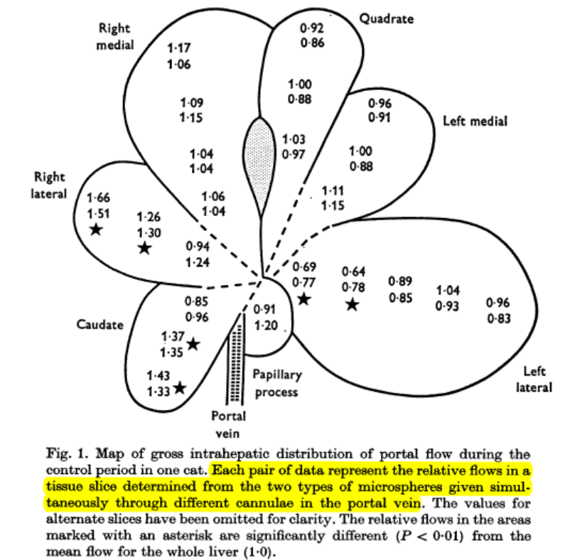
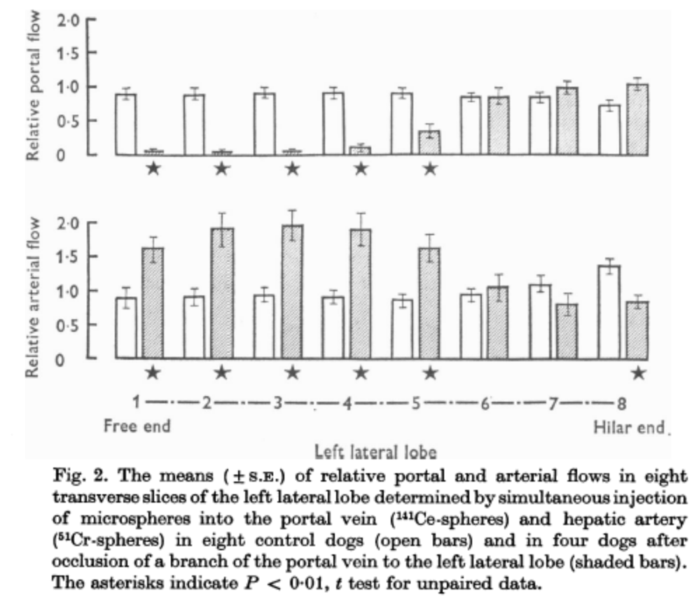
Visible acute changes in liver size can be seen without the intervention of technology. Liver volume is easily demonstrated to increase dramatically in response to elevated central venous pressure or venous outflow block.
The hepatic artery flow, portal venous flow and total hepatic flow were 0.377 +/- 0.10; 0.614 +/- 0.21; 0.992 +/- 0.2761/min, respectively. The ratio of hepatic arterial flow to portal venous flow was 0.66 +/- 0.259. There was a sharp, significant increase in hepatic arterial flow (29.8 +/- 6.1%, p < 0.01) after the temporary occlusion of portal vein, while the temporary occlusion of the hepatic artery did not have any significant effect on portal venous circulation.

Hepatic Blood Volume (Capacitance and compliance)
Capacitance, or total blood volume, consists of stressed volume and unstressed volume [104,112,121,325,326]. Stressed volume depends on the relationship between intrahepatic pressure and hepatic compliance. Compliance is a measure of the elasticity of the vascular bed and is defined as the change in volume per unit change in pressure (many studies incorrectly interchange capacitance and compliance). Hepatic compliance is linear over physiological pressures (2.5–3 ml/mmHg per 100 g or 0.6 ml/mmHg per kilogram of body weight) [121]. If this linear relationship between intrahepatic pressure and volume is extrapolated to zero pressure, the intercept is positive, that is, a theoretical volume remains in the liver at zero venous pressure (Figure 4.3). This extrapolated volume is the unstressed volume. These concepts have major physiological importance. The unstressed volume accounts for approximately 40% of the total hepatic volume [121]. The unstressed volume is hemodynamically inactive in that relationships between pressure, flow, and volume would not be altered if this blood pool did not exist. However, it is the unstressed volume that is actively regulated.
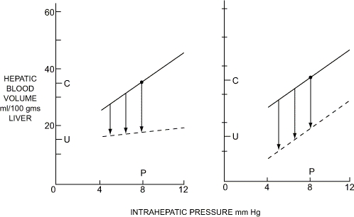
The pressure–volume relationship in the hepatic venous bed (solid line). Hepatic blood volume, or capacitance (C), at normal portal venous pressure is made up of unstressed volume (U) plus the stressed volume. The slope of the relationship (solid line) is the compliance. The stressed volume is determined by the compliance and the transmural pressure (P). Venoconstriction, shown by the arrows, could result from a change in compliance with no change in unstressed volume (broken line, left panel), a change in unstressed volume with no change in compliance (broken line, right panel), or a combination of changes in both compliance and unstressed volume. Active venoconstriction affects unstressed volume as compliance does not appear to change in response to the major constrictors. The biological response is seen in the right panel.

Intrinsic bloodflow regulation & hepatic arterial buffer response (HABR)
The liver does not control portal blood flow, which is simply the outflow of the extrahepatic splanchnic organs. If the vascular resistance to portal flow is increased to a maximum level by, for example, stimulation of the hepatic sympathetic nerves, portal pressure rises but portal blood flow does not fall. Portal blood flow is determined by the net outflows of the splanchnic organs including the stomach, spleen, pancreas, intestines, and omentum. If portal blood flow changes, the hepatic arterial flow changes in the opposite direction, thus tending to maintain total hepatic blood flow constant. This mechanism does not completely compensate but rather buffers the effect of portal blood flow changes on total hepatic flow, thus accounting for the name I chose for this response, the hepatic arterial buffer response (HABR) [192].
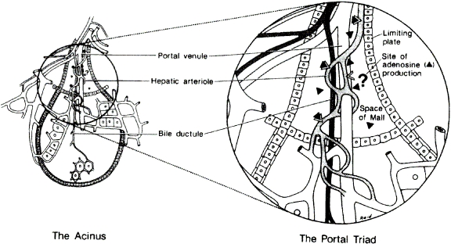
Adenosine washout hypothesis for the integrated intrinsic flow regulators of the hepatic artery: the HABR and autoregulation. The hepatic acinus represents a cluster of parenchymal cells arranged like a 2-mm berry on a vascular stalk, the portal triad, which leads into the center of each acinus. In contrast with the schematic figure, clear delineation does not exist between adjacent acini, the outer zones of adjacent acini possibly draining into more than one hepatic venule. The terminal branches of the hepatic arteriole, portal venule, and bile ductule lie within the enclosed space of the portal triad delimited by a limiting plate of cells. The fluid surrounding these vessels and contained within the limiting plate comprises the space of Mall. Adenosine is proposed to be continuously secreted into the space of Mall (independent of general parenchymal cell oxygen supply or demand), and the local concentration of adenosine determines the tone of the hepatic artery. Adenosine can be washed away into the bloodstream of the portal vein or hepatic artery. The HABR is accounted for by this mechanism, whereby a reduced portal blood flow washes away less adenosine and the accumulated adenosine leads to dilation of the hepatic artery. Classic autoregulation is explained by the same adenosine washout hypothesis. For example, increased arterial blood pressure leads to increased arterial blood flow with a subsequent washout of adenosine and resultant arterial constriction. The unique anatomical arrangement precludes substances released from the parenchymal cells from diffusing upstream against the blood flow to affect hepatic arterial tone.

The end result was that changes in portal flow tended to produce opposite changes in hepatic arterial flow such that total hepatic blood flow was maintained at a remarkably constant level. This work had two surprising conclusions. The first was that the oxygen supply-to-demand ratio for the liver did not appear to be an appropriate stimulus to change hepatic arterial blood flow. The second was that the major factor that appeared to be controlling hepatic arterial blood flow was portal venous flow [185].
Although the HABR has been shown in a wide variety of species, it has not been quantitated in terms of buffer capacity in conscious animals or humans. Clearly, to fully appreciate the homeostatic role of the HABR, it is essential to know the buffer capacity of the hepatic artery.
If the hepatic arterial flow is not regulated by hepatic oxygen supply or demand, does this imply a serious pathophysiological problem for the liver with regard to hypoxic damage? The liver has often been referred to as an organ verging on hypoxia. This, in fact, is not the case. When oxygen delivery was reduced to the liver to 68% in our hemodilution studies, oxygen uptake was able to be maintained at completely normal levels simply by increasing the oxygen extraction from the available supply. Because of the unique microvascular anatomy, the liver is able to extremely efficiently extract compounds from the blood.
In many conditions, the HABR, despite being insensitive to reduced hepatic oxygen, serves to protect oxygen delivery coincidentally. For example, the hepatic arterial flow is preserved during hemorrhage. This relative sparing of the hepatic artery is secondary to the HABR responding to the decrease in portal blood flow [227]. Thus, the buffer response in this instance serves to preserve the oxygen supply of the liver without the oxygen supply being directly regulated.
In considering the teleological purpose for evolving a flow-regulatory system that tends to maintain blood flow, per se, constant to the liver, it was fortunate that we had recently concluded studies relating blood flow to hepatic drug clearance. The liver is involved with clearance of an extremely wide range of endogenous compounds including hormones, such as aldosterone and corticosterone [186,265], in a blood flow-dependent manner. It was proposed [186] that a major function of the liver might be considered to be an endocrine function according to the following logic. Traditionally, when one thinks of regulation of plasma hormone levels, only the endocrine gland that produces the hormone is considered. However, for the endocrine gland to be able to increase or decrease hormone levels in the blood, it is important that there be a reasonably rapid and quite constant clearance of the hormone to serve as a background against which secretion can lead to fine tuning. If hepatic blood flow was not prevented from rapid, transient changes secondary to similar changes in the portal venous flow, endocrine homeostasis would be imperiled. It thus seems highly likely that general endocrine and metabolic homeostasis is subserved by the function of the HABR.

Metabolism and hepatic blood flow
In this way, we could measure total hepatic blood flow, control hepatic venous pressure, and measure liver metabolism in a preparation that had intact nerves and inflow vessels [184].
We continued examination of this first observation using dinitrophenol to increase oxygen demand or SKF525A to inhibit metabolism. The hepatic artery showed no tendency to change in response to the metabolic alterations; the hepatic oxygen demands were maintained solely by altered hepatic extraction [191]. Scattered reports had been consistent with this conclusion. As early as 1950, Myers et al. [285] reported that an increased splanchnic metabolism coexistent with a normal splanchnic blood flow provided an exception to the hypothesis that the rate of local tissue metabolism regulates the blood flow through the liver. Chronic alcohol exposure in rats, for example, led to elevated oxygen demand by the liver, but the hepatic artery actually constricted [33]. Lactic acidosis in dogs resulted in elevated portal flow but reduced oxygen delivery to the liver and reduced hepatic venous oxygen content. The hepatic artery did not respond to the decreased oxygen supply, but rather it constricted in response to the elevated portal flow [139].

Similarly in humans it was observed by indirect methods that following a meal (Myers & Hickman, 1948) or infusion of amino acids (Myers, 1948) the splanchnic oxygen uptake was dramatically increased with no increase in hepatic blood flow.
How is the relation between nutrition and oxygen content of portal blood?

Dauzat M, Lafortune M, Patriquin H, Pomier-Layrargues G. Meal induced changes in hepatic and splanchnic circulation: a noninvasive Doppler study in normal humans. Eur J Appl Physiol 68: pp. 373–380, 1994. [PubMed] [Cross Ref]
“Postprandial haemodynamic changes were maximal 30 min after the meal; at that time, mesenteric artery RI decreased significantly [mean -11% (SEM 14%)] whereas portal vein blood flow increased markedly [mean +79% (SEM 14%)]; a significant increase in hepatic artery RI was observed in both liver lobes. The ratio between maximal velocities of the intrahepatic artery and the intrahepatic portal vein was reduced significantly; this ratio decreased more markedly in the right lobe of the liver. These findings would suggest that there was an adaptation of hepatic artery to portal vein blood flow after a meal. The subsequent increase in intrahepatic portal vein flow velocity was found to be greater in the right lobe of the liver.”

That the liver cannot regulate its blood flow in accordance with the metabolic activity of the parenchymal cells is not disadvantageous to the liver under normal physiological conditions because of the excess oxygen delivered and the hepatic capacity to increase oxygen extraction. However, a relatively hypoxic liver shows increased toxic effects of alcohol [145], carbon tetrachloride [342], and halothane [262]. The formation of active toxic metabolites may occur to a greater extent and the ability of glutathione to detoxify such metabolites may be reduced when the NAD⁺/NADH ratio is altered by hypoxia (Chapter 12). Although the HABR is seen in cirrhotic livers, the buffer capacity may be insufficient to maintain a normal oxygen supply [332], and there is suggestion that severely diseased livers lose the HABR [329].

Resistance in the venous system
Twenty-five percent of the cardiac output flows through the liver with at least two thirds of this derived from the portal vein. This huge portal venous flow is driven through the liver across a minute pressure gradient. The pressure gradient between the portal inflow to the liver and the hepatic venous outflow from the liver is usually no more than 5 mmHg.
The resistance to blood flow through the portal vein is so low because of the unique hepatic vasculature, with conducting blood vessels terminating in each of the microvascular units of the acinus and flowing past only approximately 20 hepatocytes before exiting into the wide hepatic venules. The resistance is so low that at least 50% of the entire blood content of the liver can be expelled without adding significant vascular resistance.

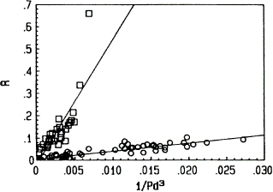
Demonstration in one cat of the passive relation between total vascular resistance (isolated in situ liver perfused only through portal vein) and distending blood pressure calculated as mean of portal venous and hepatic outflow venous pressure. Data were obtained by changing blood flow over the range of 10–50 ml/min/kg in several steps at normal (3 mmHg) venous pressure and raised (6 and 9 mmHg) venous pressure and by holding flow steady and raising outflow pressure in steps from 3 to 15 mmHg in the control state and during norepinephrine infusion (1.25 µg/min/kg). Because the IC curves extrapolate to zero, IC can be calculated from one data point. Norepinephrine resulted in a large increase in IC (slope), but the passive relationship remained unaltered and was linearly related (IC = R × P_{d}³). Reproduced from Lautt WW, Greenway CV, Legare DJ. Index of contractility: quantitative analysis of hepatic venous distensibility. Am J Physiol 260: pp. G325–G332, 1991.
In addition, we demonstrated the extreme distensibility of these resistance sites and described the mathematical relationship between the distending pressure of the venous blood and the vascular resistance at the distensible resistance sites in both the hepatic vein and portal venule inlets.
A small change in vascular distending pressure resulted in a large change in the resistance that was defined by the equation R = 1/P_{d}³, where R is the resistance, calculated based on the pressure on either side of the distending tissue, divided by blood flow across the resistance site. Distending pressure (P_{d}) is calculated as the mean of the pressure above and below the resistance site. By this equation, a linear relationship is plotted between resistance and 1/P_{d}³ with the intercept passing through zero. The ope of the line is the index of contractility and is calculated as IC = R × P_{d}³.
The liver cannot control portal blood flow, which is simply the total venous efflux from all of the splanchnic organs. Hepatic venous resistance is so low that even maximal stimulation of the hepatic sympathetic nerves, although resulting in a doubling or tripling of portal venous pressure, does not alter portal outflow from the splanchnic organs and therefore does not alter portal inflow to the liver. The liver must accommodate the entire portal flow and must accommodate to the quite large fluctuations that occur in portal blood flow, while maintaining its other homeostatic functions. The passively distensible portal venous and hepatic venous resistance sites explain how it is possible for portal blood flow to double while producing no more than a 2-mmHg change in portal pressure.
The resistance to blood flow through the liver is extremely low with pressure gradients between the portal venous inflow and hepatic venous outflow of the liver being in the range of 5 mmHg or less. Considering that the pressure gradients across all other organs are in the range of 115 mmHg, the vascular resistance within the hepatic portal system might erroneously appear to be trivial and of no consequence. In fact, the pressures are regulated at precise regions of the venous circuit at presinusoidal and postsinusoidal sites, and the proportion of pressure drop across the two sites and the total resistance determines intrahepatic and portal venous pressure and volumes.

The pressures of relevance are the portal venous pressure before entry into the liver, the central venous pressure (CVP) at the exit of the hepatic veins, and the intrahepatic pressure representing sinusoidal blood pressure. With these three pressures, and portal and hepatic blood flows, the presinusoidal and postsinusoidal resistance can be quantified.
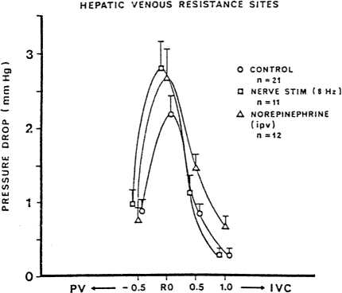
Intrahepatic pressure is measured by passing a catheter with a sealed tip and side holes beyond the hepatic venous sphincters to a point that results in wedging of the venous catheter. The catheter is then withdrawn in 0.5-cm steps. After the catheter has been withdrawn from 1 to 2 cm, the pressure recorded undergoes a large drop from a pressure that was similar to portal venous (PV) pressure down to a pressure similar to vena caval pressure. The data shown are standardized to plot the mean decrease in measured pressure as the catheter is withdrawn past the sphincter site. RO is standardized as the area of greatest pressure drop and is, therefore, the site of the hepatic venous sphincter. Most of the pressure drop between the portal vein and vena cava occurs across a vascular segment less than 0.5 cm in length. Active vasoconstriction imposed by intraportal infusion of norepinephrine (1.25 µg/kg/min), and the response to 8-Hz stimulation of the hepatic nerves leads to a hepatic venous sphincter constriction and a rise in lobar and portal venous pressures. Note that active vasoconstriction caused hepatic venous constriction across the same narrow resistance site that afforded basal resistance. The points on the graph are slightly offset so that the symbols do not overlap. IVC, inferior vena cava. Reproduced from Lautt WW, Greenway CV, Legare DJ. Effect of hepatic nerves, norepinephrine, angiotensin, elevated CVP on postsinusoidal resistance sites and intrahepatic pressures in cats. Microvascular Research, vol. 33, no. 1, p. 55. © 1987 by Academic Press. (This figure from publication Microvascular Research is reproduced with permission of publisher Academic Press).

The observation that equal reductions in arterial and portal flow lead to the same changes in hepatic volume [19] supports the contention that virtually all of the resistance to venous flow is in the hepatic veins. The pressure gradient between the portal vein (PVP) and the pressure (LVP) measured just proximal to the hepatic venous sphincters is assumed to represent primarily resistance within the portal venules. Note, however, that the pressure gradient represents pressure lost across the large and small portal tributaries, and the sinusoidal bed, as well as the small hepatic venules proximal to the LVP catheter. Active vasoconstriction results in a very significant increase in the PVP to LVP gradient.

Vascular Resistance/Conductance
Vascular resistance is defined as the pressure gradient across the vascular bed, divided by the flow through the bed. I will discuss the merits of quantifying arterial vascular tone using resistance or, more appropriately, conductance (flow divided by pressure gradient).
The vascular tone in blood vessels is affected by both active and passive forces. Constriction of vascular smooth muscle results in an active increase in vascular resistance to blood flow. An increase in blood pressure will result in a passive elastic stretch of the resistance vessels.
At constant perfusion pressure, conductance is linearly related to blood flow. Local changes in vascular tone produce primarily changes in blood flow rather than systemic pressure. Both the pressure and flow parameters must be considered when expressing vascular tone because both parameters change simultaneously.

For pharmacodynamic studies, accurate dose–response relationships can be obtained by measurements of blood flow in the artery, the inflow and outflow blood pressures, and access to an intra-arterial infusion site (preferably by administration into a side branch such as is possible in the superior mesenteric artery preparation or the hepatic arterial preparation) [184]
Nerves
In isolated rat liver perfused at constant flow with erythrocyte-free Krebs-Henseleit bicarbonate buffer containing 5 mM glucose and 2 mM lactate, perivascular stimulation of the hepatic nerves caused a rapid decrease of oxygen uptake, a decrease of the periportal and, after a transient rise, of the perivenous tissue po2 of surface acini, an increase of portal pressure, and an enhancement of glucose output. Furthermore, nerve stimulation changed the intrahepatic distribution of the perfusate drastically. Infusion of trypan blue 20 s after nerve stimulation resulted in a heterogeneous staining of the liver both at the surface and in cross-sections, while it led to a homogeneous distribution in non-stimulated controls. It is concluded that the major component in the mechanism of the nerve-dependent decrease of oxygen uptake is the microcirculatory change rather than a metabolic effect.
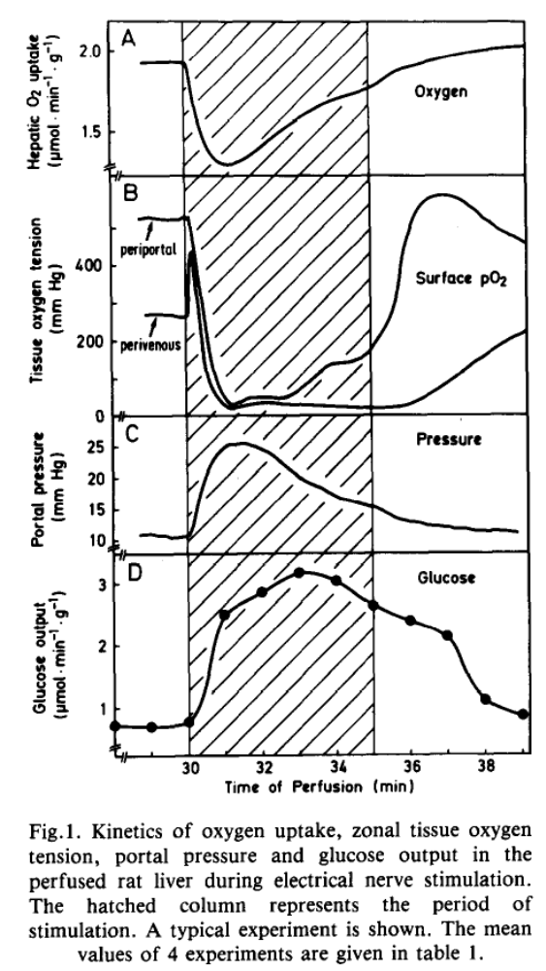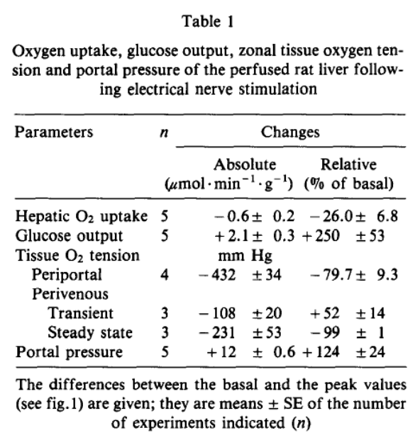
Stimulation of hepatic nerves in an isolated perfused liver preparation leads to a marked and well-maintained decrease in oxygen uptake corresponding with a reversible gross heterogeneity of flow, as shown by surface appearance after injection of trypan blue. Approximately 30% of the tissue was estimated to be without flow during stimulation, but flow appeared normal 10 min after cessation of stimulation [155]. Similar heterogeneity was produced in this type of preparation in response to noradrenaline infusion [17]. It was concluded that the mechanism of the reduced oxygen uptake is related to the circulatory changes rather than a metabolic effect [155]. In contrast, flow distribution is not altered in vivo in response to noradrenaline infusion [172] or hepatic nerve stimulation as shown by distribution of radioactive microspheres [119] and unaltered uptake of lidocaine [234] and oxygen [185]. In cats, oxygen uptake decreased transiently but as vascular escape proceeded, oxygen uptake returned to control levels suggesting that some redistribution of flow may have occurred at the onset of stimulation secondary to arterial sphincter-like constriction [188]. Indicator-dilution methodology in dogs confirmed that, despite a 40% reduction in vascular volume (induced reflexly by carotid arterial occlusion), the interstitial space and accessible cell water space were unchanged, indicating that there were no significant zones of no flow [59].
Reports of induction of heterogeneous blood flow with stagnant areas being seen in isolated liver preparations appears to be an artifact of the preparation as nerve-induced heterogeneity is reported for isolated livers but not for livers of the same species in vivo. The dramatic contrast between the isolated, in situ perfused rat liver and the responses of cat and dog livers in vivo reinforces the concerns raised by Greenway and Stark [122] that “conclusions from isolated perfused liver preparations cannot be extrapolated to the intact liver and such preparations have proven of limited value in vascular studies.”
Hepatic Blood Flow
Hepatic clearance of many drugs is blood flow dependent. Compounds with high hepatic extraction show clearance rates that are directly dependent on hepatic blood flow. If fewer compounds are delivered to the liver, fewer compounds are removed from the circulation. In contrast, generally, compounds with lower extraction ratios tend to be blood flow independent [114,165]. Clearance of a number of important hormones, including aldosterone and corticosterone [265], is blood flow dependent.
Of equal importance, for the endocrine gland to afford fine control of hormone levels, a relatively constant background clearance rate of the hormone from blood must be maintained. If a hormone level is to be rapidly adjustable by altered output from the endocrine gland, rapid turnover of the hormone must occur. It is important that the high catabolic rate be maintained as constant as possible in order that the hormone levels can be accurately controlled by the glandular output. If hepatic blood flow was not prevented from rapid, transient changes secondary to similar changes in the portal venous flow, endocrine homeostasis would be imperiled. Thus, any toxic reaction that leads to an impaired hepatic arterial buffer response would be anticipated to result in subtle endocrine and metabolic disturbances.
Hepatic blood flow declines significantly with aging and is suggested to account for the predominance of reduced hepatic drug clearance in the elderly [336,380].
Heterogeneity of perfusion
Heterogeneity of blood flow occurs at different levels within the liver. The most obvious heterogeneity occurs at the smallest vascular unit, the sinusoid. One form of heterogeneity that is seen in this situation is related to the unique microvasculature of the hepatic acinus whereby mixed portal and hepatic arterial blood enter the sinusoids in zone 1 at the center and flow outward to drain from zone 3. Autonomic innervation of hepatocytes is most dense in zone 1, as is the population of Kupffer cells. The heterogeneity in this case is primarily related to the constituents of the blood and the changes that occur in the constituents as the blood flows through the sinusoids, having compounds removed or added. The trans-acinus gradients can be extremely steep, positively and negatively. The gradient of oxygen can result in regulation of enzyme selectivity in different zones.
Heterogeneity, as the term is usually used, is also seen within the liver, again most obviously at the smallest unit. Individual sinusoids show episodic flow varying from swift passage of red blood cells to the opposite extreme of temporarily fully stagnant sinusoids. Temporary reversal of sinusoidal flow or even circular flow around a few parenchymal cells has also been demonstrated.
The capsule of the liver receives approximately 25% more arterial flow than deeper tissues [232]. Portal flow distribution within liver lobes most often shows a pattern of highest flow to the top, graduating down to lowest flow to the bottom (the dorsal side on animals placed on a surgical table). This degree of heterogeneity of perfusion appears to be under dynamic and multiple interacting forces [232]. The significant heterogeneity shown for flow on immediately adjacent portions of the liver surface indicates that extreme caution is needed when using small areas of flow determination to reflect changes to the entire organ. The functional implications of the gross levels of heterogeneity are not clear. However, heterogeneity does not appear to be significantly increased in studies of large animals under in vivo conditions even under conditions of low flow, norepinephrine infusion, sympathetic nerve stimulation, or raised venous pressure [59,119,120].
Can J Physiol Pharmacol. 1993 Feb;71(2):128-35.

Hepatic blood flow distribution: consideration of gravity, liver surface, and norepinephrine on regional heterogeneity.
Lautt WW, Schafer J, Legare DJ.

Capillarization
A further hepatic vascular dysfunction occurs through the process known as capillarization where chronic exposure to toxic compounds leads to a decrease in fenestration size, with the endothelial cells becoming similar to capillaries of other organs. Kupffer cell concentration is reduced in capillarized sinusoids [246].
The first drug shown to alter fenestrae size was ethanol, which initially dilates the fenestrae and may partially account for the protective effect from atherosclerosis ascribed to low-dose ethanol consumption. Long-term alcohol abuse, however, leads to capillarization of the sinusoidal endothelium. Capillarization is a reversible process so that 4 months after discontinuation of thioacetamide, the sinusoidal fenestrations were increased and, by an additional 6 months, the basement membrane in the space of Disse disappeared in rats [278].
Although the effect of capillarization on the ability of drugs to diffuse to the hepatocyte may be controversial, clearly the alteration of fenestrae numbers and size has the potential to cause serious metabolic disturbances with lipid metabolism. The fenestrated hepatic sinusoidal endothelium serves as a sieve that separates the hepatic blood from the plasma in the space of Disse. The fenestrations are of such a size that they act as a barrier to the large triglyceride-rich chylomicrons and, only after the chylomicron has diminished in size, secondary to triglyceride uptake in adipose tissue, is the remnant chylomicron sufficiently small to pass through the fenestrations to contact the hepatocyte (reviewed by Fraser et al. [86]). The triglyceride exported from the liver as very low-density lipoprotein in the hepatic lymphatics might be maintained, whereas the hepatic uptake of circulating cholesterol (low-density lipoprotein) could be severely compromised. This liver sieve serves as a site for regulation of hepatic selection and metabolism of dietary cholesterol and fat-soluble vitamins. The ability of the hepatic sieve to partially restrict albumin access to hepatocytes in healthy livers [101] implies that capillarization could lead to reduced availability of protein-bound compounds to hepatocytes. The disturbance of lipid and endocrine homeostasis may contribute significantly to liver disease and some of the dysfunctions in other organs that are seen in liver disease [86].
Hiss
Both of these “feeding signals” are necessary but neither is sufficient alone to allow a pulse of insulin to cause the release of a pulse of HISS from the liver. HISS acts selectively on skeletal muscle. A full description of the HISS hypothesis is beyond the scope of this chapter, but recent reviews provide a full referenced background including the hypothesis that absence of HISS action after a meal is the first metabolic defect leading progressively to obesity, syndrome X, and type 2 diabetes (reviewed in references [200–203,228]).

Multiple Mechanisms Maintaining a Constant Hepatic Blood Flow to Liver Mass Ratio
These regulatory processes act over different time scales and with different consequences, but the ultimate homeostatic role is to maintain constancy of blood flow relative to the metabolic machinery of the liver. This is important for homeostatic stability, as clearance of many drugs and hormones is blood flow-dependent and a relatively constant rate of removal of hormones from the plasma is necessary to allow fine control of blood levels by the endocrine glands.
There are multiple interrelated mechanisms that act acutely and chronically to maintain a constant hepatic blood flow-to-liver mass ratio. Maintenance of hepatic blood flow is made more complex by the unique characteristics of the hepatic vascular bed. The liver receives approximately 25% of the entire cardiac output and three quarters of that blood flow is provided to the liver through the portal venous drainage from the stomach, intestines, spleen, pancreas, and visceral fat. The liver is not capable of directly controlling portal blood flow. Yet, as will be discussed, the liver can have very significant indirect effects to regulate portal blood flow via mechanisms impacting on blood flow to the splanchnic organs that drain into the portal vein.
The first mechanism is a simple physical consequence of the very high vascular capacitance (blood volume) and compliance (change in hepatic blood volume per unit change in intrahepatic pressure). A decrease in portal blood flow leads to a passive decrease in intrahepatic pressure and a passive expulsion of blood from the large hepatic reservoir into the central venous system. This increase in venous return leads to increased cardiac output that, in turn, leads to elevated blood flow in the splanchnic arteries that feed the portal venous bed, thus at least partially correcting the initial flow deficit. At the same time, the reduced portal flow activates the hepatic arterial buffer response (HABR). By this mechanism, reduced portal flow leads to accumulation of adenosine and hepatic arterial dilation, thereby serving to buffer the impact that changes in portal flow have on total hepatic blood flow. The hepatic artery is dilated within seconds and the response is well maintained.

The liver accounts for 12% of the total blood volume and half of that blood can be rapidly expelled from the liver in response to both active and passive influences, thus giving the liver a dramatic role as a blood volume reservoir.

Lymph Flow
The volume of lymph secreted per 24 h in a dog amounts to 47% of the estimated total plasma volume. This fluid volume contains 35% of the total circulating plasma proteins. In experimental cirrhosis, the flow of hepatic lymph has been estimated to increase as much as 258% and, over a 24-h period, contains as much as 207% of the circulating plasma proteins (Child, 1954). Total lymph flow from the liver apparently has not been measured. Brauer [30] estimated it at 0.04–0.06 ml/min per 100 g of liver, whereas Laine et al. [180] reported 0.06 ml/min from one prenodal lymphatic in dogs
A linear relationship between hepatic venous pressure and hepatic lymph flow was shown in cats by Neil Granger and collaborators [101] and in dogs by his brother Harris and collaborators [180].
The Starling forces of hydrostatic pressure and colloid osmotic pressure acting across the endothelial cells to regulate fluid exchange between the extracellular fluid compartments of plasma and interstitial fluid seems irrelevant to the liver because the equivalent of the extracellular interstitial fluid, the space of Disse, appears to have a protein content and hydrostatic pressure level indistinguishable from that of the plasma compartment. Although these observations may suggest a trivial role for the hepatic lymphatics, the huge contribution of hepatic lymph flow to total lymph flow and the large volume of hepatic lymph that is formed per day suggest that our knowledge rather than the function of the lymphatics is insignificant.

Flow limited distribution of blood-borne substances (multiple indicator dilution technique)
The “multiple indicator dilution technique” consists of determining the hepatic venous efflux after rapid intraportal injection of a reference substance, whose behavior is known, and one or more other substances, whose behavior is to be characterized. One of the pioneers who used the technique for studies in the liver was Carl Goresky. For this method, red blood cells were usually used as the reference curve. A labeled red cell travels faster than a bolus of labeled albumin. The difference in rate of efflux from the liver represents different accessibility to the hepatic spaces. Access to intracellular space is restricted according to molecular weight. The restriction by molecular size demonstrated by the indicator dilution outflow curves from the liver is compatible with the completely different approach of demonstrating physical size limitation to hepatic lymph outflow [12].
On the basis of a series of studies with multiple-indicator dilution techniques, Goresky [98] confirmed that no continuous anatomic barrier exists between plasma and the space of Disse. The endothelial lining serves to contain red cells, but virtually immediate lateral diffusion equilibrium is expected for most molecules within the space of Disse. As blood cells squeeze through the sinusoids, they massage the endothelial cells and further mix plasma and Disse fluid.
Metabolic Zonation
The partial pressure of oxygen in rat livers has been estimated at approximately 65 mmHg in the periportal zone (zone 1) with pO₂ in the perivenous zone (zone 3) of approximately 30–35 mmHg [360,379]
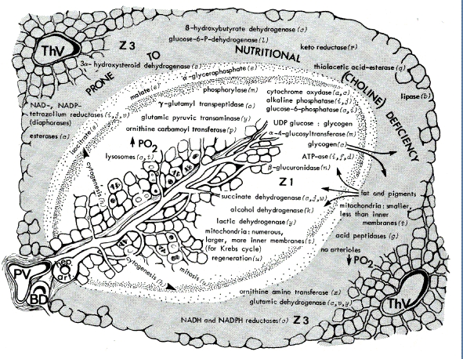
Metabolic areas in the acini. The central region (zone 1) is in the center of the acinus where oxygen content is the highest (white periportal area) and decreases progressively to zone 3 (shaded area). PV, portal vein; ThV, terminal hepatic venule; BD, bile ductule; hep. art., hepatic arteriole; Z1, zone 1 or periportal area; Z3, zone 3 or perivenous zone. Reproduced from Rappaport AM. In: Diseases of the Liver, Fourth Edition, edited by Schiff L. Philadelphia: Lippincott, Chapter 1, p. 10, 1975.

Lobule & acinus architecture
To this day, there is no complete consensus on whether the microvascular unit of the liver should be referred to as a lobule, centering on a hepatic vein, or an acinus, centering on a “portal triad” consisting of a terminal branch of the hepatic artery, portal vein, and bile duct, encased within a limiting plate of cells defining the space of Mall.
The space of Mall, variously known as the portal duct or portal triad, represents the service conduit that supplies the center of each acinus with portal and arterial blood, collects bile and lymph, and through which passes a rich array of sensory and efferent nerves. The terminal branches of the hepatic artery are in intimate contact with the terminal branches of the portal vein. Direct arterial branches have been shown to enter the terminal portal venules before entry into the sinusoids. An additional vascular circuit exists within the space of Mall, the peribiliary plexus (Figure 2.7). The hepatic artery sends off small branches that form a dense mesh-like plexus surrounding the bile duct. A significant proportion of the hepatic arterial flow passes through the peribiliary plexus before it drains into the portal vein at or near where the portal vein and hepatic artery merge at the origin of sinusoids. The function of the peribiliary plexus is not known, although substances such as adenosine, when back-perfused through the bile duct, reach the hepatic arterial resistance vessels and cause dilation
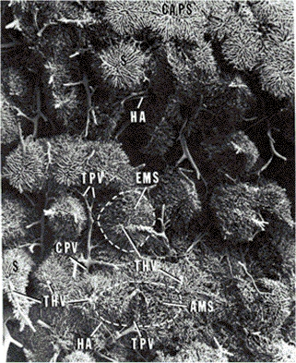
A cast of the hepatic microvessels of the rat made by perfusing casting medium through the aorta until all hepatic vessels were filled. Both subcapsular sinusoids (CAPS) and deeper vessels are focused. Tufts of sinusoids surround terminal limbs of afferent and efferent vessels. Terminal hepatic veins (THV) collect sinusoids (S), each tuft comprising an efferent microvascular segment (EMS) or hexagonal lobule. Terminal portal veins (TPV) supply sinusoids, each tuft comprising an afferent microvascular segment (AMS) or acinus. Conducting (CPV) and distributing (DPV) portal veins and accompanying hepatic arteries (HA) are shown (magnification, approximately ×40).
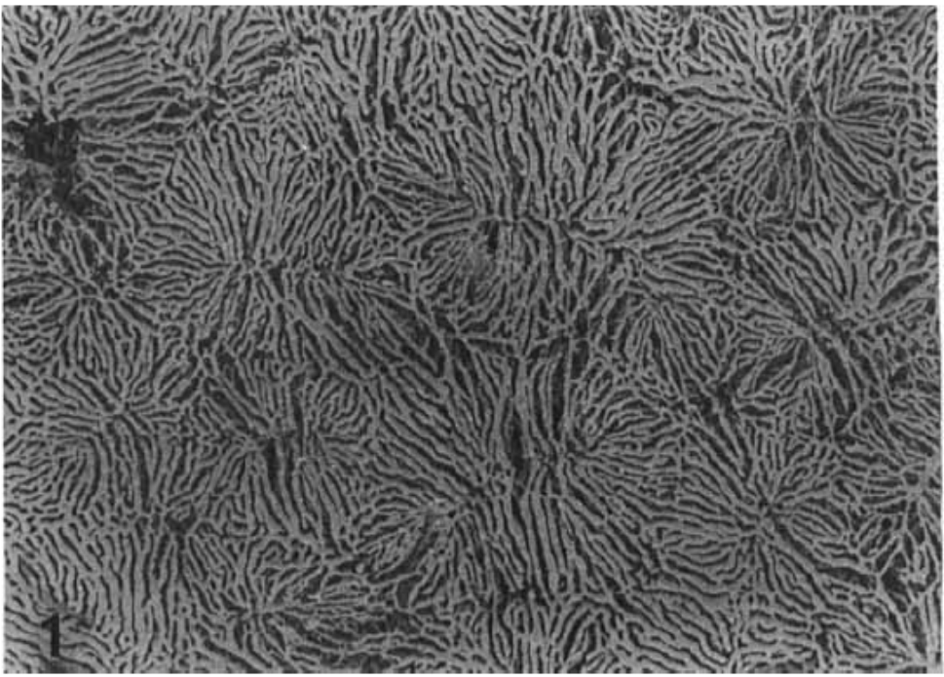
SEM of a microvascular corrosion cast of the superior surface of a control liver. A continuous network of sinusoids is visible (original
magnification x 65)

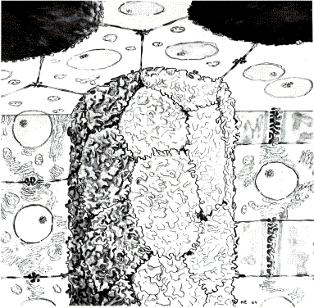
Hepatocytes are connected as a syncytium of cell plates of one cell thick. The syncytium is tunneled through with lacunae that are defined by the space between hepatocyte plates and contain the space of Disse (equivalent to extracellular space in other tissues), the fenestrated endothelial cells (equivalent to capillary endothelium in other tissues), and the plasma volume.

Morphological studies suggest that the sinusoidal lumen is 10.6% of liver volume, the space of Disse is 5%, and the bile canaliculi comprise 0.4% of volume [24]. The picture that emerges from this anatomy is compatible with the physiological data on extracellular spaces in the liver. Sodium (8.9%), sucrose (8.8%), and inulin (7.7%) spaces were almost equal. Albumin extravascular space was 5.7% of liver weight and 64% of the Na⁺ space (98). The albumin space was 59% of the interstitial space, and this increased to 66% when hepatic venous pressure was raised. The lymph-to-plasma concentration ratio varied only slightly with molecular size and was 1.0 for lactoglobulin, 0.88 for albumin, and 0.69 for γ-globulin. Protein content of lymph was 80–95% that of plasma, and hepatic lymph proteins originated from blood, not from new synthesis [30,71,101,122,180].

Species Differences

Alterations of Hepatic Microcirculation in Disease
Chronic liver disease is frequently associated with capillarization of the hepatic endothelial cells with reduced fenestrations and, subsequently, reduced freedom of movement between hepatocytes and plasma. The space of Disse is a small space, equivalent to the interstitial fluid of other vascular beds.
Cirrhosis
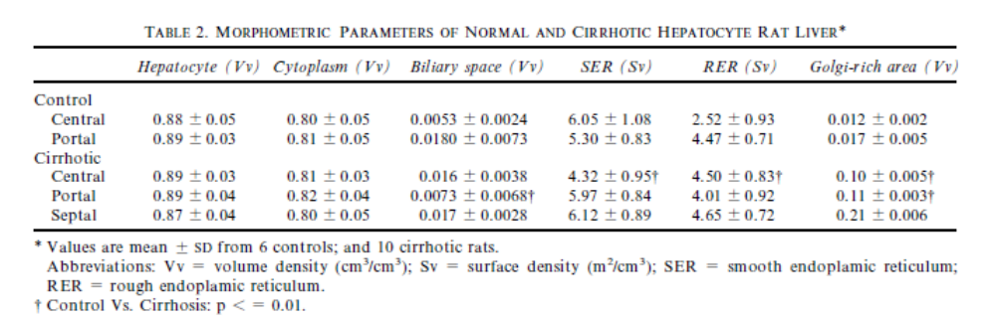4]
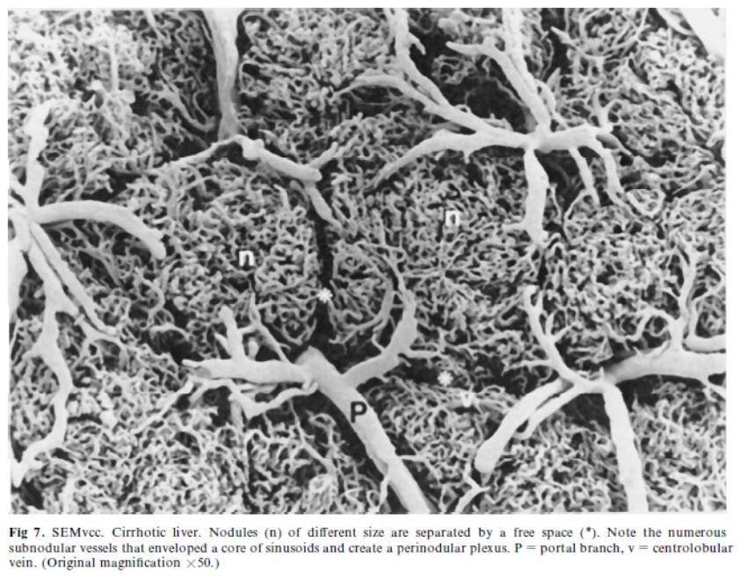
[1] Lautt, W. W., Hepatic Circulation: Physiology and Pathophysiology, San Rafael (CA) 2009.
[2] Rappaport, A. M., Hepatic blood flow: morphologic aspects and physiologic regulation. International review of physiology 1980, 21, 1-63.
[3] Lautt, W. W., Legare, D. J., Daniels, T. R., The comparative effect of administration of substances via the hepatic artery or portal vein on hepatic arterial resistance, liver blood volume and hepatic extraction in cats. Hepatology 1984, 4, 927-932.
[4] Greenway, C. V., Oshiro, G., Intrahepatic distribution of portal and hepatic arterial blood flows in anaesthetized cats and dogs and the effects of portal occlusion, raised venous pressure and histamine. J Physiol 1972, 227, 473-485.
[5] Jakab, F., Rath, Z., Schmal, F., Nagy, P., Faller, J., The interaction between hepatic arterial and portal venous blood flows; simultaneous measurement by transit time ultrasonic volume flowmetry. Hepato-gastroenterology 1995, 42, 18-21.
[6] Ji, S., Beckh, K., Jungermann, K., Regulation of oxygen consumption and microcirculation by alpha-sympathetic nerves in isolated perfused rat liver. FEBS letters 1984, 167, 117-122.
[7] Gaudio, E., Pannarale, L., Onori, P., Riggio, O., A scanning electron microscopic study of liver microcirculation disarrangement in experimental rat cirrhosis. Hepatology 1993, 17, 477-485.
[8] Gaudio, E., Onori, P., Franchitto, A., Sferra, R., Riggio, O., Liver metabolic zonation and hepatic microcirculation in carbon tetrachloride-induced experimental cirrhosis. Digestive diseases and sciences 1997, 42, 167-177.

