Galactose metabolism has an importnant role in human infants consuming lactose as their primary carbohydrate source and studies in dogs and rats suggest that it could be the preferred carbon source in mammalian neonates, being incorporated into glycogen more efficiently than is glucose [Leslie2003 -> 30]
Galactose is a hexose differing from glucose only by the configuration of the hydroxyl-group at the carbon-4 position. Galactose exists abundantly in milk, dairy products, and other foods like fruits and vegetables [Lai2009->11].

(ALDR) Aldose reductase (galactitol NAD 1-oxidoreductase);
(ATPS) ATP synthesis;
(GALDH) Galactose 1-dehydrogenase;
(GALE) UDP-glucose 4-epimerase;
(GALK) Galactokinase;
(GALT) Galactose-1-phosphate uridyl transferase;
(GLUT2) Facilitated glucose transporter member 2;
(GTFGAL) Glycosyltransferase galactose;
(GTFGLC) Glycosyltransferase glucose;
(NADPR) NADP reductase;
(NDKU) Nucleoside diphosphokinase, ATP:UDP phosphotransferase;
(IMP) Inositol monophosphatase;
(PGM1) Phosphoglucomutase-1;
(PPASE) Pyrophosphatase;
(UGALP) UDP-galactose pyrophosphorylase;
(UGP) UDP-glucose pyrophosphorylase;

(adp) ADP;
(atp) ATP;
(gal) D-galactose;
(gal1p) D-galactose 1-phosphate;
(galnat) D-galactonate;
(galtol) D-galactitol;
(glc) D-glucose;
(glc1p) D-glucose 1-phosphate;
(glc6p) D-glucose 6-phosphate;
(nadp) NADP;
(nadph) NADPH;
(pi) phosphate;
(pp) pyrophosphate;
(udp) UDP;
(udpgal) UDP-D-galactose;
(udpglc) UDP-D-glucose;
(utp) UTP;

Galactose Elimination by the Liver
“The extent to which flow or function determines the rate of clearance determines the rate of clearance depends on the biochemical efficiency of the liver for removal of the substrate relative to flow [Schirmer1986 -> 45, 68, 99]. Substances efficiently removed relative to flow are used for HBF (hepatic blood flow) estimation whereas substances removed with low efficiency relative to flow are useful for estimating hepatic function.
The quotient (c_{i}-c_{o})/c_{i} is known as the extraction fraction or extraction ratio (ER). The ER determines the degree to which clearance (CL) approximates flow (F) CL = F*ER
Galactose and radiolabeld colloids are two substances that are completely or nearly completely cleared on single pass through the liver and their clearance can be used to estimate liver blood flow [Schirmer1986 -> 20, 21, 35, 36, 47, 87, 91, 92, 95]

Galactose Clearance at low concentrations (GCLC) has proven to be as near ideal a method for estimating EHBF (effective hepatic blood flow) as is available.

Contributions other pathways elimination:
RBC galactokinase activity is second to the liver with in vitro studies suggesting that galactose elimination by this route is on the order of 1% of the total elimination [Schirmer1986 -> 34]. The primary site of extrahepatic galactose elimination is the urine [Schirmer1986 -> 22, 84, 87]. Tygstrup demonstrated that urinary galactose elimination increased linearly with concentration [84]. As blood concentration increased the percentage of galactose elimination increased the percentage of galactose elimination accounted for in the urine progressively increased because the liver has a maximal elimination capacity while the kidney has not. In the concentration ranges required for EHBF determinations in the rat, urinary elimination is <1% ot the total galactose elimination [70]. Therefore the sum of all extrahepatic sites for galactose elimination in the appropriate concentration range is roughly 2%.
Numerous studies about liver galactose elimination capacity (GEC) [5, 9, 17, 22, 41, 78, 79, 82, 83, 88, 96]
Hepatic vein catheterization at high concentrations revealed a constant hepatic arterial-hepatic venous concentration difference [87,88]. The GEC became an accepted test of liver function and its value taken to reflect the functional hepatic mass [17,82, 83, 88, 96].
At concentrations less than 200mcg/ml the hepatic vein concentration was virtually zero. (complete extraction)
Henderson et al. confirmed the near complete extraction of galactose across the liver (ER = 0.94) in subjects without hepatic disease by performing hepatic vein catheterization [35].
The most extensive work on galactose elimination kinetics was done by Keiding and co-workers [43-45, 48, 50, 85, 99]. The “sinusoidal perfusion model” they developed provides a sound theoretical justification for using galactose clearance at low concentrations to estimate EHBF [44, 45, 48, 50, 99].
Hepatic galactose elimination follows Michaelis-Menten saturation kinetics [43, 50, 70]; Its hallmarks are an early, concentration-dependent (first-order) elimination phase followed by a definable clearance maximum (GEC) at higher concentrations (zero-order phase).
Definition of velocity as amount of galactose removed per unit time per 100g of body weight (as opposed to rate per individual man [82, 96] or rate per g of liver weight [43, 50].
Blood flows unidirectionally through the sinusoids at prescribed rates [4, 26, 27]. The inflow concentration exceeds the outflow concentration with a gradient through the liver.
Apparent Km for galactose elimination in rat with sinusoidal perfusion model is 30.1 mcg/ml ~ 0.167mM, which is in close agreement with values reported by others [18 27, 43, 48, 50];

The Vmax for galactose elimination is much higher in humans than in rats [47,82,96], with the Km being similar [47].

Glycosylation
“Glycosylation, the reaction of a saccharide with a hydroxy or amino functional group to form a glycoside; especially the reaction with a protein or lipid to form a glycoprotein or glycolipid.
glycosylation is thought to be the most complex post-translational modification, because of the large number of enzymatic steps involved. The donor molecule is often an activated nucleotide sugar”
Over 40 disorders of glycosylation have been reported in humans.^{[6]} These can be divided into four groups: disorders of protein N-glycosylation, disorders of protein O-glycosylation, disorders of lipid glycosylation and disorders of other glycosylation pathways and of multiple glycosylation pathways. No effective treatment is known for any of these disorders. 80% of these affect the nervous system.
Approximately half of all proteins typically expressed in a cell undergo this modification, which entails the covalent addition of sugar moieties to specific amino acids. Most soluble and membrane-bound proteins expressed in the endoplasmic reticulum are glycosylated to some extent, including secreted proteins, surface receptors and ligands and organelle-resident proteins. Additionally, some proteins that are trafficked from the Golgi to the cytoplasm are also glycosylated. Lipids and proteoglycans can also be glycosylated, significantly increasing the number of substrates for this type of modification.
Glycosylation is thought to be the most complex post-translational modification because of the large number of enzymatic steps involved (5). The molecular events of glycosylation include linking monosaccharides together, transferring sugars from one substrate to another and trimming sugars from the glycan structure. Unlike other cell processes such as transcription or translation, glycosylation is non-templated, and thus, all of these steps do not necessarily occur during every glycosylation event. Instead of using templates, cells rely on a host of enzymes that add or remove sugars from one molecule to another to generate the diverse glycoproteins seen in a given cell. While it may seem chaotic because of all of the enzymes involved, the different mechanisms of glycosylation are highly-ordered, step-wise reactions in which individual enzyme activity is dependent upon the completion of the previous enzymatic reaction. Because enzyme activity varies by cell type and intracellular compartment, cells can synthesize glycoproteins that differ from other cells in glycan structure (5).
Enzymes that transfer mono- or oligosaccharides from donor molecules to growing oligosaccharide chains or proteins are called glycosyltransferases (Gtfs). Each Gtf has specificity for linking a particular sugar from a donor (sugar nucleotide or dolichol) to a substrate and acts independent of other Gtfs. These enzymes are broad in scope, as glycosidic bonds have been detected on almost every protein functional group, and glycosylation has been shown to incorporate most of the commonly occurring monosaccharides to some extent (6).
• Walsh C. (2006) Posttranslational modification of proteins : Expanding nature's inventory. Englewood, Colo.: Roberts and Co. Publishers. xxi, 490 p. p.
• Spiro R. G. (2002) Protein glycosylation: Nature, distribution, enzymatic formation, and disease implications of glycopeptide bonds. Glycobiology. 12, 43R-56R.

Galactokinase deficiencies/mutations
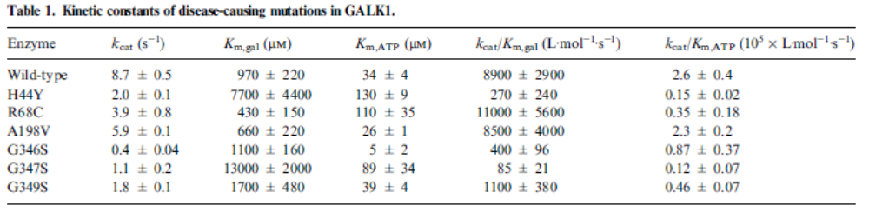

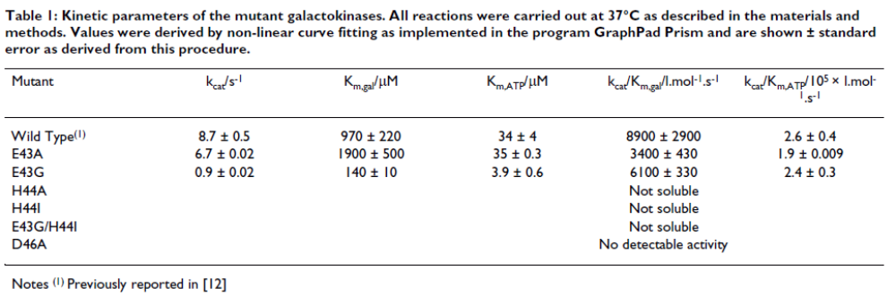

GALT deficiencies/mutations
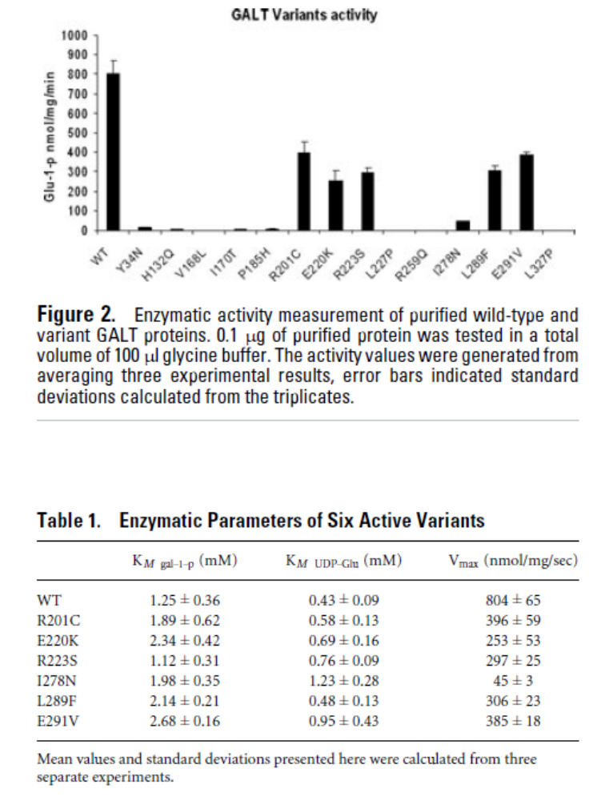
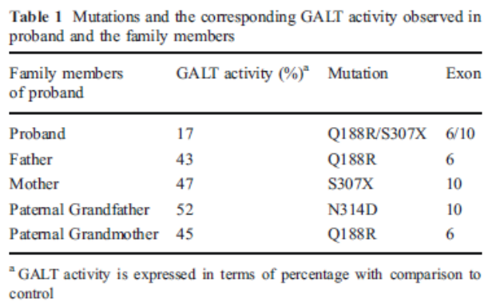
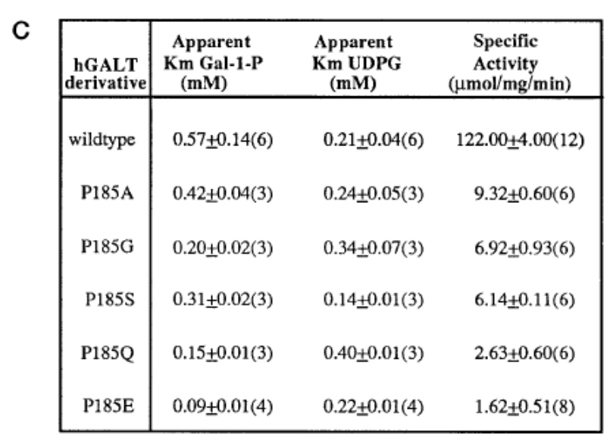

GALE deficiencies/mutations
