A tissue-scale model of zonated hepatic glucose metabolism
Matthias König
Metabolic zonation designates the finding that homotypic cells in a tissue may comprise significant differences in the capacity of specific metabolic pathways depending on their local access to nutrients and oxygen. Well-studied examples are hepatocytes which may alternatively operate as glucose producers in well-oxygenated regions (aerobic) of the tissue (periportal) or glucose consumers in poorly oxygenated (hypoxic) regions (perivenious).
In this project we investigate metabolic zonation of hepatic glucose metabolism on a sinusoidal scale. A detailed kinetic model of hepatic glycolysis (GLY), gluconeogenesis (GNG) and glycogen metabolism ¹ was coupled with a tissue-scale model of hepatic sinusoid architecture (Figure 1; implementation similar to ²). Transcriptomics and proteomics data were integrated with the metabolic model to account for the periportal and perivenious phenotypes of glucose metabolism. Our model predicts a zonated metabolic phenotype along the sinusoid in line with experimental data with glucose production mainly in the periportal region and glucose utilization in the perivenious region.
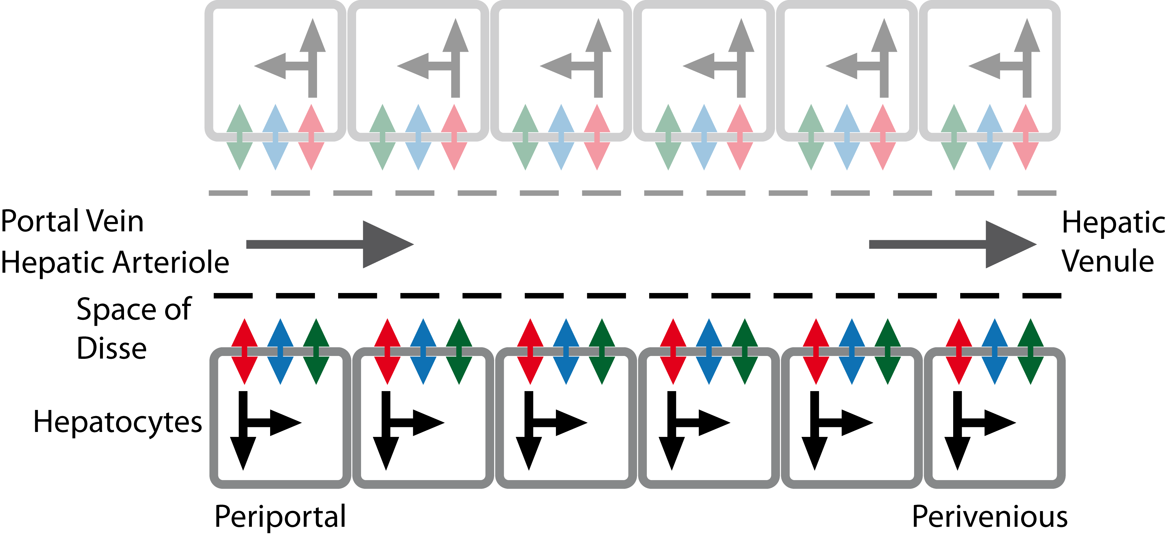
Figure 1 –Sinusoid-scale kinetic model of hepatic glucose metabolism
Overview of the multi-scale model of hepatic glucose metabolism integrating convective and diffusion-based transport of metabolites in the extracellular space (grey) with detailed kinetic models of glucose metabolism on the cellular level. Exchangeable metabolites between the cells and the extracellular space are glucose (red), lactate (green) and oxygen (blue). The single hepatocytes are supplied with nutrients and oxygen via the sinusoidal blood flow.
1 König, M. & Holzhütter, H. G. Kinetic modeling of human hepatic glucose metabolism in type 2 diabetes mellitus predicts higher risk of hypoglycemic events in rigorous insulin therapy. The Journal of biological chemistry 287, 36978-36989, doi:10.1074/jbc.M112.382069 (2012).
2 König, M., Holzhütter, H. & Berndt, N. Metabolic Gradients as Key Regulators in Zonation of Tumor Energy Metabolism: A Tissue-scale Model Based Study. Biotechnology Journal (2013).

