A kinetic model to study the role of metabolic zonation of hepatocytes on the regulation of the hepatic glucose metabolism under normal and diabetic conditions
Project summary – Matthias König

Introduction
The smallest functional unit of the liver is the sinusoid, differentiated in a perivenious area next to the hepatic vein and a periportal area near the portal vein and hepatic artery [REF]. The periportal and perivenious hepatocytes possess different metabolic capabilities due to varying activities and protein levels of important enzymes of glucose and oxidative energy metabolism [Jungermann1992]. The periportal hepatocytes are mainly involved in the glucose release and glycogen synthesis via gluconeogenesis as well as oxidative catabolism of fatty and amino acids, whereas the perivenious hepatocytes preferentially perform glucose uptake for glycogen formation and glycolysis coupled to liponeogenesis [Jungermann1992, Jungermann1997] (Figure 1). This differentiation of metabolism according to the location of the hepatocytes in the sinusoid is called 'metabolic zonation'.
Main factors influencing the metabolic zonation are hormonal (insulin, glucagon, epinephrine) as well as metabolite gradients (for instance oxygen, lactate, glucose) from the periportal to the perivenious region (Figure 2).

Methods
Periportal and perivenious phenotype
The shift in phenotype due to variation in Vmax values for the human hepatocyte model [Koenig2011] is analyzed. Single periportal and perivenious hepatocyte models (Figure 3) are generated by varying the Vmax according to experimental protein and expression data.
Zonation Model
The detailed model of glucose metabolism for single hepatocytes [Koenig2011] is integrated in a sinosoid model of blood flow (Figure 4). The enzyme capacities are modulated according to gradients in metabolites and hormones. The sinusoid consists of around 10 – 20 hepatocytes linearly organized around the blood vessels. Depending on the location in the sinusoid the hepatocytes exhibit varying metabolic capacities according to their position.

Results
Periportal and perivenious hepatocytes
Periportal and perivenious hepatocyte models by variation of Vmax values of key enzymes of HGP and HGP in accordance with observed expression and protein changes have been developed (Figure 3). The periportal hepatocytes preferentially export glucose and storing glycogen from gluconeogenesis. Perivenious hepatocytes exhibits a perivenious phenotype consisting of glucose uptake, storage of glucose as glycogen and performing glycolysis. The gluconeogenesis of the periportal hepatocyte compared to the perivenious hepatocyte is largely increased. The switch point from glucose uptake to glucose production in the periportal hepatocytes lies at significantly higher glucose values than for the perivenious hepatocyte. This shift is mainly due to an shift in the switch point between gluconeogenesis and glycolysis. The switch point between glycogen synthesis and glycogenolysis is nearly unaffected by phenotype switch from periportal to perivenious. The difference in shift of gluconeogenesis/glycolysis and glycogen synthesis/glycogenolysis switch points is the main reason for the different glycogen phenotypes and explains the so called 'glucose paradox', meaning a large part of glycogen in the liver is synthesized via the indirect pathway of gluconeogenesis. Periportal and perivenious phenotypes have glycogen synthesis above 5 mM and glycogenolysis below 5mM. The source for glycogen synthesis and the destination of the glucose-6p from glycogenolysis varies depending on the phenotype and the switch point in glycolysis/gluconeogenesis.
The kinetic model of glucose metabolism is able to reproduce the characteristic periportal and perivenious phenotypes by including the information of changes in activity and amount of key enzymes of HGP and HGU.

Integration of expression data
The work on integration of expression data for periportal and perivenious hepatocytes has just started. The current changes in Vmax are not based on observed expression data.

Blood compartment model
The work on the detailed blood compartment model of the sinusoid has just started.

Outlook
- including real liver sinusoid organization and blood vessel data (3D reconstructions of the liver and usage of the available 3D data)

References
Jungermann1992
Jungermann1997

Figures
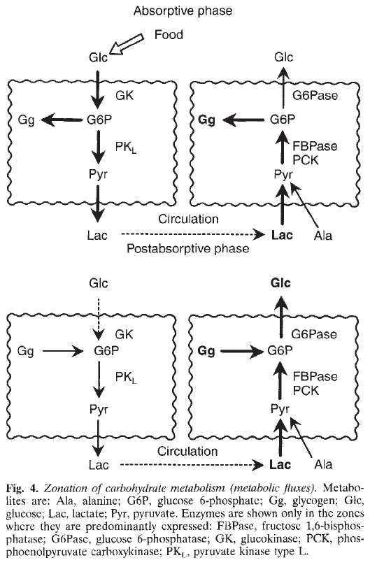

Figure 1: Zonation of carbohydrate metabolism and the periportal and perivenious phenotype of glucose metabolism (from [Jungermann1997])

Figure 2: Zonation of signal input (from [Jungermann1997])
During the passage of blood through the sinosoids concentration gradients of oxygen, substrates, products (B) as well as hormones and mediators (C) are occuring.
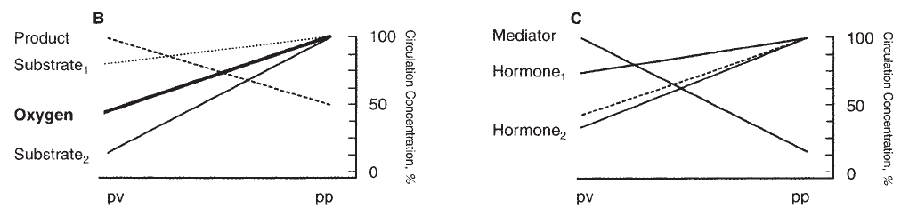

Figure 3: Periportal and perivenious hepatocytes
Changing Vmax values of key enzymes of HGP and HGU in accordance with observed changes in gene expression and protein levels for the perivenious and periportal hepatocytes results in the respective phenotypes. Changes in HGU[green]/HGP[red] (1st panel), glycolysis[green]/gluconeogenesis[red] (2nd panel) and glycogen synthesis[green]/glycogenolysis[red] (3rd panel) for different periportal and perivenious hepatocytes.
A periportal
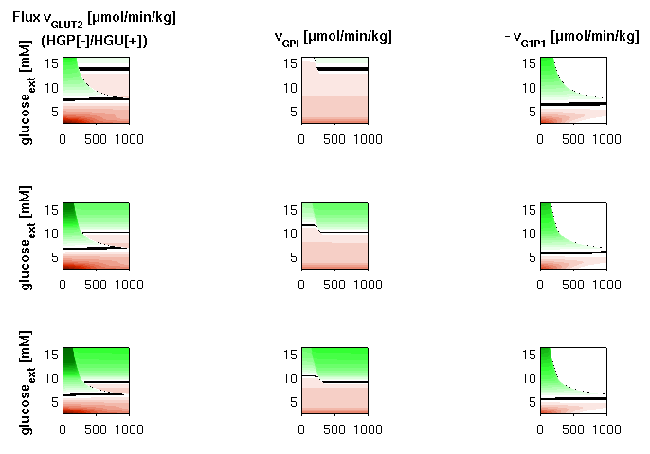
B perivenious
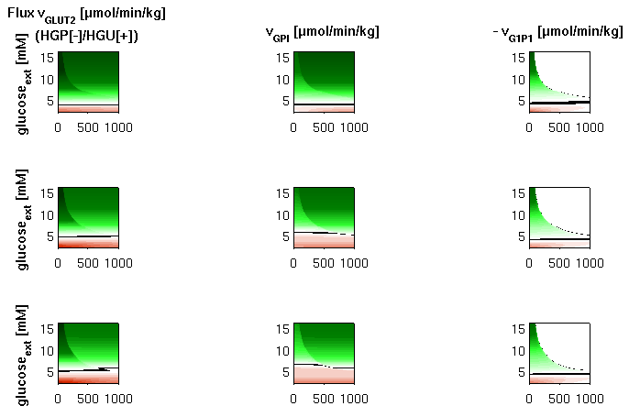

Figure 4: Metabolic model of zonation
Substrates and products like glucose, oxygen and lactate as well as hormonal signals of insulin, glucagon and epinephrine are transported via the blood stream through the sinusoid. The hepatocytes adjacent to the blood are influenced by the hormonal signals and exchange metabolites with the blood stream. Enzyme pattern of key enzymes of HGP and HGU change over the sinusoid due to hormonal and metabolic gradients.
