Multiple indicator dilution data

# Multiple indicator dilution technique

An indicator substance introduced into the blood flowing into an organ becomes dispersed in the effluent blood and the conentratins oft he substance in the effluent blood form an indicator ddilution curve.

Labeled red blood cells (a vascular indicator), labeled sucrose (an extracellular reference), and labeled galactose are rapidely injected into the portal vein, and from rapidely sampled venous blood, normalized outflow-time patterns are measured (Goresky, et al., 1973).

The area under the curve (AUC), mean transit time (MTT), and variance of the transit time (VTT) were calculated directly from the dilution curves using the following equations {Warren2008}:

AUC=0∞sppk(t) dt MTT=0∞tsppk(t) dtAUC MTT=0∞t2sppk(t) dtAUC-(MTT)2

# Galactose experiments

At low blood galactose concentrations, the labeld galactose appears at the outflow with labeld sucose, but is much reduced in magnitude, and exhibits a long tailing. Its outflow recovery is much reduced. At high blood galactose concentrations, the initial part of the profile increases towards that for labeled sucrose, the tailing becomes much larger in magnitude, and the outflow recovery becomes virtually complete. (Goresky, et al., 1973).

The capacity of the process subserving cell entry is found to be 40 times that for phosphorylation; and, whereas the Km value for sequestration is less than 15mg/100ml (0.83mM), that for entry is approximately 500mg/100ml (27.8mM)

The D-galactose level was increased by steady infusion, so that the characteristics of the saturation phenomena could be defined

|  |  |  |  |
| --- | --- | --- | --- |
|  | A | B | C |
|  | Galactose 5mg/100ml  Glucose 117mg/100ml | Galactose 225mg/100ml  Glucose 103mg/100ml | Galactose 315mg/100ml  Glucose 118mg/100ml |
|  | Galactose 0.28mM  Glucose 6.5mM | Galactose 12.5mM  Glucose 7.2mM | Galactose 17.5mM  Glucose 6.6mM |
|  |  |  |  |

The mean sinusoidal transit time for red cells averaged 5.35sec. If the length of the hepatic sinusodc is 0.5mM, the mean linear rate of passage of red cells in the exchange area is approximately 93µm/s. (Goresky, 1963)

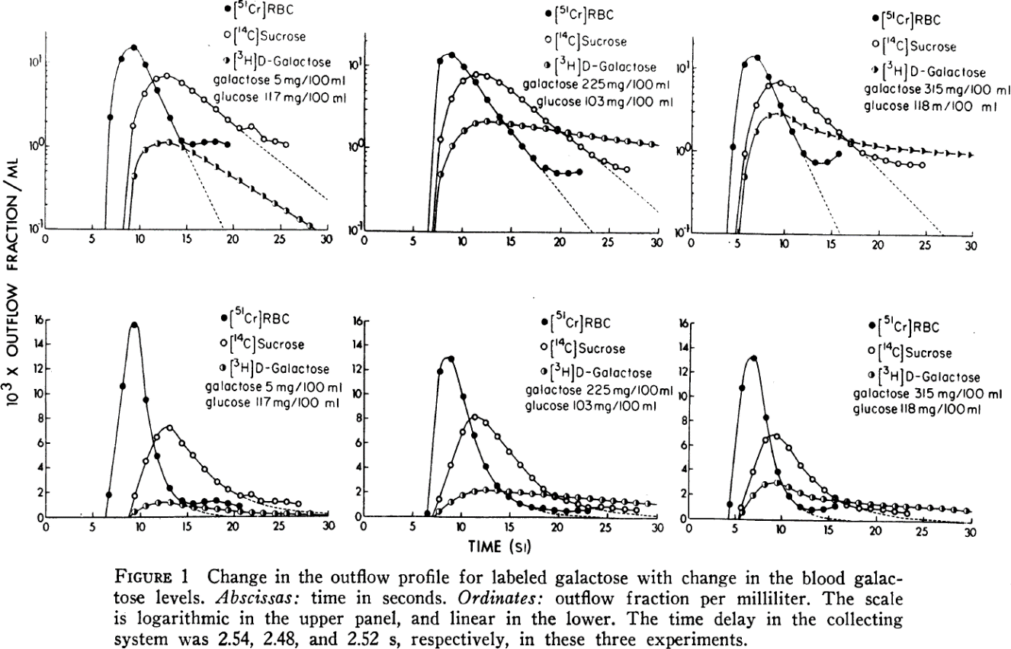

In ordert o relate the outflow pattern of one substance to that of another, they are each expressed as a fraction of the amount injected per milliliter vs. time.

Goresky, C.A. (1963) A linear method for determining liver sinusoidal and extravascular volumes, *Am J Physiol*, **204**, 626-640.

Goresky, C.A., Bach, G.G. and Nadeau, B.E. (1973) On the uptake of materials by the intact liver. The transport and net removal of galactose, *The Journal of clinical investigation*, **52**, 991-1009.