PKPD model for human galactose metabolism

Data collection and PKPD models for the whole-body simulation of galactose clearance.

Important are systemic clearance, urinary clearance, blood flow between the main compartments (i.e. heart, liver, kidney) and the volumes of distribution.

How is galactose distributing in the body?

How is the intestinal uptake changing the kinetics?

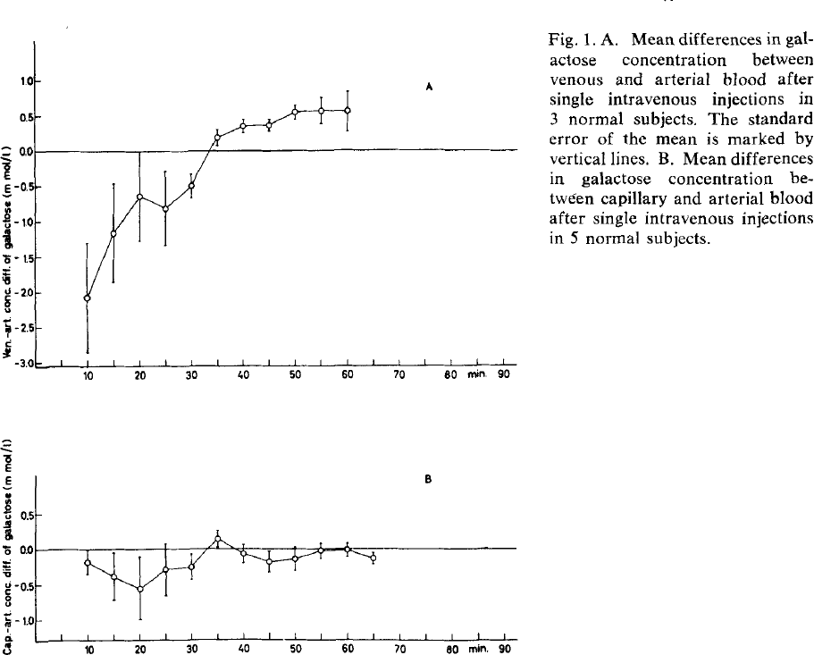{Lindskov1970}

Differences between arteriell, capillary and venous blood.

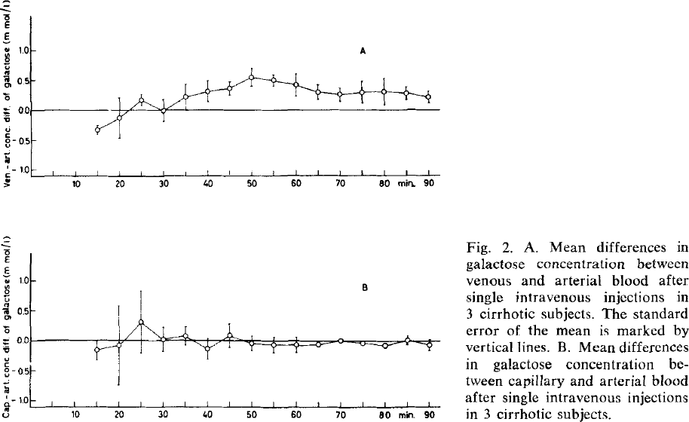{Lindskov1970}

# Components

Liver function, urinary excretion, basal rest elimination (brain, erythrocytes).

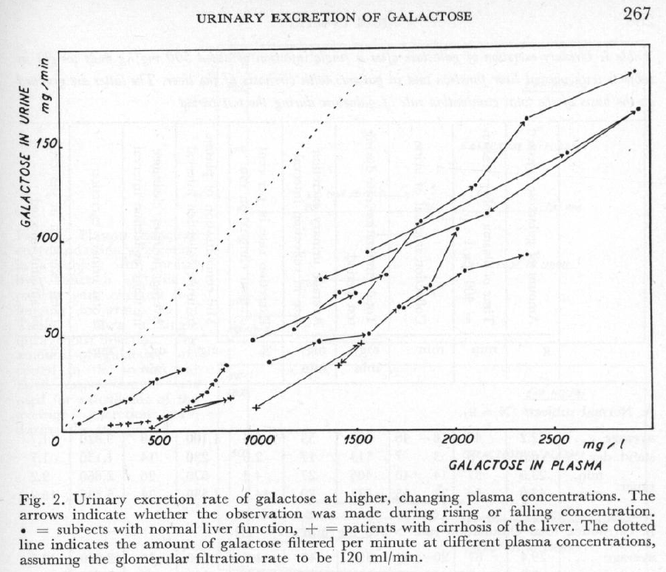

{Tygstrup1960}

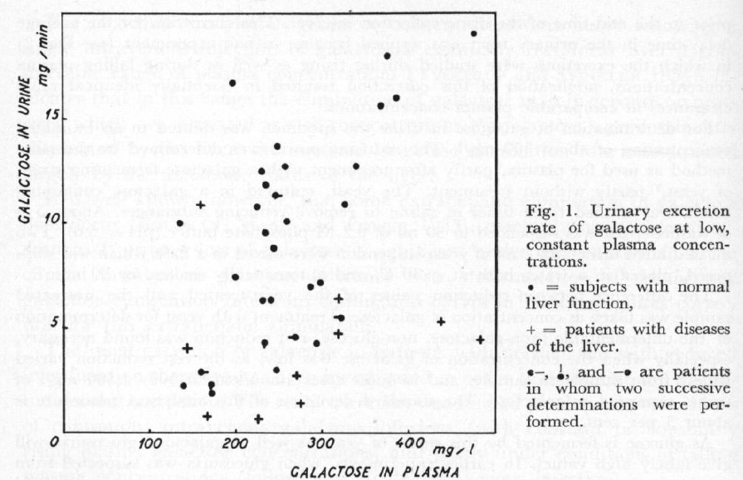

{Tygstrup1960}

# {Tygstrup1960}

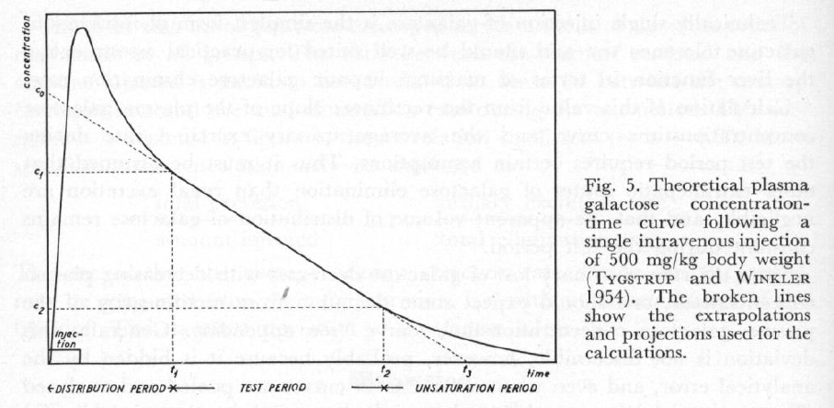{Tygstrup1960}

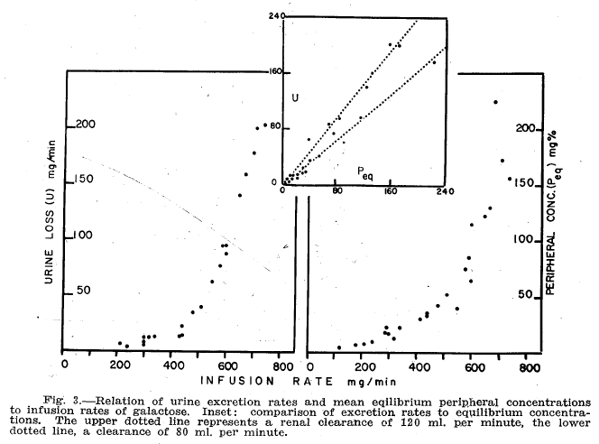{Waldstein1960}

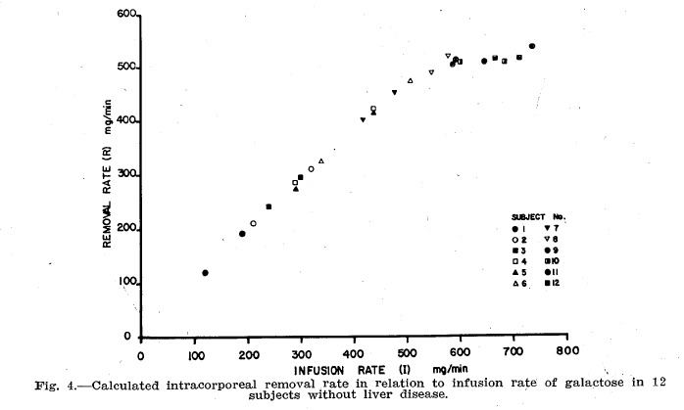

{Waldstein1960}

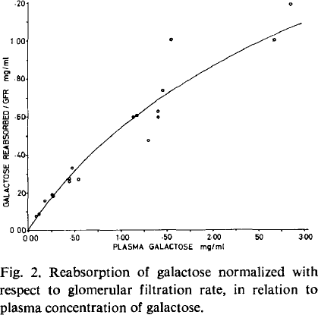{Tengström1968}

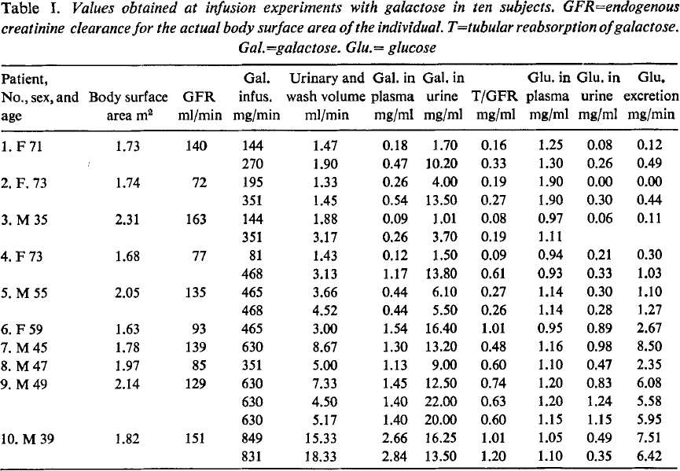{Tengström1968}

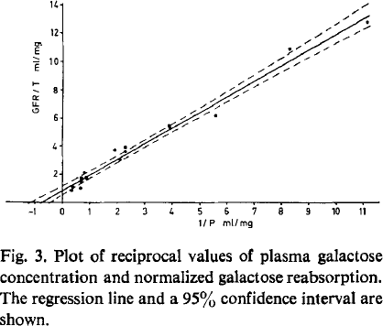{Tengström1968}

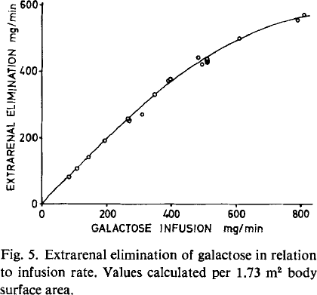{Tengström1968}

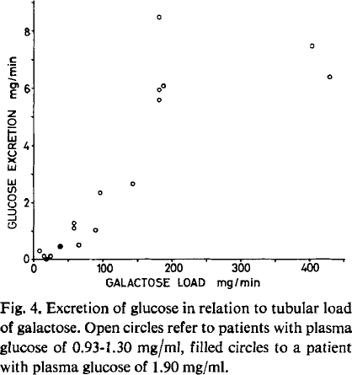{Tengström1968}

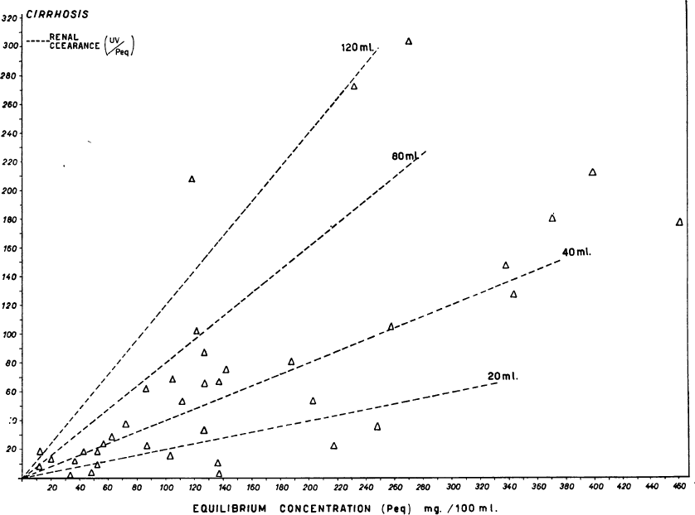{Palu1965}

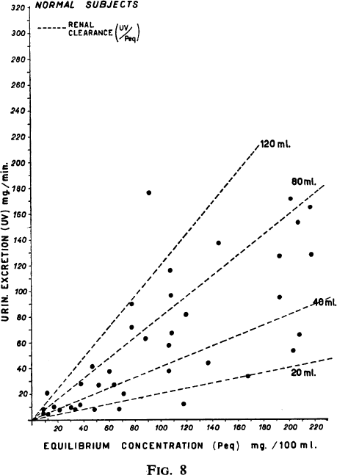{Palu1965}

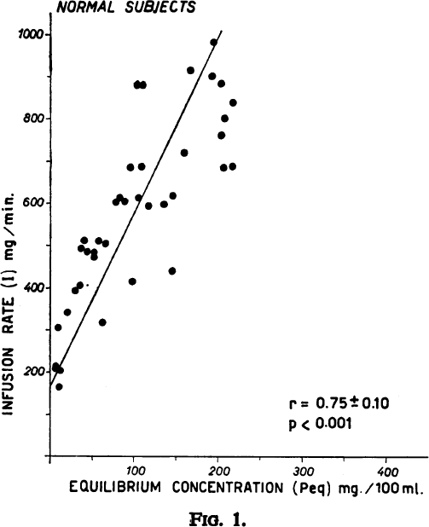{Palu1965}

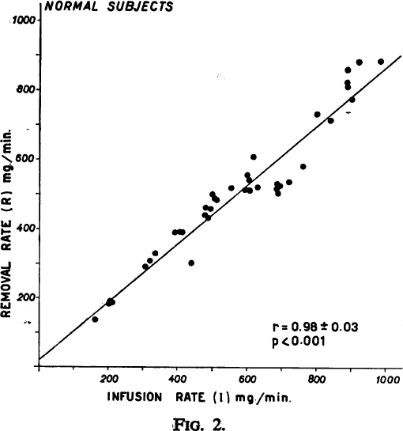{Palu1965}

# References

Lindskov, J. (1970). Differences in concentration of galactose in arterial, capillary, and venous blood following a single intravenous injection. *Scandinavian Journal of Clinical & Laboratory Investigation*, *26*(3), 221-226.

Dal Palù, Cesare, Piero Spandri, and Renzo Zuin. "Hepatic Clearance and Lm of Galactose in Normal and Cirrhotic Subjects." *Postgraduate medical journal* 41.475 (1965): 261.

Tengström, B. (1968). Renal excretion of galactose in man, with determination of the maximal tubular reabsorption for galactose. *Scandinavian Journal of Clinical & Laboratory Investigation*, *21*(4), 321-326.

Tygstrup, N. (1961). The urinary excretion of galactose and its significance in clinical intravenous galactose tolerance tests. *Acta Physiologica Scandinavica*, *51*(2‐3), 263-274.