# **A multi-scale model of Human hepatic Galactose Metabolism: Predictions of Galactosemias**

*König M.*1*, and Holzhütter HG.*1

### *Galactosemias*

Galactosemias, rare Mendelian metabolic disorders, are caused by deficiencies in either GALK (OMIM 230200), GALT (OMIM 230400) or GALE (OMIM 230350) (Novelli and Reichardt, 2000). The underlying basis of most pathophysiology in galactosemia is unclear (Leslie, 2003; Tyfield and Walter, 2002), but untreated as well as treated patients with galactosemia show accumulation and/or depletion of specific metabolites, and often abnormalities of glycosylation (Fridovich-Keil, 2006; Tyfield and Walter, 2002; Walter, et al., 1999). As a consequence of intracellular accumulation of galactose or gal1p , alternative metabolic pathways may become active in galactosemias, which under normal conditions only metabolize trace quantities of galactose (Fridovich-Keil, 2006): i) reduction of galactose by aldolase reductase (ALDR) to galactitol, which is not further metabolized and accumulates; ii) oxidation of galactose to galactonate, presumably by galactose dehydrogenase (GALDH) (Fridovich-Keil, 2006; Tyfield and Walter, 2002); iii) the formation of udpgal by UDP-glucose pyrphosphorylase (UGP) (Knop and Hansen, 1970).

The model was applied to the normal physiological state and the different variants of galactosemia caused by deficiency of the galactokinase (GALK), galactose-1-phosphate uridyl transferase (GALT) or UDP-galactose 4´-epimerase (GALE).

### *Hypothesis of Pathophysiology in Galactosemias*

*“The more we learn of the ‘single gene’ metabolic disorders, the more it becomes clear that intricate cascades of regulation and combinatorial control operate here as well, overseeing the interplay of enzymes and metabolic pathways under normal conditions, and mediating pathophysiology and the severity of patient outcome under abnormal conditions. Identifying the players and inter-relationships not only teaches us about normal metabolism, it further empowers a rational approach to the development of novel and potentially more effective treatments.”(Fridovich-Keil, 2006)*

“Multiple mechanism resulting in the pathophysiology in galactosemia were proposed (Fridovich-Keil, 2006) [Lai2009] *(reviewed in Tyfield and Walter 2002, Leslie 2003)*:

1. Accumulation of toxic metabolites in the blocked Leloir Pathway
2. accumulation of toxic products of alternate galactose metabolism
3. Alterations of absolute UDP-galactose, UDP-glucose and relative UDP-glucose/UDP-galactose levels with implications in protein glycosylation and galactosylation, *Lebea2005 have proposed that depletion of UDP-gal in GALT deficiency may impede the function of cerebroside galactosyl transferase, responsible for the galactosylation of cerebrosides. Considering that both UDPgal and UDP-glc serve as important activated sugar donors for glycosyltransferases, the connection to pathophysiology may involve defects in the biosynthesis of glycoproteins and/or glycolipids in the cells and tissues of galactosemic patients (Segal, 1995, Tyfeld and Walter 2002). Indeed such abnormalities have been found.” (Fridovich-Keil, 2006)*

*With both levels and approximate 1:3 ratio of UDP-gal and UDP-glc are very tightly controlled in normal cells (Segal1995), these levels and ratio may be disturbed in both GALT and GALE-deficiency galactosemia*

1. Perturbation in inositol metabolism, with reports suggesting that increased gal1p could inhibit myoinositol monophosphatase (IMP) [Fridovich-Keil2006 ->Wells1965].
2. Futile cycles of phosphorylation/dephosphorylation in galactose metabolism might result in ATP depletion [Fridovich-Keil2006 -> Miller1973]
3. *Elevated intracellular gal1p might inhibit a number of important enzymes, including glucose-6-phosphatase, phosphoglucomutase, … [Fridovich-Keil2006 -> Gitzelmann]*

Trapping of uridine phosphate with galactose (similar to galactosamine induced hepatitis) could explain the neonatal liver failure, …. [Keppler1969, 1970]. Similar effects, in case of certain mutations, the galactose production of the body could be sufficient to lower the UDP levels. “The decrease in UTP is considered to be the most essential primary mechanism of galactosamine-induced liver damage [Keppler1970->18,19] and is proposed to explain the increased toxicity of galactose by ethanol. (Keppler, et al., 1970)” [Discuss]

Methods

GALK, GALT and GALE deficiencies were implemented by changing the kinetic parameters for the respective enzyme from *wildtype* to values for the impaired enzyme variants (Table 1) with all other model parameters unchanged.

“With the reports that there is a large daily endogenous production of galactose [10–12] which provides a galactose burden in addition to that imposed by food intake, it is apparent that patients with galactosemia with little or no GALT must have mechanisms for disposal of the sugar. Otherwise, they would continue toaccumulate galactose metabolites such as galactose-1-phosphate (Gal-1-P), galactitol and galactonate. This, however, is not the case: most patients manifest their own relatively unique steady-state levels of plasma galactose[13], RBC galactose-1-phosphate [14], galactitol and galactonate [15], and urinary galactitol [16] and galactonate[17] excretion. Estimates are that urinary excretion of metabolites account for about 30% of the daily burden [7,12]. [Berry2004]

“*Specific metabolites known to reach abnormal levels in the hemolysates and/or tissues of untreated patients with classic galactosemia (****GALT deficiency****) include galactose, gal1p, galactitol, and inositol. Abnormal galactonate also forms but is excreted in the urine and does not accumulate in tissues (revied in Holten et al 2000, Tyfield and Walter 2002). Patients with classic galactosemia may also experience a partial depletion of UDP-gal, at least in their red blood cells.*

*“Following dietary restriction of galactose, patients with GALT deficiency demonstrate marked normalization of their metabolic profiles, although gal1p often remains outside the normal range (>5mM untreated, ~0.1mM treated, undetectable in normal (Gitzelmann 1995). Indeed, a number of studies have correlated the presence of elevated gal1p in patients on dietary galactose restriction with severity of clinical outcome (Kaufman 1988, Ng1991, Xu1995b).” (Fridovich-Keil, 2006)*

*Untreated* ***GALE deficiency*** *also accumulate abnormal high levels of RBC galactose and gal1p. In addition these pationes also accumulate* ***very high levels of UDP-gal*** *(Holton et al, 1981; Walter et al., 1999, Openo et al, 2006). Considering that gal-1P is a substrate of GALT but not GALE, the fact that it accumulates to abnormal high levels in GALE-impaired cells demonstrates the interdependence of enzymes in the pathway. Presumably, gal1p accumulates in these cells secondary to the accumulation of UDP-gal, which exerts product inhibition on GALT.” (Fridovich-Keil, 2006)*

“In GALT-deficient mice created by Ning2000, gal1p accumulated in liver, kidney and brain, with very high levels of gal1p in red blood cells, comparable to findings in GALT-deficient humans. Surprisingly, these mice showed no evidence of galactose toxicity. However, the concentrations of galactitol in these GALT-defcient mice were significantly lower than observed in humans. This is probably caused by the low levels of aldose reductase in normal mouse tissues (Ai et al 2000). (Bosch, et al., 2002).”

“In galactosemic infants on an unrestricted lactose intake, a potentially lethal organ toxicity syndrome develops, presumably because D-galactose-derived metabolites (D-galactose-1-phosphate and D-galactitol) accumulate within the cells. (Schadewaldt, et al., 2000)”

#### Alterations in Galactosemias

* Differences in GALK, GALT and GALE deficiencies
* Metabolic control analysis as predictor of alterations (which parameters have the largest impact on metabolic levels (especially byproducts galactitol, galactose and galactose-1p
* Simulation of multitude of “real-world” changes in enzyme activity based on characterization of typical mutants

#### Role of Alternative Galactose Pathways

Alternative pathways of galactose metabolism become important under impaired GALK, GALT or GALE.

“Overexpression of human IMP was found to overcome galactose toxicity in GALT deficient yeast cells” [Lai2009->95]

#### UDP-galactose pyrophosphorylase

*“The formation of UDP-glucose is believed to be the major physiological function of the pyrophosphorylase (I). However, at a slower rate, the enzyme also catalyzed the pyrophosphorolysis of UDP-galactose. The saturating concentration for UDP-galactose is 10 times that of UDP-glucose. Under normal physiological conditions, this may not be significant, but, in a galactosemic patient, in which the normal galactose metabolism is impaired, the pyrophosphorylase may participate in an abnormal role. Isselbacher has suggested that a pyrophosphorylase is responsible for the increased ability of some galactosemics to metabolize galactose by synthesizing UDP-galactose from galactose-1-P and UTP (3). Gitzelmann, on the other hand, has suggested that a pyrophosphorylase may be responsible for the elevated galactose-1-P levels found in the blood of some galactosemics on supposedly galactose-free diets (11). Thus, a pyrophosphorylase has been suggested to catalyze both the biosynthesis and the pyrophosphorolysis of UDP-galactose in galactosemics”. (Knop and Hansen, 1970)*

*Abraham and Howell (12) extracted UDP-galactose pyrophosphorylase activity from human liver and, without purification, the catalytic properties were elaborated upon. The specificity of their extract for substrate was not reported” (Knop and Hansen, 1970)*

#### Accumulation of Byproducts of galactose metabolism

“**Galactitol** accumulation has been demonstrated in the brain of toxic neonates with classical galactosemia [Leslie2003 -> 3, 46, 59]. The amounts of galactitol measured directly in GALT-deficient mice are lower (2mM) than levels detected by magnetic resonance spectroscopy in human subjects (8mM) [Leslie2003 -> 3, 57].

A high galactitol content in the lens was detected in a GALT-defiecnt patient with cataract”[Wang2001->8]

Galactitol has been isolated from tissues and urine of galactosemic patients [Segal1968 - > 19,20] and from tissues of rats fed high galactose diet [Segal1986 -> 21,22]

Accumulation of galactitol lens (cataracts)

“Cataract caused by galactitol accumulation seems to be the only consistent abnormality in galactokinase deficiency and this can be prevented with a galactose-restricted diet (Bosch, et al., 2002)->Holton2001.” “This relatively benign course of the disease is in strong contrast with high percentage of late complications that have been reported in the more common disorder of galactose metabolism, GALT deficiency. (Bosch, et al., 2002)”

Indeed excretion of abnormal quantities of galactitol in the urine of galactosemic patients is characteristic of the disorder [Wang2001-> 6].”[Wang2001]. “

*For example,patients with significant* ***GALE-deficiency accumulate*** *strikingly elevated levels of* ***UDPgal*** *in response to galactose exposure (Walter1999, Openo2006). In contrast, patients with* ***GALT deficiency*** *may experience abnormal depletion of UDPgal and/or UDPglc (Xu1995a, Holton et al2000, Lai et al., 2003).*

“In **GALT-deficient mice** created by Ning2000**, gal1p accumulated in liver**, kidney and brain, with very high levels of gal1p in red blood cells, comparable to findings in GALT-deficient humans. (Bosch, et al., 2002).”

“Accumulation of gal1p is regarded one of the most important pathogenic factors in **GALT deficiency** (Tang, et al., 2012)->Gitzelmann1995, Gitzelmann1967

“In humans, deficiency of GALT activity caused by deleterious

variations of the *GALT* gene can result in a potentially lethal disorder

called classic galactosemia (MIM# 230400) [Isselbacher et al.,

1956; Segal and Berry, 1995]. If the affected neonates are not treated

in time, they will suffer fromsevere hepatic and renal failure, bleeding

diatheses, and *E. coli* sepsis, which can lead to death within days

of birth [Goppert, 1917; Isselbacher et al., 1956; Mason et al., 1935;

Segal and Berry, 1995]. The exact pathophysiology of these acute

symptoms remains uncertain, partially because of the lack of experimental

animal model for this disease [Leslie et al., 1996], but the accumulation of gal-1P is regarded as one of the most important

pathogenic factors [Gitzelmann, 1995; Gitzelmann et al., 1967]. (Tang, et al., 2012)“

Abnormalities in gal-Metabolism and liver disease: “Some patients with hepatic disease have increased Gal in their blood [Yamaguchi1989 -> 4], as shown by our patient with peliosis hepatitis, and also glycogen storage disease type XI. Also, liver dysfunction is an early clinical complication of galactosemia” [Yamaguchi1989]

### *GEC in Galactosemias*

Comparison of measeared plasma profiles of galactose (GEC) and cellular concentrations of intermediates of galactose metabolism (gal1p, udpgal, …) with model values for the GALK, GALT and GALE deficiencies.

### *Figure 4 – Effect of metabolic deficiencies (galactosemias) on cellular, tissue and organ level (metabolic control analysis single cell level & altered steady state values)*

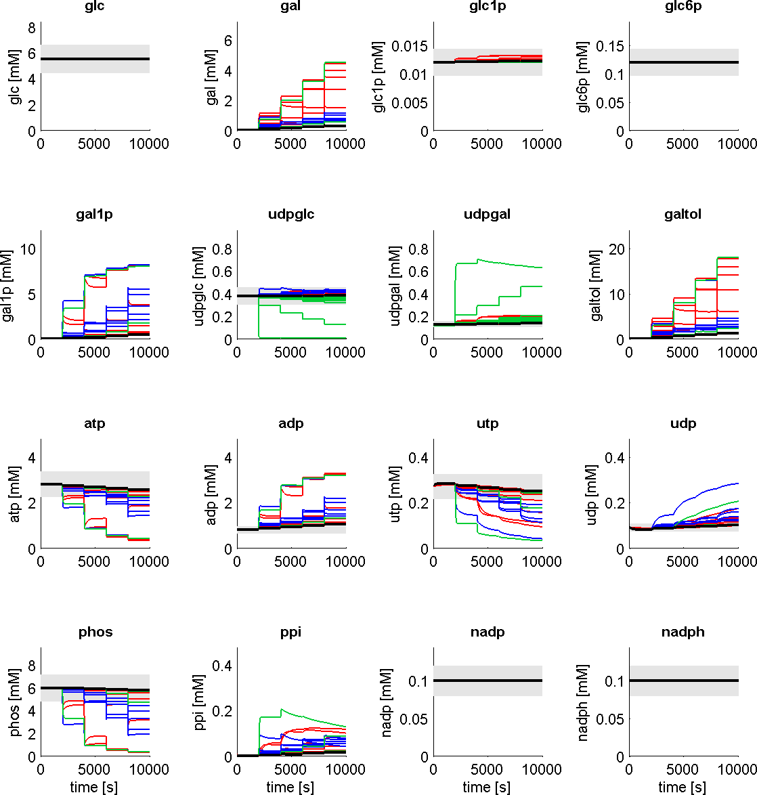 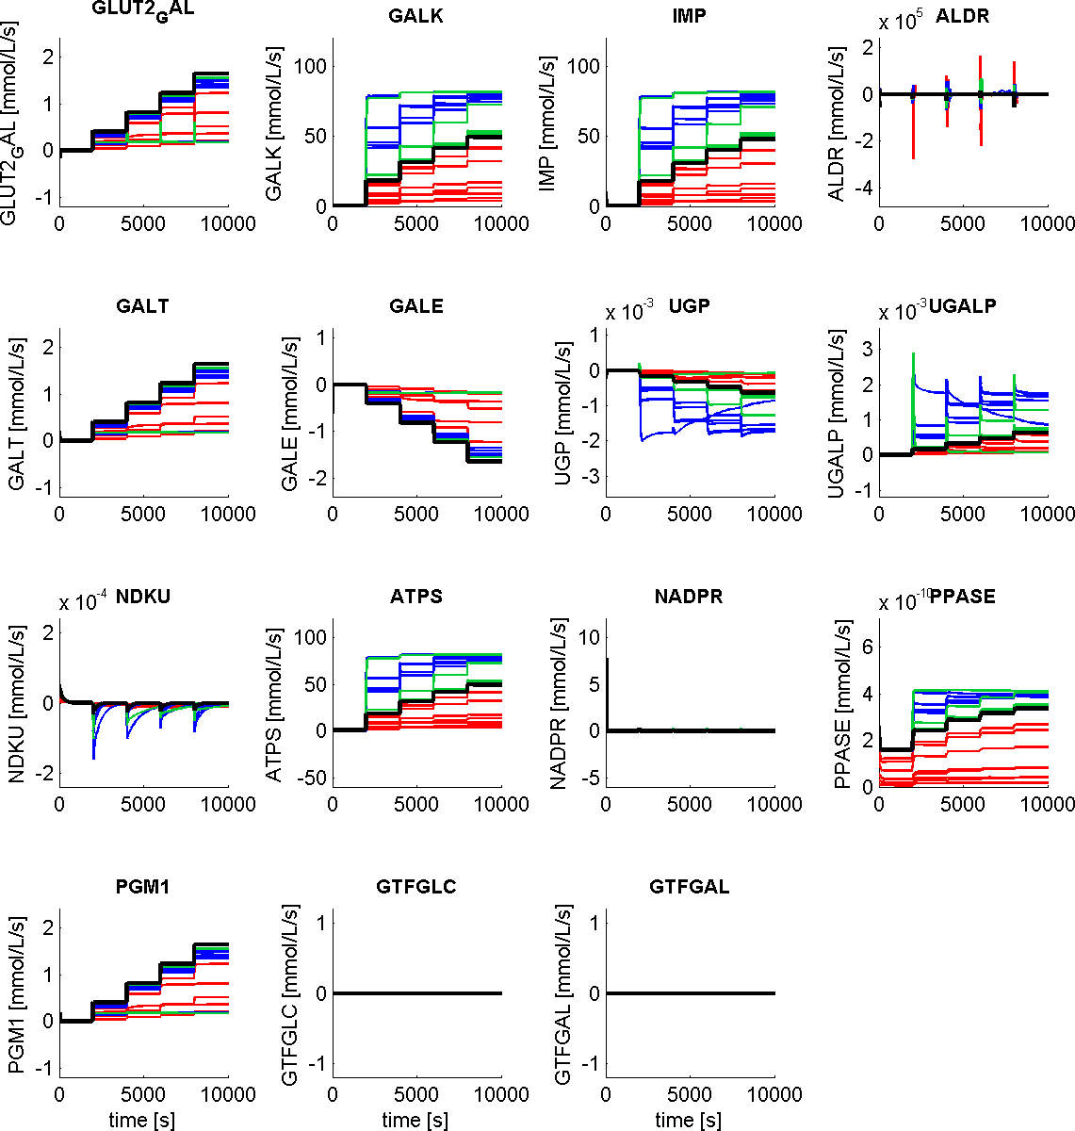Concentrations

Fluxes

Alterations in metabolite levels and fluxes in GALK, GALT and GALE deficiencies (Table 1) compared to normal hepatic galactose metabolism. Galactose and galactitol accumulate in the deficiencies. The absolute udpglc and udpgal concentrations as well as the normal relative value of ~udpglc/udpgal are altered. Some of the deficiencies result in a marked decrease of energy state (ATP/ADP) due to the high futile cycles in the GALK/IMP system.

### 

### *(Keppler, et al., 1970)*

### *Typical effect of galactose challenge on the galactose metabolism of single cell model. Prediction of effects of GALE inhibition. GALE is inhibited by ethanol ingestion, due to altered NAD/NADH quotient resulting in altered GALE activity due to NAD cofactor. Ethanol ingestion was simulated by altering the NAD levels. Experimental data from (Keppler, et al., 1970)*

### 

### *Table 1 –Alterations in kinetic properties in galactosemias.*

|  |  |  |  |  |  |  |
| --- | --- | --- | --- | --- | --- | --- |
|  | **Enzyme** | **Variant** | **kcat [1/s] (%wt)** | **Km(gal) [mM] (%wt)** | **Km(atp) [mM] (%wt)** | **Reference** |
|  | GALK | Wild Type | 8.7±0.5 (100) | 0.97±0.22 (100) | 0.034±0.004 (100) | (Timson and Reece, 2003) |
| 1 | GALK | H44Y | 2.0±0.1 (23) | 7.70±4.40 (794) | 0.130±0.009 (382) | (Timson and Reece, 2003) |
| 2 | GALK | R68C | 3.9±0.8 (45) | 0.43±0.15 (44) | 0.110±0.035 (324) | (Timson and Reece, 2003) |
| 3 | GALK | A198V | 5.9±0.1 (68) | 0.66±0.22 (68) | 0.026±0.001 (76) | (Timson and Reece, 2003) |
| 4 | GALK | G346S | 0.4±0.04 (5) | 1.10±0.16 (113) | 0.005±0.002 (15) | (Timson and Reece, 2003) |
| 5 | GALK | G347S | 1.1±0.2 (13) | 13.0±2.0 (1340) | 0.089±0.034 (262) | (Timson and Reece, 2003) |
| 6 | GALK | G349S | 1.8±0.1 (21) | 1.70±0.48 (175) | 0.039±0.004 (115) | (Timson and Reece, 2003) |
| 7 | GALK | E43A | 6.7±0.02 (77) | 1.90±0.50 (196) | 0.035±0.0003 (103) | (Timson and Reece, 2003) |
| 8 | GALK | E43G | 0.9±0.02 (10) | 0.14±0.01 (14) | 0.0039±0.0006 (11) | (Timson and Reece, 2003) |
|  | **Enzyme** | **Variant** | **Vmax [nmol/mg/s] (% wt)** | **Km(gal1p) [mM] (%wt)** | **Km(udpglc) [mM] (%wt)** | **Reference** |
|  | GALT | Wild Type | 804±65 (100) | 1.25±0.36 (100) | 0.43±0.09 (100) | (Tang, et al., 2012) |
| 9 | GALT | R201C | 396±59 (49) | 1.89±0.62 (151) | 0.58±0.13 (135) | (Tang, et al., 2012) |
| 10 | GALT | E220K | 253±53 (31) | 2.34±0.42 (187) | 0.69±0.16 (160) | (Tang, et al., 2012) |
| 11 | GALT | R223S | 297±25 (37) | 1.12±0.31 (90) | 0.76±0.09 (177) | (Tang, et al., 2012) |
| 12 | GALT | I278N | 45±3 (6) | 1.98±0.35 (158) | 1.23±0.28 (286) | (Tang, et al., 2012) |
| 13 | GALT | L289F | 306±23 (38) | 2.14±0.21 (171) | 0.48±0.13 (112) | (Tang, et al., 2012) |
| 14 | GALT | E291V | 385±18 (48) | 2.68±0.16 (214) | 0.95±0.43 (221) | (Tang, et al., 2012) |
|  | **Enzyme** | **Variant** | **kcat [1/s] (%wt)** | **Km(udpglc) [mM] (%wt)** |  | **Reference** |
|  | GALE | Wild Type | 36±1.4 (100) | 0.069±0.012 (100) |  | (Timson, 2005) |
| 15 | GALE | N34S | 32±1.3 (89) | 0.082±0.015 (119) |  | (Timson, 2005) |
| 16 | GALE | G90E | 0.046±0.0028 (0) | 0.093±0.024 (135) |  | (Timson, 2005) |
| 17 | GALE | V94M | 1.1±0.088 (3) | 0.160±0.038 (232) |  | (Timson, 2005) |
| 18 | GALE | D103G | 5.0±0.23 (14) | 0.140±0.021 (203) |  | (Timson, 2005) |
| 19 | GALE | L183P | 11±1.2 (31) | 0.097±0.040 (141) |  | (Timson, 2005) |
| 20 | GALE | K257R | 5.1±0.29 (14) | 0.066±0.015 (96) |  | (Timson, 2005) |
| 21 | GALE | L313M | 5.8±0.36 (16) | 0.035±0.011 (51) |  | (Timson, 2005) |
| 22 | GALE | G319E | 30±1.3 (83) | 0.078±0.013 (113) |  | (Timson, 2005) |
| 23 | GALE | R335H | 15±0.48 (42) | 0.099±0.012 (143) |  | (Timson, 2005) |