## Galactose Elimination, Elimination Ratio, …

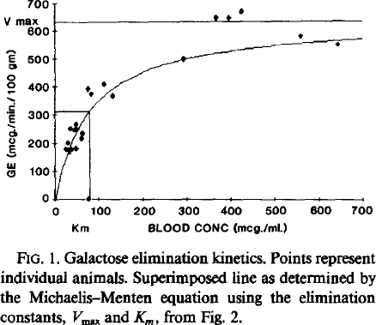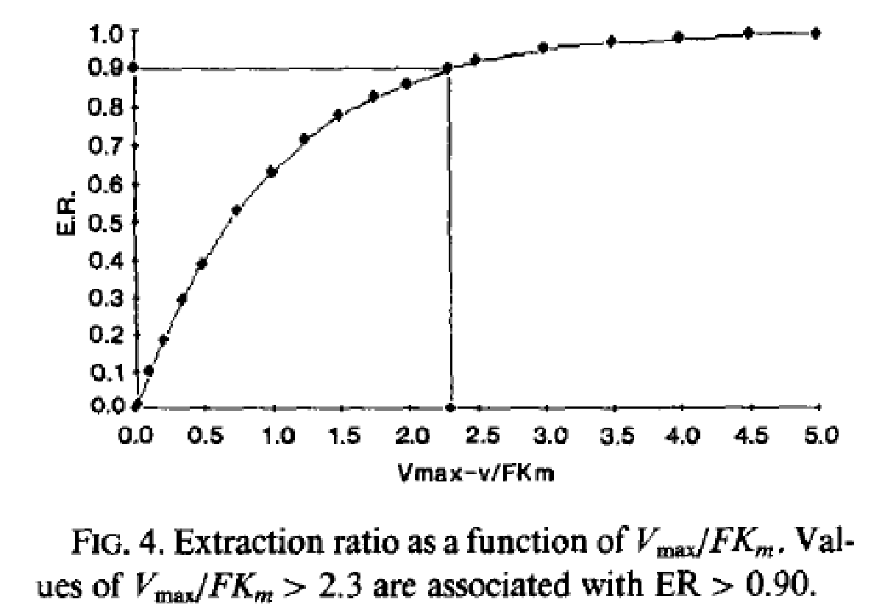

## GEC_curve_T1.png

## ***Dilution Curves***

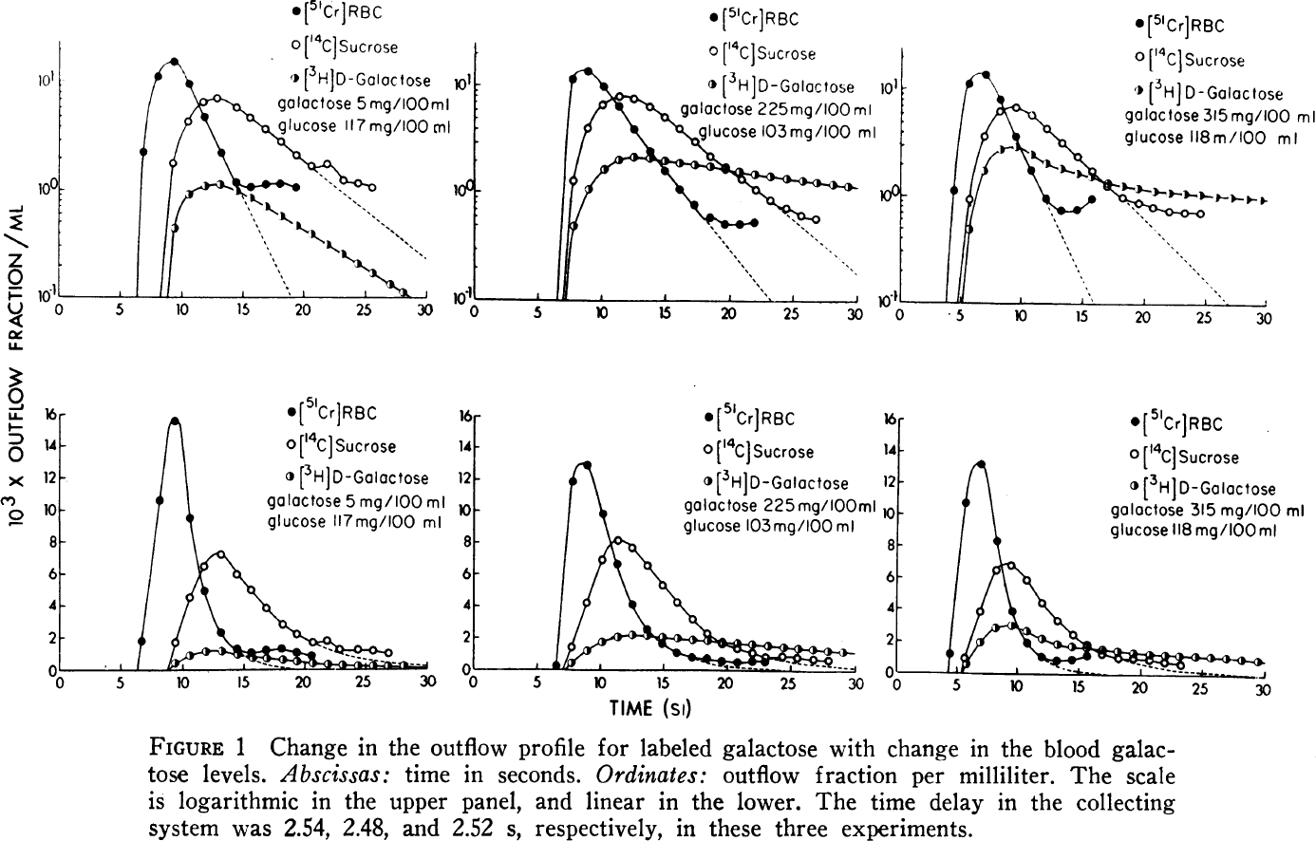

Galactose metabolism has an importnant role in human infants consuming lactose as their primary carbohydrate source and studies in dogs and rats suggest that it could be the preferred carbon source in mammalian neonates, being incorporated into glycogen more efficiently than is glucose [Leslie2003 -> 30]

Galactose is a hexose differing from glucose only by the configuration of the hydroxyl-group at the carbon-4 position. Galactose exists abundantly in milk, dairy products, and other foods like fruits and vegetables [Lai2009->11].

### *Galactose Elimination by the Liver*

*“The extent to which flow or function determines the rate of clearance determines the rate of clearance depends on the biochemical efficiency of the liver for removal of the substrate relative to flow [Schirmer1986 -> 45, 68, 99]. Substances efficiently removed relative to flow are used for HBF (hepatic blood flow) estimation whereas substances removed with low efficiency relative to flow are useful for estimating hepatic function.*

*The quotient (ci-co)/ci is known as the extraction fraction or extraction ratio (ER). The ER determines the degree to which clearance (CL) approximates flow (F) CL = F\*ER*

*Galactose and radiolabeld colloids are two substances that are completely or nearly completely cleared on single pass through the liver and their clearance can be used to estimate liver blood flow [Schirmer1986 -> 20, 21, 35, 36, 47, 87, 91, 92, 95]*

*Galactose Clearance at low concentrations (GCLC) has proven to be as near ideal a method for estimating EHBF (effective hepatic blood flow) as is available.*

*Contributions other pathways elimination:*

*RBC galactokinase activity is second to the liver with in vitro studies suggesting that galactose elimination by this route is on the order of 1% of the total elimination [Schirmer1986 -> 34]. The primary site of extrahepatic galactose elimination is the urine [Schirmer1986 -> 22, 84, 87]. Tygstrup demonstrated that urinary galactose elimination increased linearly with concentration [84]. As blood concentration increased the percentage of galactose elimination increased the percentage of galactose elimination accounted for in the urine progressively increased because the liver has a maximal elimination capacity while the kidney has not. In the concentration ranges required for EHBF determinations in the rat, urinary elimination is <1% ot the total galactose elimination [70]. Therefore the sum of all extrahepatic sites for galactose elimination in the appropriate concentration range is roughly 2%.*

*Numerous studies about liver galactose elimination capacity (GEC) [5, 9, 17, 22, 41, 78, 79, 82, 83, 88, 96]*

*Hepatic vein catheterization at high concentrations revealed a constant hepatic arterial-hepatic venous concentration difference [87,88]. The GEC became an accepted test of liver function and its value taken to reflect the functional hepatic mass [17,82, 83, 88, 96].*

*At concentrations less than 200mcg/ml the hepatic vein concentration was virtually zero. (complete extraction)*

*Henderson et al. confirmed the near complete extraction of galactose across the liver (ER = 0.94) in subjects without hepatic disease by performing hepatic vein catheterization [35].*

*The most extensive work on galactose elimination kinetics was done by Keiding and co-workers [43-45, 48, 50, 85, 99]. The “sinusoidal perfusion model” they developed provides a sound theoretical justification for using galactose clearance at low concentrations to estimate EHBF [44, 45, 48, 50, 99].*

*Hepatic galactose elimination follows Michaelis-Menten saturation kinetics [43, 50, 70]; Its hallmarks are an early, concentration-dependent (first-order) elimination phase followed by a definable clearance maximum (GEC) at higher concentrations (zero-order phase).*

*Definition of velocity as amount of galactose removed per unit time per 100g of body weight (as opposed to rate per individual man [82, 96] or rate per g of liver weight [43, 50].*

*Blood flows unidirectionally through the sinusoids at prescribed rates [4, 26, 27]. The inflow concentration exceeds the outflow concentration with a gradient through the liver.*

*Apparent Km for galactose elimination in rat with sinusoidal perfusion model is 30.1 mcg/ml ~ 0.167mM, which is in close agreement with values reported by others [18 27, 43, 48, 50];*

***The Vmax for galactose elimination is much higher in humans than in rats [47,82,96], with the Km being similar [47].***

### *Glycosylation*

“Glycosylation, the [reaction](http://en.wiktionary.org/wiki/reaction) of a [saccharide](http://en.wiktionary.org/wiki/saccharide) with a [hydroxy](http://en.wiktionary.org/wiki/hydroxy) or [amino](http://en.wiktionary.org/wiki/amino) [functional group](http://group) to form a [glycoside](http://en.wiktionary.org/wiki/glycoside); especially the reaction with a [protein](http://en.wiktionary.org/wiki/protein) or [lipid](http://en.wiktionary.org/wiki/lipid) to form a [glycoprotein](http://en.wiktionary.org/wiki/glycoprotein) or [glycolipid](http://en.wiktionary.org/wiki/glycolipid).

glycosylation is thought to be the most complex post-translational modification, because of the large number of enzymatic steps involved. The donor molecule is often an activated [nucleotide sugar](http://sugar)”

Over 40 disorders of glycosylation have been reported in humans.[[6]](https://en.wikipedia.org/wiki/Glycosylation#cite_note-Jaeken2013-6) These can be divided into four groups: disorders of protein N-glycosylation, disorders of protein O-glycosylation, disorders of lipid glycosylation and disorders of other glycosylation pathways and of multiple glycosylation pathways. No effective treatment is known for any of these disorders. 80% of these affect the nervous system.

Approximately half of all proteins typically expressed in a cell undergo this modification, which entails the covalent addition of sugar moieties to specific amino acids. Most soluble and membrane-bound proteins expressed in the endoplasmic reticulum are glycosylated to some extent, including secreted proteins, surface receptors and ligands and organelle-resident proteins. Additionally, some proteins that are trafficked from the Golgi to the cytoplasm are also glycosylated. Lipids and proteoglycans can also be glycosylated, significantly increasing the number of substrates for this type of modification.

Glycosylation is thought to be the most complex post-translational modification because of the large number of enzymatic steps involved (5). The molecular events of glycosylation include linking monosaccharides together, transferring sugars from one substrate to another and trimming sugars from the glycan structure. Unlike other cell processes such as transcription or translation, glycosylation is non-templated, and thus, all of these steps do not necessarily occur during every glycosylation event. Instead of using templates, cells rely on a host of enzymes that add or remove sugars from one molecule to another to generate the diverse glycoproteins seen in a given cell. While it may seem chaotic because of all of the enzymes involved, the different mechanisms of glycosylation are highly-ordered, step-wise reactions in which individual enzyme activity is dependent upon the completion of the previous enzymatic reaction. Because enzyme activity varies by cell type and intracellular compartment, cells can synthesize glycoproteins that differ from other cells in glycan structure (5).

Enzymes that transfer mono- or oligosaccharides from donor molecules to growing oligosaccharide chains or proteins are called glycosyltransferases (Gtfs). Each Gtf has specificity for linking a particular sugar from a donor (sugar nucleotide or dolichol) to a substrate and acts independent of other Gtfs. These enzymes are broad in scope, as glycosidic bonds have been detected on almost every protein functional group, and glycosylation has been shown to incorporate most of the commonly occurring monosaccharides to some extent (6).

Walsh C. (2006) Posttranslational modification of proteins : Expanding nature's inventory. Englewood, Colo.: Roberts and Co. Publishers. xxi, 490 p. p.

Spiro R. G. (2002) Protein glycosylation: Nature, distribution, enzymatic formation, and disease implications of glycopeptide bonds. Glycobiology. 12, 43R-56R.

### *Galactokinase deficiencies/mutations*

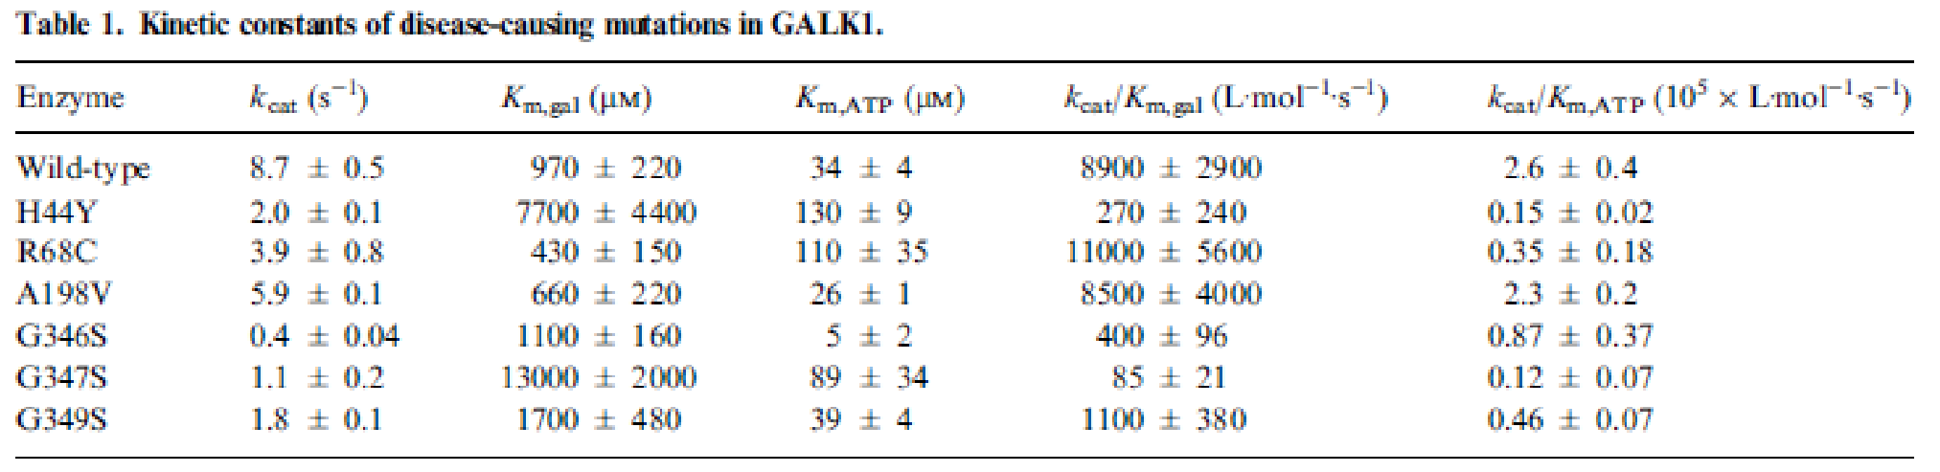

(Timson and Reece, 2003)

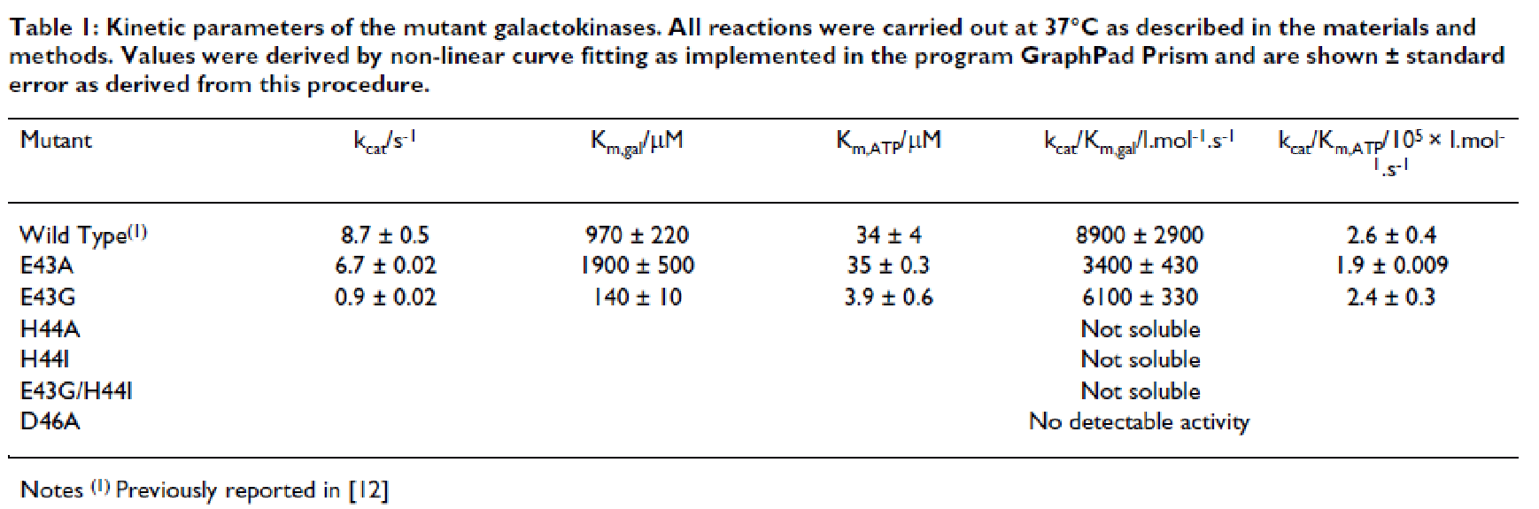

(Timson and Reece, 2003)

### *GALT deficiencies/mutations*

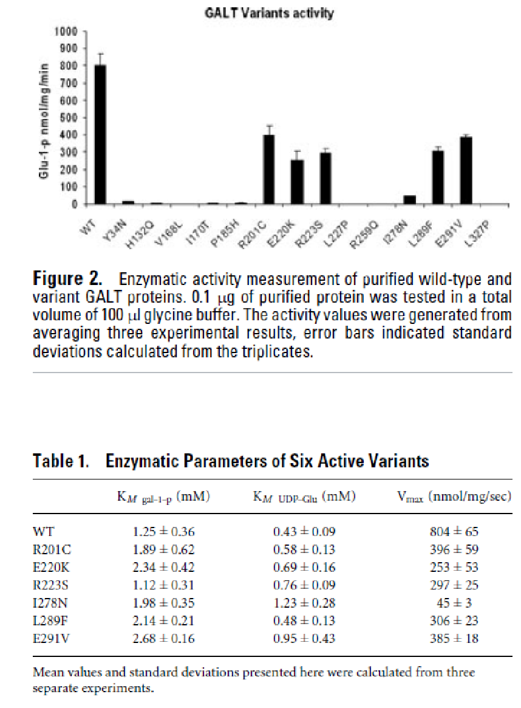(Tang, et al., 2012)

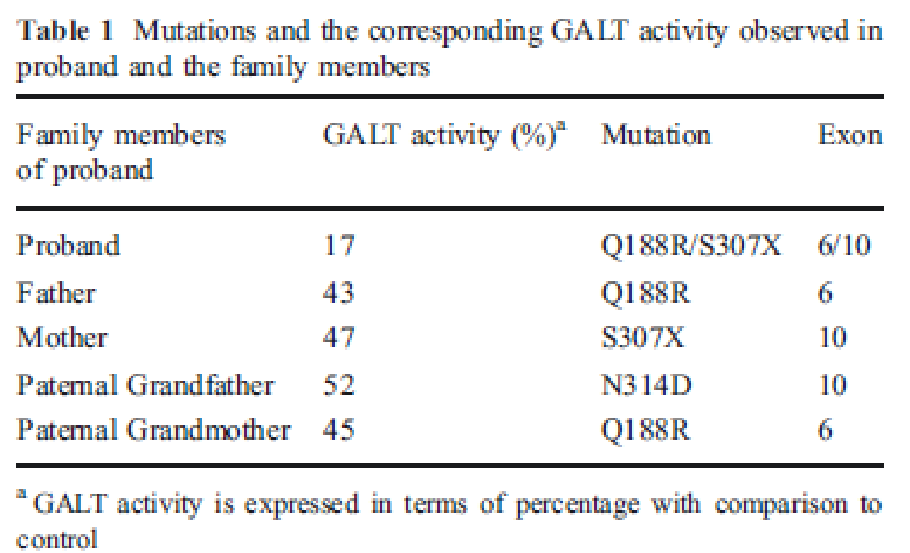(Singh, et al., 2011)

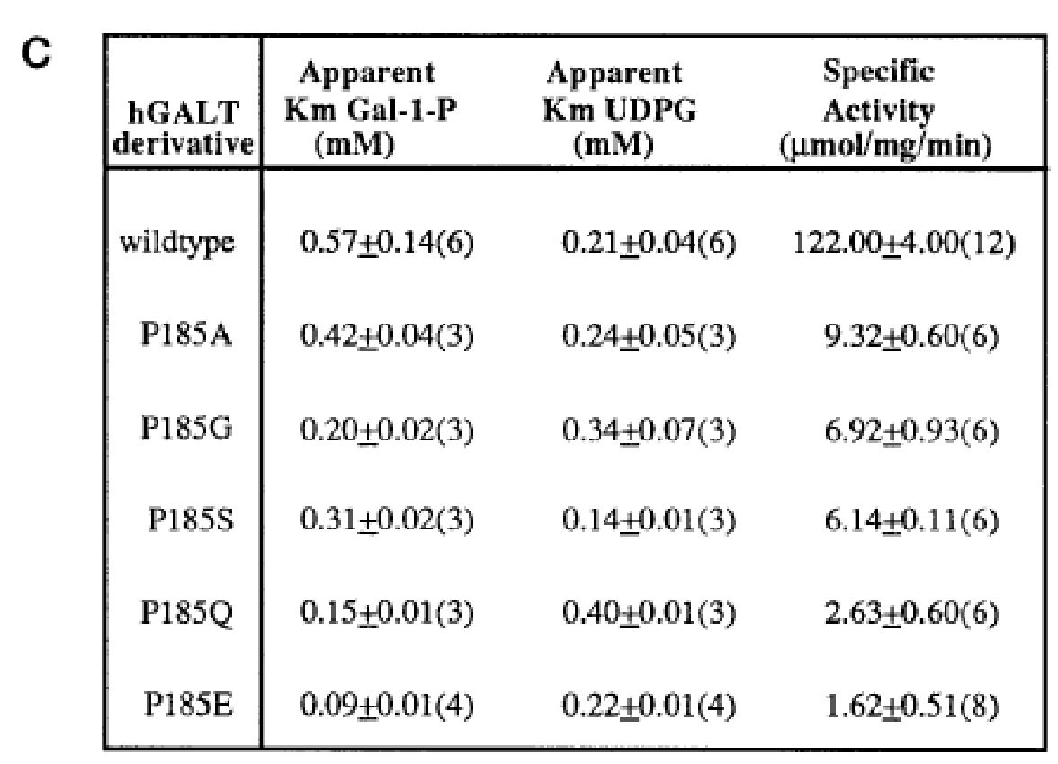(Quimby, et al., 1996)

### *GALE deficiencies/mutations*

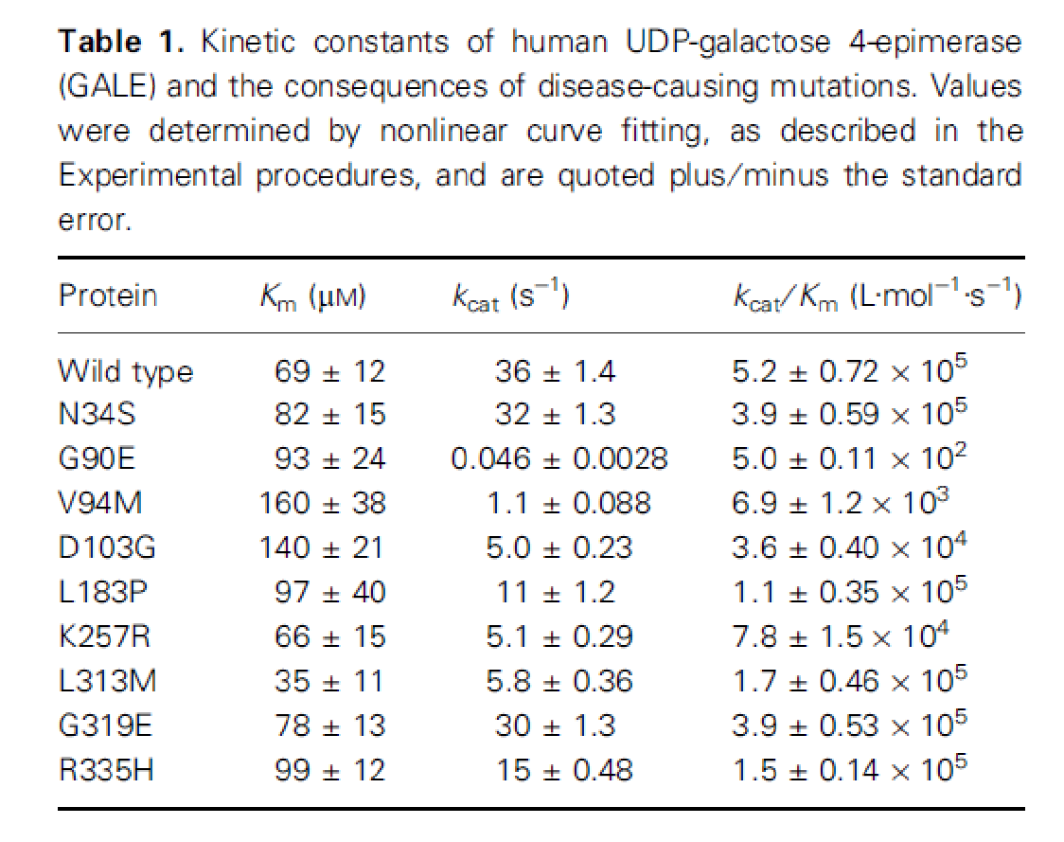(Timson, 2005)

## ***GEC in Alcohol NADH/NAD***

“During ethanol oxidation in normal livers, NAD is reduced to NADH2 and a diminution occus in the ratio of NAD to NADH2 (4). NADH2 is a potent inhibitor of UDP-galactose-4-epimerase (12), which is one of the key enzymes in the metabolism of galactose. As a result inhibition of galactose oxidation by ethanol can be demonstrated by means of both in vivo and in vitro studies (23,24,9). In fatty rat livers induced by a choline-deficient high fat diet, low in protein, ethanol no longer reduces the NAD/NADH2 ratio (21). Ethanol does not diminish the rate of galactose oxidation in these rats (19).” (Salaspuro and Salaspuro, 1968)

## ***Alterations in liver disease and intoxication***

Disease of the liver is often associated with changes in the structural parameters, hepatocyte cell mass and/or altered local or global perfusion. We evaluated the effect of such alterations in liver structure anomalies and liver diseases like cirrhosis, fibrosis, occlusion of the hepatic arteria, CCL4 intoxication on the dilution curves and resulting GEC curves.

TODO: collect data of changes in GEC

“*Fenestrae are altered by a number of facors in vivo. Enlargement of fenestrae diameter has been reperted after alcohol (Wisse1985 -> 18,19,29), pressure (Wisse85 ->30-32), CCl4 (Wisse85 ->29), hypoxia,irradiation and endotoxin (Wisse85->33). Fenestrae enlarge (18,19), but decrease in number under the influence of alcohol (Wisse1985 -> 19)*

*“On the basis of morphological and physiological evidence, it was reported that the grouped fenestrae act as a dynamic filer (Braet2004 -> 7-9)*

*Fenestraetion Cirrhosis (Braet2002 -> 36), fibrosis (Braet2002->37)*

*In general, it has been notet that defenestraetion of the sinusoidal endothelioum occurs ealy in the pathogenesis of cirrhosis both in humans exposed to hepatotoxins and in animal models of cirrhosis (Braet2002->32].*

### *Alcoholic Liver Injury*

*A significant reduction of number of fenestrae and porosity may influence the blood hepatocytic exchange and contribute to the alcohol-induced liver injury. (Horn1987)*

*“Any morphological alteration concerning the endothelium and the space of Disse may influence the normal exchange of metabolites and may thereby have adverse effects on the function of the parenchymal cells. Alterations in this hepatocellular microenvironment in the form of deposition of collagen in the space of Disse (Horn1987 ->4) and the formation of basal laminas may be induced by alcohol (Horn1987 -> 4,5).*

*“Liver fibrosis and cirrhosis (Wisse2008 ->22), alcoholic liver disease without cirrhosis (Wisse2008 -> 23) and aging (Wisse2008 -> 24) may lead to reduced permeability of the sinusoidal endothelium by reduced number of fenestrae and the development of a basal lamina.*

### *Hepatitis*

GEC in rats subjected to experimental acute hepatits by CCL4 has been found to be decreased, down to 40% of control values depending on dose and time after intoxication [Vilstrup1983 ->18]

### *Cirrhosis*

-> changes in fenestraetion

Hepatic extraction in normal subjects was 94% while in cirrhotics it was 79%. Extrahepatic clearance showd 2% of the total to occur in the urine, and 2.3% to occur by erythrocyte metabolism. The overall mean (+-SD) clearance in the nomal subject of 1378+- 218 ml/min was significantly greater than for the stable cirrhotics at 918+-279ml/min, but not significantly different from patients with actue hepatocellular damage of 1186+-300 ml/min.

“In healthy people, plasma galactose clearance was **1366 +- 172 ml/min**, and hepatic extraction was 95%: Clearance in cirrhotics depends on the stage of their disease; in a stable group of patients with advanced cirrhosis, clearance was 835 +- 87 ml/min, with hepatic extraction ranging from 60% to 95 %.”[Henderson1983]

Cirrhosis leads to impairmaent of the clearance of several drugs [Gariepy1963 -> 1,2]

### *CCL4 & CCL4 – induced cirrhosis*

Intoxication with carbon tedrachloride (CCL4) results in destruction of perivenious hepatocytes.

Effects of acute carbon tetrachloride intoxication on kinetics of galactose elimination in perfused tat liver -> resulting Vmax were decreased by CCl4 from 1.20+y0.18 in controls to 0.78+y0.19µmol/min/100gbw. The affinity constant was decreased from 0.18+-0.06 to 0.11+-0.19 mmol/l [Vilstrup1983]

[Gariepy1963]

### *NAFDL*

* Liver volume changes, changes in perfusion

### *Aging*

*A significant negative correlation as observed between age and both liver volume and apparent liver blood flow. The reduction in liver volume, apparent liver blood flow and perfusion may at least partly account for the decline in the clearance of many drugs undergoing liver metabolism, which has been noted to occur with aging in man” (Wynne, et al., 1989)*

“**Schnegg1986**(Schnegg and Lauterburg, 1986)

**Wynne1989** *(Wynne, et al., 1989)*

Abnormalities in gal-Metabolism and liver disease: “Some patients with hepatic disease have increased Gal in their blood [Yamaguchi1989 -> 4], as shown by our patient with peliosis hepatitis, and also glycogen storage disease type XI. Also, liver dysfunction is an early clinical complication of galactosemia” [Yamaguchi1989]

“Aging is accompanied by marked changes in the physiology of many organs, as well as in their constituent cells. These nonpathological alterations in structure and/or function may affect normal physiological processes in the elderly (individuals > 65 years), for example drug disposition. The liver plays a major role in drug clearance and aging has been reported to diminish this hepatic capacity, particularly the clearance of drugs that undergo mandatory oxidation by the microsomal cytochrome P450-dependent mono-oxygenase systems. Liver volume and blood flow decline with age in humans and, no doubt, this contributes to the diminished clearance of drugs that exhibit first-pass kinetic profiles”

“An age-related decrease in the hepatic clearance of many drugs has been reported. Several mechanisms have been proposed, but only some are supported by hard evidence. Liver volume declines with age, as does hepatic blood flow--changes which may largely account for the reduced clearance of capacity- and flow-limited drugs, respectively. Age-related histological changes in the liver are minor and of uncertain significance; standard liver function tests do not change significantly with aging.”(Woodhouse and Wynne, 1992)

“Pseudocapillarization of the sinusoidal endothelium in the liver, restricting oxygen diffusion, and the decline in liver size and liver blood flow may influence age-related changes in rate of hepatic metabolism”

One o fth eealiest and largest studies of liver sie in relation to age was undertaken in 1933 [71]. 1582 subjects aged between 20 and 90, and ding of acute injury or accident were studied in autopsy. Liver size fell by 18% in woman and 24 % in men between these ages, with te most marked changes occurring after the sixth decade. In another autopsy study [72] a 25% fall in lever weight was observed between the ages of 20 and 70 years, with a more marked reduction in the very elderly – a fall of 46% between the third and thenth decade.”(Woodhouse and James, 1990)

### *Heterogeneous and homogeneous alterations of perfusion*

“The fundamental problem raised by the observed variations from one part of the liver to another is how local changes in the perfusion in the liver is related to changes in hepatic extraction and *vice versa” [Winkler1965]*.

* Blockage of parts of the liver (occlusion of the hepatic arteria)
* Sinusoidal obstruction

The alterations in the GEC curves shows the close interaction between liver structure and metabolic function, which becomes already obvious in such simple metabolic cases like galactose metabolization.

It becomes obvious that modelling liver metabolism without modelling the heterogeneity on a structural level on tissue and organ scale can only give insights into certain aspects, but neglegts the complex interaction occurring in the hierarchical liver architecture.

Quimby, B.B.*, et al.* (1996) Functional requirements of the active site position 185 in the human enzyme galactose-1-phosphate uridylyltransferase, *The Journal of biological chemistry*, **271**, 26835-26842.

Salaspuro, M.P. and Salaspuro, A.E. (1968) The effect of ethanol on galactose elimination in rats with normal and choline-deficient fatty livers, *Scandinavian journal of clinical and laboratory investigation*, **22**, 49-53.

Schnegg, M. and Lauterburg, B.H. (1986) Quantitative liver function in the elderly assessed by galactose elimination capacity, aminopyrine demethylation and caffeine clearance, *J Hepatol*, **3**, 164-171.

Singh, R.*, et al.* (2011) A case of classical galactosemia: identification and characterization of 3 distinct mutations in galactose-1-phosphate uridyl transferase (GALT) gene in a single family, *Indian journal of pediatrics*, **78**, 874-876.

Tang, M.*, et al.* (2012) Correlation assessment among clinical phenotypes, expression analysis and molecular modeling of 14 novel variations in the human galactose-1-phosphate uridylyltransferase gene, *Human mutation*, **33**, 1107-1115.

Timson, D.J. (2005) Functional analysis of disease-causing mutations in human UDP-galactose 4-epimerase, *The FEBS journal*, **272**, 6170-6177.

Timson, D.J. and Reece, R.J. (2003) Functional analysis of disease-causing mutations in human galactokinase, *European journal of biochemistry / FEBS*, **270**, 1767-1774.

Timson, D.J. and Reece, R.J. (2003) Sugar recognition by human galactokinase, *BMC biochemistry*, **4**, 16.

Woodhouse, K. and Wynne, H.A. (1992) Age-related changes in hepatic function. Implications for drug therapy, *Drugs Aging*, **2**, 243-255.

Woodhouse, K.W. and James, O.F. (1990) Hepatic drug metabolism and ageing, *Br Med Bull*, **46**, 22-35.

Wynne, H.A.*, et al.* (1989) The effect of age upon liver volume and apparent liver blood flow in healthy man, *Hepatology*, **9**, 297-301.