Secret Garden

These works are of various materials, methods, and topics. Each of them covers a secret.

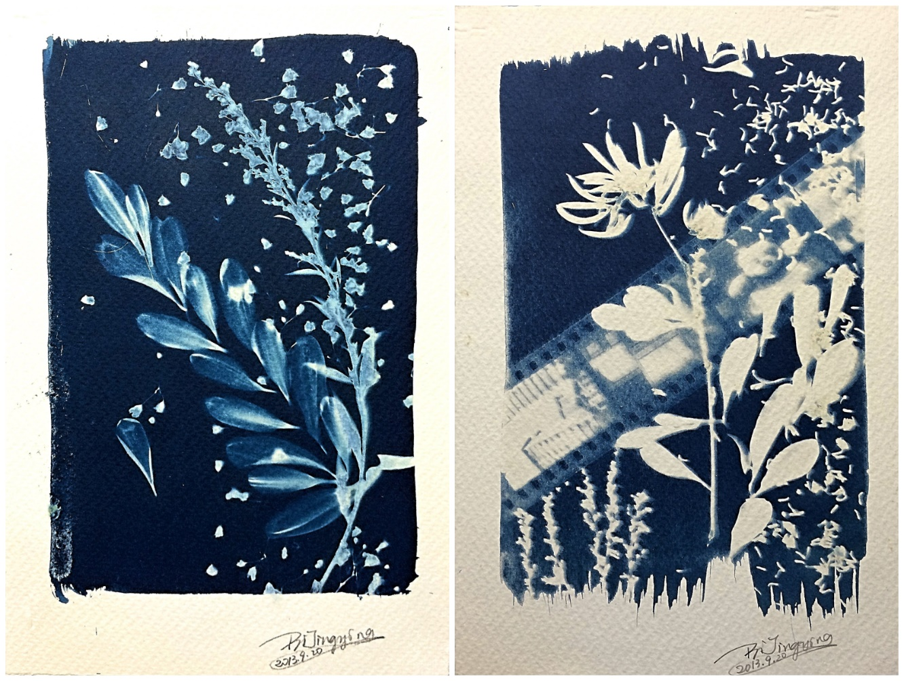**It’s A Windy Day**

This is cyanotype effect with cyan-blue print. It is a photographic printing process discovered in 1840s.   
**STEP 1** Mix two chemicals, light-sensitive iron(III) complex with a readily oxidizable polybasic carboxylic acid, usually citric acid or oxalic acid, and hexacyanoferrate(III).   
**STEP 2** Coated the cotton-paper with the solution made in **STEP 1** and dry the paper.   
**STEP 3** Decorate the dried paper with old photographic film strip, petals etc. Then Expose it to sunlight.   
**STEP 4** Rinse the paper under running water to wash off the unexposed part.

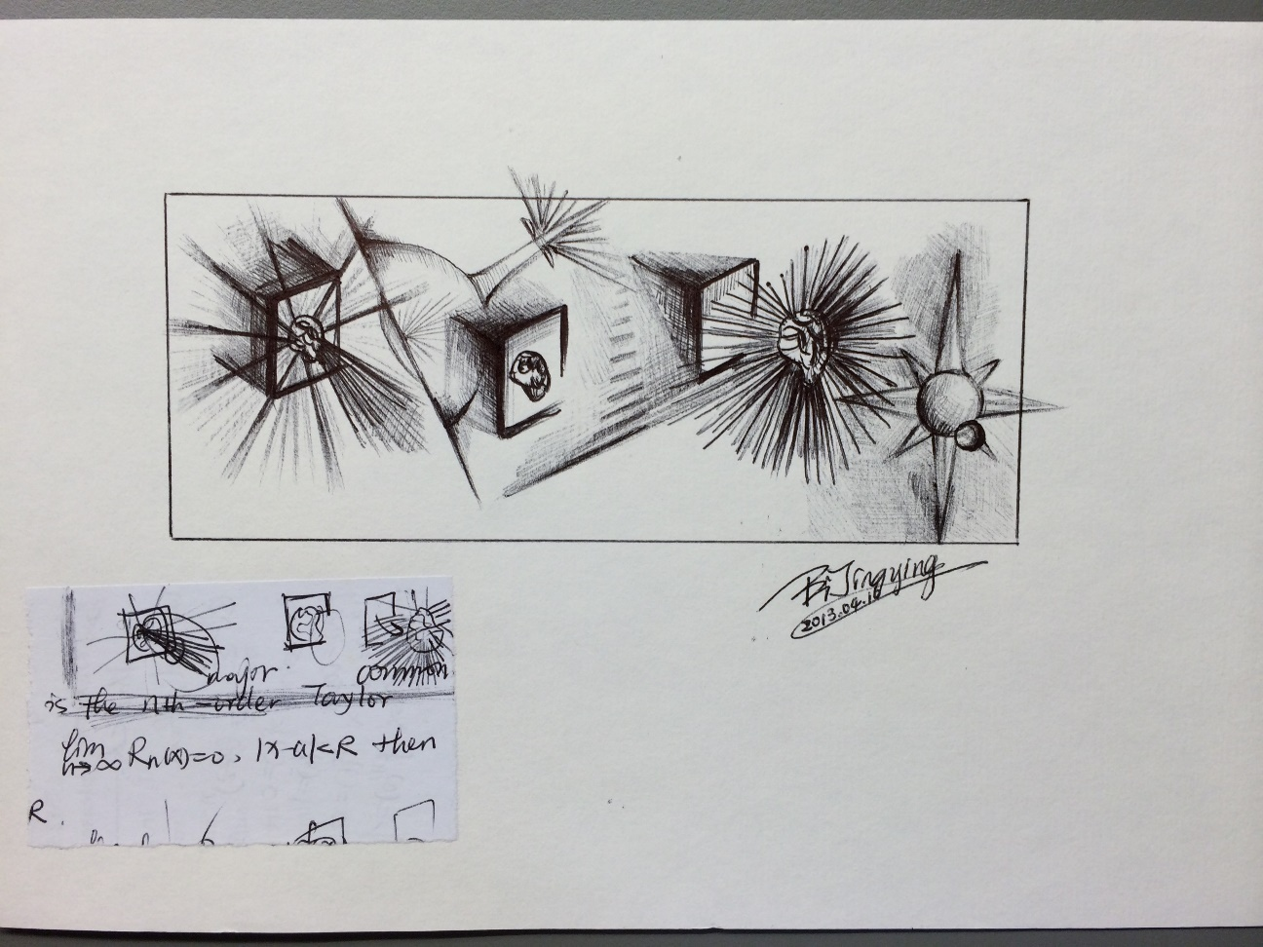

[**Think Out Of Box**](https://jingyingjanebi.github.io/Art_Works/Think_Out_of_Box.jpg)

The idea came from a math tutorial question. First draft is at the lower left bottom.

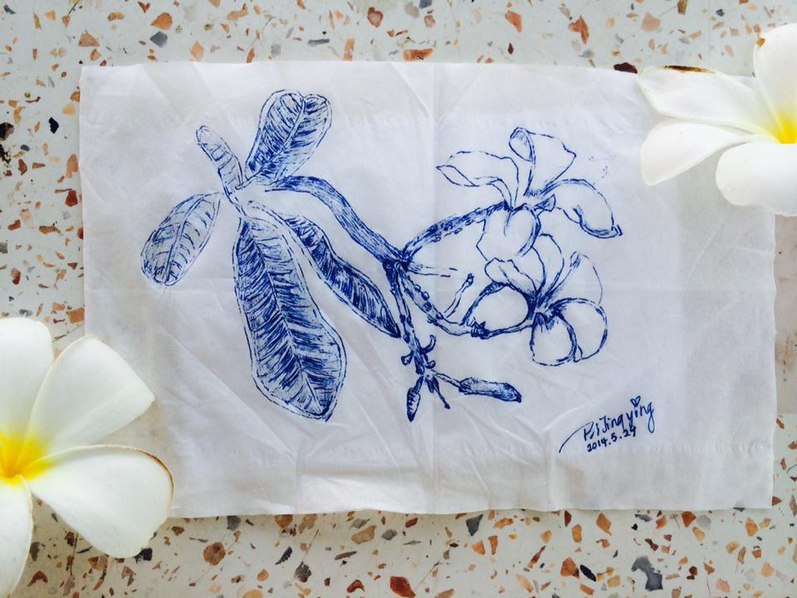

**L-E-E-L-A-W-A-D-E-E**

I drew it on a napkin while sitting on a swing under the tree. My Thai father told me that it was called "L-E-E-L-A-W-A-D-E-E".

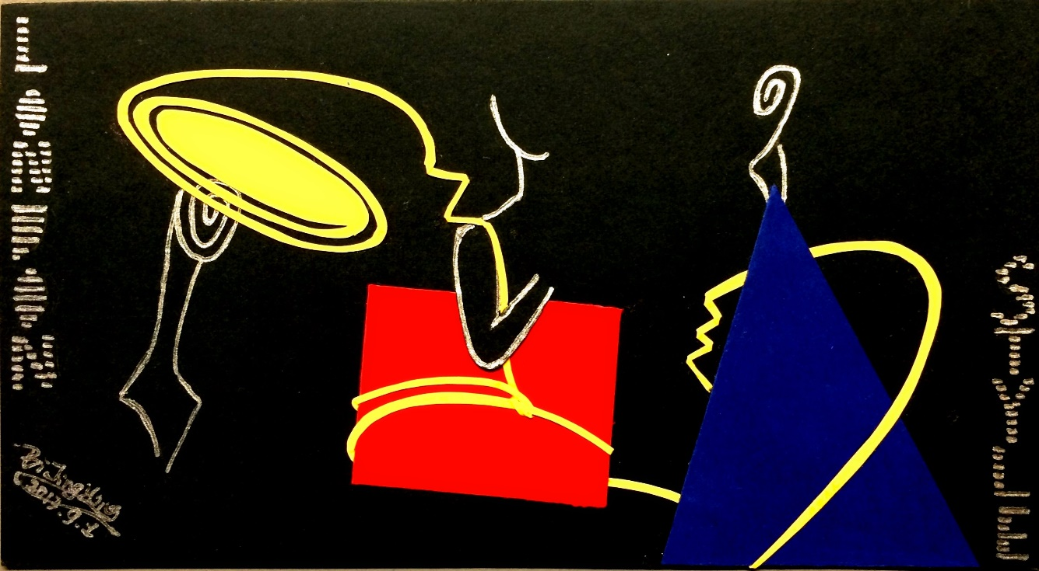

**London Style**

The assignment topic is "Use the square, circle and triangle to design something". Inspiration came from three fashion icons in U.K. They are Queen Elizabeth II (hat), Prime Ministers Thatcher (handbag), and Princess Kate (dress).

*Updated: September 2018*