Analysis of Wavelength Spectra and Optical-Frequency Spectra of an Optical Pulse Train

Jingyi LI

r2295014

The optical pulse train has a pulse duration of 2 picoseconds and a repetition rate of 168 GHz. The center wavelength of the pulse train is set to 1550 nm, corresponding to an optical frequency of 200 THz. The Fourier transform is applied to obtain the spectra.

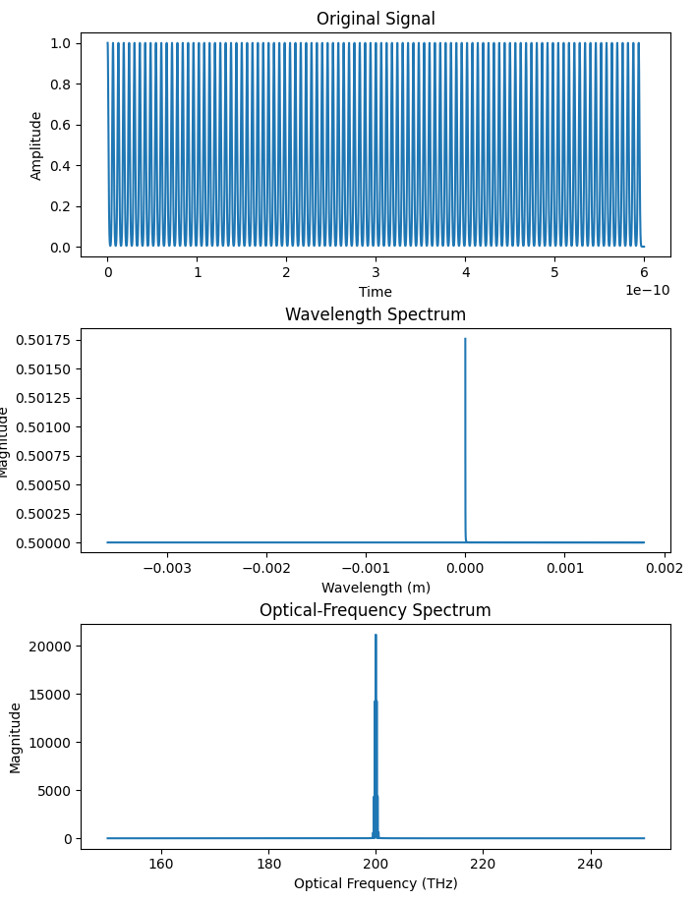

The pulse train is generated using rectangular pulses with a duration of 2 picoseconds and a temporal distance between pulses of 6 picoseconds. The temporal and spectral domains are linked through the Fourier transform. By performing the Fourier transform, we obtain the spectra in the wavelength and optical-frequency domains.

The wavelength spectra provide information about the distribution of optical power across different wavelengths. The center wavelength of 1550 nm is used as a reference point. The spectra show the magnitude of each wavelength component and its corresponding power. That is, the wavelength spectra exhibit a range of wavelengths with varying power levels.



The optical-frequency spectra offer insights into the distribution of power in the frequency domain. The central frequency of 200 THz serves as the reference point. The spectra display the magnitude of each frequency component and its associated power. That is, the optical-frequency spectra reveal the power distribution in the frequency domain.

OUTPUT:

