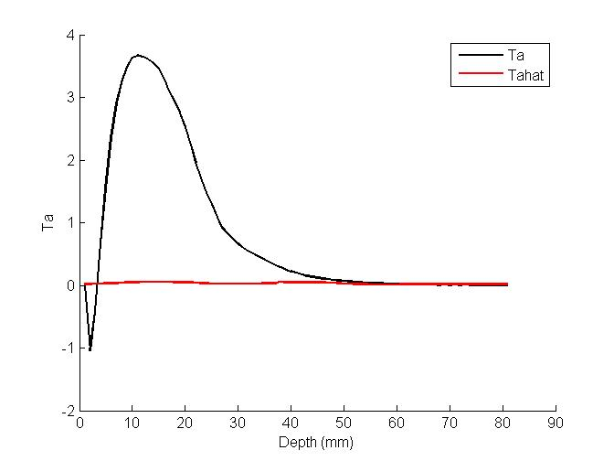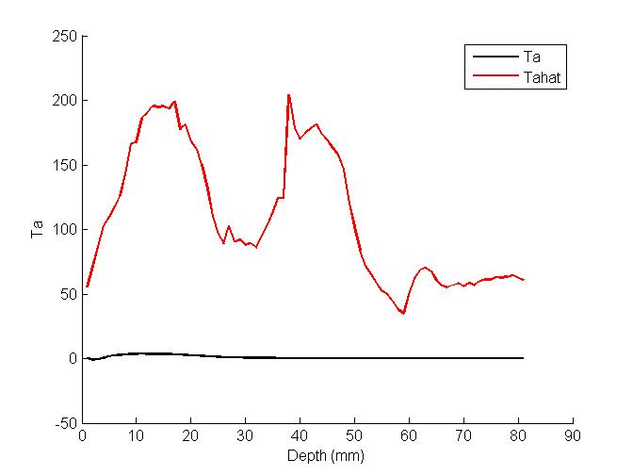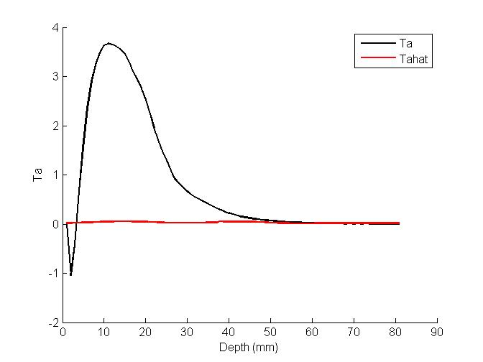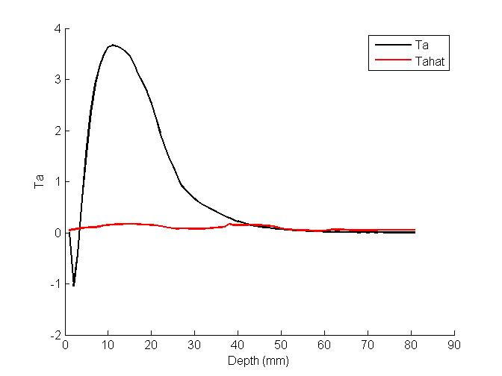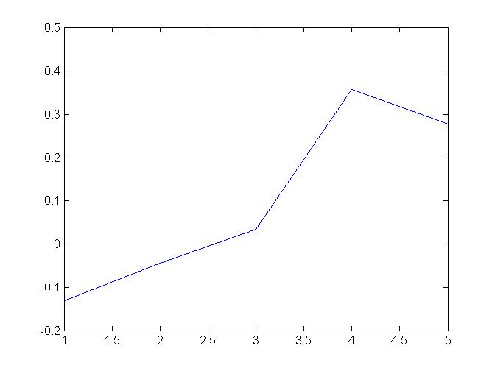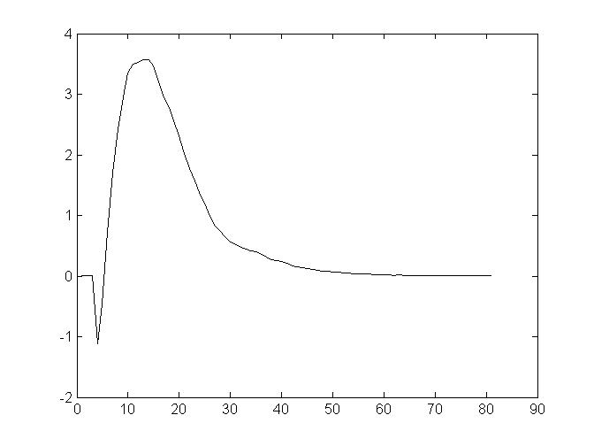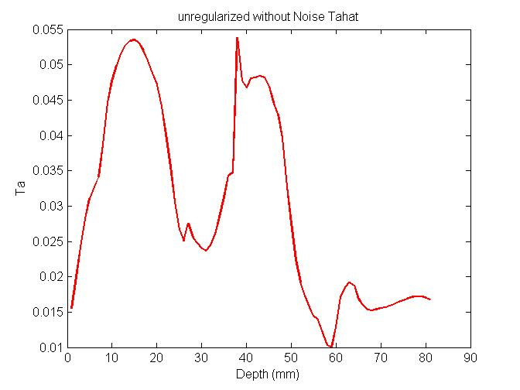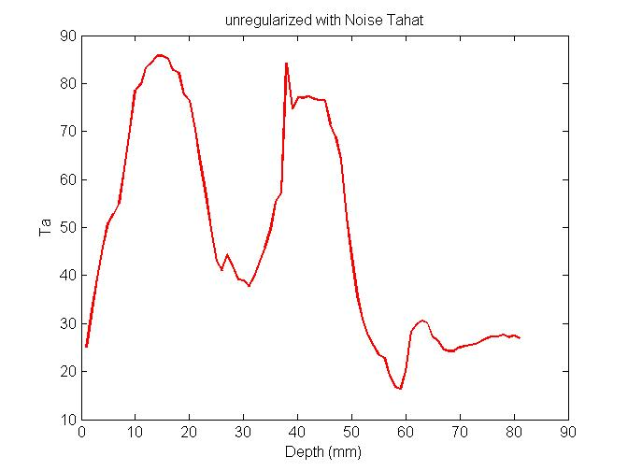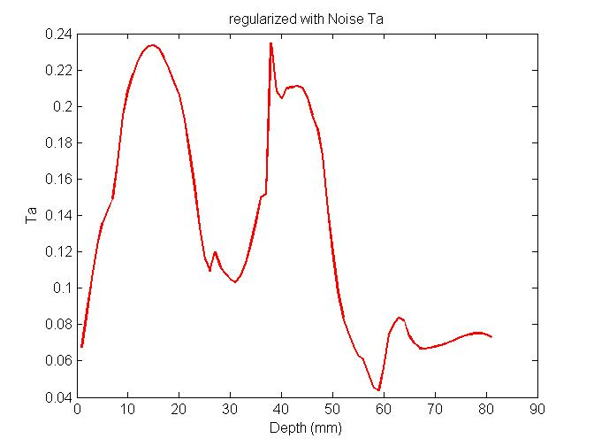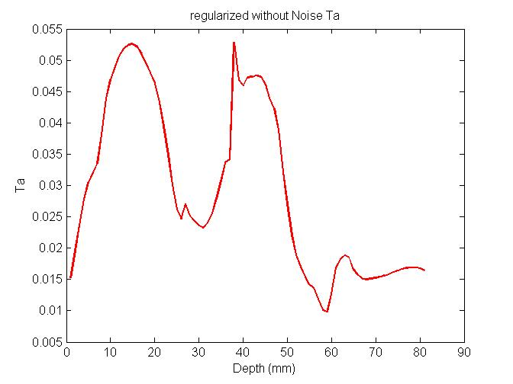

|  |  |  |  |  |  |
| --- | --- | --- | --- | --- | --- |
| variable | Row1 | Row2 | Row3 | Row4 | Row5 |
| $$λ$$ | -9.1e-25 | -4.7e-26 | 2.3e-26 | 1.0e-24 | 5.6e-07 |
| $$λ_{R}$$ | 1e-8 | 1e-8 | 1e-8 | 1e-8 | 1e-8 |
| TB_abn | 29.1206 | 0.1891 | 0.2112 | 0.0146 | 0.0587 |
| TB_nominal | 29.0906 | 0.1889 | 0.2110 | 0.0146 | 0.0586 |
| TB_delta | 0.03 | 1.95e-4 | 2.18e-4 | 1.50e-5 | 6.06e-6 |
| TB_delta1 | 0.0838 | 0.1836 | -0.2257 | 0.0862 | 0.0319 |
| TBn | 0.0538 | 0.1834 | -0.2259 | 0.0862 | 0.0319 |

TB_delta =TB-abn1 - TB_nominal % without Noise

TB_delta =TB-abn1 - TB_nominal +TBn % with Noise

Tumor radius = 10mm, Tumor_x_center = 30mm, Tumor_y_center = 90mm, Tumor_z_center = 76mm

Tumor Depth = 10mm

