Introduction
The National Basketball Association (NBA), is the premier men’s basketball league in the world. On June 6th, 1946, the league was created with 11 teams. Much has changed since the creation of the league; players has become stronger and faster, strategic advertisement has made the league a international sensation, and salaries has grown significantly in the past 70 years. In fact, NBA players are the world’s best paid athletes by average annual income per player. In the 2017-2018 season, the average salary is at $6.5 millions, and the median salary is at $2.9 million.
So what determines this number? I hypothesize that player salary is largely dependent on their on-court performance, and this number is intricately recorded through every game. To be able to precisely determine a player’s salary is impossible, but having a model that can predict salary with certain accuracy could help the teams and players with their assessment on contract negotiation. Knowing how a player measures up against the rest of the league can help prevent players from being underpaid or overpaid.

Data
The data is gather from two sources:
For salary data from 1990-2016, https://data.world/datadavis/nba-salaries
For advanced and basic statistics, https://www.basketball-reference.com/
http://data.world/ has a large collection of data for all purposes. I was fortunate to find this dataset, because unlike MLB, NBA does not have record of player salary for the general public. This dataset has all the player salaries, categorized by year, team, and salary ranking within the team. The salary is not adjusted for inflation.
Basketball-reference.com is where I acquired basic statistics for each player. Those statistics include their average statistics over the season such as rebound, assist, field goal percentage, and age. To help improve model accuracy, I also combined the players’ advanced statistics from another file. These advanced statistics include WS (win shares), VORP (value of replacement player), BPM (box plus/minus), and PER (player efficiency rating).

Data Wrangling
The first step is to prepare the data for analysis. In order to do so I decided to download five years of data from basketball-reference.com. All the basic and advanced statistics are in their separate csv file. Therefore I saved each basic stats into a variable:
s15=pd.read_csv('nba_data/2015stats.csv')
s14=pd.read_csv('nba_data/2014stats.csv')
s13=pd.read_csv('nba_data/2013stats.csv')
s12=pd.read_csv('nba_data/2012stats.csv')
s11=pd.read_csv('nba_data/2011stats.csv')
s10=pd.read_csv('nba_data/2010stats.csv')
The advanced stats are stored the same way:
a15=pd.read_csv('nba_data/advanced2015.csv')
…...
a10=pd.read_csv('nba_data/advanced2010.csv')
The salary data are read as well:
salaries=pd.read_csv('NBASalaries1990to2016.csv')
Running s15.columns and a15.columns, I noticed that there is no “Year” column within the dataframe. Therefore, I added a “Year” column to all the advanced and basic stats before merging.
s15['Year']=2015
……
s10['Year']=2010
a15['Year']=2015
……
a10['Year']=2010
Now the advanced and basic statistics are ready to concatenated with themselves.
To concatenate basic stats:
statsdf=[s15,s14,s13,s12,s11,s10]
stats=pd.concat(statsdf)
To concatenate advanced stats:
advancedf=[a15,a14,a13,a12,a11,a10]
advancedstats=pd.concat(advancedf)
Next, we check for missing values in stats and advancedstats.
stats.isnull().sum()
advancedstats.isnull().sum()
After analyzing the data, I found out that the columns with the most missing values is due to zeros in the denominator. For those statistics, I replaced the NaNs with 0:
stats[["3P%",'FT%','FG%','2P%','eFG%']]=stats[["3P%",'FT%','FG%','2P%','eFG%']].fillna(0)
advancedstats[['TS%','3PAr','FTr']]=advancedstats[['TS%','3PAr','FTr']].fillna(0)
Then I dropped the empty rows in advancedstats:
advancedstats=advancedstats.drop(['Unnamed: 19','Unnamed: 24'],1)
With insignificant amount of missing values leftover, I decided to drop all the NaNs:
advancedstats.dropna(inplace=True)
To merge the data, I decided to use inner join on all the columns the dataset has in common, and I don’t want to preserve any columns that does not match.
result=pd.merge(stats,advancedstats,how='inner',on=['Year','Player','Rk','Pos','Age','Tm','G','MP'])
It was a successful merge, going from 3589 entries to 3575 entries. The dropped entries are due to dropped missing values from the advancedstats dataframe.
To merge the player stats data with the player salary data, I have to repeat the data wrangling process again. Fortunately, the salary data from data.world is already clean, with no missing values. But from the stats data, player names are followed by “/” and player ID. In order to merge the two dataframe, I have to separate player name and player ID.
result[['Player','ID']]=result['Player'].str.split(r'\\', expand=True)
In the stats dataframe, the team names are abbreviations, and the salaries dataframe, the teams are in its full name. Next step is to create uniformity:
team_change={'ATL':'Atlanta Hawks', 'BOS':'Boston Celtics', 'BRK':'Brooklyn Nets',
'CHA':'Charlotte Hornets', 'CHI':'Chicago Bulls', 'CLE':'Cleveland Caveliers',
'DAL':'Dallas Mavericks', 'DEN':'Denver Nuggets', 'DET':'Detroit Pistons',
'GSW':'Golden State Warriors', 'HOU':'Houston Rockets', 'IND':'Indiana Pacers',
'LAC':'Los Angeles Clippers', 'LAL':'Los Angeles Lakers', 'MEM':'Memphis Grizzlies',
'MIA':'Miami Heat', 'MIL':'Milwaukee Bucks', 'MIN':'Minnesota Timberwolves',
'NOP':'New Orleans Pelicans', 'NYK':'New York Knicks', 'OKC':'Oklahoma City Thunder',
'ORL':'Orlando Magic', 'PHI':'Philadelphia 76ers', 'PHO':'Phoenix Suns',
'SAC':'Sacramento Kings', 'SAS':'San Antonio Spurs', 'TOR':'Toronto Raptors',
'UTA':'Utah Jazz', 'WAS':'Washington Wizards'}
result=result.replace({"Tm":team_change})
Comparing teams between salaries and stats dataframe, I noticed that salaries dataframe doesn’t have records for team abbreviation TOT, POR, CHO, and NOH. I expect there to be missing values after merging dataframes.
I select out only data from 2010-2015:
salary=salaries[(salaries.Year>=2010) & (salaries.Year<=2015)]
Then I merge the two datasets via left join, because I want to preserve all entries containing salary data:
m1=pd.merge(salary,result,how='left',on=['Player','Team','Year'])
As expected, there are a total of 410 missing values due to the missing teams in the salary dataframe. I decide to drop all the missing values since the NaNs are due to missing records of certain team instead of error in calculation.
m1.dropna(inplace=True)

Exploratory Data Analysis
The first step in my analysis is to find out the relationships between the variables I have and the salary. Since the salaries are only recorded for the span of 6 years, I will not adjust the numbers for inflation.
First, I will analyze the response variable. Calling m1.Salary.describe() yields a general statistic of the salary.
count 2.378000e+03
mean 4.416256e+06
std 4.706159e+06
min 1.991400e+04
25% 1.120560e+06
50% 2.677320e+06
75% 6.000000e+06
max 3.045380e+07

To visualize the data I create a ECDF (empirical cumulative distribution function):
def ecdf(data):
n=len(data)
x=np.sort(data)
y=np.arange(1,n+1)/n
return x,y
x,y=ecdf(m1.Salary)
plt.plot(x,y,marker='.',linestyle='none')
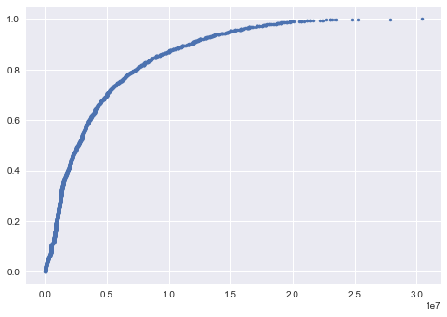

With empirical cumulative distribution function, I can tell that 50% of players make under $3 millions and 90% of the players make under $13 millions. Less than 1% of the players actually make more than $20 millions.
I use distplot, which is a combination of histogram and kernel density estimate:
sns.distplot(m1.Salary)
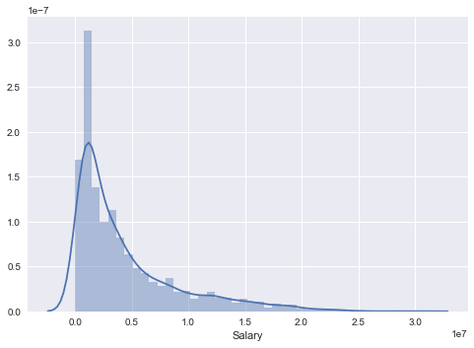

From this graph we can tell that salaries are left skewed, only a small proportion of players actually get paid significantly more.
Before doing further analysis, I will filter out players who played less than 20 games out of 82 games. The statistics are based off of players’ season performance, players who doesn’t play enough games could have uncharacteristic statistic. Doing so will eliminate some players who exhibit outlier statistics. Also, this filters out injured players who cannot perform as expected from their contract.
To find the relationships between the predictor variable and response variable, I decide to create pairplots using seaborn to visualize all the relationships. With a dataset of over 3000 observations, it would be difficult to understand the graph with cluttering points. So I decided to use panda’s df.sample() function to randomly sample 300 observations from the original dataset.
sns.pairplot(m1.sample(n=300), x_vars=['Age','G','GS', 'MP', 'FG', 'FGA', 'FG%', '3P', '3PA', '3P%'], y_vars='Salary', size=7, aspect=0.5, kind='reg')
'Age' 'G' 'GS' 'MP' 'FG' 'FGA' 'FG%' '3P' '3PA' '3P%'
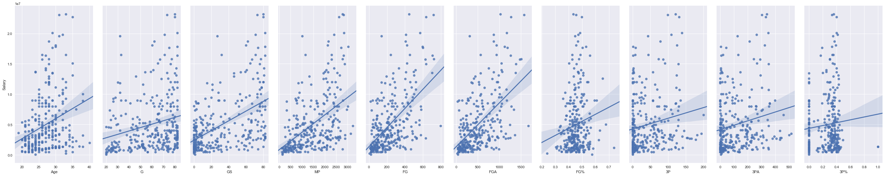
sns.pairplot(m1.sample(n=300), x_vars=['2P', '2PA', '2P%', 'eFG%', 'FT', 'FTA', 'FT%', 'ORB', 'DRB', 'TRB'], y_vars='Salary', size=7, aspect=0.5, kind='reg')
‘2P' '2PA' '2P%' 'eFG%' 'FT' 'FTA' 'FT%' 'ORB' 'DRB' 'TRB'
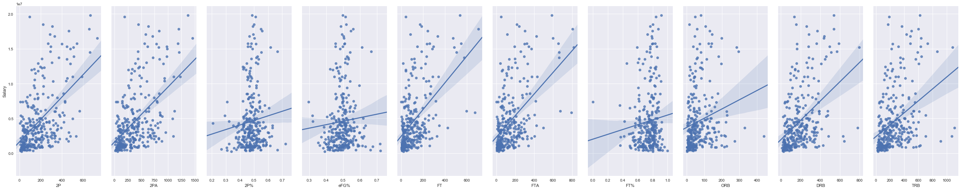
sns.pairplot(m1.sample(n=300), x_vars=['AST', 'STL', 'BLK', 'TOV', 'PF', 'PTS', 'PER', 'TS%', '3PAr', 'FTr'], y_vars='Salary', size=7, aspect=0.5, kind='reg')
'AST' 'STL' 'BLK' 'TOV' 'PF' 'PTS' 'PER' 'TS%' '3PAr' 'FTr'
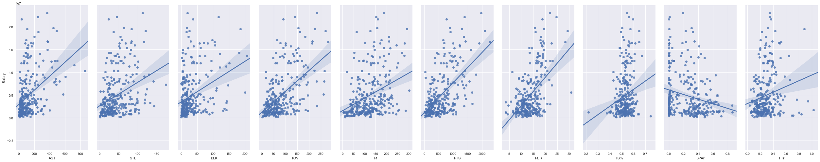
sns.pairplot(m1.sample(n=300), x_vars=['ORB%', 'DRB%', 'TRB%', 'AST%', 'STL%', 'BLK%', 'TOV%', 'USG%', 'OWS'], y_vars='Salary', size=7, aspect=0.5, kind='reg')
'ORB%' 'DRB%' 'TRB%' 'AST%' 'STL%' 'BLK%' 'TOV%' 'USG%' 'OWS'
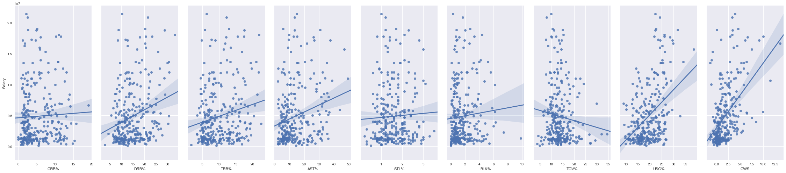
sns.pairplot(m1.sample(n=300), x_vars=['DWS', 'WS', 'WS/48', 'OBPM', 'DBPM', 'BPM', 'VORP'], y_vars='Salary', size=7, aspect=0.5, kind='reg')
'DWS' 'WS' 'WS/48' 'OBPM' 'DBPM' 'BPM' 'VORP'
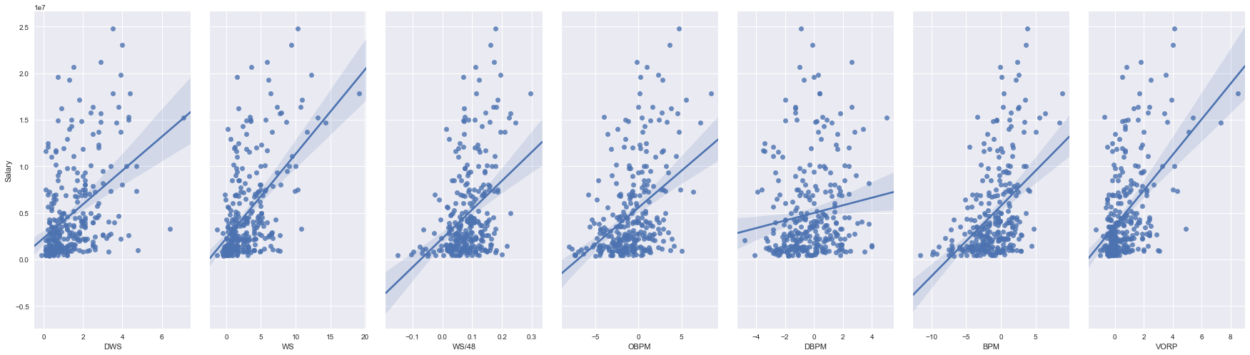
To help pick out predictor variables, I look for relationships where there is a wide spread on the x axis as well as a strong positive or negative relationship in the fitted line. As I look over the graphs I picked out feature_cols=['Age','GS','FG',’2P’,'MP','FTA','TRB','AST','STL','BLK','PTS','OWS','VORP',’USG%’,’PER’]
There are around 12 players on each team, and only five of the players are starter. I have the statistics for games played (“G”) and games started (“GS”), but is there a correlation between the ratio of GS/G and player salary? To find out I create a separate column called “GS/G” and plot the relationship:
m1['GS/G']=m1.GS/m1.G
sns.regplot(x='GS/G',y='Salary',data=m1.sample(n=300))
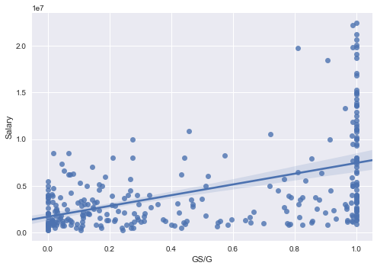

To analyze the effect of GS/G ratio on player salary further, I decide to do a hypothesis testing.
Null hypothesis: GS/G ratio has no effect on player salary.
Alternative hypothesis: GS/G ratio has effect on player salary.
lowGSG = m1[(m1['GS/G']<=0.5)&(m1['GS/G']>0.3)]['Salary']
highGSG= m1[(m1['GS/G']>0.5)&(m1['GS/G']<=0.7)]['Salary']
stats.ttest_ind(lowGSG, highGSG)
Ttest_indResult(statistic=-0.55694244545195537, pvalue=0.57796098804271734)
With a pvalue of 0.58, null hypothesis is not rejected. This is an indication that GS/G is not a good predictable variable for player salary.
Next, I will construct a correlation matrix to visualize multi-collinearity within my predictor variables.
correlation_matrix=m1[['Age','GS','FG','2P','MP','FTA','TRB','AST','STL','BLK','PTS','OWS','VORP','USG%','PER']].corr(method='pearson')
mask = np.zeros_like(correlation_matrix)
mask[np.triu_indices_from(mask)] = True
sns.heatmap(correlation_matrix, cmap='RdYlGn_r', vmax=1.0, vmin=-1.0 , mask = mask, linewidths=2.5)
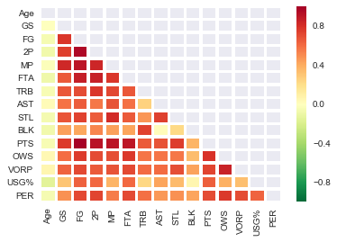

Based off the graph, I will drop variables that are strongly correlated. I decided to drop FTA, VORP, PTS, and 2P
After dropping the variables, I plot the correlation matrix again.
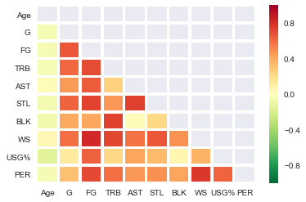

Next, I will use a boxplot to visualize the relationship between player position and salary.
sns.boxplot(x='Pos',y='Salary',data=m1)
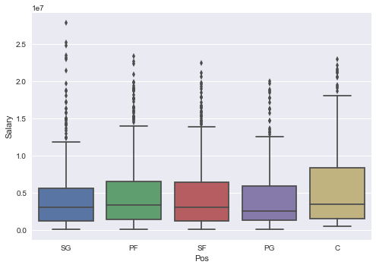

To find out if there is a correlation between the positions and salary, I will do another hypothesis testing.
Null hypothesis: there is a difference in salary between PG and SF.
Alternative hypothesis: there is no difference in salary between PG and SF
PG = m1[(m1['Pos']=='PG')]['Salary']
SF= m1[(m1['Pos']=='SF')]['Salary']
stats.ttest_ind(PG, SF)
Ttest_indResult(statistic=-1.4137337589626986, pvalue=0.15784163819043515)
With a significance value of 0.05, I get pvalue of 0.16, therefore I will reject the alternative hypothesis. I picked PG and SF as the two positions for comparison because they have similar graph. Performing a hypothesis testing on similar data can help determine whether the differences are significant. Since the difference in salary could be due to chance, I will not be including “Pos” as a predictor variable.

Model Building
Before we start building the model, I am going to standardize the predictor variables so it has a mean of 0.
feature_cols=['MP','Age','G','FG','TRB','STL','AST','BLK','WS','USG%','PER']
X=m1[feature_cols]
y=m1['Salary']
scaler=StandardScaler().fit(X)
rescaledX=scaler.transform(X)
Next we will split the data into training and testing sets, with default split of 75/25, and then calculate the accuracy.
from sklearn.model_selection import train_test_split
x_train, x_test,y_train,y_test=train_test_split(rescaledX,y)
clf=LinearRegression()
clf.fit(x_train,y_train)
pred=clf.predict(x_test)
score=clf.score(x_test,y_test)
print (score)
0.530404153887
I just performed a simple linear regression model. There aren’t any hyperparameters to tune, and we are able score around 0.53, meaning we are able to predict 53% of player salaries with our model. Train/test split score is not a good indicator for out of sample data, but it is very fast and capable of deeper analysis such as residual plot and calculating the coefficients.
sns.residplot(pred,(pred-y_test))
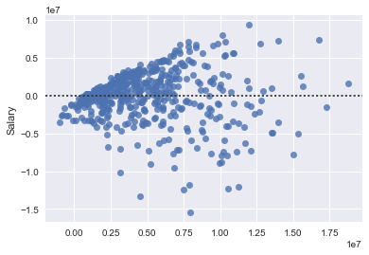

Looking at the residual plot, we discover an issue with heteroscedasticity. This is most likely caused by the the predictor variable’s error terms not having the same variance. Those predictor variables most likely will lack a normal distribution, which is something linear regression performs the best under. To fix the issue, we can transform predictor variables with a non-normal distribution. Another solution would be using a non-linear model such as Random Forest Regression.
Since we performed train/test split, we have the option of finding the coefficients of the predictor variables:
coeff=pd.DataFrame(X.columns)
coeff['Coefficient_Estimates']=pd.Series(clf.coef_)
coeff['Coefficient_Estimates']=coeff.Coefficient_Estimates.astype(int)
coeff.sort_values('Coefficient_Estimates',ascending=False)

 | 0 | Coefficient_Estimates
0 | Age | 1640141
2 | FG | 1574977
8 | USG% | 785259
3 | TRB | 745323
4 | AST | 709273
7 | WS | 689109
6 | BLK | 453907
9 | PER | 155197
5 | STL | -435549
1 | G | -1348366

######

To overcome the caveats of train/test split we will run a k-fold cross validation.
from sklearn.linear_model import LinearRegression
from sklearn.model_selection import cross_val_score
clf=LinearRegression()
scores=cross_val_score(clf,rescaledX,y,cv=10,scoring="r2")
print (scores.mean())
0.519085015943
Running a 10 fold cross validation yields a score of 0.52. This is a more accurate score, and a better metric for out of sample data.
Since the residual plot showed heteroscedasticity, it is an indication that our data is not suitable for linear model, unless the predictor variables that are causing problems are transformed. Linear model is a very basic regression technique, while it is fast and interpretable, other techniques such as Random Forest usually yield better results. I will first run a Random Forest Regressor model with default hyperparameters.
from sklearn.ensemble import RandomForestRegressor
clf = RandomForestRegressor()
scores=cross_val_score(clf,X,y,cv=10,scoring="r2")
scores.mean()
0.61303693593995812

Without any tuning of the hyperparameters, we are already achieving a much high R-squared score than linear regression. Using GridSearchCV, we should be able to further improve model accuracy.

