DetectParticles Android App Release Notes

Opuses LLC

March 15, 2016

1. **New Features**
   1. **Super user**

The super-user mode can only be entered from the first screen of the APP:

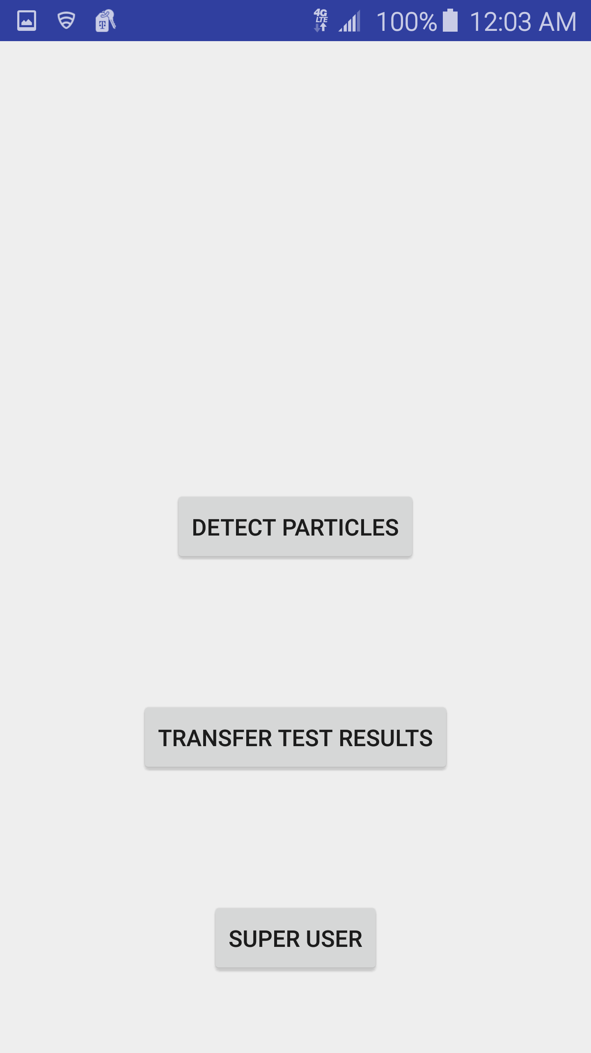

* 1. Master Key

In super-user mode, a master key has to be used to access the camera settings. It is set to “1234” for testing.

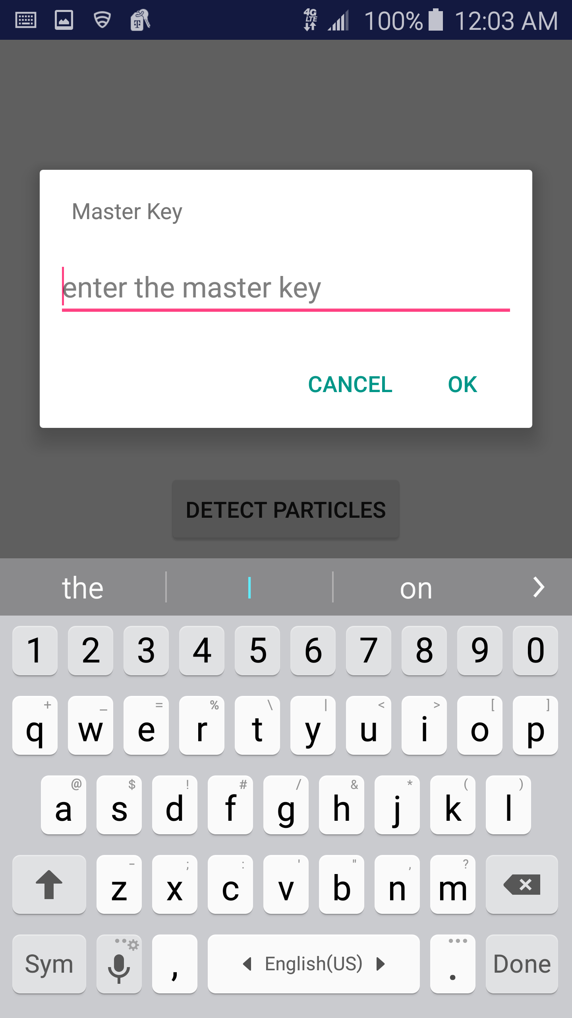

* 1. Set Camera Settings

The value of camera settings will be checked when press NEXT or DONE on the soft key pad:

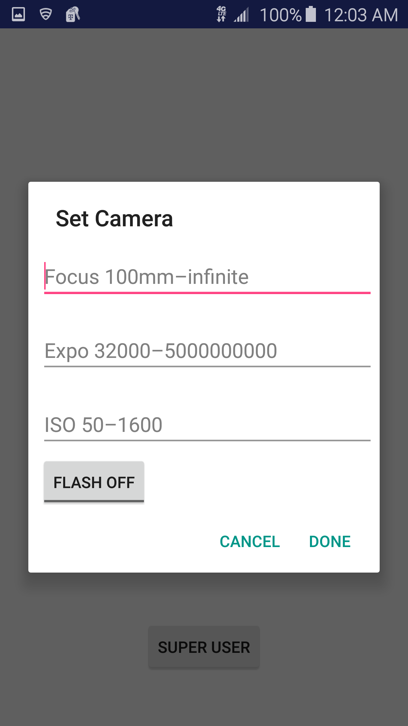

1. **Known Issues (same as the previous version)**

1. After the result is deleted from the App, the file still exists under a temporary directory on the device. This will be addressed in the next release.