DetectParticles Android App Release Notes

Opuses LLC

March 18, 2016

1. **Install App Notes**

To make the new version of App working correctly, the old version of APP has to be uninstalled. That is because the database table stores the test data has changed.

1. **New Features**
   1. **The Camera is working!**

Press TEST SAMPLE (please suggest the wording for this button) will create a dng file under /Download directory on the device, and the file will be named with the “yymmss_hhmmss.dng” format.

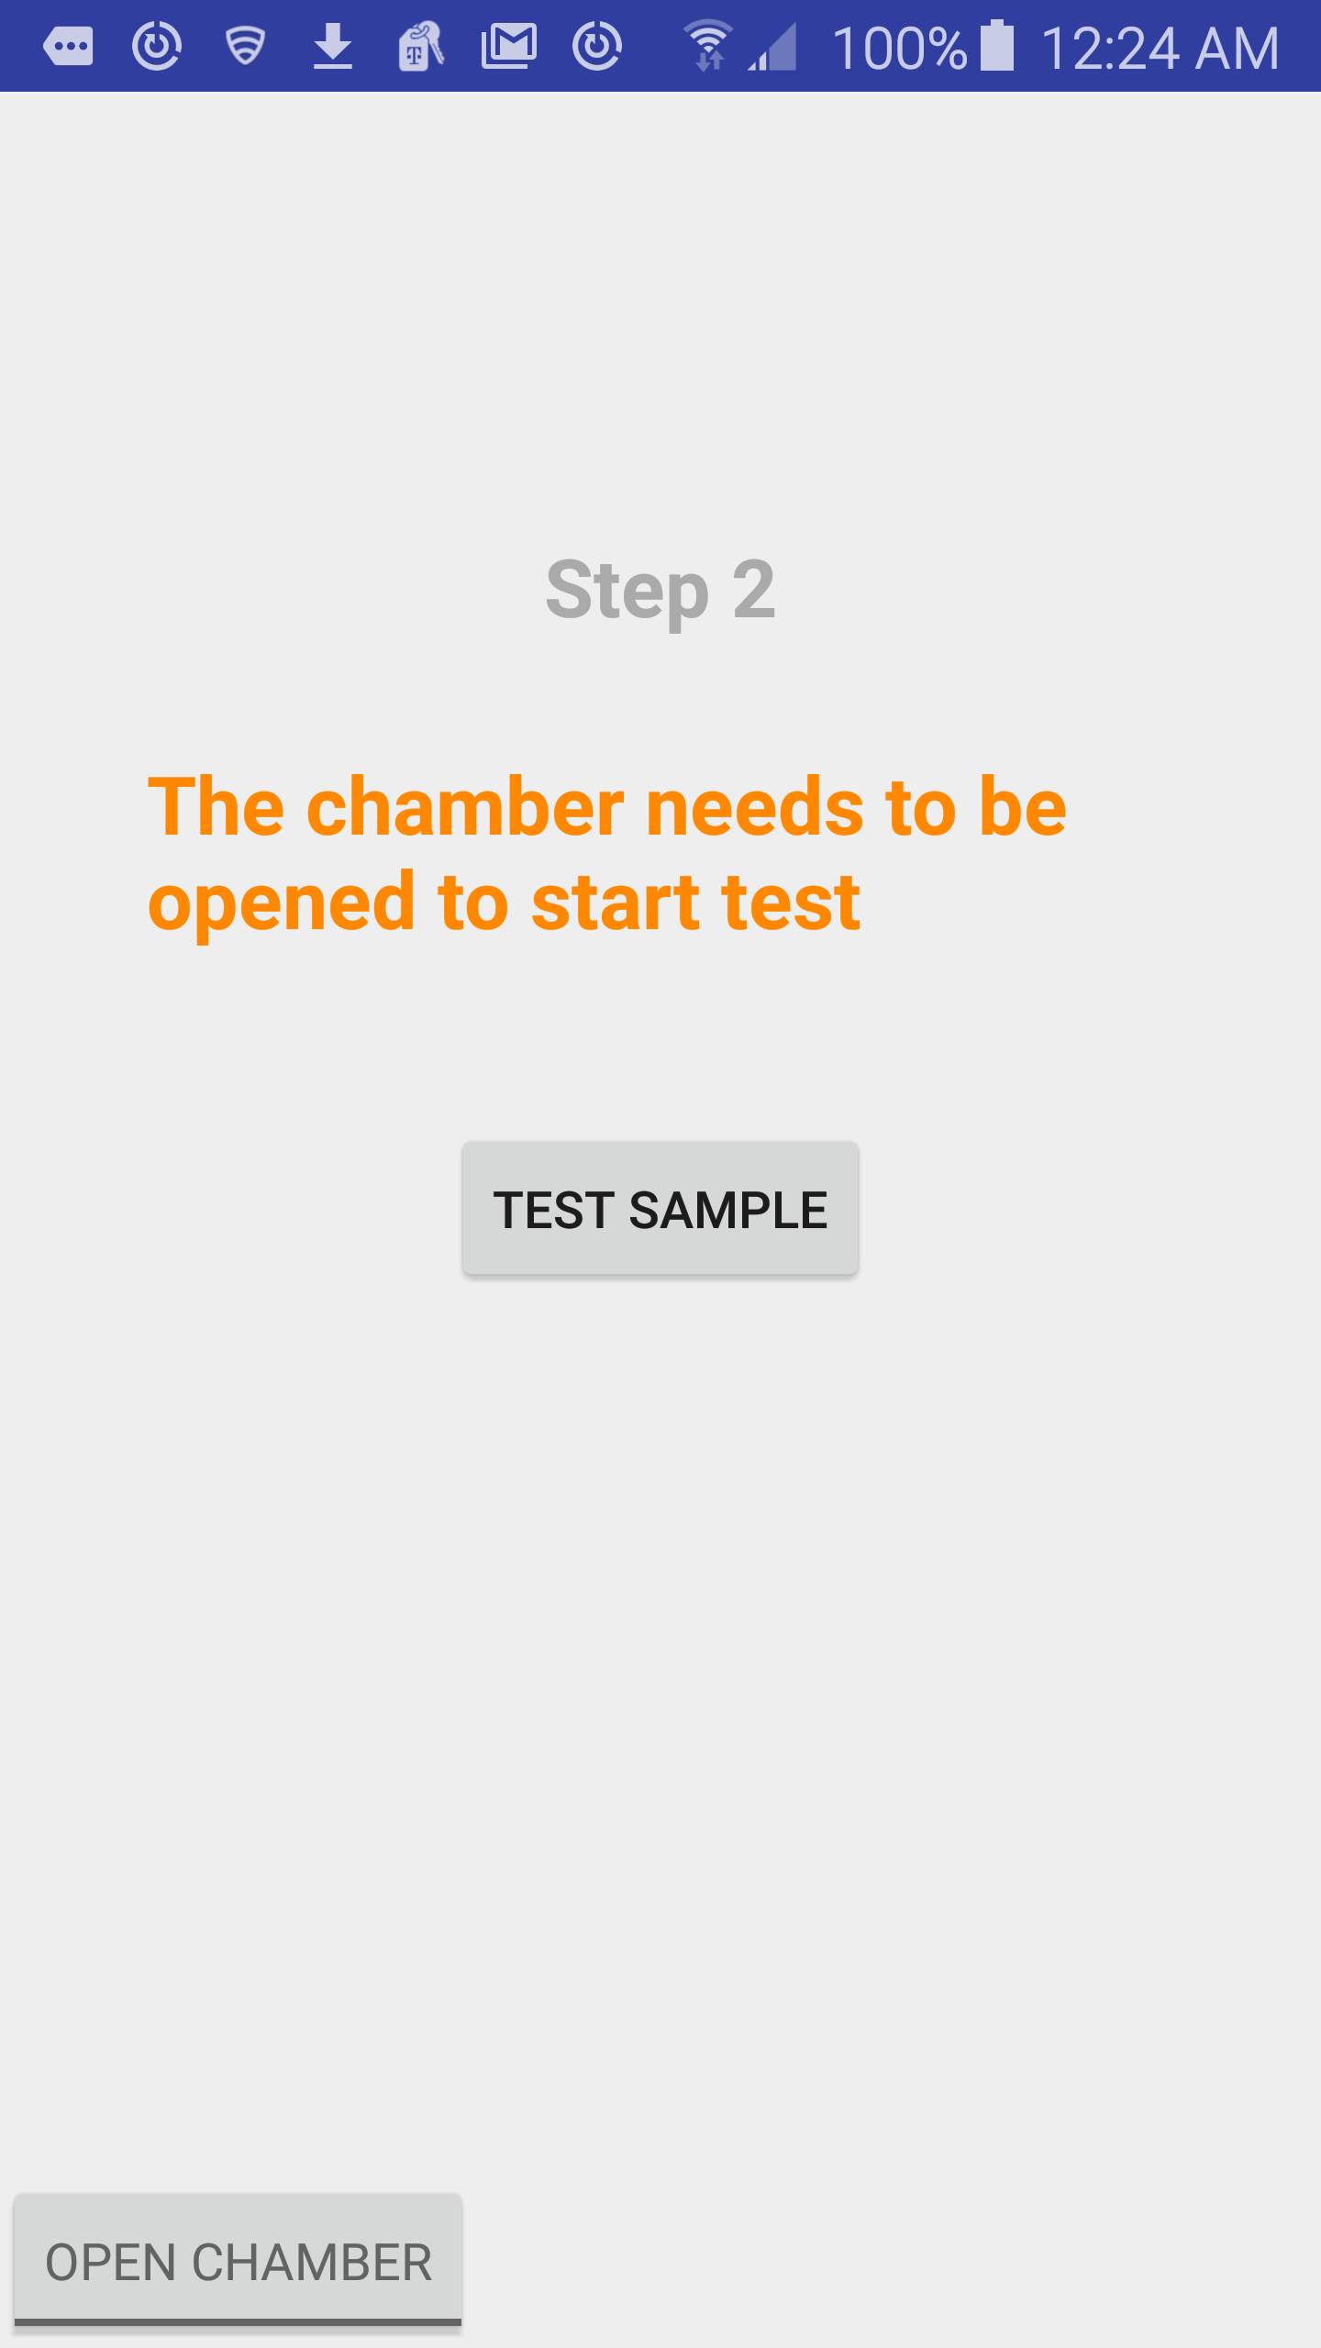

The camera settings are read from the settings entered by the super user from the following screen. If the user does not enter the settings, the default settings will be used. The passcode for access the super user is now set to “1234”.

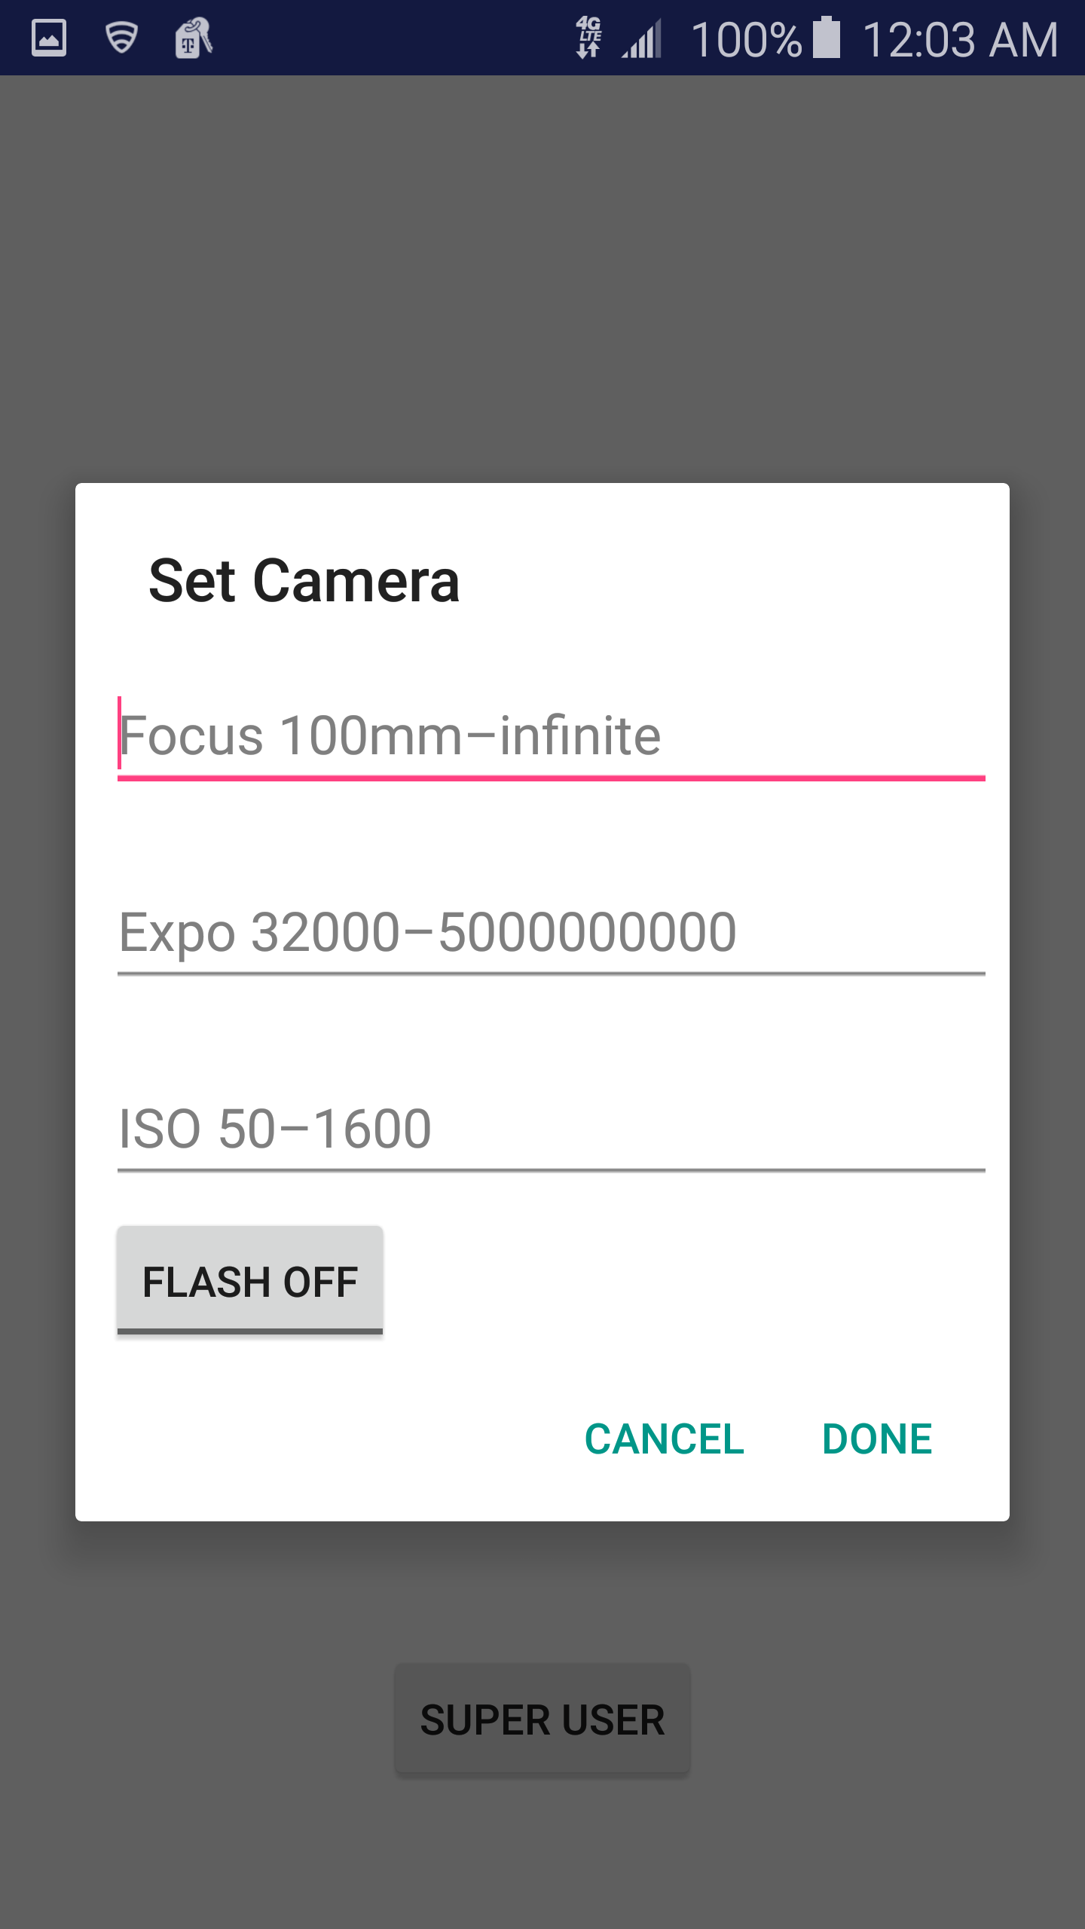

* 1. **Loading Files to DropBox**

It is working now to load both the dng file and the text file that contains the test information to the DropBox.

* 1. **Delete Files**

Delete file feature will remove both the dng file and the text file from the device.

* 1. **Location Service Settings**

In Step 2 screen, if the location service is turned off, a dialog will be pop up, and select OK will lead to Location selection in Settings.

1. **Known Issues (same as the previous version)**
2. The DELETE ALL in the list screen does not work yet.
3. When the Application is closed when it is on the Result Screen, the image file will stay in the storage of the device without being removed. It has to be manually removed.