**Introduction:**

This instruction manual covers the 3 basic steps needed to install and operate the equipment required for this project.

1. Mounting of the camera equipment
2. How to run the SnowCAM app
3. How to download the data

The initial setup of the camera will have already been handled by CMU when the equipment arrives. This document is merely a guide to insure the equipment is being properly installed and used in the field. Below is a list of the equipment that will be installed:

|  |
| --- |
| Samsung Galaxy Camera EK-GC100 |
| 64 GB microSD card (camera memory) |
| USB Power Cord |
| Windshield Quick Release Camera Mount |
| Felt cover to reduce reflections |

Any camera installation questions can be directed to:

**Christoph Mertz** [-cmertz@andrew.cmu.edu](mailto:-cmertz@andrew.cmu.edu)

**Mounting of the Camera**

**The camera is mounted in 5 easy steps:**

**Step 1. )** You first must select the camera’s installation location.

***The camera must be in an area of the windshield that:***

* Has a clear view of the roadway and does not obstruct the view of the driver
* Is cleaned by the windshield wiper; so the camera has a clear view of the road
* Is not near the heating wires are in the windshield, these will obstruct the view
* The camera’s USB power cord is able to reach the cigarette lighter outlet

**Step 2. )** Attach the camera to the mount by screwing them together. The camera will need to be attached tightly to the mount. A loosely attached camera could compromise the picture integrity by shaking or turning.

*(For detailed instruction on how to install/remove the quick release mount, see Appendix A at the end of this document)*

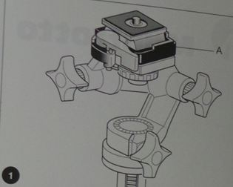

**Step 3. )** Attach the mount to the selected windshield using the mount’s suction cup.

**Step 4. )** Install the black felt drop cloth to the mount

**Step 5. )** Plug the camera’s USB power cord in to the cigarette lighter and insure the camera turns on.

***Below are images to assist in camera mounting installation:***

Below is picture of what the final Camera mount installation should look like: Red Arrow- Suction Cup, Yellow-Quick release, Blue- Black Felt Shield

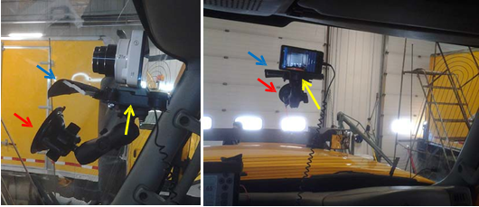

By turning the camera’s power on and looking at the LCD display; you should be able to adjust the camera view to the needed angle. The preferred view should look similar to the below picture.

* The camera should be approximately looking down the center of the vehicle
* There should be some part of the hood in the image as well as some sky
* It is very important that the mirror on the right is visible

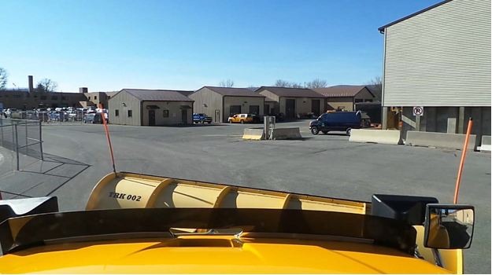

**Operation of the SnowCAM App**

After installation of the camera equipment, the next step is to familiarize yourself with the SnowCam app.

**Step 1.) Turn the camera on using the power button**

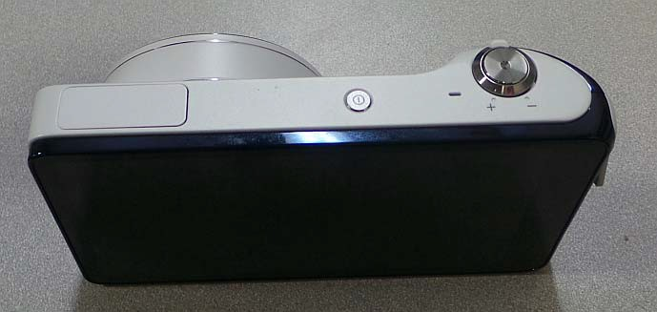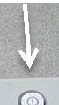

**Step 2.) Access the “Home” Screen**

When you turn the camera on it will default to “camera” mode. Tap the “house” icon in the top left portion of the screen to take the camera into its home screen.

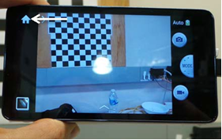

**Step 3.) Enter the SnowCAM app**

The camera’s home screen will have 5 icons. The SnowCAM’s icon will be a large snowflake. Click on this icon to activate the app. (*If the SnowCAM App is missing from your camera, immediately contact Christoph Mertz )*

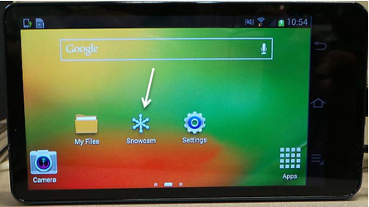

**Step 4.) Running SnowCAM**

Tap on the snowflake icon and the SnowCAM app will activate. When you are ready to start recording, tap on the capture video button; the app will now start recording. The capture video button, while recording, will now say “stop”. You can tap on the stop button to halt recording. When you are finished recording the camera will automatically save your video to its file directory.

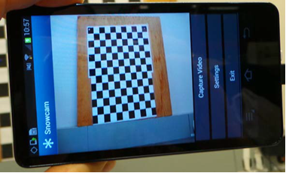

**Downloading the Image Data to your Commonwealth Computer**

Once you are finished recording your road conditions the images will need to be moved from the camera to a Commonwealth computer. For this process you will need the camera’s USB cable to connect the 2 devices. The camera will need to be powered on, or in sleep mode for files to be transferred.

**Step 1. )** Remove the camera from the mount inside the truck

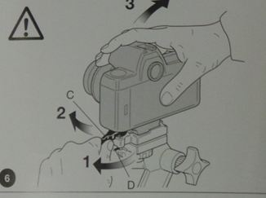

**Step 2. )** Connect the camera to your computer using its USB cable

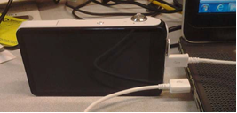

**Step 3. )** A window will appear on your computers screen when you connect the camera. Click on the “open device to view files” button.

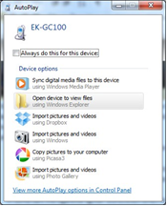

Clicking on this option will bring up the camera’s file directory. You will be able to access the cameras files by selecting the folder with the name that corresponds with the date and time of the video.

Example:

Folder name: 20131204_110715_502

2013 –Year 12- Month 04 –Day 1107- 11:07 AM (Military Time)

(The last group of numbers is the part of the time stamp, broken down to the millisecond)

**Below is screen shot of what the camera’s file directory will look like.**

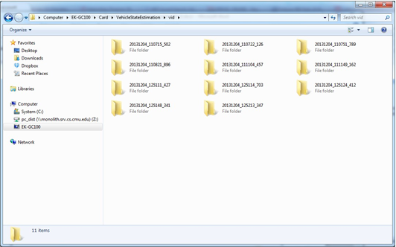

**Step 4. )**

You will now need to transfer the files to your computer.

“Right Click” on the folder you want to move from the camera’s file directory and select “Cut.” Then, “Paste” into the appropriate folder in the Project directory. Repeat this process until all the necessary files are removed from the camera.

NOTE: Be sure to select “Cut” instead of “Copy.” This is critical in order to free up memory on the camera.

**Appendix-A**

