LLM Duel
User Manual — run one prompt against two LLMs, side by side.
Streamlit application · June 2026

1 What it is
LLM Duel lets you hold the same conversation with two (or more) language models at once and watch their answers stream in side by side. Each model is driven by a small block of Python you can edit in the app, so you can wire up ChatGPT, Claude, Gemini, a local model, or your own — without the app needing to know how any of them work.
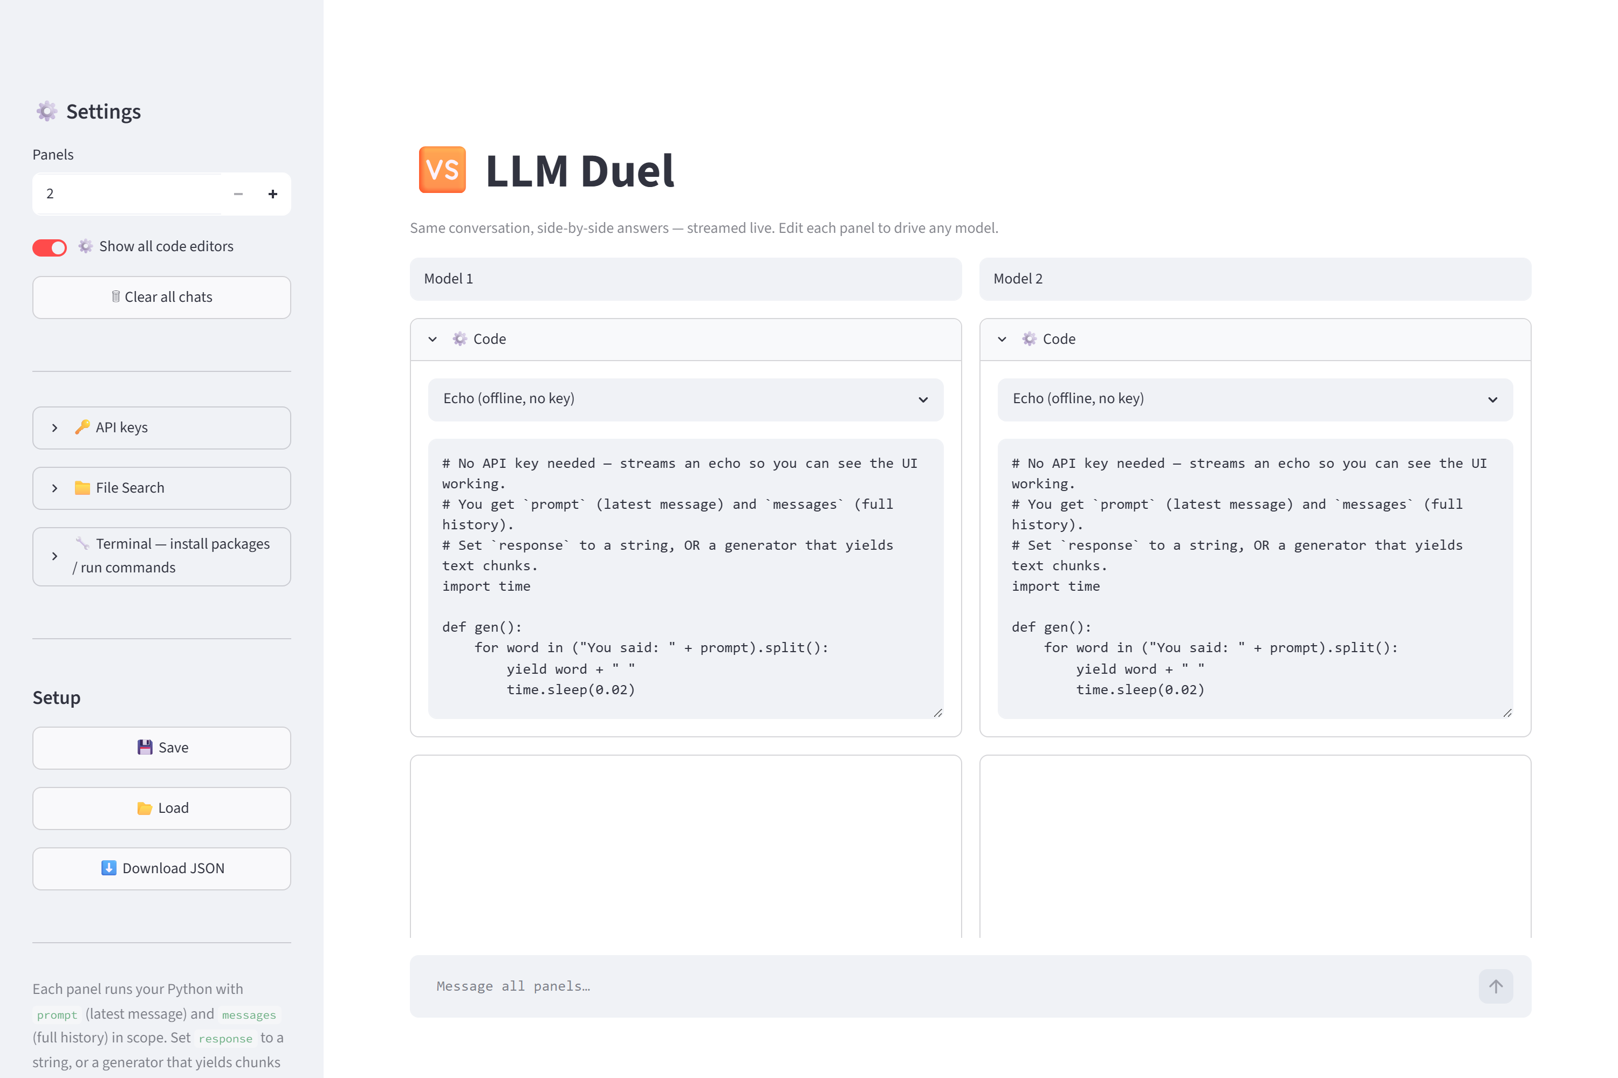
The main window: settings sidebar (left), two model panels each with an editable code box, and a shared message box at the bottom.

2 Install & run
You need Python with Streamlit installed. From the project folder:
pip install -r requirements.txt
copy .env.example .env # then paste in your API keys (optional)
Then start it in any of these ways:
- Double-click run.bat — the quickest way.
- Or run streamlit run app.py in a terminal.
Your browser opens at http://localhost:8501. It works immediately with the built-in Echo template — no API keys required — so you can try the interface right away.

3 The interface

Sidebar (Settings)
- Panels — compare 2, 3, or 4 models at once.
- Clear all chats — wipe every conversation and start fresh.
- Save / Load / Download JSON — store your panel names + code to llm_duel_config.json so your setup survives a restart.

Each model panel
- Display name — label the panel (e.g. “GPT-4o”, “Claude”).
- Code — an editable Python box plus a template menu. It opens automatically and collapses once the conversation starts.
- Transcript — the running conversation for that model.

Message box
Type once at the bottom; your message goes to every panel at the same time.

4 How it works — the contract
The clever part is a tiny, fixed contract that every panel's code follows. That single convention is what lets one app drive any model:
Direction | Name | What it is
in | prompt | The latest user message (a string).
in | messages | The full conversation so far — a list of {"role", "content"} dictionaries.
out | response | Either a plain string (shown at once), or a generator that yields text chunks (streamed live).

Pick a starting point from the template menu — OpenAI, Anthropic, Gemini, a local model (Ollama), or Echo — then edit it. A real example (OpenAI, streaming, multi-turn):
import os
from openai import OpenAI
client = OpenAI(api_key=os.environ.get("OPENAI_API_KEY"))
stream = client.chat.completions.create(
model="gpt-4o",
messages=messages, # full history, so it remembers the conversation
stream=True,
)
def gen():
for event in stream:
if event.choices[0].delta.content:
yield event.choices[0].delta.content
response = gen() # a generator -> streamed token by token
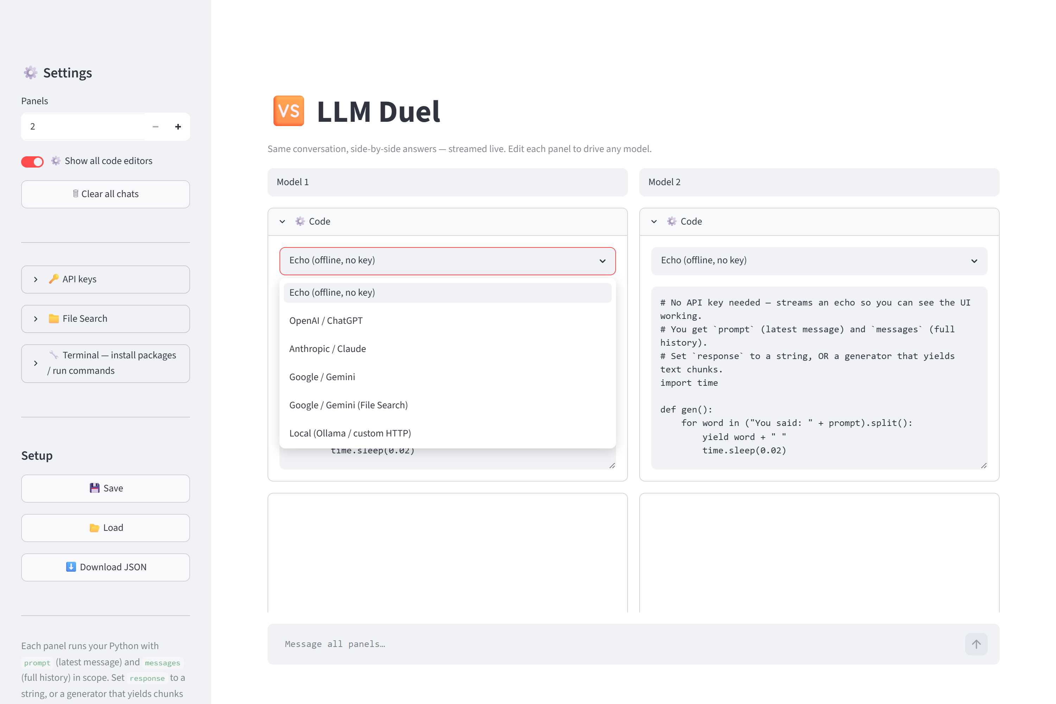
The template menu in each panel — a ready-made starting point for each provider.

5 Using it — a worked example
- In each panel, pick a template from the Code menu and adjust the model name.
- Put your API keys in a .env file (see section 7).
- Type a question in the message box and press Enter.
- Watch both answers stream in, then compare. Ask a follow-up — each model remembers its own thread.
Below, two panels were given different code (a plain echo vs. a small text analyzer) so you can see how distinct each side's answer can be. The ⏱ stamp under a reply shows how long it took.
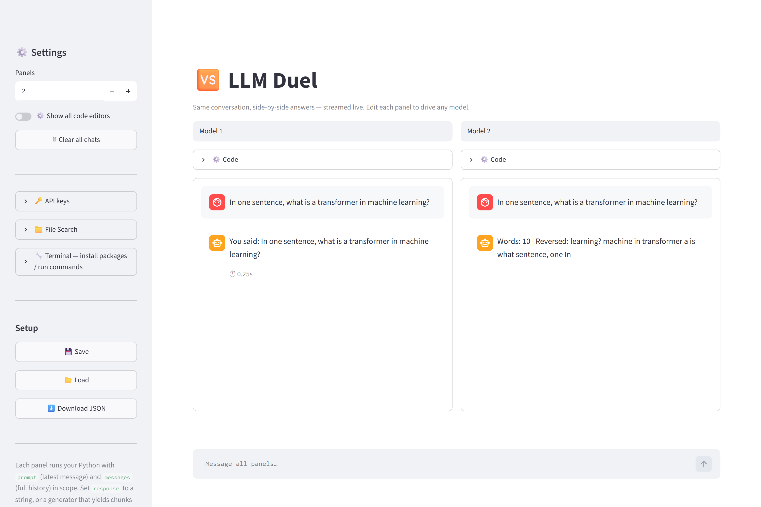
Same question, two panels, two answers — streamed live and shown side by side.

6 Installing model packages (Terminal)
Different models need different Python packages. The built-in Terminal panel runs commands in the same interpreter the app uses, so anything you pip install there is immediately importable by your panel code.
pip install openai anthropic google-generativeai
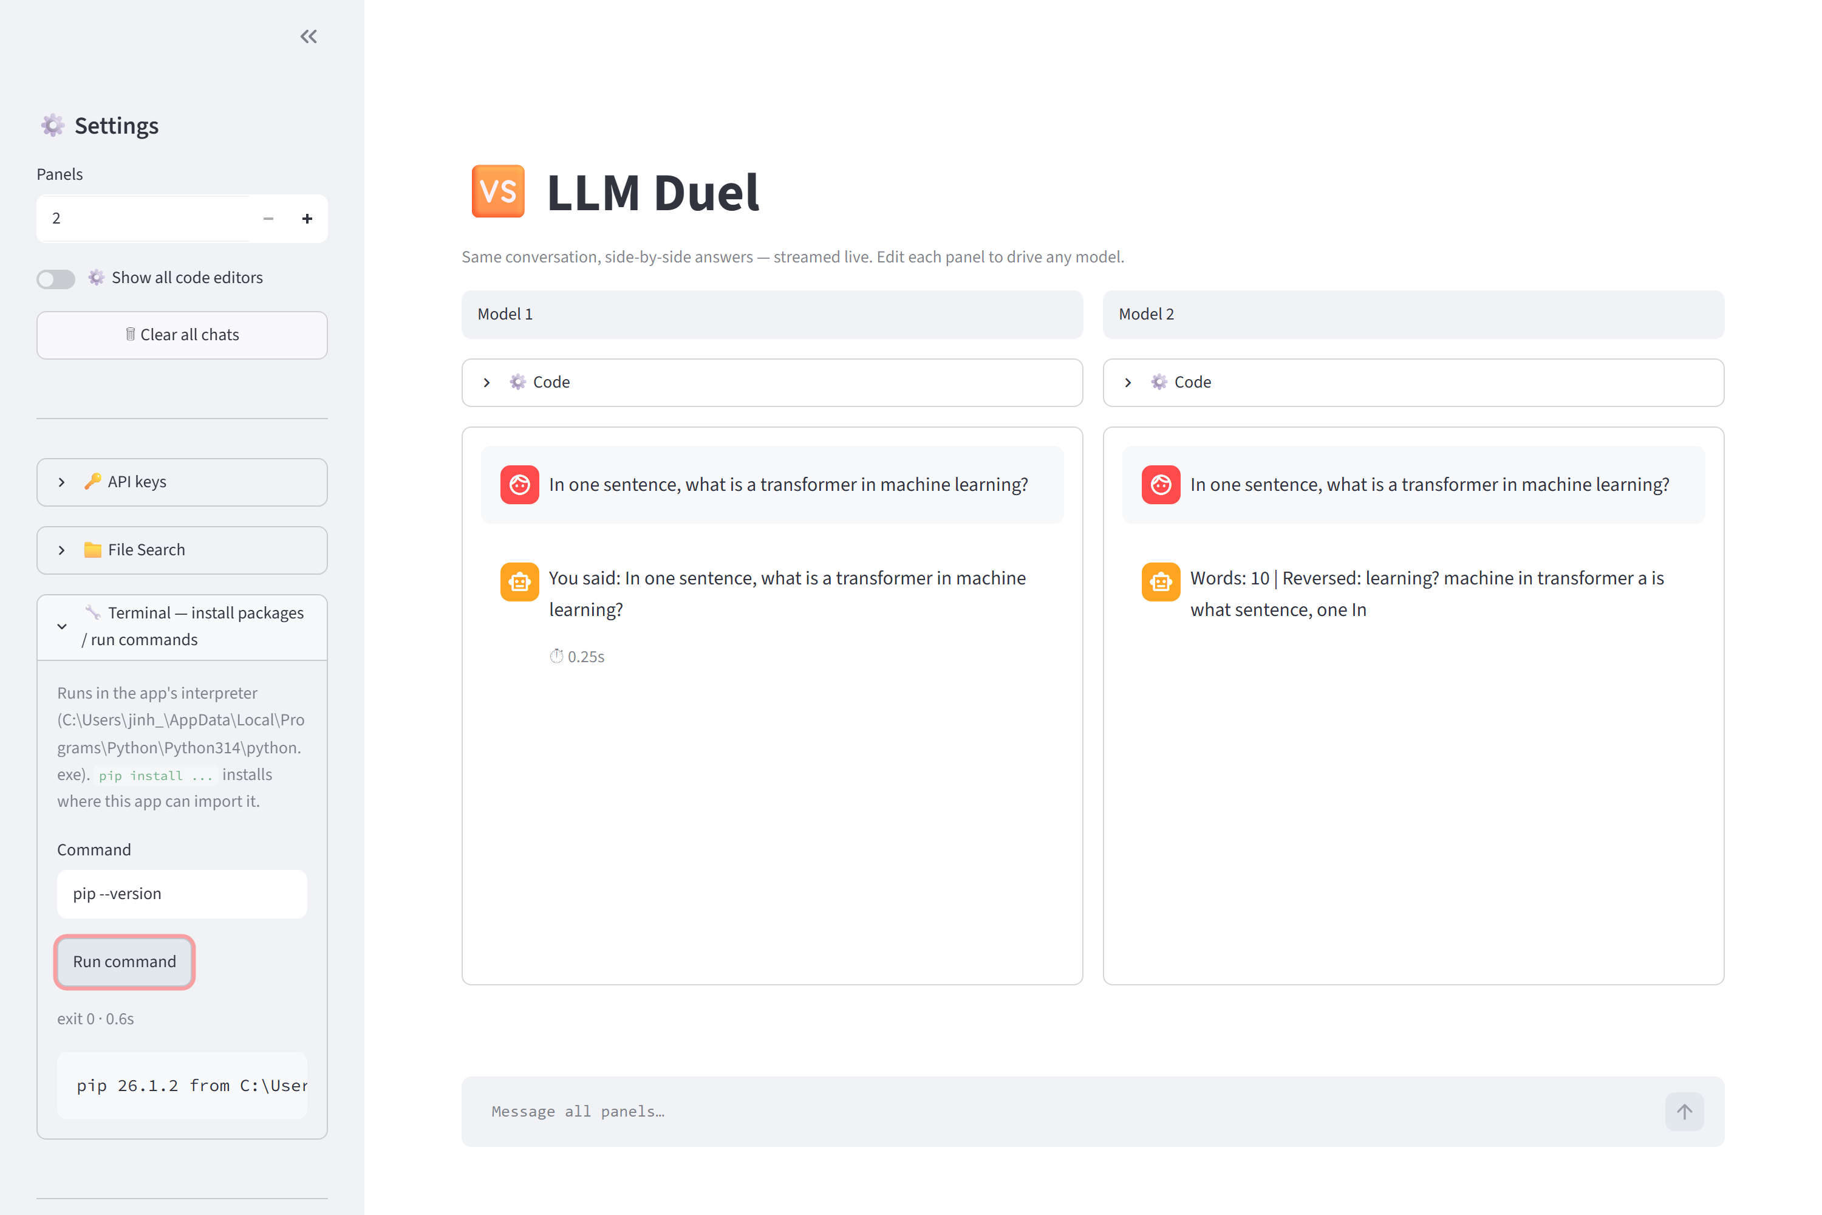
The Terminal panel running a command and showing its output and exit code.

7 Saving setups & API keys
Use Save in the sidebar to write your panel names and code to llm_duel_config.json; it loads automatically next time. Download JSON gives you a portable copy.
API keys live in a .env file beside app.py and are read by your panel code via os.environ:
OPENAI_API_KEY=sk-...
ANTHROPIC_API_KEY=sk-ant-...
GOOGLE_API_KEY=...

8 Security & troubleshooting
Security: panels run with exec() and the Terminal runs shell commands — full power, by design, so any SDK works. Only paste code you trust. This is built as a local, single-user tool.
- Browser didn't open: go to http://localhost:8501 manually.
- ModuleNotFoundError in a panel: install the package from the Terminal panel, e.g. pip install openai.
- Authentication error: check the matching key in .env, then restart the app.
- “model not found”: edit the model="..." line in that panel's code.
- One panel is slow: that's just that model — panels stream independently and in parallel.

