GitHub tutorial part 1

<http://www.youtube.com/watch?v=mYjZtU1-u9Y>

Download the github file and install it.

Git-scm.com/download/win

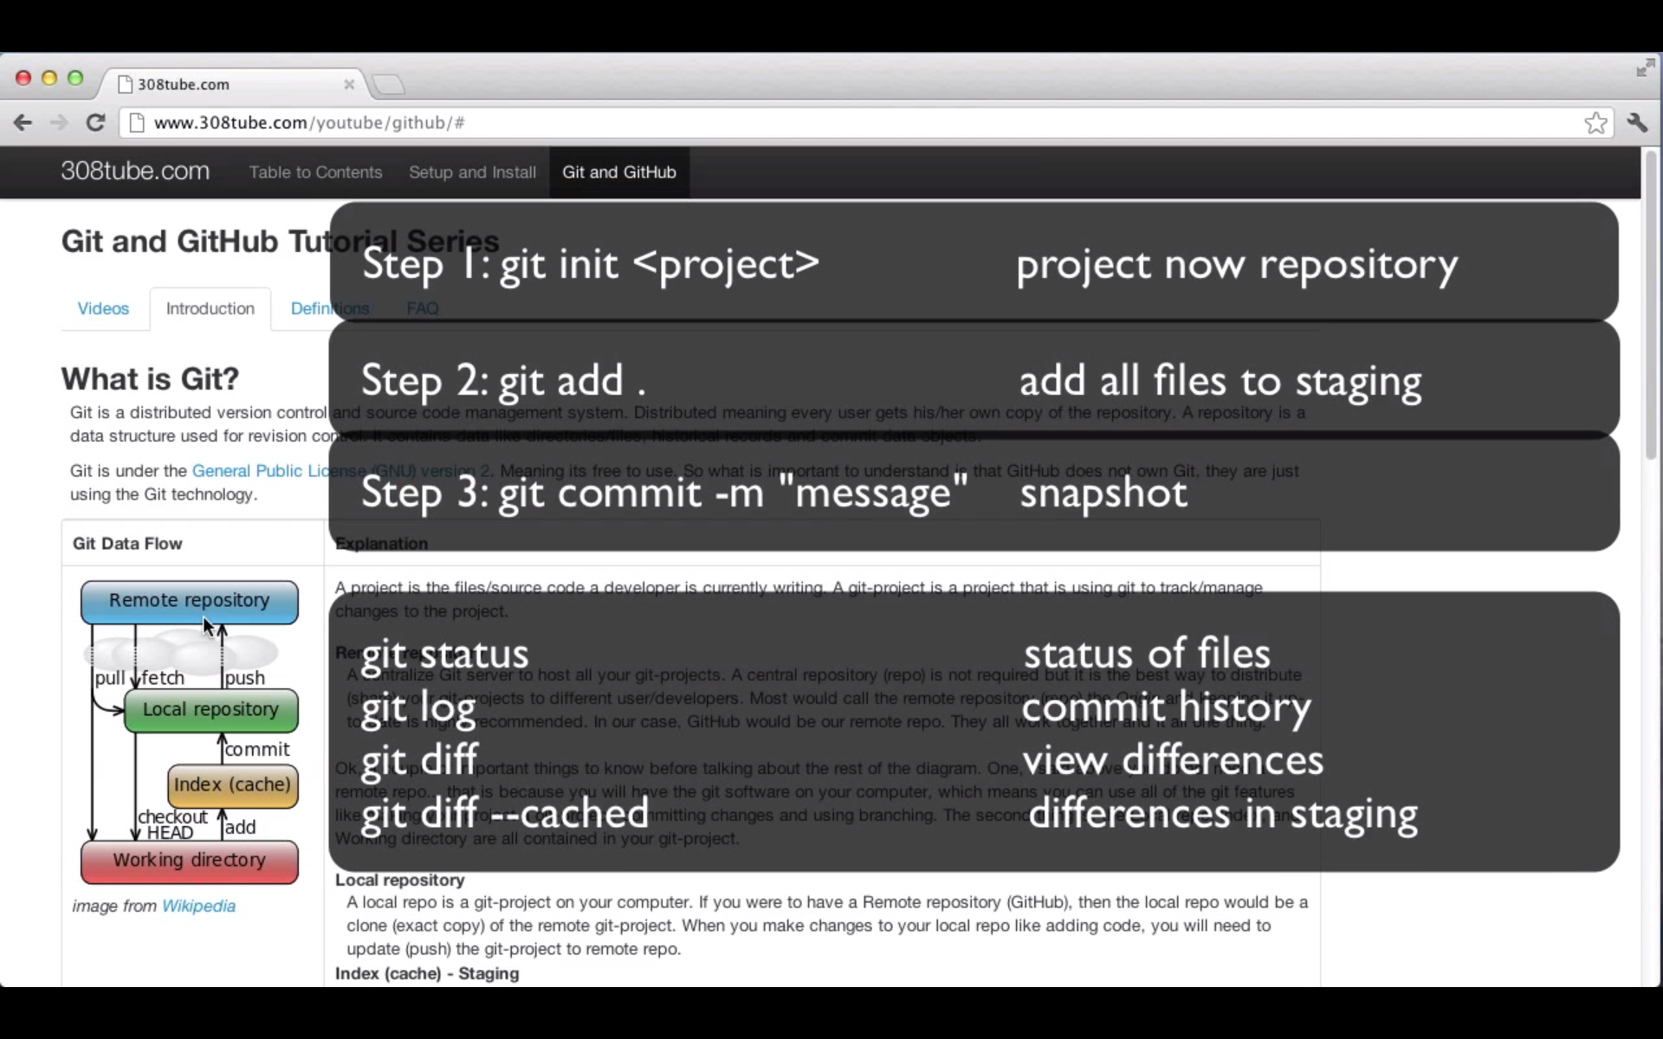

git init <project>

git add .

git add readme.txt

git rm –cache test.txt

git commit –m “Initial commit” <- m: message

git status

git log

(Each time a file is modified, you need to add the file into cache – staging area)

git add test.txt

git diff <- compare the file between one on the machine and one on the cache)

git diff –cache

git log –oneline <- only see the messages, no author or other information

git commit –a –m “shortcut message” <- all all files into staging area and commit all.

Git status -s