How to create and run automation tests

* Server machine: 192.168.128.76
* Username/password: genius/trial (🡨 recommended to use this one).
* Root username/password: root/minime

1. **Prerequisites:**
2. Install Java and Java SE Development Kits(JKD)

<http://java.com/en/download/index.jsp>

~~(~~[~~http://www.oracle.com/technetwork/java/javase/downloads/index.html~~](http://www.oracle.com/technetwork/java/javase/downloads/index.html)~~)~~

<http://www.oracle.com/technetwork/java/javase/downloads/jdk7-downloads-1880260.html>

1. Install Eclipse
2. Install Testng

http://testng.org/doc/download.html

1. Download selenium webdriver
2. **On Eclipse UI:**
3. Create a Java project
4. Create a package
5. Import selenium libraries
6. Create testng classes for each test case
7. Create a suite or testng.xml file
8. Run the tests by using “Run as “ – testing
9. **On Linux server machine**, make sure the following script is running.

/root/Selenium/runSeleniumNode.sh

1. **On Windows test machine**, which is used for automation test, configure the following.

(The Windows machine 192.168.128.89, which has Windows 7. Username/password: minifire/trial)

1. Make sure “runSeleniumNode” in running. (C:\Users\mirifice\Desktop\Selenium\ runSeleniumNode.bat)
2. IE option, set “Enable protected Mode” for all Security zones to be the same value.
3. Disable internal network firewall.

<https://code.google.com/p/selenium/wiki/InternetExplorerDriver>

1. **On Linux test machine**, which is used for automation test, execute the following script.

(It is the same machine as the server, IP address 192.168.128.76, username: root/minime)

/root/Selenium/runSeleniumNode.sh

Make sure the chrome drive is executable by user.

-rwx-----x 1 root root 17868256 Apr 8 15:32 /root/Selenium/chromedriver

1. **Test results:**

After all tests have been run, observe the results on Eclipse UI.

1. Console tab
2. Testng result tab:

* “All Tests”
* “Failed Tests”
* “Summary”

1. “Test-output” folder in “Package Explorer”. Click “index.html” to open test results in html format.
2. **Export a project from eclipse**

<http://eclipse.dzone.com/articles/exporting-and-importing>

Select one or more project and use the ‘Export’ context menu or File > Export. Here I select General > Archive File:

[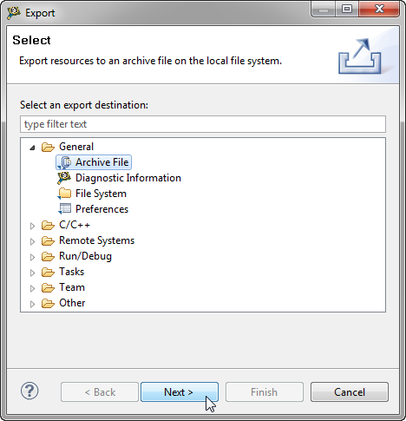](http://mcuoneclipse.files.wordpress.com/2012/05/export-archive-file.png)

Export Project as Archive File.

1. **Import a project to eclipse**
2. Create a project named “Saiku-UI-test”
3. Import the files (Do not import the whole project as jar files are in different locations.)
4. Select source files and folders to import

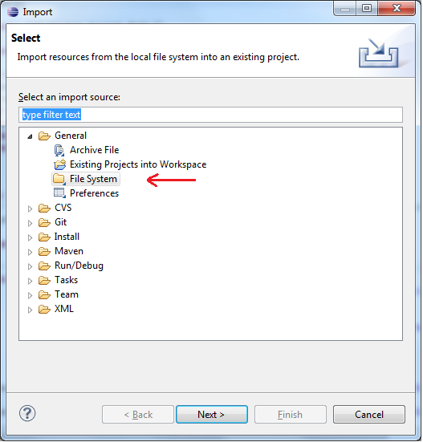

1. **IE driver**

Internet explorer driver: even you work on 64bit Windows 8.1 OS, you should use 32bit IE driver. It will solve the problem of very slow running test. (15/10/2014)