PrimeNet: An Observatory for Prime Information Structures
Jinhua Liao
Independent Researcher

Abstract
Large-scale computational investigations in number theory frequently require researchers to repeatedly construct computational repositories, implement supporting software, verify computational correctness, organize derived products, and manage increasingly complex computational workflows. While considerable attention has been devoted to algorithms and mathematical analysis, comparatively less attention has been given to the engineering infrastructure required to support persistent, reproducible, and extensible computational investigation.
This paper presents PrimeNet, a reference architecture for persistent computational arithmetic. PrimeNet organizes deterministic repository construction, independent verification, canonical observational coordinates, modular observatories, observation sessions, computational products, atlases, metadata management, registry services, and publication support into a unified computational framework designed for long-term scientific investigation.
The current reference implementation includes a persistent repository covering the interval 1 <= n <= 10^12, containing 37,607,912,018 verified prime numbers organized into 100 independently verified repository segments, with complete repository verification performed after deterministic construction. The architecture further supports reusable computational observatories that generate standardized observational products while preserving computational provenance and reproducibility.
The primary contribution of this work is not a new algorithm for prime computation nor a new mathematical theory of prime numbers. Rather, it is the design, implementation, and validation of a persistent computational architecture that enables computational investigations to become reproducible, extensible, and reusable scientific resources. PrimeNet is presented as a reference architecture upon which future computational investigations in prime arithmetic may be systematically developed.
Keywords: Computational arithmetic; prime numbers; scientific infrastructure; repository architecture; reproducible computing; computational observatory; research software engineering.

PrimeNet Reference Implementation
Characteristic | Reference Implementation
Repository interval | 1 <= n <= 10^12
Verified prime numbers | 37,607,912,018
Largest stored prime | 999,999,999,989
Repository segments | 100
Segment size | 10^10 integers
Repository verification | 100/100 passed
Repository construction | Deterministic
Prime Space | Implemented
Observatory Framework | Implemented
Product Framework | Implemented
Registry Services | Implemented

Canonical Architecture Figures
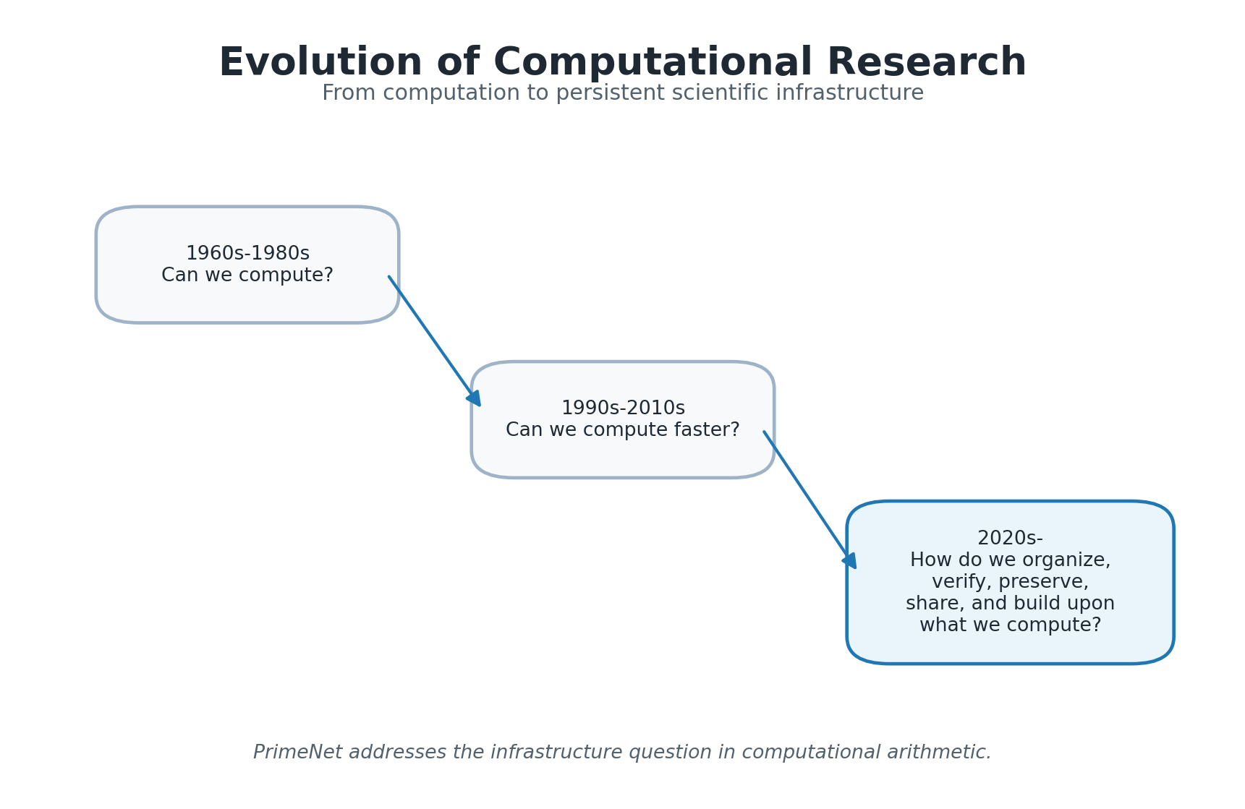
Figure 1. Evolution of Computational Research. The figure summarizes the shift from computational feasibility and performance toward organization, verification, preservation, sharing, and reuse.
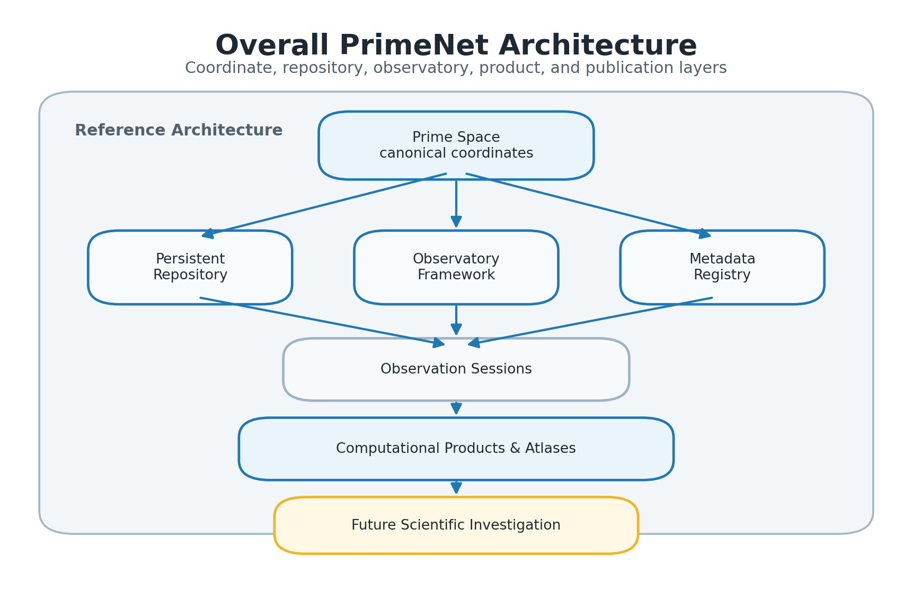
Figure 2. Overall PrimeNet Architecture. PrimeNet organizes Prime Space, persistent repositories, observatories, metadata, observation sessions, products, and atlases into a unified computational architecture.
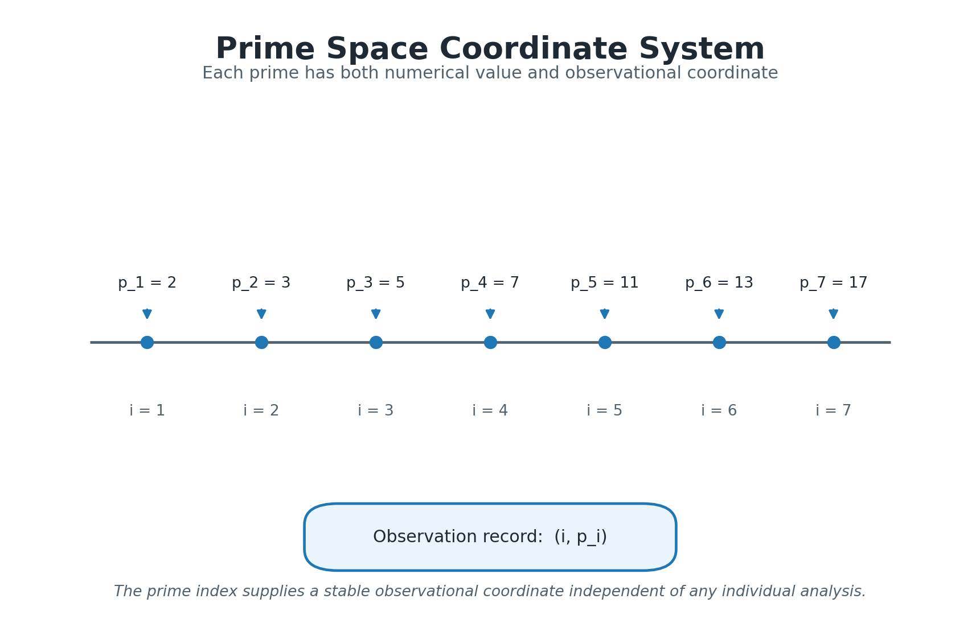
Figure 3. Prime Space Coordinate System. Prime Space represents each prime using both its numerical value and its prime index, providing canonical observational coordinates for computational products.
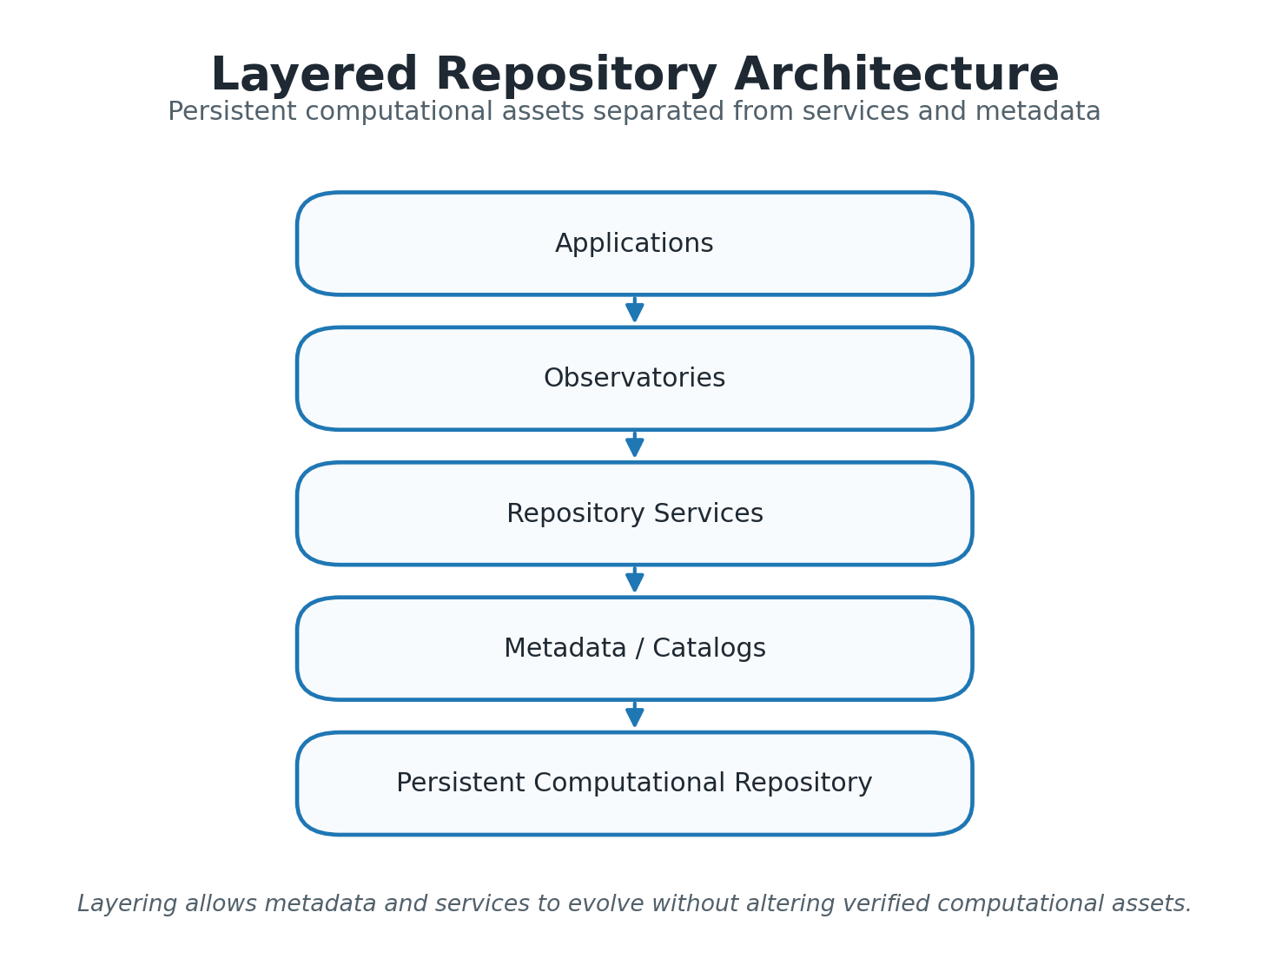
Figure 4. Layered Repository Architecture. The layered organization separates applications, observatories, repository services, metadata, and persistent computational assets.
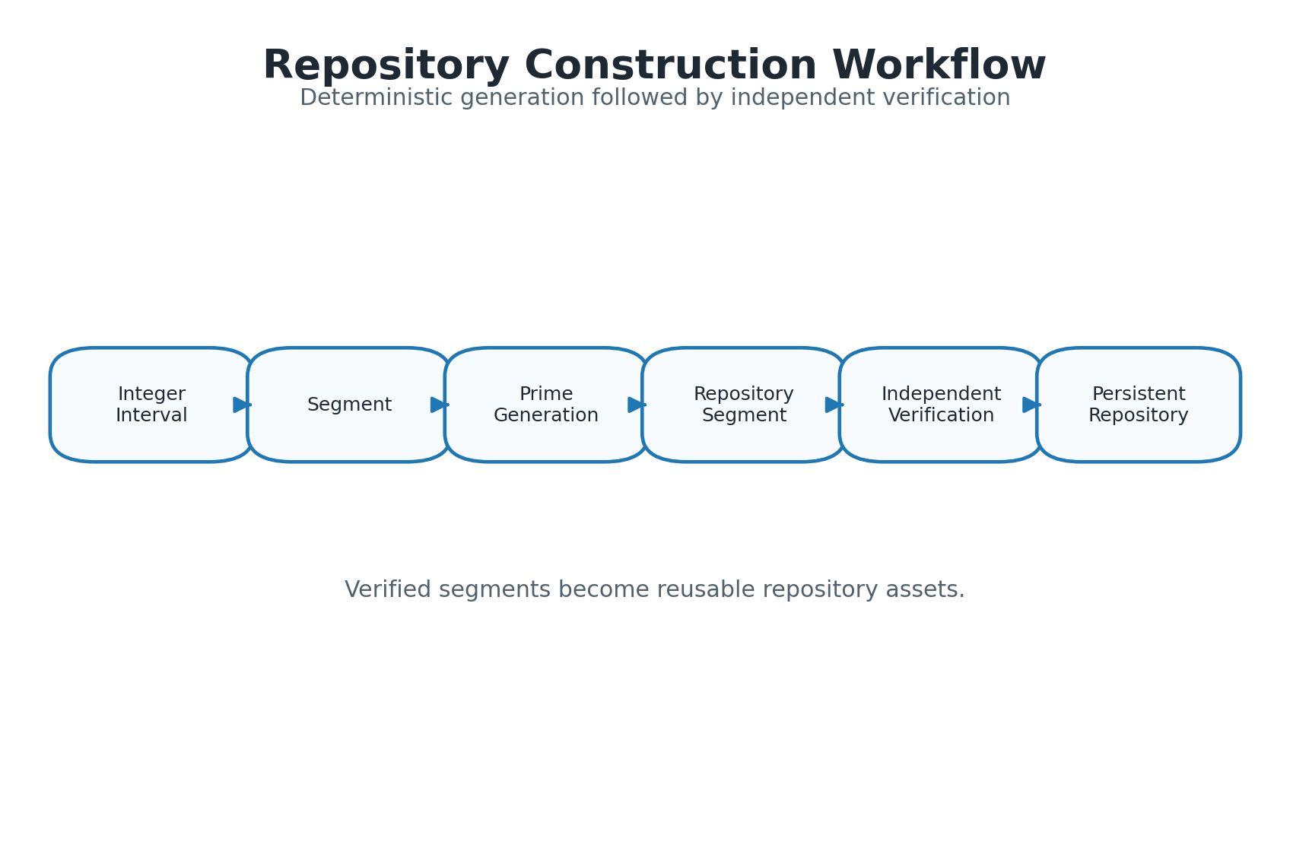
Figure 5. Repository Construction Workflow. Deterministic segmented construction produces repository segments that are independently verified before becoming persistent repository assets.
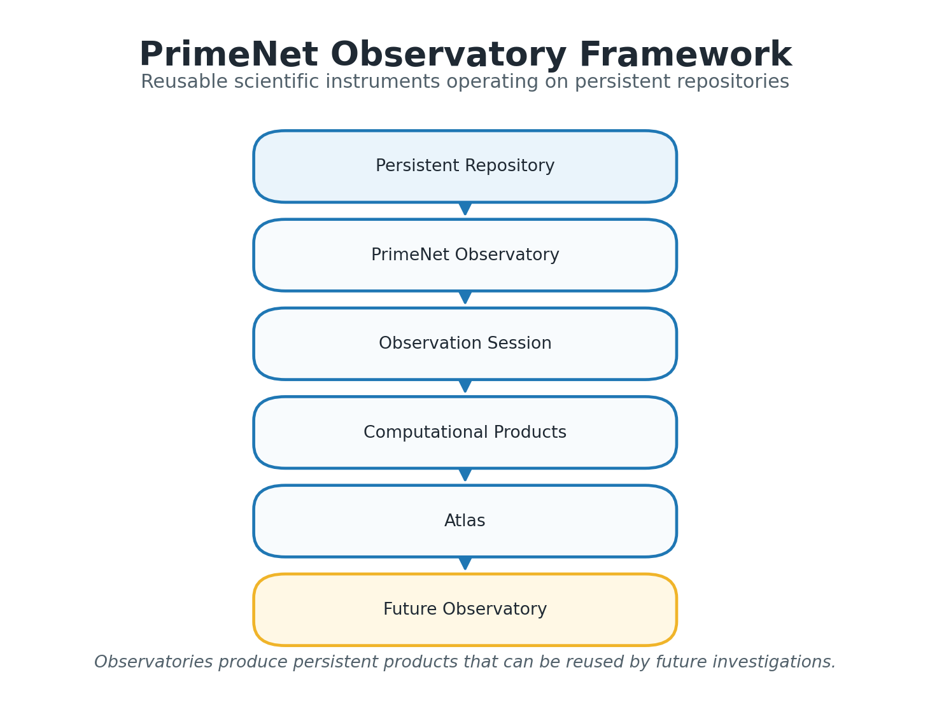
Figure 6. PrimeNet Observatory Framework. Observatories operate on the persistent repository, record observation sessions, generate computational products, and organize related products into atlases.
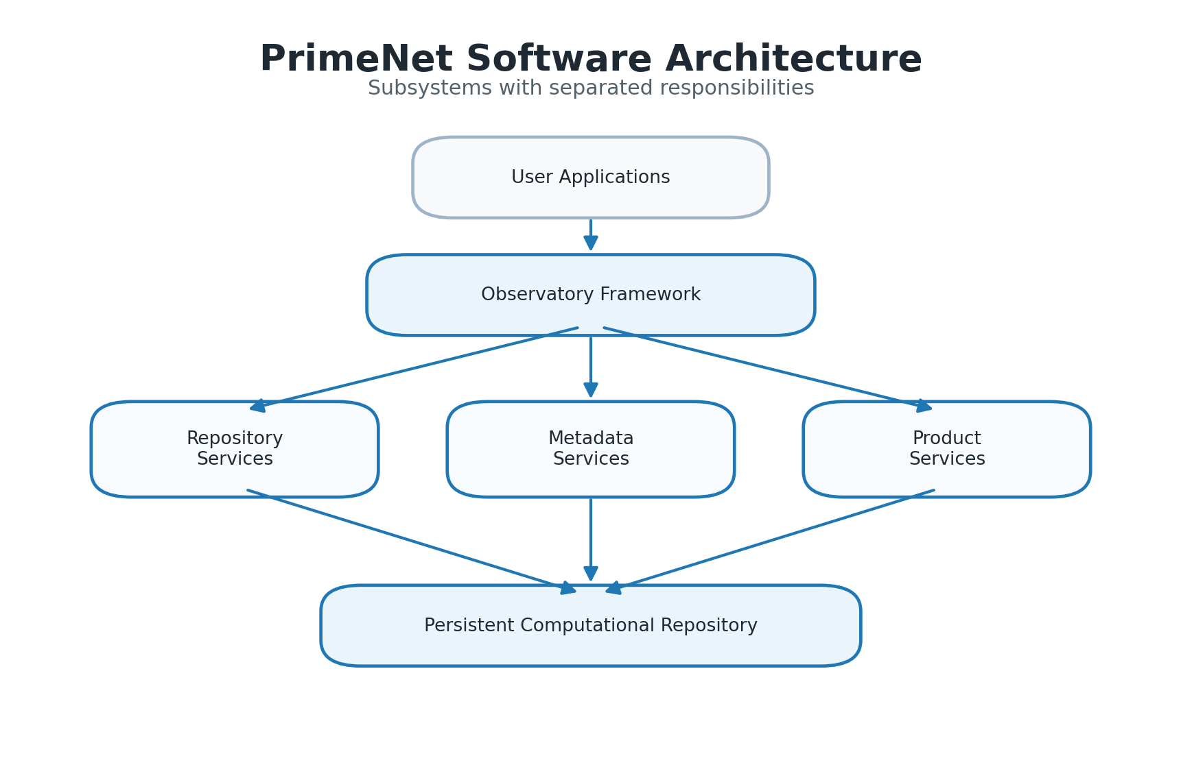
Figure 7. PrimeNet Software Architecture. The implementation separates observatory execution, repository services, metadata services, product services, and persistent repository resources.
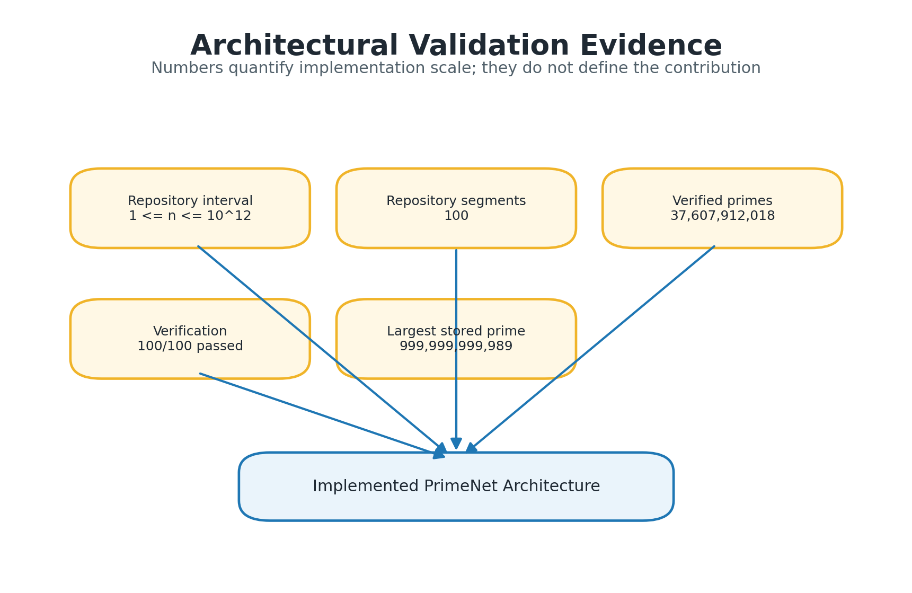
Figure 8. Architectural Validation Evidence. Repository scale, segment count, verified prime count, verification status, and largest stored prime provide evidence that the architecture has been realized at trillion scale.
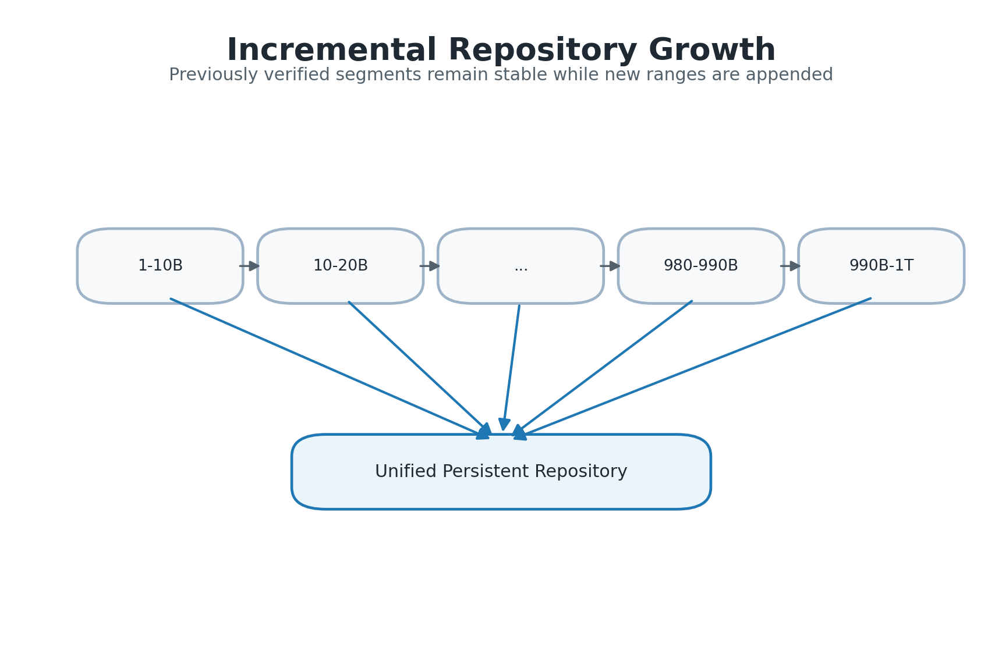
Figure 9. Incremental Repository Growth. Repository segments may be appended incrementally without reconstructing previously verified computational assets.
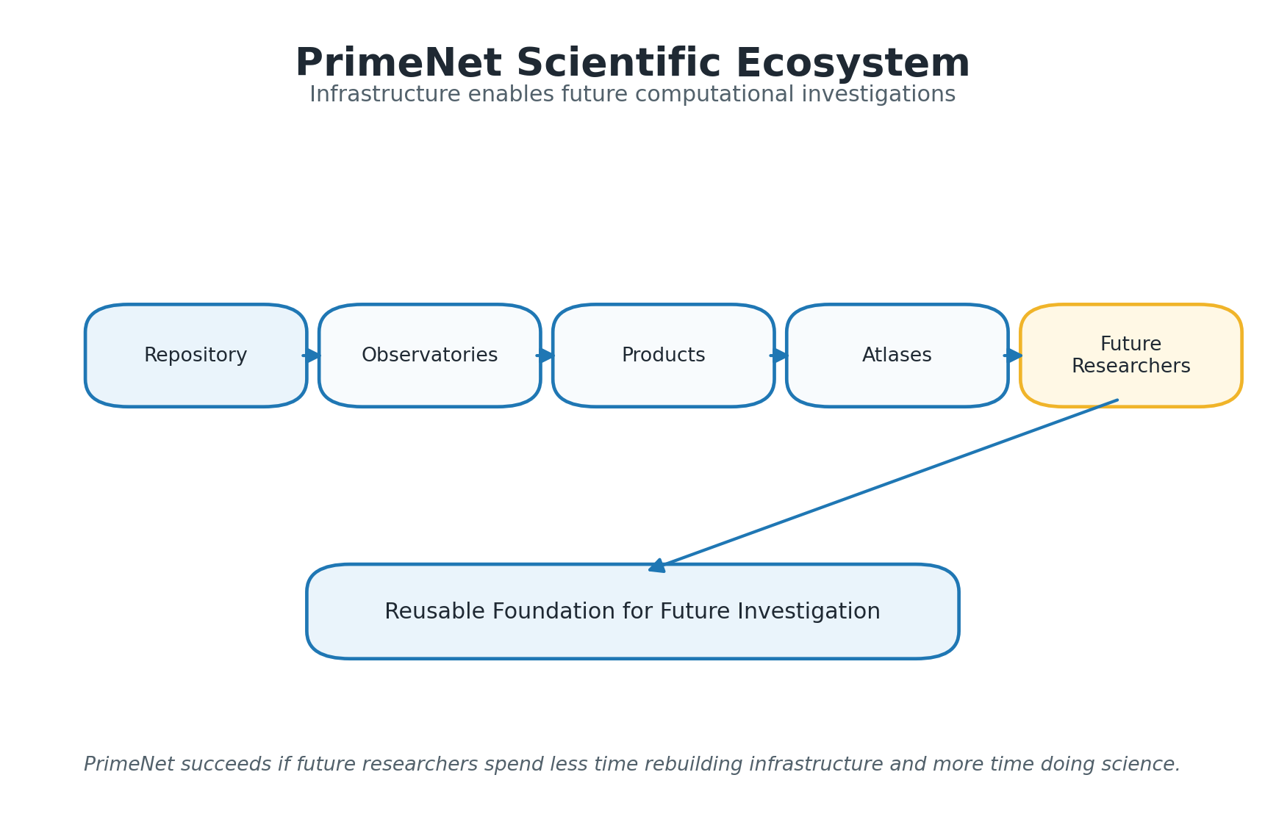
Figure 10. PrimeNet Scientific Ecosystem. Repositories, observatories, products, and atlases form reusable infrastructure supporting future computational investigations.

Canonical Tables
Table 1. PrimeNet Reference Implementation.
Characteristic | Reference Implementation
Repository interval | 1 <= n <= 10^12
Verified prime numbers | 37,607,912,018
Largest stored prime | 999,999,999,989
Repository segments | 100
Segment size | 10^10 integers
Repository verification | 100/100 passed
Repository construction | Deterministic
Prime Space | Implemented
Observatory Framework | Implemented
Product Framework | Implemented
Registry Services | Implemented

Table 2. Design Principles and Architectural Realization.
Design Principle | Architectural Realization
Observation before explanation | Repository + Observatory Framework
Persistent repository architecture | Verified persistent repository segments
Reproducibility by design | Deterministic construction + independent verification
Canonical coordinate system | Prime Space and prime index
Separation of responsibilities | Repository / Observatory / Product / Registry layers
Extensibility through modular architecture | New observatories and products can be added incrementally

Table 3. PrimeNet Architectural Components.
Component | Primary Responsibility
Prime Space | Canonical observational coordinate framework
Repository | Persistent computational assets
Observatory | Reusable computational investigation
Observation Session | Provenance and execution context
Product | Persistent observational output
Atlas | Curated collection of related products
Registry | Discovery and lifecycle management
Publisher | Publication assets and manuscript generation

Table 4. Repository Statistics as Architectural Evidence.
Metric | Value
Repository interval | 1 <= n <= 10^12
Verified primes | 37,607,912,018
Largest stored prime | 999,999,999,989
Repository segments | 100
Segment size | 10^10 integers
Verification result | 100/100 passed

Table 5. Software Architecture Subsystems.
Subsystem | Responsibility
Repository construction services | Deterministic generation of repository segments
Repository management services | Inventory, catalogs, and lifecycle management
Verification services | Independent repository validation
Metadata services | Repository and product description
Observatory execution framework | Run reusable computational investigations
Product management | Preserve and organize persistent outputs
Registry services | Discover observatories and products
Publisher services | Generate publication figures, tables, and manuscript scaffolds

Table 6. Reproducibility Features.
Feature | Purpose
Deterministic construction | Repeatable repository generation
Independent verification | Validate repository integrity
Structured metadata | Preserve repository and product context
Observation sessions | Preserve execution provenance
Persistent products | Enable reuse without recomputation
Registry services | Support discoverability and consistency
Publication manifest | Preserve publication build provenance

