PrimeNet: An Observatory for Prime Information Structures
Jinhua Liao
Independent Researcher

Abstract
Large-scale computational investigations in number theory frequently require researchers to repeatedly construct computational repositories, implement supporting software, verify computational correctness, organize derived products, and manage increasingly complex computational workflows. While considerable attention has been devoted to algorithms and mathematical analysis, comparatively less attention has been given to the engineering infrastructure required to support persistent, reproducible, and extensible computational investigation.
This paper presents PrimeNet, a reference architecture for persistent computational arithmetic. PrimeNet organizes deterministic repository construction, independent verification, canonical observational coordinates, modular observatories, observation sessions, computational products, atlases, metadata management, registry services, and publication support into a unified computational framework designed for long-term scientific investigation.
The current reference implementation includes a persistent repository covering the interval 1 <= n <= 3,000,000,000,000, containing 108,340,298,703 verified prime numbers organized into 300 independently verified repository segments. Exact repository products are additionally compared with classical prime-count, mean-gap, and twin-prime reference laws.
The primary contribution of this work is not a new algorithm for prime computation nor a new mathematical theory of prime numbers. Rather, it is the design, implementation, and validation of a persistent computational architecture that enables computational investigations to become reproducible, extensible, and reusable scientific resources.
Keywords: Computational arithmetic; prime numbers; scientific infrastructure; repository architecture; reproducible computing; computational observatory; research software engineering; analytic number theory validation.

PrimeNet Reference Implementation
Characteristic | Reference Implementation
Repository interval | 1 <= n <= 3,000,000,000,000
Verified prime numbers | 108,340,298,703
Largest stored prime | 2,999,999,999,933
Repository segments | 300
Segment size | 10,000,000,000 integers
Repository verification | 300/300 passed; SHA-256 certified
Repository construction | Deterministic
Prime Space | Implemented
Observatory Framework | Implemented
Product Framework | Implemented
Registry Services | Implemented

1. Introduction
Computational methods have become an indispensable component of modern scientific research. Across disciplines, large-scale computational investigations increasingly generate data products, software artifacts, metadata, and derived observations that must be organized if they are to remain useful after the original computation has completed.
Computational arithmetic presents a similar engineering challenge. Researchers may repeatedly generate prime data, verify files, write analysis scripts, and preserve outputs in project-specific formats. PrimeNet was developed to reduce this duplication by organizing computational arithmetic as persistent scientific infrastructure.
The purpose of this paper is to document the PrimeNet reference architecture. The contribution is architectural rather than mathematical: PrimeNet provides an implemented framework for deterministic repository construction, canonical observational coordinates, reusable observatories, persistent products, and publication support.
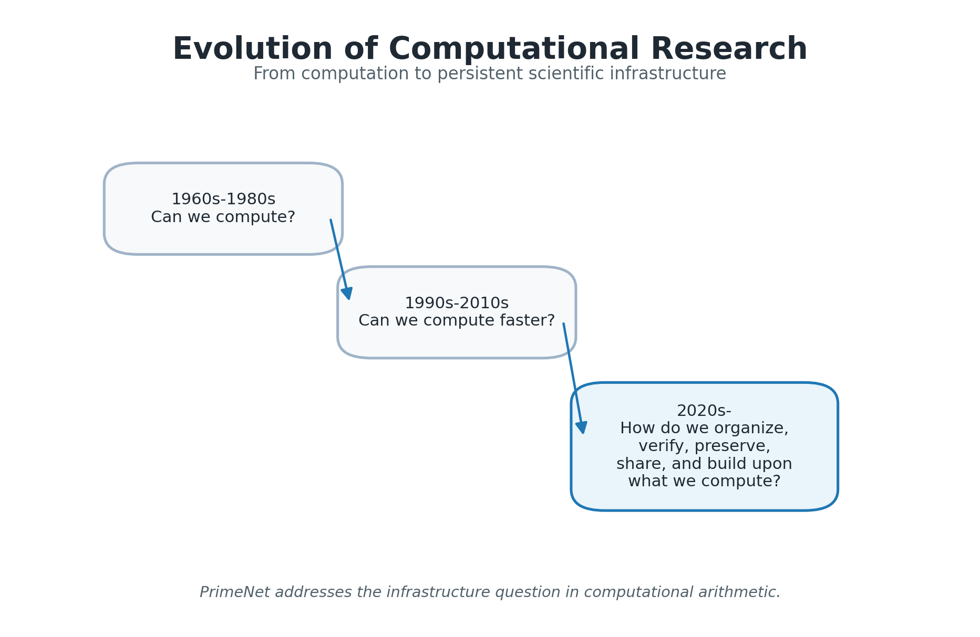
Figure 1. Evolution of Computational Research. The figure summarizes the shift from computational feasibility and performance toward organization, verification, preservation, sharing, and reuse.

2. Design Philosophy
PrimeNet was not designed all at once. Its architectural principles emerged through the practical engineering process of building, verifying, organizing, and reusing large-scale prime computation. The resulting design favors stable interfaces, separation of responsibilities, deterministic construction, and reusable scientific products.
A central principle is observation before explanation. PrimeNet does not require a specific conjecture or theoretical model before computation can begin. Instead, it provides a systematic environment in which observations can be generated, recorded, compared, and reused.
The architecture also treats reproducibility as a structural requirement. Verification, metadata, sessions, registries, and publication manifests are not optional decorations; they are part of the system design.
Table 2. Design Principles and Architectural Realization.
Design Principle | Architectural Realization
Observation before explanation | Repository + Observatory Framework
Persistent repository architecture | Verified persistent repository segments
Reproducibility by design | Deterministic construction + independent verification
Canonical coordinate system | Prime Space and prime index
Separation of responsibilities | Repository / Observatory / Product / Registry layers
Extensibility through modular architecture | New observatories and products can be added incrementally

3. Prime Space
Prime Space is the canonical coordinate system used by PrimeNet. Instead of treating prime numbers only as numerical values, PrimeNet records observations using the prime index together with the prime value. This gives each observed prime a stable coordinate within the ordered sequence of primes.
The prime index is important because many observational products concern relationships between successive primes, prime gaps, fixed-gap languages, transition structures, and other sequence-based phenomena. Using a canonical coordinate system makes these products easier to compare and reproduce.
Prime Space therefore acts as an organizing layer between raw arithmetic computation and higher-level observation. It is the coordinate foundation upon which repositories, observatories, and products can agree.
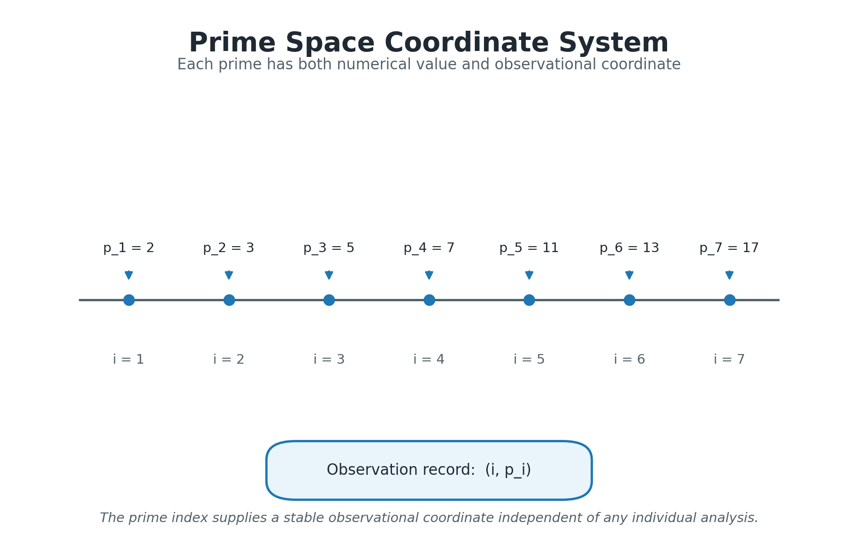
Figure 3. Prime Space Coordinate System. Prime Space represents each prime using both its numerical value and its prime index, providing canonical observational coordinates for computational products.

4. Repository Architecture
The Repository is the persistent computational foundation of PrimeNet. It stores verified computational assets in a form that can be reused by observatories and future investigations without regenerating the same data repeatedly.
The reference implementation covers the interval 1 <= n <= 3,000,000,000,000, contains 108,340,298,703 verified prime numbers, and is organized into 300 independently verified repository segments. These values serve as architectural evidence that the repository model has been realized at substantial scale.
Repository services separate access, metadata, verification, and persistent storage. This separation allows the repository to remain stable while services and observatories evolve above it.
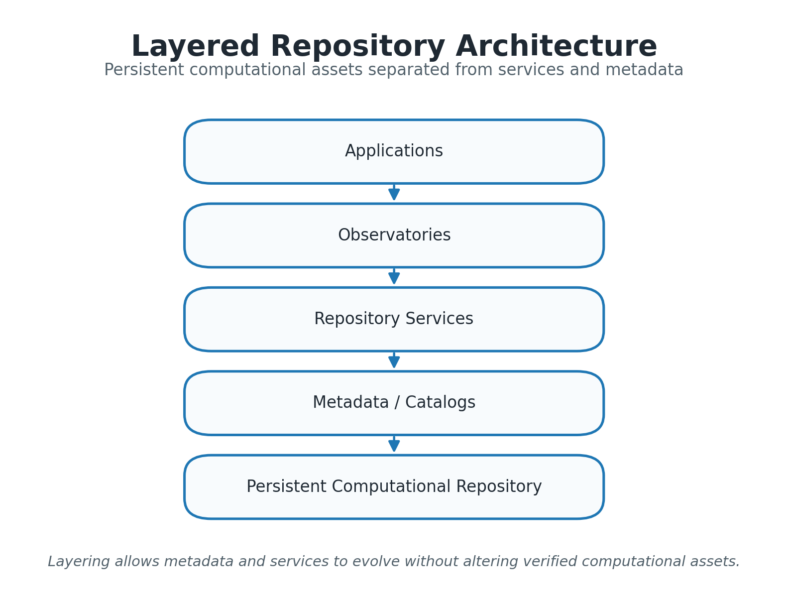
Figure 4. Layered Repository Architecture. The layered organization separates applications, observatories, repository services, metadata, and persistent computational assets.
Table 4. Repository Statistics as Architectural Evidence.
Metric | Value
Repository interval | 1 <= n <= 3,000,000,000,000
Verified primes | 108,340,298,703
Largest stored prime | 2,999,999,999,933
Repository segments | 300
Segment size | 10,000,000,000 integers
Verification result | 300/300 passed; SHA-256 certified

5. Repository Construction and Verification
Repository construction proceeds through deterministic segmentation, prime generation, segment persistence, and independent verification. Each segment becomes part of the persistent repository only after passing verification.
This workflow is intentionally conservative. The goal is not merely to compute primes, but to create computational assets that can be trusted and reused. A verified segment is treated as a persistent scientific resource rather than a temporary output file.
The construction and verification model also supports incremental growth. New ranges can be appended while previously verified segments remain stable.
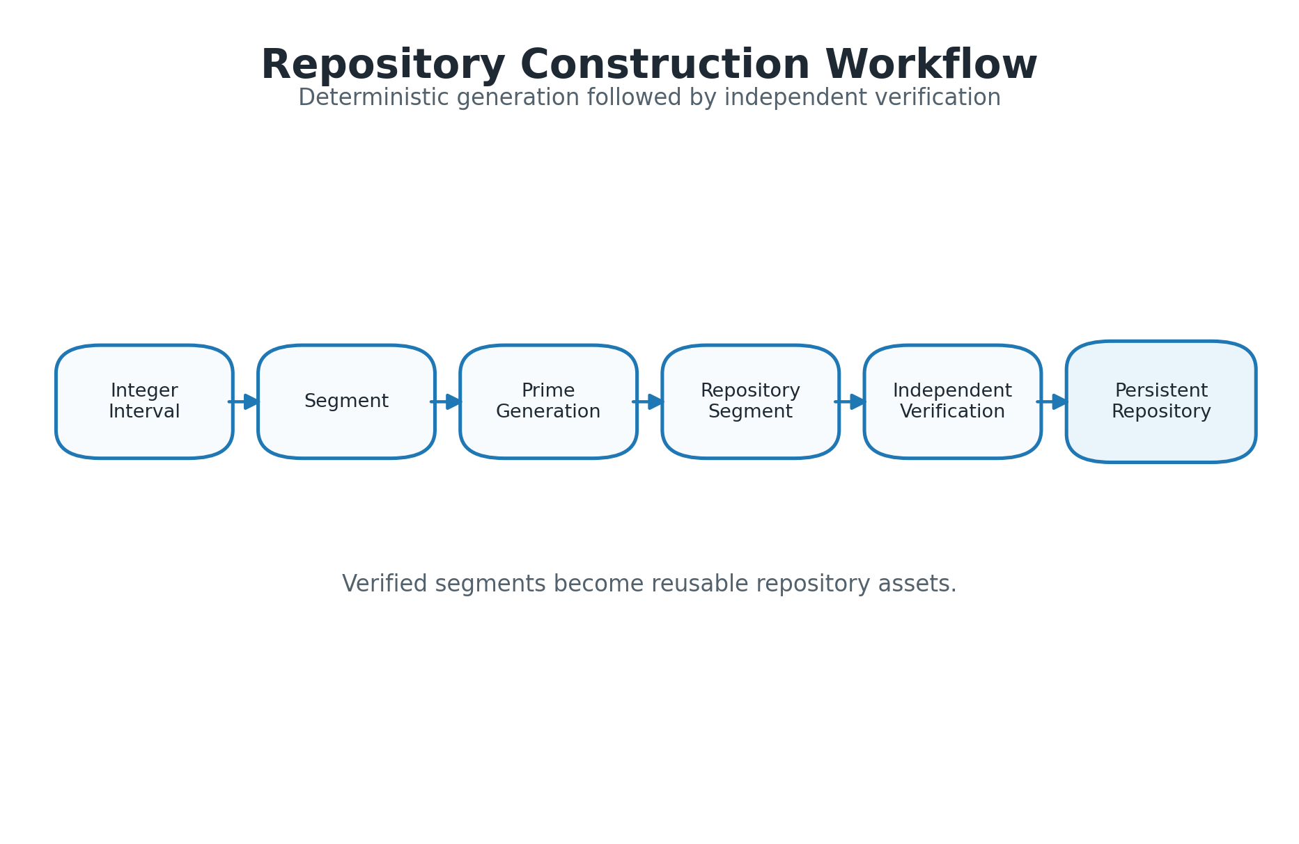
Figure 5. Repository Construction Workflow. Deterministic segmented construction produces repository segments that are independently verified before becoming persistent repository assets.

6. Observatory Framework
The Observatory Framework defines how scientific investigations are performed in PrimeNet. An observatory operates on repository assets, records an observation session, generates computational products, and may contribute to an atlas.
This structure separates persistent computational data from observational logic. New observatories can be added without changing the repository, and existing products can be reused by future observatories.
Observation Sessions preserve execution context and provenance. Products are therefore not isolated files but traceable outputs of a defined computational process.
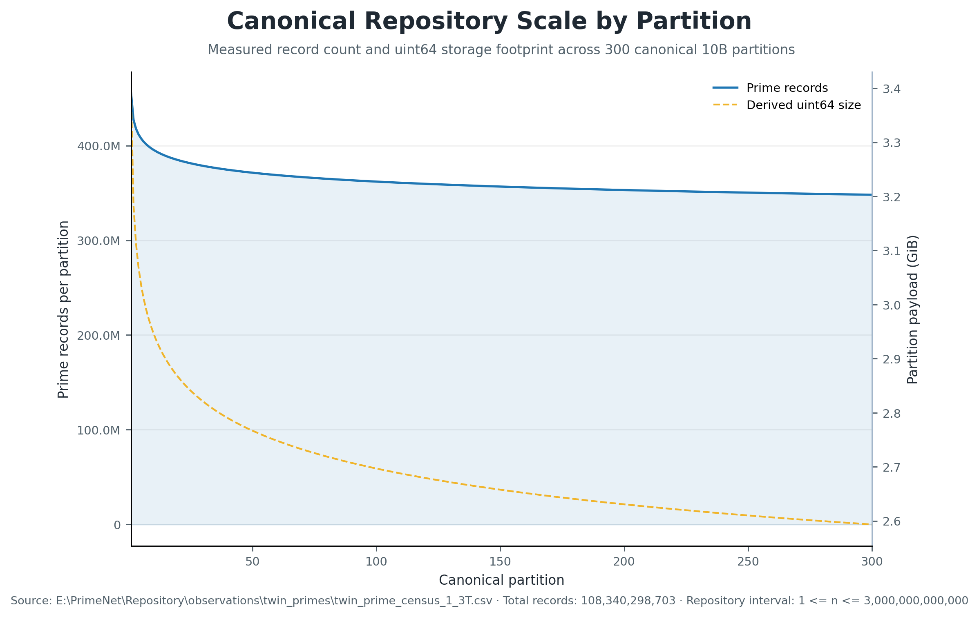
Figure 6. Canonical Repository Scale by Partition. Measured record counts and derived uint64 payload sizes show the physical scale profile across the 300 canonical 10-billion-integer partitions.
Table 3. PrimeNet Architectural Components.
Component | Primary Responsibility
Prime Space | Canonical observational coordinate framework
Repository | Persistent computational assets
Observatory | Reusable computational investigation
Observation Session | Provenance and execution context
Product | Persistent observational output
Atlas | Curated collection of related products
Registry | Discovery and lifecycle management
Publisher | Publication assets and manuscript generation

7. Products and Atlases
Products are persistent outputs generated by observatories. They may include tables, summaries, transition data, entropy measurements, figures, manifests, or other structured computational artifacts.
Atlases organize related products into reusable scientific collections. The atlas concept reflects the view that computational observations should accumulate over time instead of disappearing after individual experiments.
Products and atlases are essential to PrimeNet because they convert computational work into reusable scientific memory.

8. Software Architecture
PrimeNet is implemented as a modular software system. Repository services, metadata services, product services, observatory execution, and publication support are separated into distinct responsibilities.
This modularity is important for long-term maintainability. A new observatory should not need to reimplement repository access, metadata recording, product organization, or publication formatting.
The software architecture follows a simple rule: each subsystem should reduce the manual work required by the next subsystem.
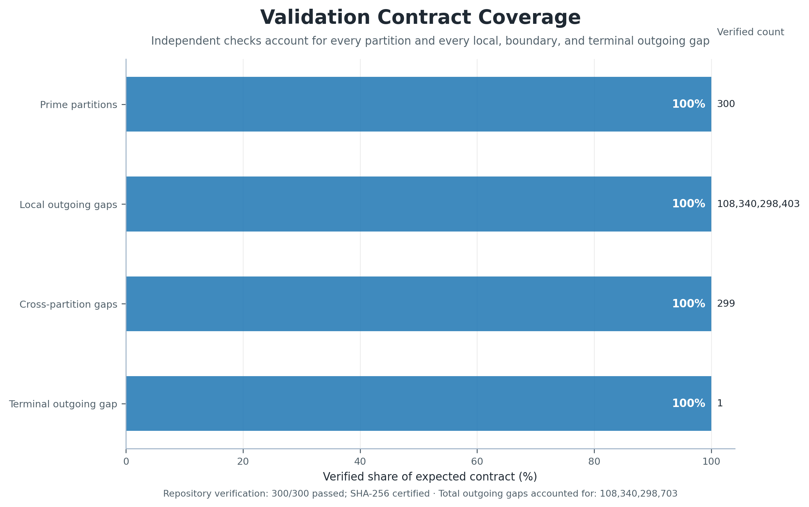
Figure 7. Validation Contract Coverage. Independent verification accounts for all prime partitions and every local, cross-partition, and terminal outgoing gap required by the Prime Space ownership contract.
Table 5. Software Architecture Subsystems.
Subsystem | Responsibility
Repository construction services | Deterministic generation of repository segments
Repository management services | Inventory, catalogs, and lifecycle management
Verification services | Independent repository validation
Metadata services | Repository and product description
Observatory execution framework | Run reusable computational investigations
Product management | Preserve and organize persistent outputs
Registry services | Discover observatories and products
Publisher services | Generate publication figures, tables, manuscript drafts, and publication manifests

9. Reproducibility and Publication Support
Reproducibility in PrimeNet is supported by deterministic construction, independent verification, structured metadata, observation sessions, persistent products, registries, and publication manifests.
PrimeNet Publisher extends the reproducibility principle into scientific communication. It generates figures, tables, manuscript scaffolds, review reports, and publication manifests from structured sources.
The publication system is included not as a convenience feature, but as part of the same engineering philosophy: computational knowledge should remain synchronized with the way it is communicated.
Table 6. Reproducibility Features.
Feature | Purpose
Deterministic construction | Repeatable repository generation
Independent verification | Validate repository integrity
Structured metadata | Preserve repository and product context
Observation sessions | Preserve execution provenance
Persistent products | Enable reuse without recomputation
Registry services | Support discoverability and consistency
Publication manifest | Preserve publication build provenance

10. Architectural Validation
Architectural validation in this paper does not mean proving a theorem about primes. It means demonstrating that the proposed architecture has been implemented and exercised at meaningful scale.
The repository interval, number of verified primes, number of repository segments, verification status, and largest stored prime are used as evidence that the architecture is concrete rather than aspirational.
The accepted 1–3T twin-prime census provides additional operational evidence. PrimeNet processed 108,340,298,703 gap records across 300 partitions in 50.122088 minutes end to end. In the conservative steady-state window, the system sustained 35,859,890.441 gap observations per second with a runtime coefficient of variation of 2.408966%.
These measurements are reported as implementation evidence rather than mathematical claims. They demonstrate that the persistent repository architecture can support stable, large-scale observational scans while preserving explicit provenance and runtime accounting.
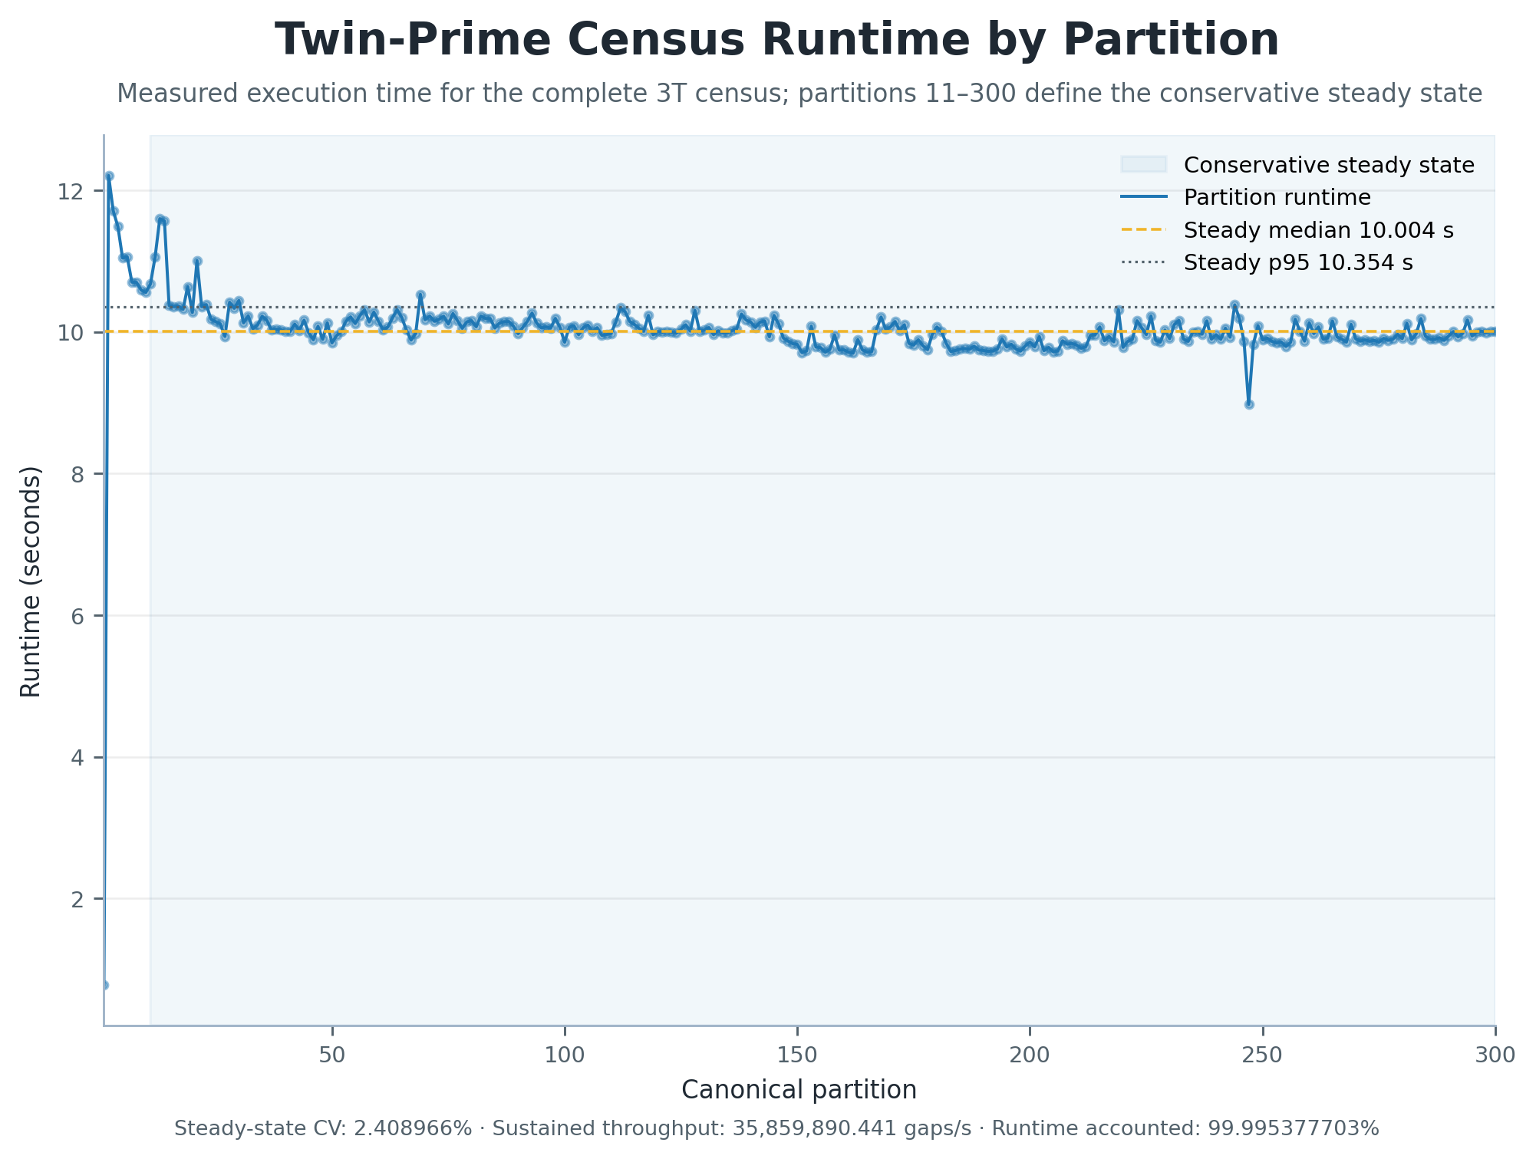
Figure 8. Twin-Prime Census Runtime by Partition. Measured partition runtimes show startup behavior and stable execution across the conservative steady-state window covering partitions 11 through 300.
Table 7. Accepted Twin-Prime Census Performance Measurements.
Metric | Accepted Measurement
Scientific domain | 1 – 3,000,000,000,000
Repository partitions | 300
Total gaps analyzed | 108,340,298,703
Twin-prime events | 5,173,760,785
Global twin density | 0.047754721437340
End-to-end runtime | 50.122088 min
Runtime accounted for | 99.995377703%
Conservative steady-state partitions | 290
Steady-state gaps analyzed | 104,222,243,890
Mean partition runtime | 10.021978 sec
Median partition runtime | 10.004263 sec
Runtime coefficient of variation | 2.408966%
Runtime P95 | 10.346914 sec
Sustained throughput | 35,859,890.441 gaps/sec

11. Validation Against Classical Number Theory
A computational infrastructure for prime arithmetic should reproduce established finite-domain consequences of classical analytic number theory before it is used to support less familiar observational studies. PrimeNet therefore compares exact repository products with standard asymptotic reference functions for prime counts, mean gaps, and twin-prime counts.
At x = 3,000,000,000,000, the exact cumulative prime count is 108,340,298,703. The elementary prime-number-theorem approximation x/log(x) has relative error -3.616844253%, whereas Li(x) and the Riemann R function have relative errors 0.000074697% and 0.000013934%, respectively.
The final partition has observed mean outgoing gap 28.728551671208, compared with log(partition midpoint) = 28.727965347505; their ratio is 1.000020409510. The cumulative twin-prime census is 5,173,760,785, compared with the Hardy–Littlewood prediction 5,173,795,178.790, with finite-domain relative discrepancy 0.000664773%.
These comparisons are validation tests, not proofs and not claims of new asymptotic theory. Their role is to show that independently generated PrimeNet products agree closely with established large-scale expectations across the verified 1–3T repository.
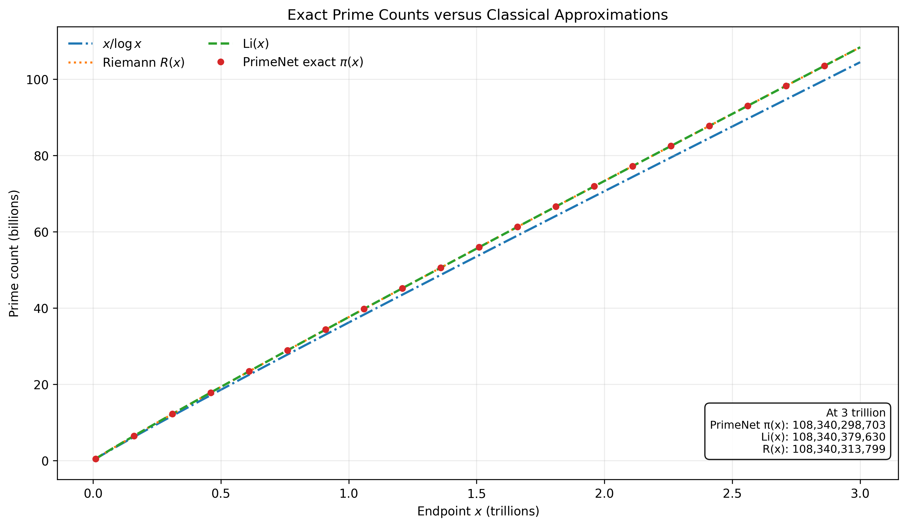
Figure 11. Prime-count validation. Exact cumulative prime counts are compared with x/log(x), the logarithmic integral Li(x), and the Riemann R function across the 300 canonical partitions.
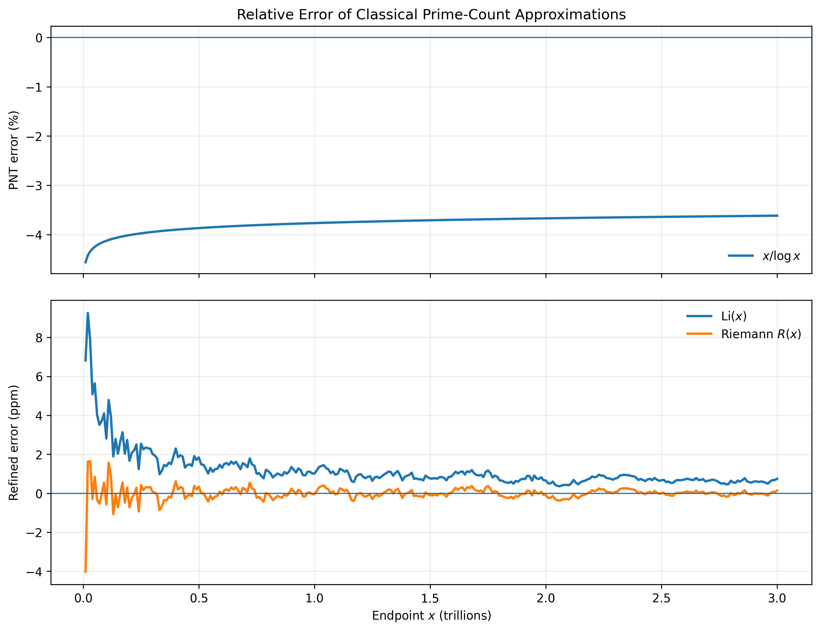
Figure 12. Relative error of classical prime-count approximations. The dominant x/log(x) error is shown separately from the much smaller Li(x) and Riemann R errors.
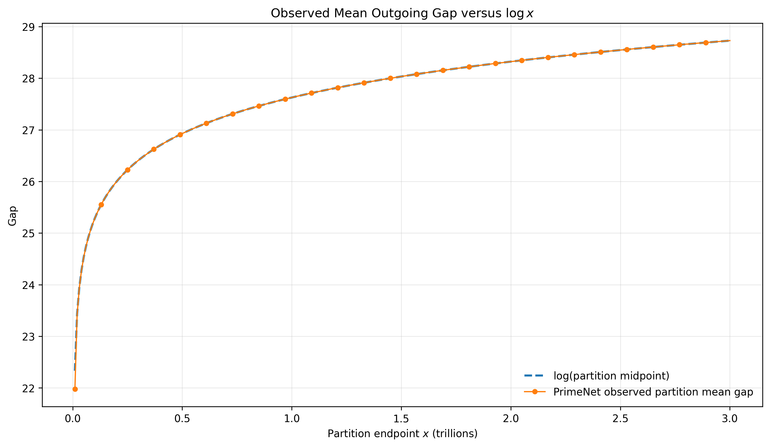
Figure 13. Mean outgoing-gap validation. Partition-level observed mean outgoing gaps are compared with the classical logarithmic scale log(x).
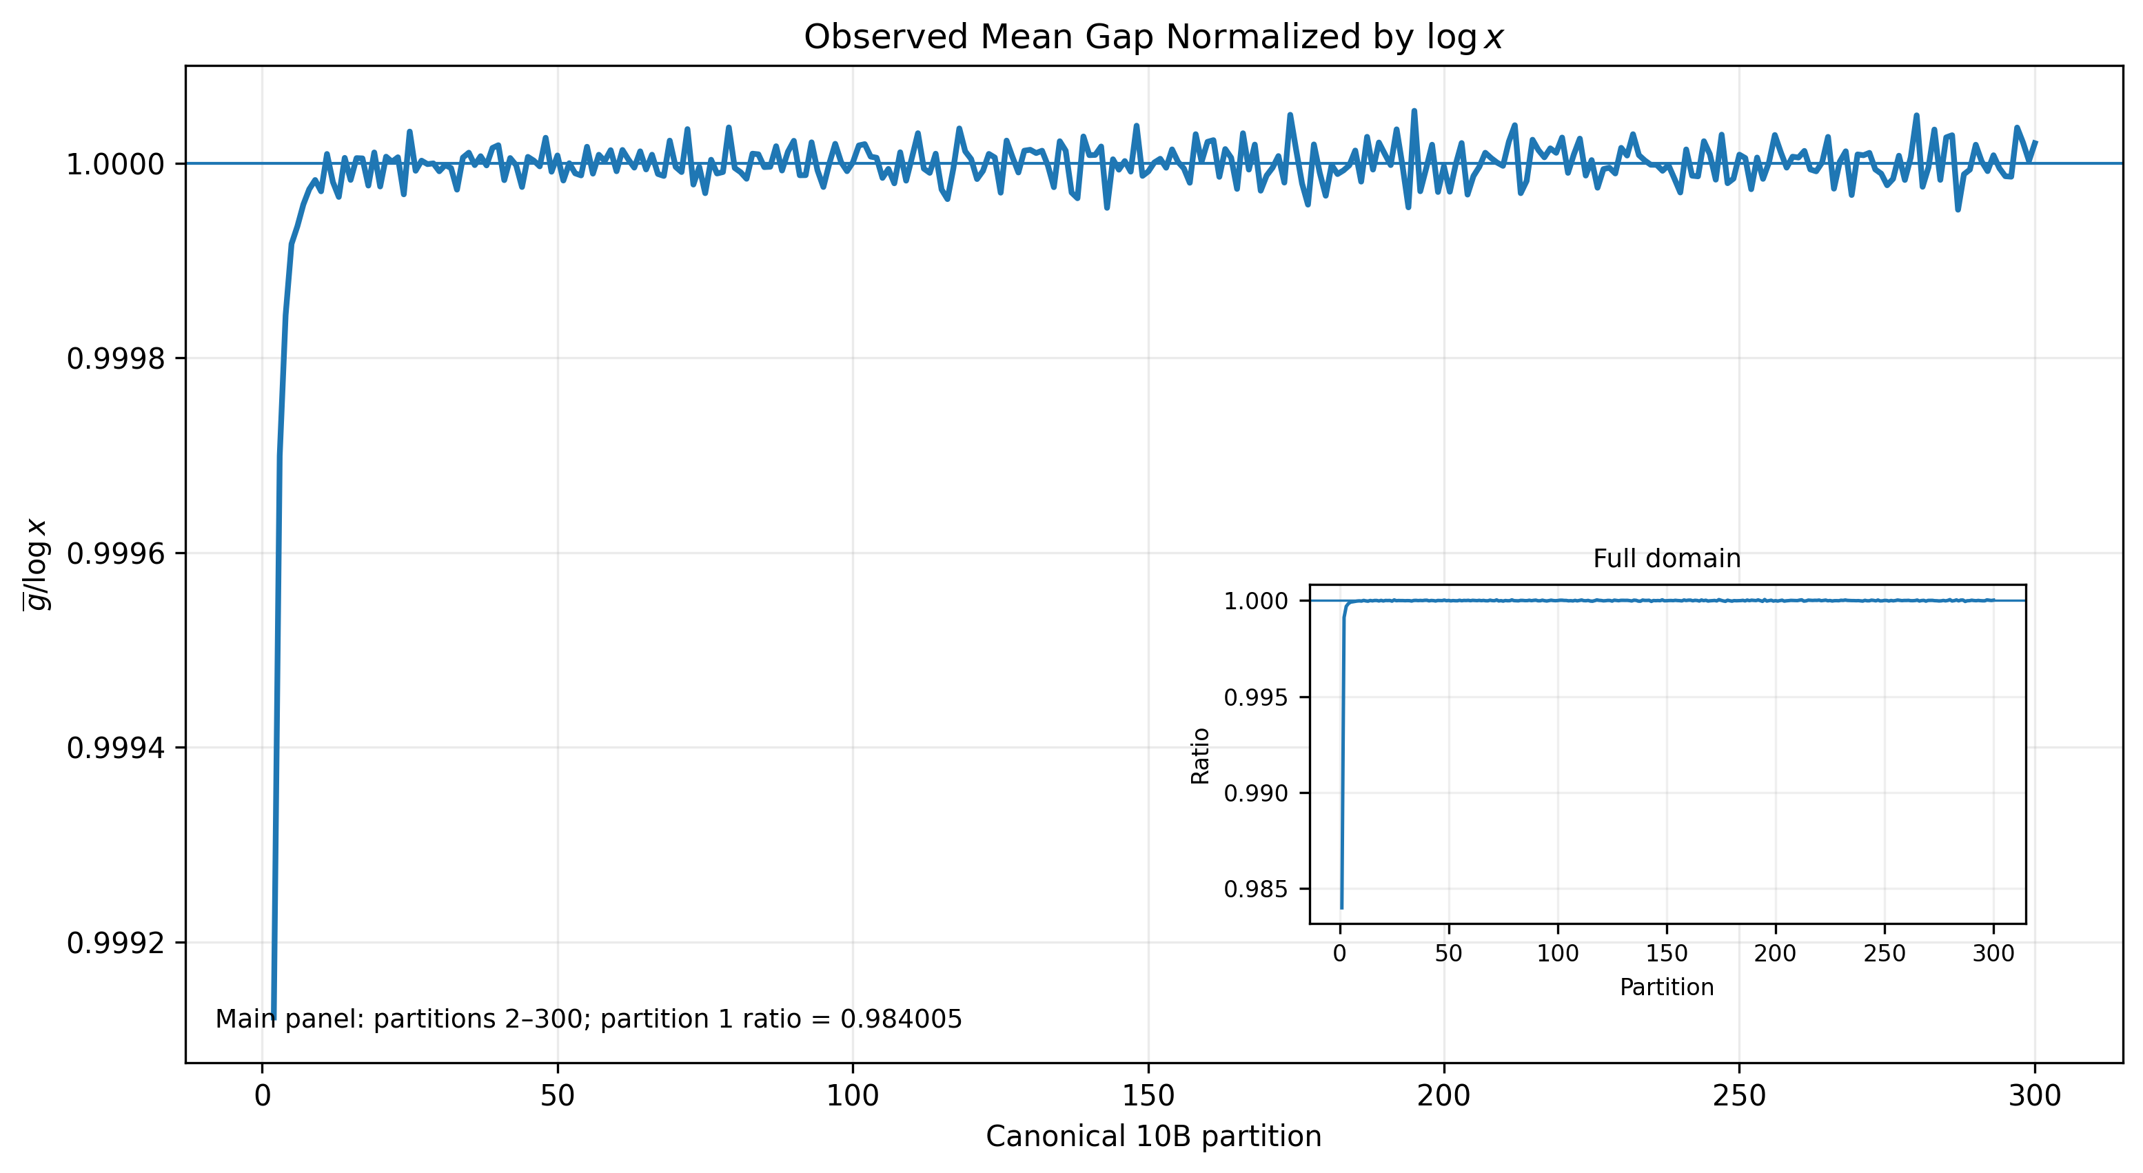
Figure 13b. Normalized mean-gap validation. The ratio of observed mean outgoing gap to log(partition midpoint) approaches unity across the verified repository domain.
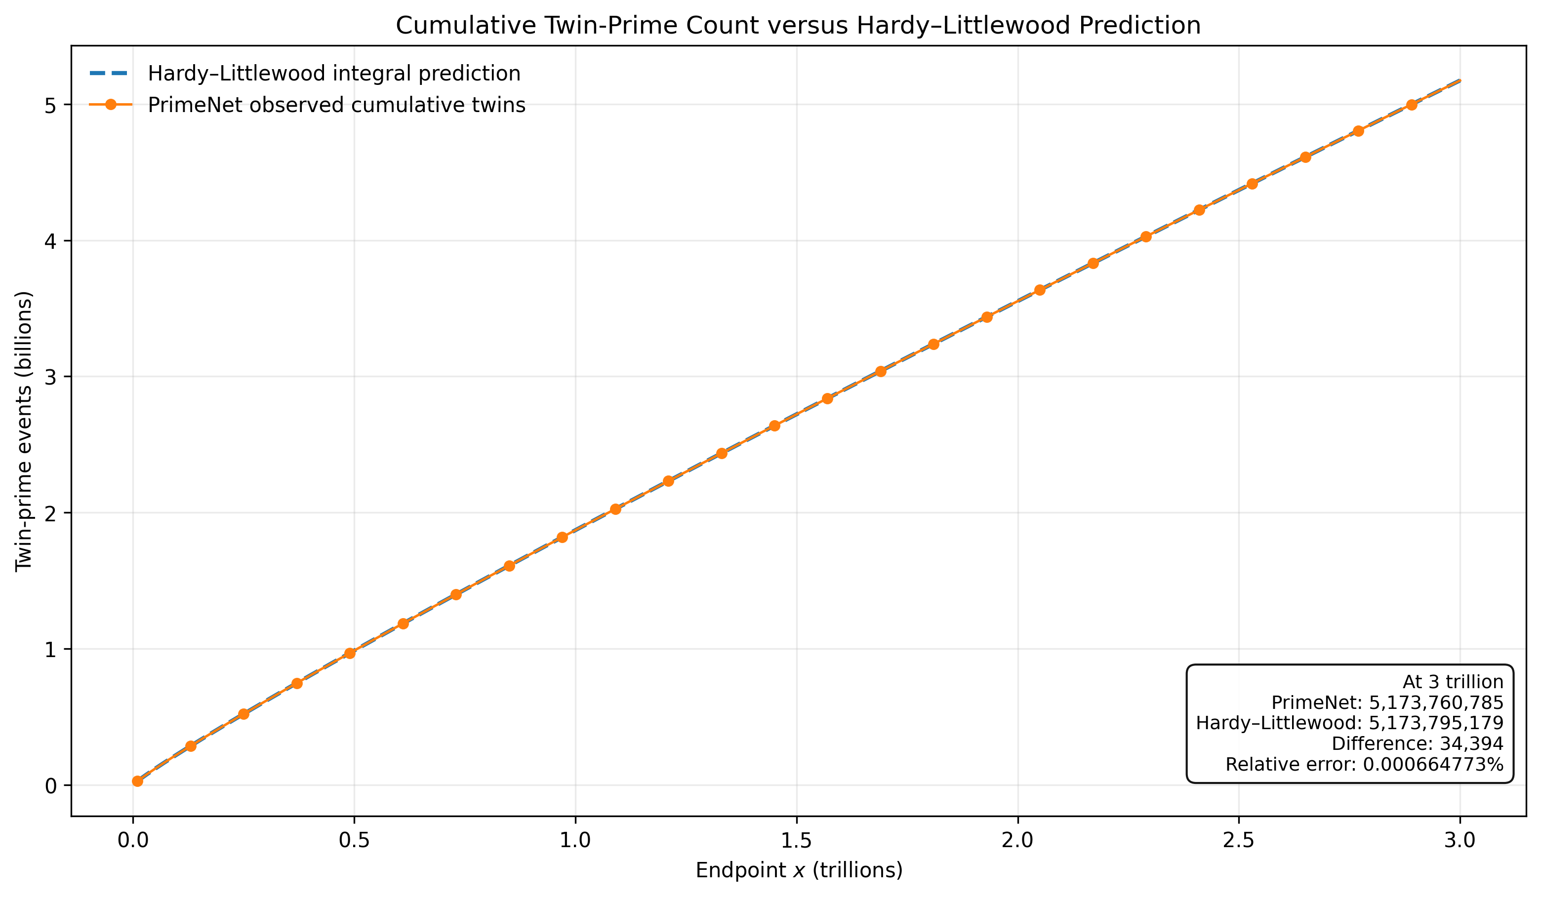
Figure 14. Twin-prime-count validation. Exact cumulative twin-prime events are compared with the Hardy–Littlewood finite-domain prediction.
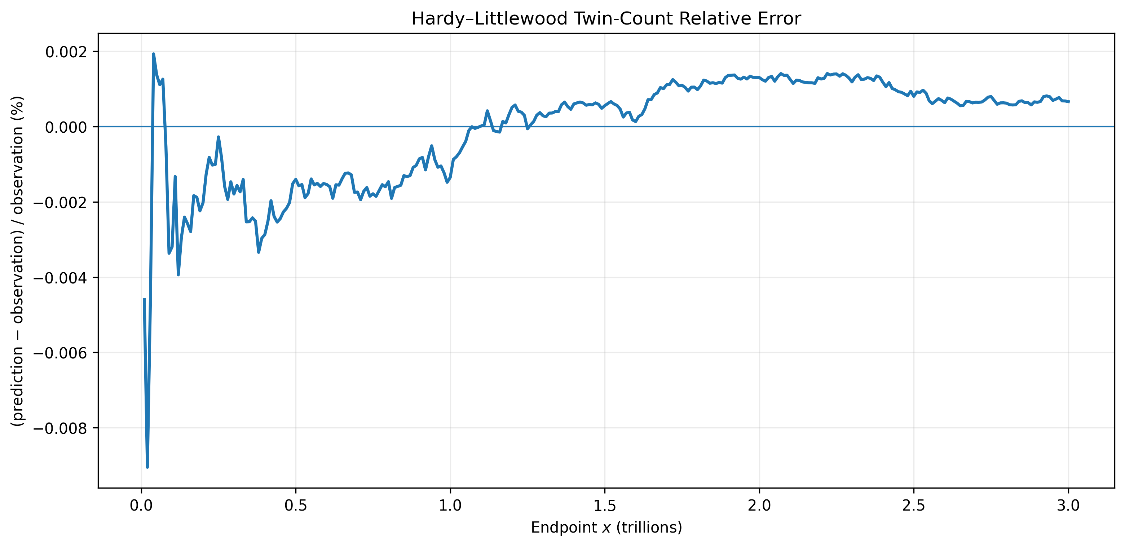
Figure 14b. Hardy–Littlewood relative error. The finite-domain relative discrepancy between the exact cumulative twin-prime census and the classical prediction is shown across the canonical partitions.
Table 8. Summary of Validation Against Classical Number Theory.
Quantity | Exact observation | Classical reference | Endpoint relative error
Prime count pi(3,000,000,000,000) | 108,340,298,703 | x/log(x) = 104,421,798,835.763 | -3.616844253%
Prime count | 108,340,298,703 | Li(x) = 108,340,379,630.280 | 0.000074697%
Prime count | 108,340,298,703 | R(x) = 108,340,313,798.635 | 0.000013934%
Mean outgoing gap | 28.728551671208 | log(midpoint) = 28.727965347505 | 0.002040951%
Cumulative twin-prime events | 5,173,760,785 | Hardy–Littlewood = 5,173,795,178.790 | 0.000664773%

12. Discussion
PrimeNet changes the role of computation in prime arithmetic from isolated calculation toward persistent infrastructure. The repository preserves computational assets, observatories preserve methods of investigation, products preserve results, and the Publisher preserves communication artifacts.
The architecture does not attempt to solve open problems in prime arithmetic. Instead, it attempts to make future computational investigations easier to perform, easier to reproduce, and easier to build upon.
The classical-validation results add an independent scientific check: exact products derived from the architecture recover established prime-count, gap-growth, and twin-prime behavior over the complete verified finite domain.
This distinction remains central to the paper. PrimeNet is not presented as a new theory of primes, but as an engineered foundation for observational computational arithmetic.
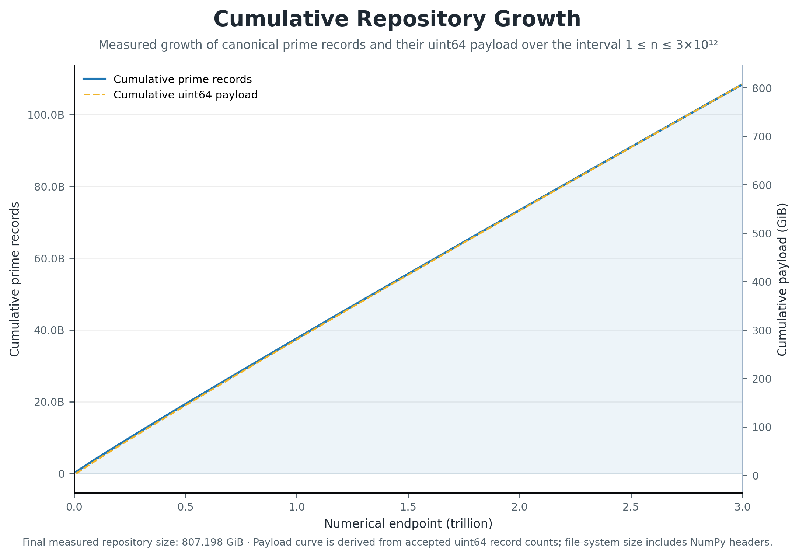
Figure 9. Cumulative Repository Growth. Accepted partition counts produce measured cumulative curves for prime records and their uint64 storage payload over the interval from 1 to 3 trillion.

13. Future Directions
Future development may extend the repository, add new observatories, enrich product formats, build additional atlases, and improve publication workflows. These extensions do not require changing the core architectural idea.
The Theory Validation Atlas can grow to include selected-gap spectra, maximal-gap behavior, Goldbach observatories, prime k-tuples, cross-scale comparisons, and other independently reproducible validation modules.
A natural long-term goal is community extension. If future researchers can add observatories, reuse repository assets, and publish reproducible computational products with less duplicated engineering effort, then PrimeNet will have achieved its intended purpose.
The value of scientific infrastructure is ultimately measured not by the infrastructure itself, but by the investigations it enables.
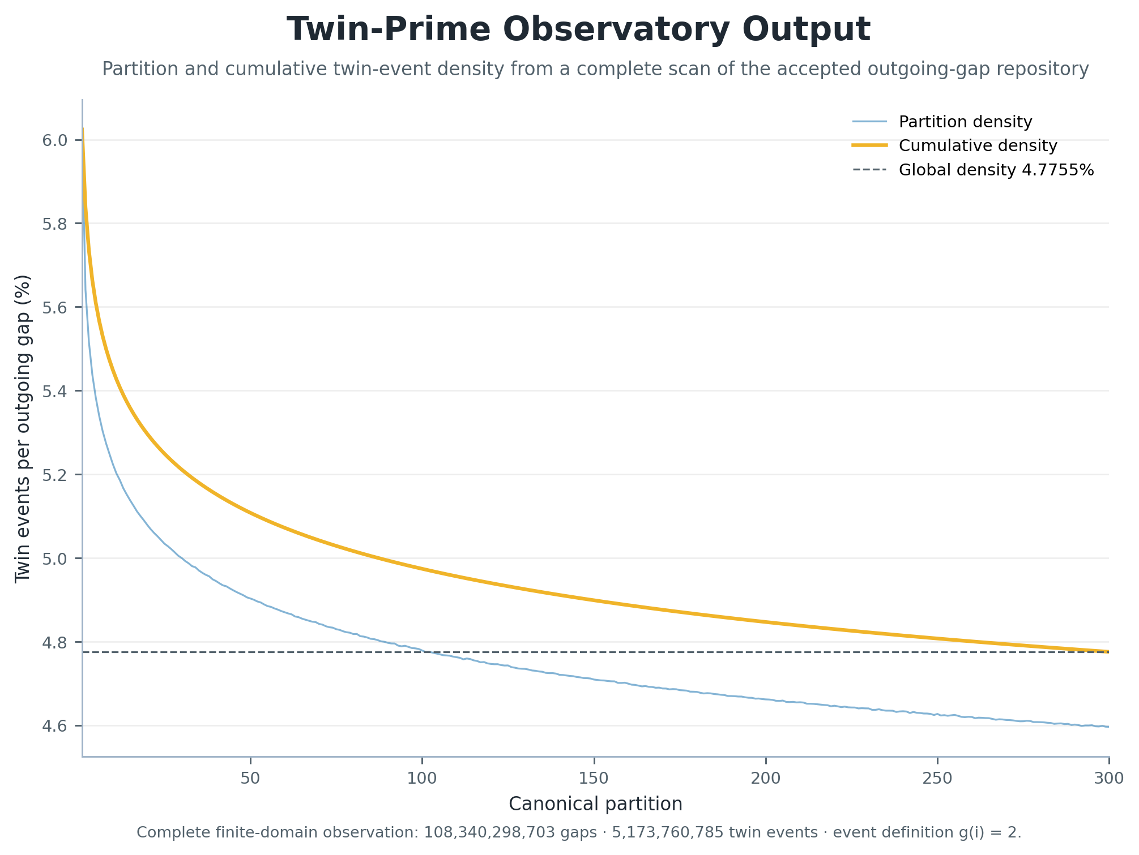
Figure 10. Twin-Prime Observatory Output. Partition and cumulative event densities visualize the complete finite-domain census of outgoing gaps satisfying g(i)=2.

14. Conclusion
PrimeNet is a reference architecture for persistent computational arithmetic. It organizes Prime Space, a verified repository, observatories, observation sessions, products, atlases, registries, and publication support into a unified system for reproducible computational investigation.
The reference implementation demonstrates the architecture through a repository covering 1 <= n <= 3,000,000,000,000, containing 108,340,298,703 verified prime numbers, and passing repository verification across 300 segments.
Independent comparison with classical prime-count, mean-gap, and twin-prime reference laws further demonstrates that the exact observational products are scientifically coherent over the verified finite domain.
The primary contribution of PrimeNet is not a new prime algorithm or mathematical theorem. It is an implemented architecture intended to help future researchers spend less time rebuilding computational infrastructure and more time doing science.

Appendix A. Canonical Tables
Table 1. PrimeNet Reference Implementation.
Characteristic | Reference Implementation
Repository interval | 1 <= n <= 3,000,000,000,000
Verified prime numbers | 108,340,298,703
Largest stored prime | 2,999,999,999,933
Repository segments | 300
Segment size | 10,000,000,000 integers
Repository verification | 300/300 passed; SHA-256 certified
Repository construction | Deterministic
Prime Space | Implemented
Observatory Framework | Implemented
Product Framework | Implemented
Registry Services | Implemented

Table 2. Design Principles and Architectural Realization.
Design Principle | Architectural Realization
Observation before explanation | Repository + Observatory Framework
Persistent repository architecture | Verified persistent repository segments
Reproducibility by design | Deterministic construction + independent verification
Canonical coordinate system | Prime Space and prime index
Separation of responsibilities | Repository / Observatory / Product / Registry layers
Extensibility through modular architecture | New observatories and products can be added incrementally

Table 3. PrimeNet Architectural Components.
Component | Primary Responsibility
Prime Space | Canonical observational coordinate framework
Repository | Persistent computational assets
Observatory | Reusable computational investigation
Observation Session | Provenance and execution context
Product | Persistent observational output
Atlas | Curated collection of related products
Registry | Discovery and lifecycle management
Publisher | Publication assets and manuscript generation

Table 4. Repository Statistics as Architectural Evidence.
Metric | Value
Repository interval | 1 <= n <= 3,000,000,000,000
Verified primes | 108,340,298,703
Largest stored prime | 2,999,999,999,933
Repository segments | 300
Segment size | 10,000,000,000 integers
Verification result | 300/300 passed; SHA-256 certified

Table 5. Software Architecture Subsystems.
Subsystem | Responsibility
Repository construction services | Deterministic generation of repository segments
Repository management services | Inventory, catalogs, and lifecycle management
Verification services | Independent repository validation
Metadata services | Repository and product description
Observatory execution framework | Run reusable computational investigations
Product management | Preserve and organize persistent outputs
Registry services | Discover observatories and products
Publisher services | Generate publication figures, tables, manuscript drafts, and publication manifests

Table 6. Reproducibility Features.
Feature | Purpose
Deterministic construction | Repeatable repository generation
Independent verification | Validate repository integrity
Structured metadata | Preserve repository and product context
Observation sessions | Preserve execution provenance
Persistent products | Enable reuse without recomputation
Registry services | Support discoverability and consistency
Publication manifest | Preserve publication build provenance

Table 7. Accepted Twin-Prime Census Performance Measurements.
Metric | Accepted Measurement
Scientific domain | 1 – 3,000,000,000,000
Repository partitions | 300
Total gaps analyzed | 108,340,298,703
Twin-prime events | 5,173,760,785
Global twin density | 0.047754721437340
End-to-end runtime | 50.122088 min
Runtime accounted for | 99.995377703%
Conservative steady-state partitions | 290
Steady-state gaps analyzed | 104,222,243,890
Mean partition runtime | 10.021978 sec
Median partition runtime | 10.004263 sec
Runtime coefficient of variation | 2.408966%
Runtime P95 | 10.346914 sec
Sustained throughput | 35,859,890.441 gaps/sec

Table 8. Summary of Validation Against Classical Number Theory.
Quantity | Exact observation | Classical reference | Endpoint relative error
Prime count pi(3,000,000,000,000) | 108,340,298,703 | x/log(x) = 104,421,798,835.763 | -3.616844253%
Prime count | 108,340,298,703 | Li(x) = 108,340,379,630.280 | 0.000074697%
Prime count | 108,340,298,703 | R(x) = 108,340,313,798.635 | 0.000013934%
Mean outgoing gap | 28.728551671208 | log(midpoint) = 28.727965347505 | 0.002040951%
Cumulative twin-prime events | 5,173,760,785 | Hardy–Littlewood = 5,173,795,178.790 | 0.000664773%

Appendix B. Theory-Validation Dataset Summary
The validation figures and Table 8 are generated from the canonical theory-validation products identified below. These products preserve partition-level values for all 300 canonical repository partitions.
Field | Value
Dataset status | GENERATED
Dataset version | 1.0.0
Partition count | 300
Numeric domain | 1 – 3,000,000,000,000
Exact prime count | 108,340,298,703
Exact twin-prime count | 5,173,760,785
Summary source | E:\PrimeNet\Repository\observations\theory_validation\theory_validation_summary.json
Partition source | E:\PrimeNet\Repository\observations\theory_validation\theory_validation_partition_data.csv

