PrimeNet Controlled Execution Benchmark Report v2
2T to 3T Repository Production Campaign
Generated: 2026-07-09 02:33:17

Executive Summary
This report summarizes the PrimeNet controlled production campaign spanning 2,000,000,000,001 to 3,000,000,000,000. The campaign was executed under the integrated PrimeNet Controlled Execution Framework, which preserved wall-clock runtime evidence, heartbeat continuity, logs, environment metadata, and verified repository outputs.
- Completed batches: 100 consecutive 10B batches.
- Total primes generated: 35,038,402,564.
- Total output size: 261.056 GB.
- Batch-derived production runtime: 4.918 hours.
- Mean runtime: 2.951 minutes per 10B batch.
- Median runtime: 2.895 minutes per 10B batch.
- 95th percentile runtime: 3.388 minutes per 10B batch.
- Verified outputs: 100/100.
- Heartbeat rows: 1,778; heartbeat gap warnings: 0.

Benchmark Configuration
Metric | Value
Campaign range | 2,000,000,000,001 to 3,000,000,000,000
Batch size | 10,000,000,000 integers
Completed batches | 100
Repository output | NumPy range files
Controlled execution | PrimeNet Controlled Execution Framework v1.0
Evidence package | C:\PrimeNet\reports\controlled_execution_benchmark_v2

Campaign Results
Metric | Value
Total runtime | 295.071 min = 4.918 h
Total primes | 35,038,402,564
Mean prime count per 10B | 350,384,025.64
Total output size | 261.056 GB
Verified batches | 100/100
Projected hours per 1T at mean | 4.918 h

Runtime Statistics
Metric | Value
Mean | 2.951 min
Median | 2.895 min
Standard deviation | 0.254 min
Minimum | 2.635 min
5th percentile | 2.662 min
25th percentile | 2.773 min
75th percentile | 3.073 min
95th percentile | 3.388 min
Maximum | 4.145 min
IQR | 0.300 min
Coefficient of variation | 0.086

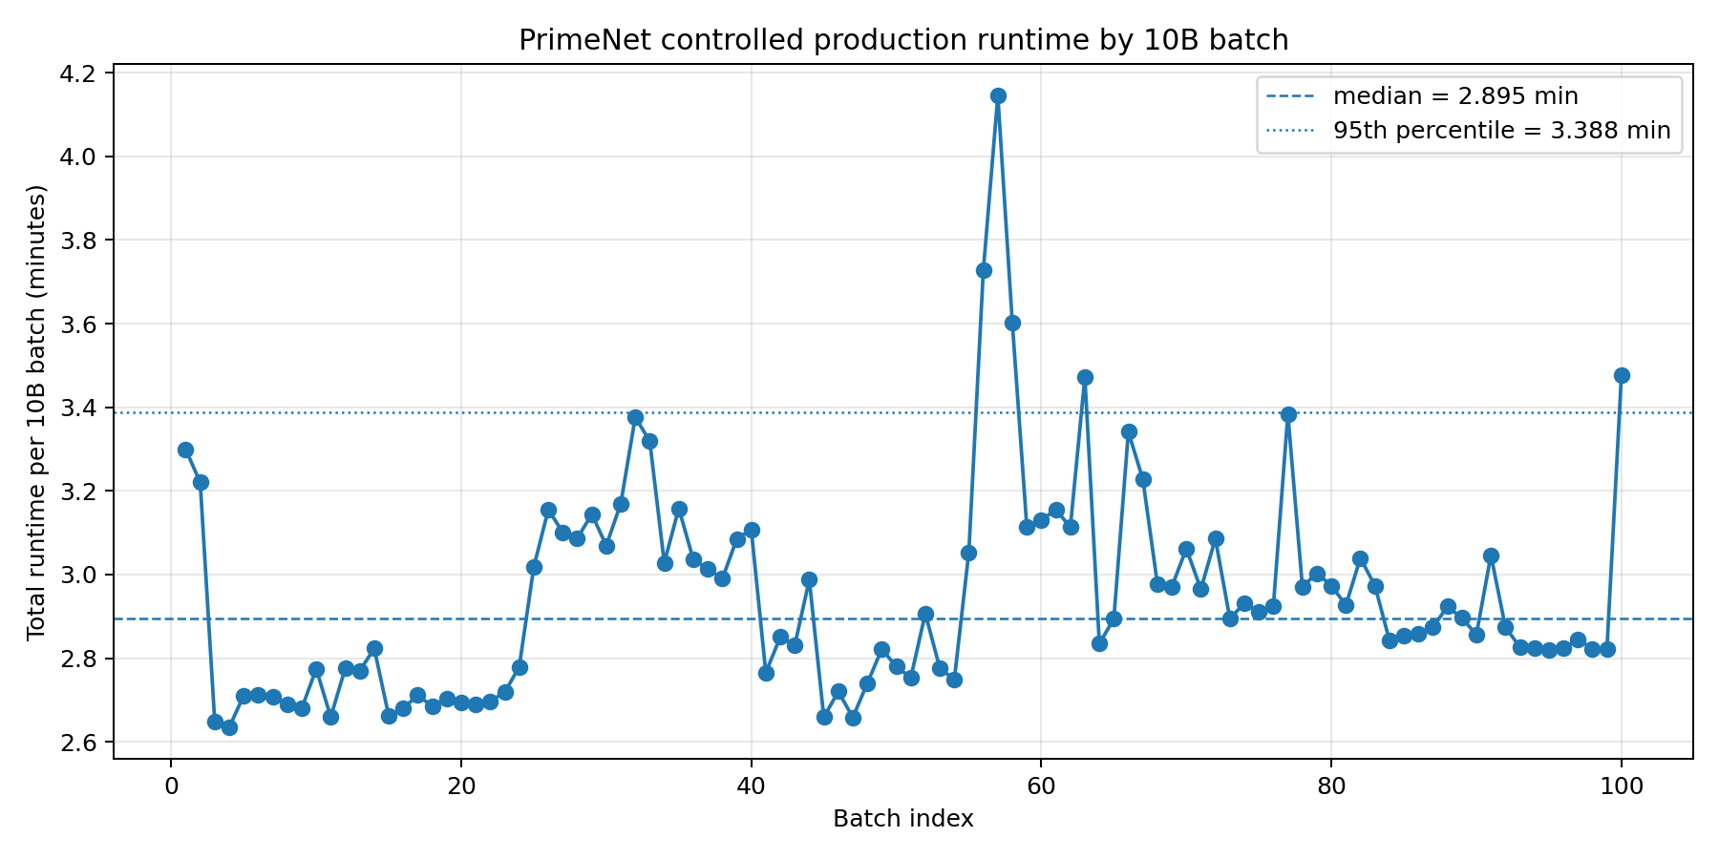
Figure 1. Total runtime per 10B batch across the controlled 2T to 3T campaign.
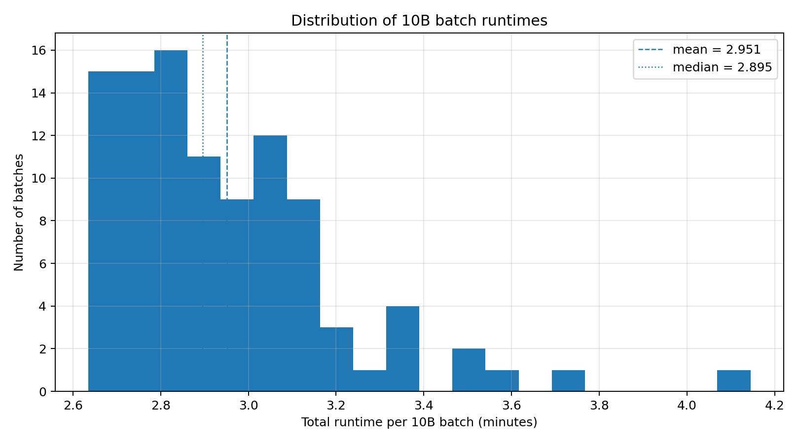
Figure 2. Distribution of 10B batch runtimes with mean and median reference lines.

Runtime Component Analysis
Generation dominates the mean runtime per batch, with output serialization as the secondary cost and verification comparatively small on average.
Metric | Value
Generate mean | 2.315 min
Save mean | 0.603 min
Verify mean | 0.033 min
Generate median | 2.265 min
Save median | 0.608 min
Verify median | 0.016 min

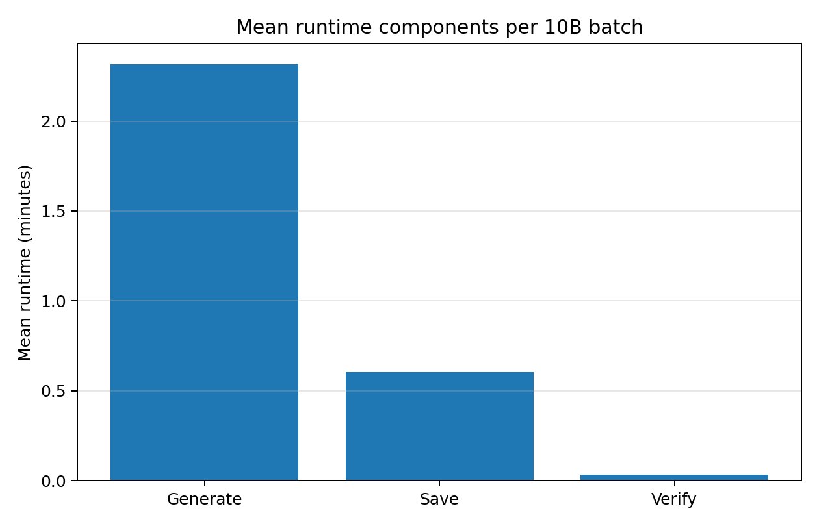
Figure 3. Mean runtime components per 10B batch.
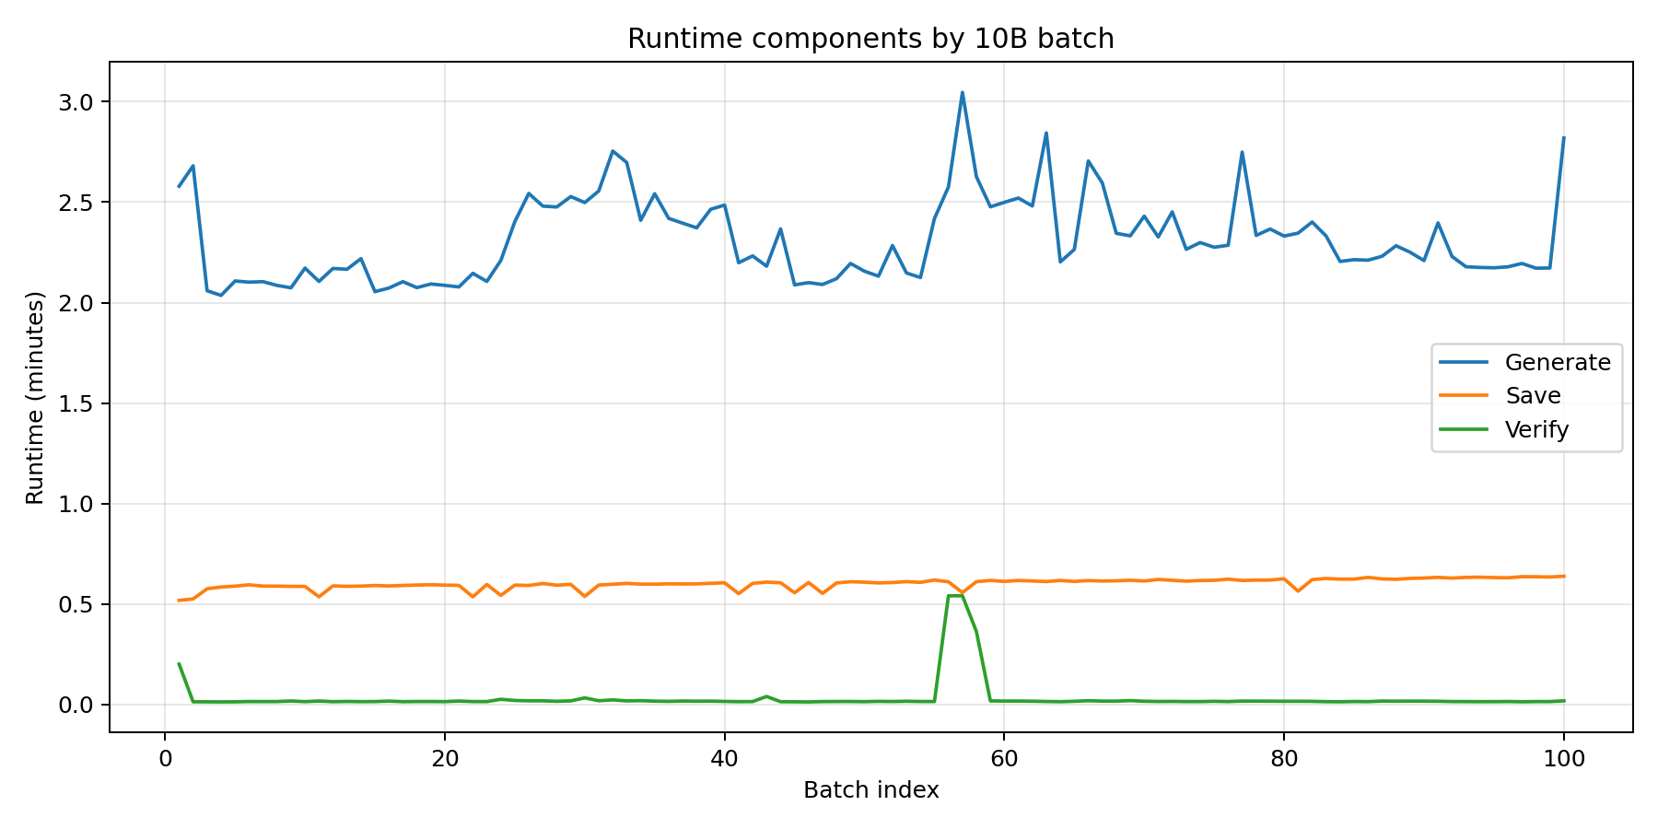
Figure 4. Runtime components by batch index.

Execution Continuity
The heartbeat record provides direct evidence that the campaign ran under continuous controlled execution. The observed heartbeat intervals remained close to the 10-second target and produced zero heartbeat-gap warnings.
Metric | Value
Heartbeat rows | 1,778
Mean heartbeat interval | 10.016 sec
95th percentile interval | 10.024 sec
Maximum interval | 10.407 sec
Heartbeat gap warnings | 0

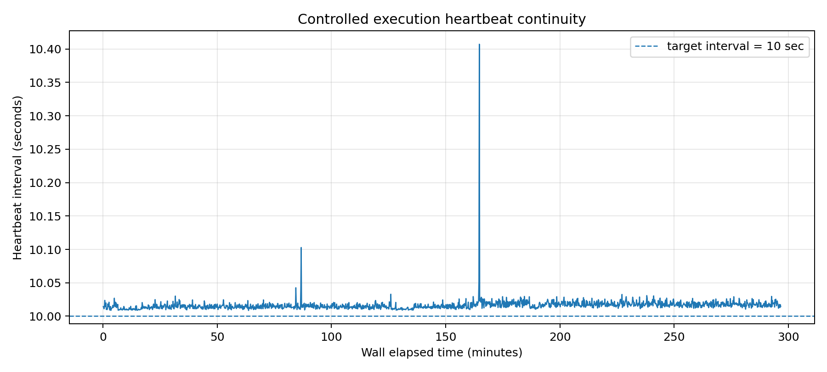
Figure 5. Controlled execution heartbeat continuity across the production campaign.

Repository Consistency Diagnostic
The prime count per 10B batch decreases smoothly over the campaign, consistent with declining prime density and with no visible repository discontinuity.
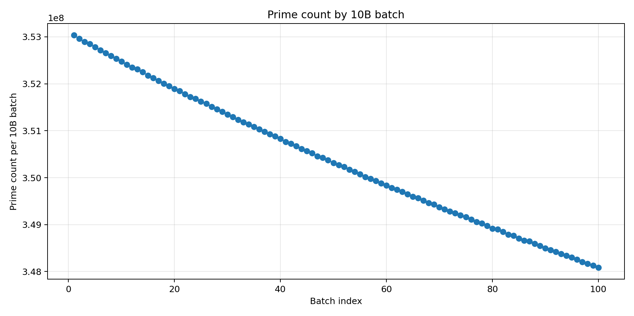
Figure 6. Prime count per 10B batch across the 2T to 3T campaign.

Stability and Runtime Excursions
A linear trend fit gives a slope of 0.001818 minutes per batch, with R^2 = 0.043 and a fitted campaign-scale change of 0.180 minutes. This is best interpreted as an engineering diagnostic rather than a mathematical law.
Using the IQR rule (Q3 + 1.5*IQR), the runtime excursion threshold was 3.523 minutes and 3 batches were flagged. The campaign returned to its baseline runtime regime after excursions, supporting the conclusion that no progressive throughput degradation was observed.

Interpretation
Under controlled execution conditions on the current commodity-hardware platform, PrimeNet demonstrated sustained repository-production throughput of approximately 10 billion integers per three minutes. Earlier anomalous wall-clock measurements are excluded from the controlled performance baseline because they were obtained under uncontrolled execution conditions. The controlled campaign instead preserved continuous execution telemetry, logs, environment metadata, and verified repository artifacts.

Reproducibility Statement
The report package preserves the evidence required to reproduce the benchmark analysis: command record, stdout and stderr logs, job summary, heartbeat telemetry, environment metadata, campaign summary, batch runtime table, correlation matrix, outlier table, and generated figures.

Conclusion
Across a controlled one-trillion-integer production campaign, PrimeNet completed 100 consecutive 10B batches with complete output verification and uninterrupted heartbeat telemetry. The mean runtime was 2.951 minutes per 10B batch and the median runtime was 2.895 minutes. These results establish a platform-specific controlled execution baseline for PrimeNet repository production.
Observe the primes. Measure the computation. Validate the evidence. Trust the result.

