

INDIVIDUAL ASSIGNMENT
TECHNOLOGY PARK MALAYSIA
CT014-3-3-CRIMISO
CRITICAL ISSUES IN MANAGING INFORMATION SYSTEMS IN ORGANIZATIONS
APU3F2502CS(AI)

HANDOUT DATE: 7th JULY 2025
HAND IN DATE: 29th AUGUST 2025
WEIGHTAGE: 40%
STUDENT NAME: |  | VOON JIN HUI
TP NUMBER: |  | TP064878

Table of Contents
Abstract 3
1.0 Introduction 4
2.0 Managing Telecommunication and Networking 5
2.1 Telecommunication Infrastructure Supports Communication and Collaboration 5
2.2 Transition to Cloud-based Networking with Microsoft Azure 8
2.3 Enhancing Connectivity with Azure ExpressRoute 11
3.0 Conclusion 14
References 15

Abstract
This report explains how Microsoft uses its telecommunication and networking systems to support its global operations. It looks at how tools like Microsoft Teams, Microsoft 365, and Viva Amplify help employees work and communicate better. It also outlines Microsoft’s transition from physical servers to cloud services using Microsoft Azure. Azure helps the company work faster, safer, and at a lower cost. The report also discusses Azure ExpressRoute, which provides private and secure internet connections. These systems help Microsoft connect offices worldwide, support remote work, and manage large amounts of data. Although challenges still exist, Microsoft continues to improve and lead in digital transformation.

1.0 Introduction
The rise of the digital era has placed telecommunication and networking systems at the core of enterprise success. Microsoft is a multinational company that spans the workforce globally. Hence, the strategic management of information systems (IS) resources, especially in telecommunications and networking, is essential. They enable Microsoft’s business agility, collaboration, and growth. Microsoft is its own “zero customer”. It uses and tests its products internally before releasing them to market. Hence, these systems are vital and can handle day-to-day operations. They can also maintain secure communications and deliver consistent global services. This paper examines how Microsoft applies its telecommunication and networking infrastructure internally. It also explores the benefits achieved, the challenges faced, and how these systems are strategically managed to support the Microsoft’s global operations.

2.0 Managing Telecommunication and Networking

2.1 Telecommunication Infrastructure Supports Communication and Collaboration
Over the decades, Microsoft has successfully developed many information systems resources that serve different purposes. To manage internal telecommunication and networking, Microsoft primarily relies on platforms such as Microsoft Teams, Microsoft 365 Integration, and Microsoft Viva Amplify. These platforms depend on a strong telecommunication infrastructure, such as internet bandwidth, WiFi, and 4G/5G mobile connectivity to deliver smooth and real-time performance (Learn, 2024; Learn, Microsoft 365 network connectivity principles, 2025).
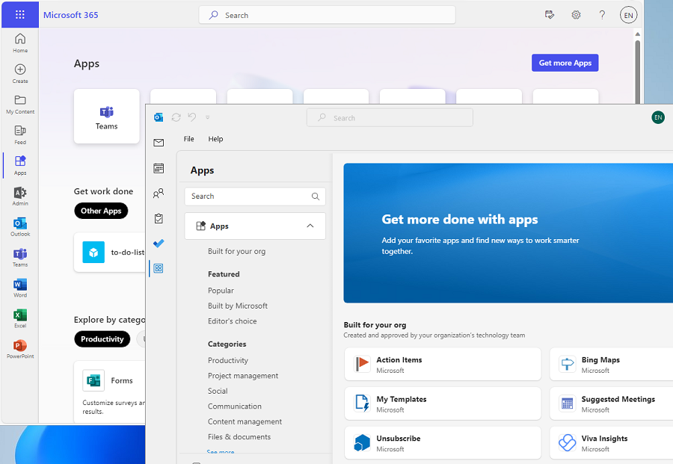
Figure 1: Microsoft Teams and Microsoft 365 Integration (Ignite, Publish Teams apps for Microsoft 365, 2024)
Microsoft Teams is a unified communication and collaboration platform that allows instant messaging, voice calls, and video calls. These real-time communication features are supported by internet bandwidth like broadband, 4G/5G networks and cloud infrastructure. These enable cross-department coordination and remote work. Hence, Microsoft employees can conduct virtual meetings internally and minimize the need for physical meetings. Teams is integrated with Microsoft 365 applications seamlessly, such as SharePoint and OneDrive (Chaushi, Nastovska, & Veseli-Kurtishi, 2024). This integration enables employees to access tools through Wi-FI, 4G/5G, 4G or corporate VPNs (Learn, Prepare your organization's network for Microsoft Teams, 2024). This network infrastructure allows real-time collaborative editing and document sharing across teams.

Figure 2: Microsoft Teams Bandwidth Requirements (KWong, 2020)
The figure above is Microsoft Teams' bandwidth requirement for different call and video quality levels. This shows how higher quality communication requires higher network capacity, which Microsoft supports through its strong telecommunication infrastructure (KWong, 2020).
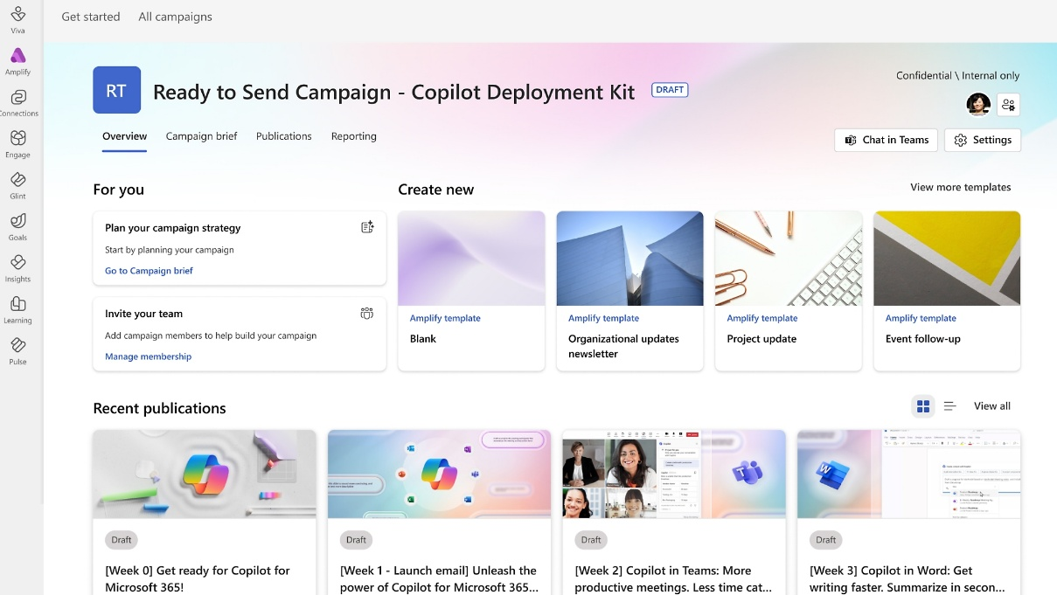
Figure 3: Microsoft Viva Amplify Interface (Microsoft, n.d.)
Additionally, Microsoft Viva Amplify is closely integrated with Microsoft Teams and Microsoft 365. It enhances internal communications by enabling internal teams to create, publish, and analyze communication campaigns across Outlook, Teams, and SharePoint. Viva Amplify enhances employee engagement and message clarity by unifying communication channels into a single campaign-driven platform. It also offers analytics to track employee engagement and ensure messages reach the right audience effectively (Reef, 2024).
Together, these platforms supported by the strong network infrastructure enable Microsoft to manage its internal communication and collaboration. This integration ensures seamless connectivity across global teams, whether employees are in the office or working remotely over broadband, Wi-Fi, or 4G/5G networks. For example, Teams supports over 300 million monthly active users and enables employees to work remotely without compromising productivity. The employees can also co-author documents in real time through SharePoint and OneDrive. This significantly enhances collaboration and decision-making across different time zones (Track, 2025). The deployment of Viva Amplify further enhances internal communication by centralizing tools and resources into a single platform (Velush, 2024).
The infrastructure supporting these platforms has brought many benefits to Microsoft. During the COVID-19 pandemic, Microsoft successfully shifted over 160,000 employees to remote work within days. This rapid transition was made possible by the cloud networks, high-speed internet, and mobile accessibility. It minimizes operational disruption and maintains collaborations among Microsoft employees (Mackie, 2021). It also saves costs from reduced travel and eliminates traditional phone systems. The productivity and engagement of employees, especially among internal IT communications teams, also improved as they can always get real-time access to the latest updates (Velush, 2025).
However, the platforms supported by the technologies also face network performance challenges. Although these platforms are cloud-based, their performance will be affected by local area network (LAN) and wide-area network (WAN) conditions. For example, poor LAN connectivity like as outdated switches or overloaded Wi-Fi networks can degrade video calls and data transfers. Weak WAN connectivity will also introduce latency that impacts real-time collaboration. To address this, Microsoft implements Quality of Service (QoS) policies and bandwidth management in these platforms to prioritize important traffic and maintain smooth performance (Learn M. , 2024).
Critical Evaluation:
Based on the findings, the telecommunication and networking technologies supporting Microsoft Teams, Microsoft 365, and Viva Amplify are highly effective and successful for Microsoft to manage its internal processes. They enable remote productivity, cost efficiency, and a collaborative work environment. Although the challenges exist, Microsoft is able to mitigate them through network optimization techniques efficiently.

2.2 Transition to Cloud-based Networking with Microsoft Azure
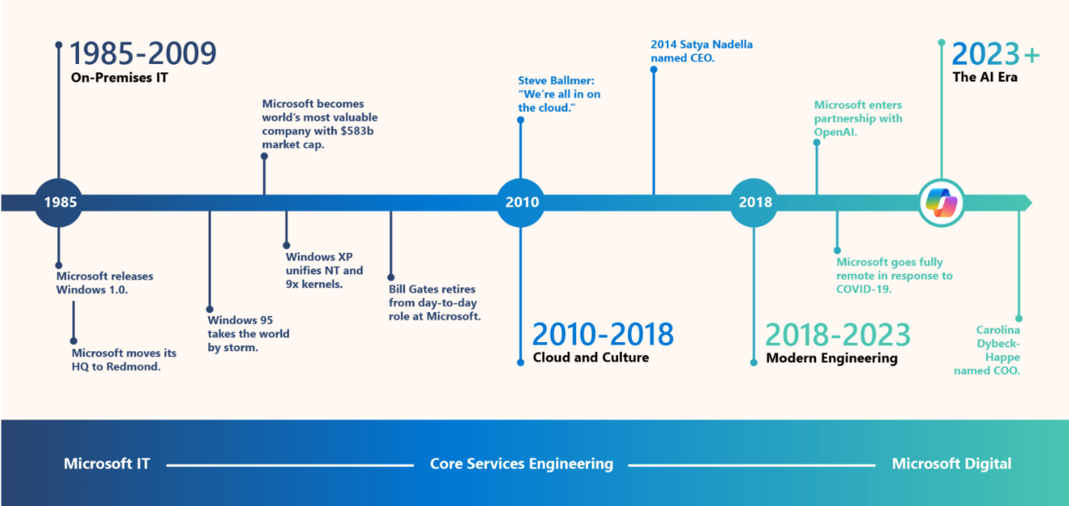
Figure 4: Different Eras of Transformation at Microsoft (Boyd, Miniken, & Hirning, 2025)
Microsoft is one of the largest IT infrastructure operators in the world. The company’s shift to a cloud-first infrastructure marks a significant milestone in its telecommunications and networking strategy. Historically, Microsoft relied on traditional on-premises data centers with physical servers and network hardware (Boyd, Miniken, & Hirning, 2025).
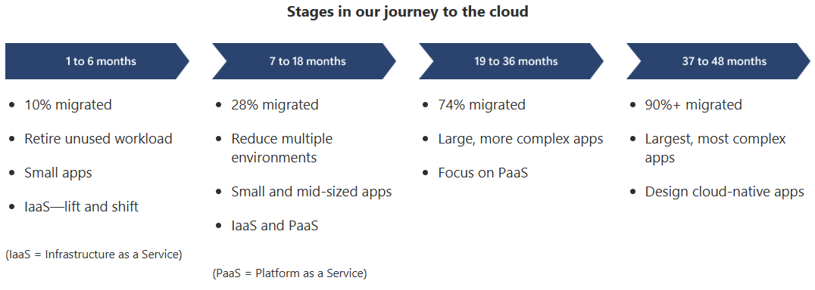
Figure 5: Microsoft’s Transition to Cloud (Hirning, 2025)
Then, Microsoft has progressively migrated its internal systems and services to its cloud computing platform, which is Microsoft Azure. Within four years, they migrated 97% of their IT infrastructure to Azure. Azure offers comprehensive networking, computing, storage, and analytics services over a global network of Microsoft-managed data centers. This transition has allowed Microsoft to modernize its operations, support remote workforces, and scale services across geographic regions efficiently and securely (Hirning, 2025).
One of the core features of Microsoft Azure is its ability to offer virtual networks (VNets). This allows Microsoft teams to create isolated networks in the cloud that mimic traditional physical networks. VNets enable secure segmentation of workloads, custom routing, and hybrid connectivity between on-premises systems and cloud resources (Borra, Microsoft Azure Networking: Empowering Cloud Connectivity and Security, 2024). Services like Azure Load Balancer, Application Gateway, and Azure Firewall offer enhanced traffic management, security, and high availability for internal applications (Ignite, What is Azure Virtual Network, 2025; Borra, Exploring Microsoft Azure's Cloud Computing: A Comprehensive Assessment, 2022). For instance, Microsoft's internal teams use Azure Monitor and Azure Network Watcher to track performance, analyse traffic patterns, and detect potential issues across global operations (Jimenez & Venkatraman, 2024).
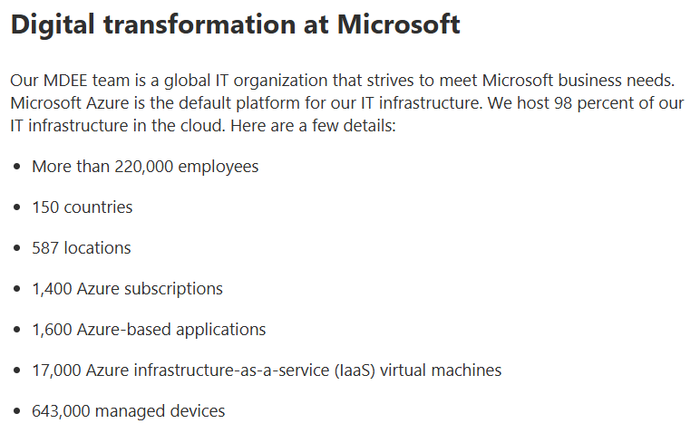
Figure 6: Details about Microsoft’s Digital Transformation (Apple, 2025)
In practice, Microsoft migrated its internal customer relationship management systems and employee platforms to Azure. This migration enables faster updates, integrates with other services, and ensures high availability. According to the Microsoft Digital Employee Experience (MDEE), using Azure for internal IT management enables self-service automation, full visibility, and management resolution across the workplace (Apple, 2025). Additionally, Microsoft’s own enterprise applications, such as Microsoft Teams and Microsoft 365, are hosted and scaled through Azure. The move to Azure enabled Microsoft to support hybrid work environments effectively during the COVID-19 pandemic by providing secure remote access and cloud-based collaboration tools (Boyd, Miniken, & Hirning, 2025).
The transition has delivered operational benefits for Microsoft’s internal operations. Firstly, Azure has improved network scalability by enabling Microsoft to deploy applications and resources instantly without the constraints of physical hardware. The platform can process millions of transactions monthly with support up to 100 messages per second and payloads of 100 MB per message. Second, Azure achieves 99.9% availability through cross-region active-active deployment and strong fault-handling mechanisms. It also has enhanced data security through Azure’s built-in compliance and identity protection mechanisms like Microsoft Entra ID. Additionally, the cloud model offers cost efficiency by reducing physical infrastructure maintenance (Staff, 2024).
However, challenges still exist for Microsoft in managing its resources. One major challenge is the complexity of migrating legacy systems. The program manager for Microsoft Azure Engineering, Pete Apple, explains that many older applications were initially migrated to Azure without re-architecting for cloud environments. Hence, the teams still had to perform manual tasks such as patching, scaling, and monitoring virtual machines. Next, managing a hybrid infrastructure during transition introduced complexity. This is because some systems are still operating on-premises and others in Azure. Therefore, Microsoft requires strong DevOps practices and consistent governance to ensure seamless integration. Furthermore, unmanaged or undermanaged cloud resources can still be costly. Microsoft has discovered that quick deployment can lead to oversupplied resources and idle workloads. As a result, it leads to inefficient resource allocation and increased cloud billing (Kellington, 2025).
Critical Evaluation:
Based on the findings, Microsoft’s move to Azure is very successful and represents a textbook example of global enterprise cloud transformation. By consolidating internal systems into a secure, scalable cloud infrastructure, Microsoft has enhanced agility, resilience, and internal connectivity. Microsoft has positioned itself to respond quickly to operational needs and market shifts.

2.3 Enhancing Connectivity with Azure ExpressRoute
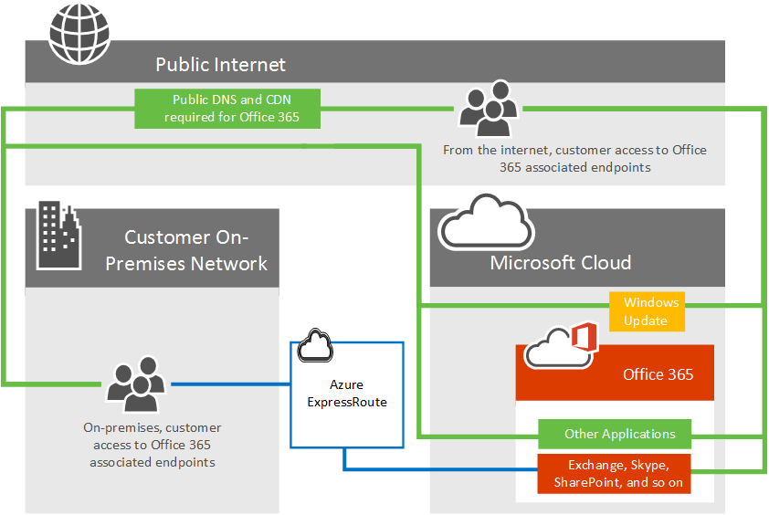
Figure 7: Network Diagram of ExpressRoute (Ignite, Azure ExpressRoute for Microsoft 365, 2024)
While Microsoft Azure provides a strong cloud-based foundation, Azure ExpressRoute adds another powerful layer. ExpressRoute enables private network connections between Microsoft’s cloud infrastructure and its on-premises data centers, offices, and partner networks (Kushwaha, Tyagi, & Kant, 2024). The connectivity can be established using an any-to-any (IP VPN) network, a point-to-point Ethernet network, or a virtual cross-connection via a connectivity provider. Unlike public internet connections, ExpressRoute bypasses the internet entirely. This offers faster speeds, lower latency, higher security, and more reliability. These advantages are crucial for Microsoft as they rely on real-time data processing, secure collaboration, and high-volume transfers (Ignite, What is Azure ExpressRoute, 2024).
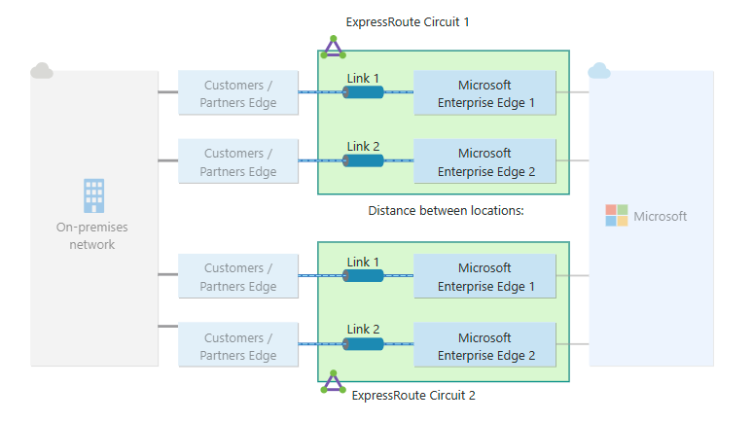
Figure 8: ExpressRoute’s Dual-Link Connectivity (Ignite, What is Azure ExpressRoute, 2024)
ExpressRoute offers several powerful features. It supports various bandwidth options from 50 Mbps to 100 Gbps. This ensures consistent performance even during peak usage. It also supports redundant dual-link connectivity. The high availability makes it ideal for mission-critical applications. Additionally, ExpressRoute can connect multiple on-premises networks to Microsoft's global cloud infrastructure through ExpressRoute Global Reach. This enables seamless interconnection between private networks using Microsoft's backbone. These capabilities allow Microsoft IT teams to maintain low latency and ensure business continuity across its global operations (Ignite, What is Azure ExpressRoute, 2024).

Figure 9: Data Centers of Microsoft (Thammineni & Challapuram, 2024)
Internally, Microsoft uses ExpressRoute to maintain its corporate networks, data centers, legacy systems, and cloud environment. For example, Microsoft's finance, HR, and R&D systems utilize ExpressRoute for secure, high-throughput communication with cloud services. During peak collaboration periods, ExpressRoute ensures databases, Teams, and Microsoft 365 services perform optimally for employees and partners by handling traffic through routes. This is crucial for financial reporting, employee data management, and large-scale research simulations. Moreover, operators and developers use ExpressRoute to accelerate innovation in cloud services. They use these routes to establish lab environments for building and testing without bandwidth limitations (Thammineni & Challapuram, 2024).
The benefit of ExpressRoute is predictable and enhanced performance. Since traffic doesn’t traverse the public internet, Microsoft ensures low latency, high availability, and strong data security. These are critical for financial transactions, confidential data transfers, and development workflows (Thammineni & Challapuram, 2024). By keeping sensitive workloads off the public internet, ExpressRoute reduces exposure to DDoS attacks. Additionally, features like private peering, Microsoft peering, and ExpressRoute Global Reach enable seamless connectivity across on-premises, cloud, and even between geographically dispersed office networks (Ignite, ExpressRoute routing requirements, 2024).
However, even at Microsoft, implementing ExpressRoutes brings challenges. Firstly, managing thousands of circuits across global data centers, offices, and labs requires close coordination between networking, IT, and product teams. In some regions, it is hard or expensive to deploy due to limited partnerships with local telecom providers. Next, asymmetric routing is a technical challenge. Traffic to services like Microsoft 365 and Power Platform may take different paths and cause delays or be blocked by firewalls. This happens because ExpressRoute does not filter traffic by service. Hence, it requires skilled engineers to handle BGP routing, peering issues, and failover (Ignite, Things to consider before you use ExpressRoute with Power Platform, 2025).
Critical Evaluation:
Despite these challenges, Azure ExpressRoute is still very successful in strengthening Microsoft’s internal and external connectivity. It plays an important role in enabling secure and low-latency access to cloud services across global operations. Microsoft’s use of ExpressRoute shows its strategic use of IS resources to ensure enterprise-grade networking performance across global operations.

3.0 Conclusion
Microsoft’s strategic use of telecommunication and networking information systems has played an important role in enabling its global success. The company has established a strong infrastructure that supports both internal collaboration and productivity. This is because it uses platforms like Microsoft Teams, Microsoft 365, Microsoft Azure, and Azure ExpressRoute that all supported by strong broadband, mobile, and cloud networking. While challenges such as system complexity, high data volume, and regional limitations persist, Microsoft continues to address these through automation, continuous improvement, and investment in emerging technologies. The company’s approach serves as a model for how IS resources can drive innovation, operational efficiency, and global digital transformation.

References
Apple, P. (6 May, 2025). Microsoft moves IT infrastructure management to the cloud with Microsoft Azure. Retrieved from Microsoft: https://www.microsoft.com/insidetrack/blog/microsoft-moves-it-infrastructure-management-to-the-cloud-with-microsoft-azure/
Borra, P. (2022). Exploring Microsoft Azure's Cloud Computing: A Comprehensive Assessment. International Journal of Advanced Research in Science, Communication and Technology (IJARSCT), 2(8), 897-906. doi:10.48175/IJARSCT-5807C
Borra, P. (2024). Microsoft Azure Networking: Empowering Cloud Connectivity and Security. International Journal of Advanced Research in Science, Communication and Technology (IJARSCT), 4(3), 469-475. doi:10.48175/IJARSCT-18949
Boyd, K., Miniken, L., & Hirning, D. (27 February, 2025). Digitally transforming Microsoft: Our IT journey. Retrieved from Microsoft: https://www.microsoft.com/insidetrack/blog/digitally-transforming-microsoft-our-it-journey/
Chaushi, B. A., Nastovska, M., & Veseli-Kurtishi, T. (2024). MS Teams for Virtual Collaboration - An Overview. International Conference on Educational Technology and Online Learning, 776-784.
Hirning, D. (19 June, 2025). Five principles that guided our network journey to Microsoft Azure and the cloud at Microsof. Retrieved from Microsoft: https://www.microsoft.com/insidetrack/blog/five-principles-that-guided-our-network-journey-to-microsoft-azure-and-the-cloud-at-microsoft/
Ignite, M. (15 March, 2024). Azure ExpressRoute for Microsoft 365. Retrieved from Microsoft Ignite: https://learn.microsoft.com/en-us/microsoft-365/enterprise/azure-expressroute?view=o365-worldwide
Ignite, M. (20 June, 2024). ExpressRoute routing requirements. Retrieved from Microsoft: https://learn.microsoft.com/en-us/azure/expressroute/expressroute-routing
Ignite, M. (30 August, 2024). Publish Teams apps for Microsoft 365. Retrieved from Microsoft Ignite: https://learn.microsoft.com/en-us/microsoftteams/platform/m365-apps/publish
Ignite, M. (16 July, 2024). What is Azure ExpressRoute. Retrieved from Microsoft Ignite: https://learn.microsoft.com/en-us/azure/expressroute/expressroute-introduction
Ignite, M. (17 April, 2025). Things to consider before you use ExpressRoute with Power Platform. Retrieved from Microsoft Ignite: https://learn.microsoft.com/en-us/power-platform/architecture/key-concepts/expressroute/things-to-consider
Ignite, M. (17 July, 2025). What is Azure Virtual Network. Retrieved from Microsoft Ignite: https://learn.microsoft.com/en-us/azure/virtual-network/virtual-networks-overview
Jimenez, J., & Venkatraman, R. (7 March, 2024). Modernizing our cloud networking infrastructure with a DevOps mindset. Retrieved from Microsoft: https://www.microsoft.com/insidetrack/blog/modernizing-our-cloud-networking-infrastructure-with-a-devops-mindset/
Kellington, J. (23 January, 2025). Doing more with less internally at Microsoft with Microsoft Azure. Retrieved from Microsoft: https://www.microsoft.com/insidetrack/blog/doing-more-with-less-internally-at-microsoft-with-microsoft-azure/
Kushwaha, S., Tyagi, G., & Kant, G. S. (2024). Hybrid Networking in Microsoft Azure: A Comparative Analysis of Site-to-Site VPN and ExpressRoute. Journal of Computational Analysis and Applications, 33(8), 5016-5024. doi:10.48047/jocaaa.2024.33.08.158
KWong. (6 May, 2020). Microsoft Teams Bandwidth requirement. Retrieved from Microsoft Learn: https://learn.microsoft.com/en-us/answers/questions/4384253/microsoft-teams-bandwidth-requirement
Learn. (25 June, 2024). Prepare your organization's network for Microsoft Teams. Retrieved from Learn: https://learn.microsoft.com/en-us/microsoftteams/prepare-network
Learn. (2 April, 2025). Microsoft 365 network connectivity principles. Retrieved from Learn: https://learn.microsoft.com/en-us/microsoft-365/enterprise/microsoft-365-network-connectivity-principles?view=o365-worldwide
Learn, M. (20 April, 2024). Implement Quality of Service (QoS) in Microsoft Teams. Retrieved from Microsoft Learn: https://learn.microsoft.com/en-us/microsoftteams/qos-in-teams
Mackie, K. (9 September, 2021). Microsoft Outlines Remote Work Trends, Delays HQ Reopening. Retrieved from Redmond: https://redmondmag.com/articles/2021/09/09/microsoft-remote-work-trends.aspx
Microsoft. (n.d.). Microsoft Viva Amplify. Retrieved from Microsoft: https://www.microsoft.com/en-my/microsoft-viva/amplify#tabs-oced40_tab3
Reef, S. (19 August, 2024). What is Viva Amplify? Retrieved from Silicon Reef: https://siliconreef.co.uk/blog/what-is-viva-amplify/
Staff, I. T. (3 September, 2024). Modernizing enterprise integration services at Microsoft with Microsoft Azure. Retrieved from Microsoft: https://www.microsoft.com/insidetrack/blog/modernizing-enterprise-integration-services-at-microsoft-with-microsoft-azure/
Thammineni, C., & Challapuram, B. (7 February, 2024). Reshaping the Azure developer experience using Azure ExpressRoute. Retrieved from Microsoft: https://www.microsoft.com/insidetrack/blog/reshaping-the-azure-developer-experience-using-azure-expressroute/
Track, I. (20 February, 2025). Microsoft Teams increases collaboration in the modern workplace at Microsoft. Retrieved from Microsoft: https://www.microsoft.com/insidetrack/blog/microsoft-teams-increases-collaboration-in-the-modern-workplace-at-microsoft/#:~:text=Microsoft%20Teams%2C%20in%20combination%20with,how%20we%20manage%20organizational%20change.
Velush, L. (18 March, 2024). Delivering communications internally at Microsoft with Microsoft Viva Amplify. Retrieved from Microsoft: https://www.microsoft.com/insidetrack/blog/delivering-communications-internally-at-microsoft-with-microsoft-viva-amplify/
Velush, L. (20 January, 2025). Getting our internal IT communications right with Microsoft Viva Amplify. Retrieved from Microsoft: https://www.microsoft.com/insidetrack/blog/getting-our-internal-it-communications-right-with-microsoft-viva-amplify/

