

INDIVIDUAL ASSIGNMENT
TECHNOLOGY PARK MALAYSIA
BM050-3-3-IMNPD
INNOVATION MANAGEMENT AND NEW PRODUCT DEVELOPMENT
APU3F2502CS(AI)

HANDOUT DATE : 7 JULY 2025
HAND IN DATE : 8 AUGUST 2025
WEIGHTAGE : 20%
STUDENT NAME: |  | VOON JIN HUI
TP NUMBER: |  | TP064878

Executive Summary
This report analyses Tealive’s new product development (NPD) process in Malaysia’s competitive bubble tea market. It explains how Tealive generates ideas, tests concept, develops products, and uses smart marketing strategies to launch new items successfully. The report also identifies challenges in F&B market such as competition, green innovation needs, and shifting health trends. Using the Ansoff Matrix, practical recommendations are suggested to help Tealive grow its business, expand into new markets, and stay sustainable.
Table of Contents
Executive Summary 2
1.0 Introduction 4
2.0 New Product Development Process 5
2.1 Idea Generation and Screening 5
2.2 Concept Development and Testing 6
2.3 Product Development and Testing 7
2.4 Market Testing 8
2.5 Commercialization 9
3.0 Challenges in NPD 10
4.0 Recommendations 11
5.0 Conclusion 12
References 13

1.0 Introduction

Figure 1: Logo of Tealive (Tealive, n.d.)
Tealive is Malaysia’s largest bubble tea brand and one of Southeast Asia’s fastest-growing beverage chains. Tealive was founded by Bryan Loo and launched in 2017 under Loob Holding Sdn Bhd. As for now, Tealive has expanded to over 800 outlets across Malaysia and other Asian countries. It serves millions of customers each month with a wide range of tea-based drinks, coffee, smoothies, and now, even retail packaged products (Tealive, n.d.).
Tealive is highly relevant in an emerging market like Malaysia because it reflects how local tastes, digital trends, and competitive pricing shape consumer brands today. The company constantly refreshes its menu with new drinks and seasonal products to attract young, trend-driven consumers (Ahmad, 2024).
Understanding how Tealive develops new products gives insights into how a local brand can stay ahead in a fast-changing, highly competitive food and beverage market. This report explains how Tealive generates ideas, tests concept, develops products, and launches its products. The report also discusses the challenges it faces and what it can do to further strengthen its new product development (NPD) process.

2.0 New Product Development Process

2.1 Idea Generation and Screening
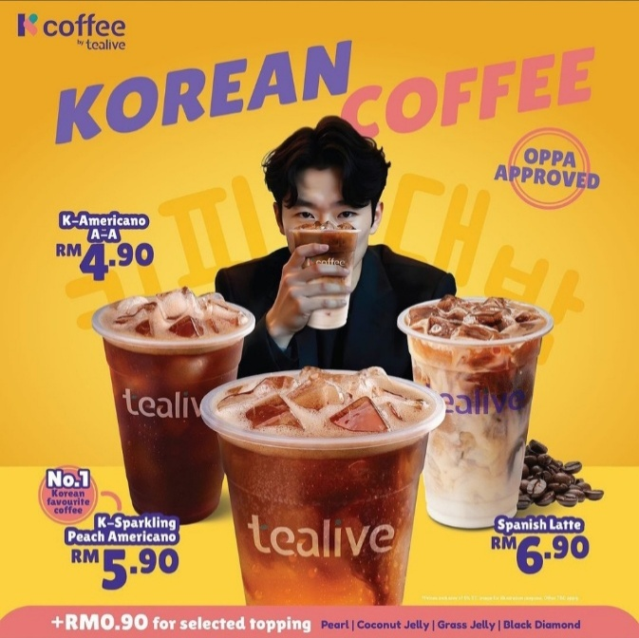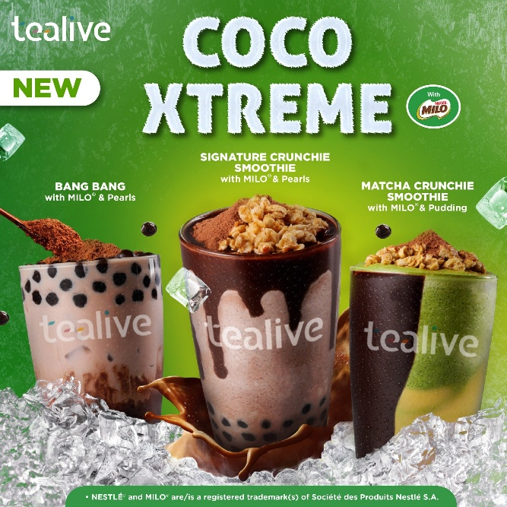
Figure 2: Tealive’s K-Coffee and Coco X-Treme Series (Cambosa, 2024; Nestle, 2023)
Tealive generates new product ideas in several ways. The company keeps a close watch on global drink trends, especially from Taiwan and Korea. This is because they are leaders in bubble tea culture. For example, Tealive introduced the K-Coffee series to tap into Malaysia’s love for Korean trends (Cambosa, 2024). It also uses local cultural influences, like combining Milo, a popular chocolate drink in Malaysia, into its menu with the Coco X-Treme range (Nestle, 2023). They also listen to customer feedback and monitor sales data to see which ingredients or flavours are popular.
These methods applied by Tealive align with the Stage-Gate process from the Decision-stage Model. This model was introduced by Robert Cooper. It suggests companies should evaluate potential ideas stage-to-stage before further investment to manage risk and resources more efficiently (Torres, Fonseca-Larios, & Ramírez-Portilla, 2024). By balancing market trend scanning and customer feedback, Tealive screens new ideas that match its brand, fit customer tastes, and can be produced at a reasonable cost.

2.2 Concept Development and Testing
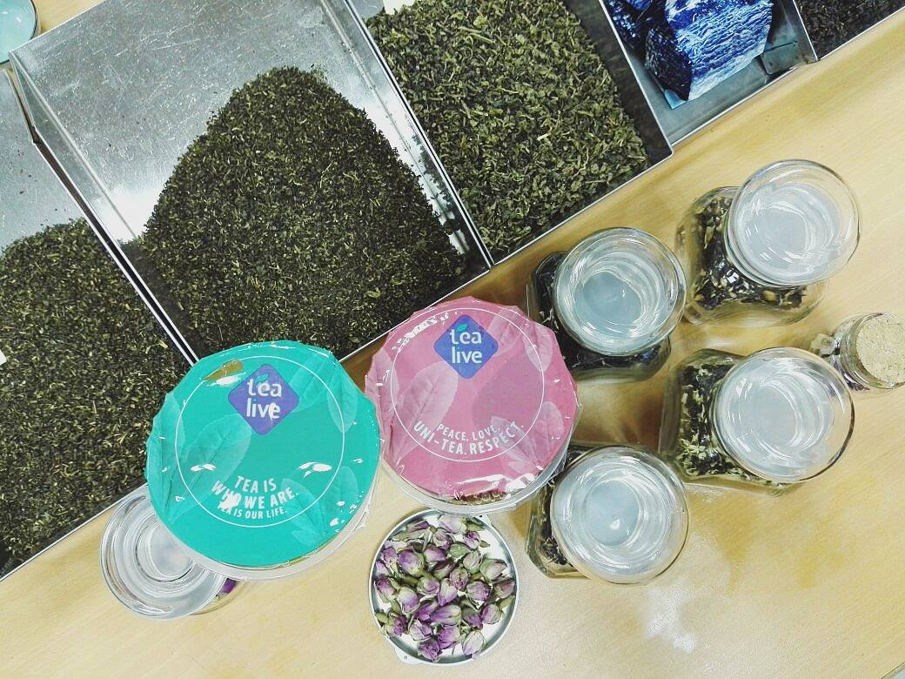
Figure 3: Tealive’s R&D Team Testing (Asia, Tealive Asia, 2017)
After Tealive finds a promising idea, its R&D team develops a drink concept and tests it internally. They experiment with many recipes, portion sizes, and cost structures in their test kitchen (Alifah, 2025). The company often holds tasting sessions with internal staff to get early feedback.
The testing approach adopts the Response Model to refine the product concept iteratively. This model involves internal teams or test users early in the development process to improve the chance of success (Hussain, Jing, Junaid, Zaman, & Shi, 2021). For example, when testing the new Light Milk Tea range, Tealive gathered feedback on sweetness levels to appeal to more health-conscious customers. By getting early feedback, Tealive can refine the product concept before investing further resources in full development. As a result, the company can reduce the risk of a product failing after launch.

2.3 Product Development and Testing
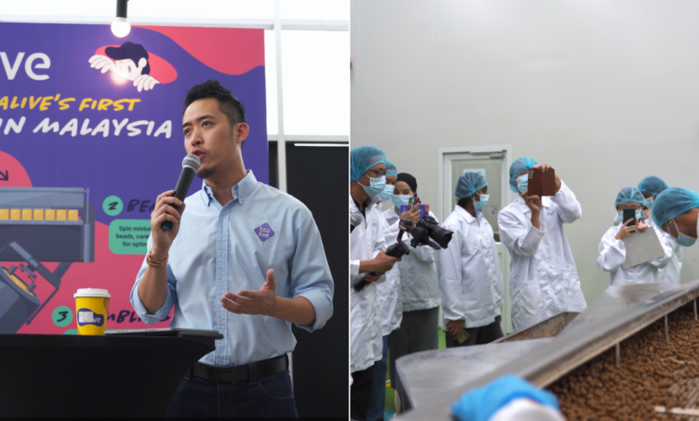
Figure 4: Tealive’s Tapioca Pearls Production (Gan, 2023)
Once the concept is refined and approved, Tealive’s R&D and operations teams work together to finalize the drink for large-scale production. This includes sourcing ingredients, finding reliable suppliers, standardizing recipes, and training staff on preparation. The company often works with local and regional suppliers for ingredients like tea leaves and tapioca pearls. Tealive even built its own tapioca pearl processing plant to secure supply and maintain quality (Gan, 2023).
This step matches the Cross-functional Model that stresses cross-functional teamwork. By involving operations, supply chain, and marketing departments early, Tealive can find problems early before full launch and improve efficiency in launching new products. For example, when developing its FMCG instant drink sachets, the team needed to ensure the drink could be prepared easily at home while tasting similar to the store version (Dong, 2025). Small pilot runs and internal testing help check that the product meets customer expectations.

2.4 Market Testing
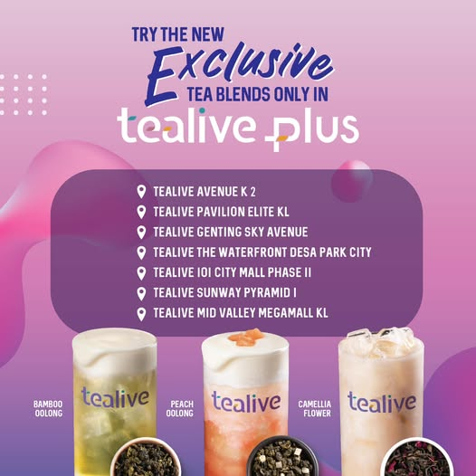
Figure 5: New Products in Selected Outlets (Asia, Tealive Asia, 2023)
Before a full launch, Tealive often tests new drinks through limited time offers or pilot launches in select outlets. For example, new flavours may appear in some stores for two weeks with special promotions to attract trial buyers (Asia, Tealive Asia, 2023). This allows the company to observe real customer reactions, gather data on sales performance, and receive feedback through its digital platforms and staff.
This market testing adopts the Minimum Viable Product (MVP) approach from the Lean Startup methodology. It suggests companies launch a basic version to test demand before investing fully (Lortie, Cox, DeRosset, & Kelly, 2025). This approach is like the conversion-process model that turns ideas into successful products through continuous testing, feedback, and refinement. Effective market testing helps Tealive see if a drink is popular, if pricing is acceptable, and if any changes are needed. If feedback is good, the drink becomes a permanent menu item or returns in the next seasonal cycle. This process reduces risk and helps Tealive launch products that match customer preferences.

2.5 Commercialization
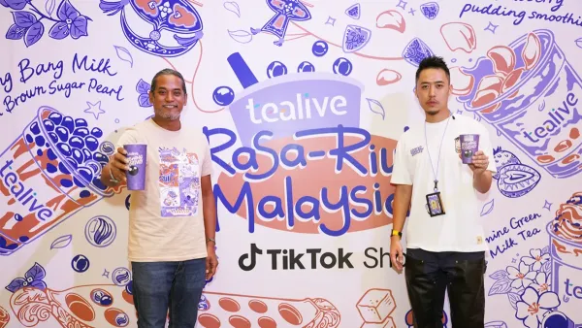
Figure 6: Tealive’s Launching of 3-in-1 Sachet Drink (Reporter, 2025)
When Tealive decides to launch a product fully, it uses a mix of strategies to reach customers quickly. For instance, the company announces new drinks through its mobile app with special deals to encourage early trials. It also collaborates with influencers and promotes on social media to create excitement. In-store promotions, like discounts for loyalty cardholders or bundle deals, help drive traffic (Lo, 2025). Tealive also partners with Aeon outlets, convenience stores, and online platforms to sell its FMCG products like instant drink sachets (Reporter, 2025).
This shows that Tealive follows the Network Model. This model highlights how new products spread through early adopters, digital channels, and social influencers. Tealive’s marketing targets early adopters, who are usually young customers. They tend to try new drinks first and often share their experiences online (Ahmad, 2024). By influencers, viral content, and word-of-mouth, Tealive moves its new products from niche interest to mainstream popularity. In an emerging market like Malaysia, pricing is also important, so Tealive makes sure its new products remain affordable while offering something new and trendy to stand out from competitors (Association, 2022). Hence, the combined efforts help Tealive to reach as many customers as possible in a short time.

3.0 Challenges in NPD
Nowadays, food and beverage (F&B) companies face different challenges in their NPD. As part of the F&B sector, Tealive faces several challenges in its new product development journey. One major challenge is strong competition. Research by Malekpour et al. (2024) identifies “competition intensity and innovation capability” as important factors influencing F&B industries’ ability to launch new products. Many local and international bubble tea brands compete for the same customers, so Tealive must keep innovating to stay ahead (Fong, 2024). According to Porter’s Five Forces, fierce competition forces companies to launch new products faster and at lower costs to maintain market share. However, this pressure can lead to shorter testing times that may affect product quality.
Another challenge is the growing need for sustainability and green innovation. Modern customers expect F&B brands to reduce plastic waste, lower carbon footprints, and source ingredients responsibly. However, adopting eco-friendly packaging or switching to local suppliers can increase production costs and complicate supply chains. This challenge matches the sustainability matches the Resource-Based View (RBV). It explains that unique resources can be difficult to build, maintain, and become a potential bottleneck (Wei & Pujari, 2025). Tealive must balance sustainability goals with product cost and convenience to stay competitive while meeting customer and regulatory expectations.
Lastly, changing consumer lifestyles and health trends pose a global challenge for the industry. Research shows that health awareness among consumers is growing. Many are switching to healthier beverage options with less sugar or natural ingredients. Hence, the demand for sugary drinks may decline if companies fail to adapt (Malekpour, Caboni, Nikzadask, & Basile, 2024). This challenge links to Consumer Behaviour Theory. It explains how shifts in attitudes and preferences shape buying decisions. For Tealive, balancing taste, cost, and health trends in its new drinks is necessary to meet modern customer expectations (Beverages, 2022). These challenges show that Tealive must carefully plan its NPD to deliver new drinks that attract customers while staying practical to produce.

4.0 Recommendations
Market Penetration  - Expand digital loyalty programme  - Offer personalised deals and limited-edition drinks | Market Development  - Expand outlets in Southeast Asia  - Enter new retail channels  - Export instant drinks to nearby countries
Product Development  - Develop low-sugar, plant-based, or healthier drink options  - Launch ready-to-drink bottled teas  - Expand FMCG line with new flavour instant sachets | Diversification  - Add complementary food or snacks  - Create bundled meal sets  - Develop eco-friendly packaging  - Partner with local farms.
Table 1: Ansoff Matrix (Trott, 2017)
To help Tealive strengthen its new product development, tackle the challenges faced in the same industry, and grow sustainably, the Ansoff Matrix can guide clear strategies (Trott, 2017). Firstly, in the Market Penetration strategy, Tealive can boost sales by expanding its digital loyalty programme. This programme can reward repeat purchases among customers more effectively. For example, it can offer personalised deals or limited-edition drinks to loyal customers through its app. This encourages customers to visit more often and increases revenue from existing outlets without significant extra costs.
In the Market Development strategy, Tealive can use its current products to enter new markets (Trott, 2017). Besides expanding outlets in Southeast Asia, Tealive can push its FMCG products like instant drink sachets into new retail channels. The channels include petrol station marts, online grocery platforms, and exports to nearby countries. By doing this, Tealive reaches new customers who may not visit its outlets but still want to enjoy its drinks at home. This expands Tealive’s market reach and creates new income streams.
Under Product Development strategy, Tealive should continue creating innovative products to serve changing consumer tastes and health trends (Trott, 2017). For instance, the R&D department can develop more low-sugar, plant-based, or healthier drink options. These options can attract health-conscious customers efficiently. Tealive can also expand its packaged product line. For example, it can sell ready-to-drink bottled teas and new flavour sachet drinks in supermarkets. The new product lines will strengthen the brand’s image as an innovator. It can also generate extra sales and help Tealive to stay ahead in a competitive market.
Lastly, Tealive can explore Diversification to reduce risk and build long-term sustainability (Trott, 2017). For example, Tealive can offer complementary food items or snacks that match its drinks and create meal sets for takeaways. Another option is to invest in sustainability projects. For instance, Tealive can produce eco-friendly packaging or support local farms for ingredients. By diversifying into related products and sustainable practices, Tealive can attract new customer segments. It can also build stronger brand loyalty and secure its position as a leading lifestyle brand in Malaysia.
The recommendations using the Ansoff Matrix may address Tealive’s main challenges. As a final suggestion, Tealive should consider a combination of Market Development and Product Development strategies. This mix can grow sustainably and is more practical than Diversification. This is because Diversification involves higher risks and unfamiliar operations. By expanding current products into new markets, Tealive can attract new customers. Meanwhile, creating innovative and healthier drinks helps Tealive to meet changing consumer preferences. This approach is less risky than launching entirely new product categories. It also spreads risk and maximises sales opportunities. Besides that, it strengthens Tealive’s position as an adaptable brand. It opens new income streams such as packaged products for home consumption. Eventually, this strategy can help Tealive become more resilient and adaptable in this fast-evolving F&B market.

5.0 Conclusion
In conclusion, Tealive’s new product development (NPD) is the main reason for its success in Malaysia’s F&B market. The brand stays ahead by following global trends, listening to customer feedback, testing ideas carefully, and using effective commercialization strategies. This helps Tealive keep its products fresh and relevant to changing customer tastes. However, Tealive must address challenges like strong competition, the need for sustainability and green innovation, and changing consumer lifestyle and health trends. By using the Ansoff Matrix, Tealive can grow its business by expanding into new markets and developing more innovative products. These strategies can help Tealive reach more customers, create new income streams, and build a sustainable brand.

References
Ahmad, N. (25 August, 2024). Tealive’s BMC. Retrieved from Gerbang Bisnes: https://gerbangbisnes.com/en/tealives-bmc/
Alifah. (25 March, 2025). Tealive: How Malaysia's Bubble Tea King Was Born. Retrieved from Biz Malaysian: https://bizmalaysian.com/blog/corporate-32/tealive-how-malaysia-s-bubble-tea-king-was-born-1208
Asia, T. (2 May, 2017). Tealive Asia. Retrieved from Facebook: https://www.facebook.com/photo.php?fbid=236485256831601&id=185419311938196&set=a.188354681644659
Asia, T. (28 October, 2023). Tealive Asia. Retrieved from Facebook: https://www.facebook.com/tealiveasia/posts/if-you-didnt-know-we-have-tealive-plus-where-you-can-enjoy-exclusive-premium-tea/711750500989547/
Association, M. F. (1 May, 2022). Brewed for survival and innovation: Tealive survived lockdown and moves forward. Retrieved from Malaysian Franchise Association: https://www.mfa.org.my/brewed-for-survival-and-innovation-tealive-survived-lockdown-and-moves-forward/#:~:text=%E2%80%9CFor%20example%2C%20in%20October%202020,reach%20out%20to%20more%20Malaysians.
Beverages, A. F. (17 July, 2022). Growing shifts towards naturally-infused Bubble Tea with unique health, flavor propositions. Retrieved from Asia Food & Beverages: https://asiafoodbeverages.com/growing-shifts-towards-naturally-infused-bubble-tea-with-unique-health-flavor-propositions/
Cambosa, T. (12 November, 2024). Tealive’s new ‘K-Coffee’ offering aimed at serving ‘oppa approved’ coffee. Retrieved from Marketech Apax: https://marketech-apac.com/tealives-new-k-coffee-offering-aimed-at-serving-oppa-approved-coffee/
Dong, I. (13 June, 2025). Tealive expands into FMCG with 3-in-1 sachets. Retrieved from InsideRetail: https://insideretail.asia/2025/06/13/tealive-expands-into-fmcg-with-3-in-1-sachets/
Fong, F. (11 September, 2024). Mixue Mania: China’s Budget Boba Boom Takes Over Malaysia. Retrieved from TRP: https://www.therakyatpost.com/news/malaysia/2024/09/11/mixue-mania-chinas-budget-boba-boom-takes-over-malaysia/
Gan, K. (1 December, 2023). Tealive To Triple Fully Self-Sufficient Production For Tapioca Pearls To 300 Tonnes/Month. Retrieved from KL Foodie: https://klfoodie.com/tealive-to-triple-fully-self-sufficient-production-for-tapioca-pearls-to-300-tonnes-month/
Hussain, K., Jing, F., Junaid, M., Zaman, Q. U., & Shi, H. (2021). The Role of Co-creation Experience in Engaging Customers with Service Brands. Journal of Product & Brand Management, 12-27. doi:10.1108/JPBM-08-2019-2537
Lo, A. (6 March, 2025). Grow Your Brand like Tealive: 7 Easy Steps. Retrieved from Tinker: https://tinkersociety.com/blog/tealive-malaysia-grow-your-brand/
Lortie, J., Cox, K., DeRosset, S., & Kelly, S. (2025). Unpacking the minimum viable. Journal of Small Business and Enterprise Development, 32(1), 212-235. doi:10.1108/JSBED-02-2024-0075
Malekpour, M., Caboni, F., Nikzadask, M., & Basile, V. (2024). Taste of success: a strategic framework for product innovation in the food and beverage industry. British Food Journal, 126(13), 94-118. doi:10.1108/BFJ-02-2023-0138
Nestle. (26 April, 2023). Tealive Launched Coco-Xtreme Series With MiloI. Retrieved from Nestle: https://www.nestleprofessional.com.my/news/tealive-launched-cocoxtreme-milo
Reporter, R. A. (16 June, 2025). Tealive enters FMCG market with launch of 3-in-1 sachet range. Retrieved from Retail Asia: https://retailasia.com/news/tealive-enters-fmcg-market-launch-3-in-1-sachet-range
Tealive. (n.d.). About Us. Retrieved from Tealive: https://www.tealive.com.my/about-us
Torres, E. G., Fonseca-Larios, R., & Ramírez-Portilla, A. (2024). Innovating R&D Practices to Adapt Swiftly to Market Trends: Insights from the Food and Beverage Industry. London: IntechOpen. doi:10.5772/intechopen.1006672
Trott, P. (2017). Innovation Management And New Product Development. Harlow: Pearson Education Limited.
Wei, Y., & Pujari, D. (2025). Drivers of green innovation and green acquisition: empirical evidence from the food and beverage industry. Journal of Business & Industrial Marketing, 40(1), 101-115. doi:10.1108/JBIM-03-2024-0198

