**Methodology**

1.**Qualitative Research**:

   - The studies often use **qualitative research methods** like field observations and interviews. This approach is well-suited for understanding complex social and environmental interactions. For instance, interviews with 20 community stakeholders help to gain insights into local issues, while environmental testing (water and air quality) provides scientific data on environmental conditions. This mixed approach supports a holistic understanding of community and environmental health.

2.**Data Collection Techniques**:

 Data collection spans both primary and secondary sources. Primary data includes firsthand observations, questionnaires, and interviews, while secondary data is drawn from literature reviews, governmental reports, and scientific publications.

Agro-Industrial Waste: Studies on byproducts (e.g., from sugarcane ethanol, cassava, milk production) focus on their physicochemical makeup, global production volumes, and environmental impacts, laying a foundation for sustainable waste management practices.

3.**Analysis and Simulation Tools**:

 NVivo is used for qualitative data analysis, allowing researchers to categorize and interpret large sets of text-based data.MATLAB and SPSS handle statistical and simulation tasks, especially when dealing with quantitative data.

Agent-Based Models and Stock-Flow Analysis: These tools are essential for simulating nutrient flows within agro-food systems, helping to understand resource management better and forecast environmental impacts.

4.**Environmental Assessment Approaches**:

Studies employ multiple frameworks for evaluating agricultural processes. Environmental assessment tools help gauge the ecological footprint of agricultural practices, while stock and flow analyses track nutrients and other resources throughout the production chain, identifying inefficiencies and opportunities for improvement.

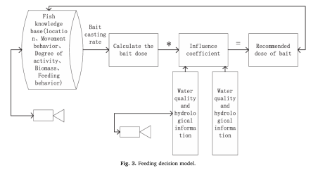

5.**Microalgae in Bioremediation**:

The methodology includes selecting specific microalgal strains like Chlorella and Scenedesmus, which are known for their high nutrient uptake. Researchers assess these strains’ effectiveness in removing pollutants from wastewater through controlled experiments.

Experimental Design: Parameters like light intensity, temperature, and nutrient concentrations are optimized to enhance microalgal growth and pollutant removal. Analytical techniques, such as nutrient analysis for nitrogen and phosphorus, are used to measure the success of bioremediation trials.

6.**Sustainable Agricultural Intensification (SAI):**

As urbanization reduces agricultural land, SAI integrates technology to boost production without expanding resource use.Climate-smart techniques,AI-based decision systems,blockchain for secure data management, and remote sensing are all employed to optimize resource use, manage crops, and track environmental impacts.

 Investment and Farm Size: Public investments are crucial for SAI, especially for small farmers who can benefit from technology and high-value crop production, while larger farms focus on mechanization.

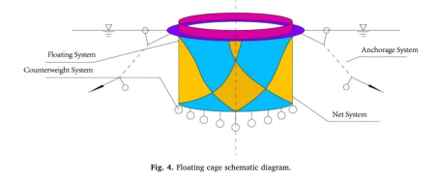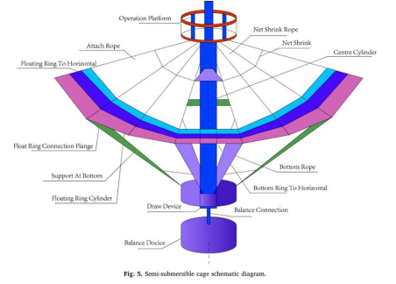

7.**IoT-Based Systems for Resource Monitoring**:

IoT systems, combined with wireless sensor networks (WSNs), monitor water quality parameters (e.g., pH, turbidity, dissolved oxygen). Sensors transmit data through networks like ZigBee, GSM, and WiFi, enabling real-time monitoring for sectors like agriculture, industry, and domestic water management.

Application in Inventory Management: IoT is also applied in inventory management systems, where sensors monitor temperature, humidity, and expiration dates for perishable goods. This helps reduce spoilage through timely alerts and data analytics.

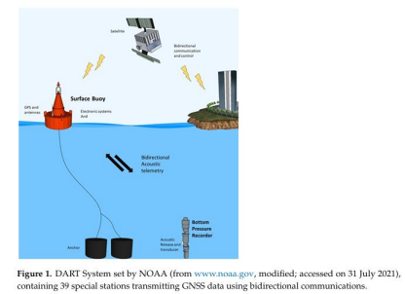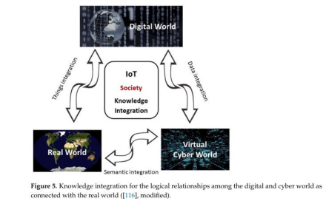

8.**Marine Environment Monitoring with Robotics**:

A study involving **autonomous underwater vehicles (AUVs) in Spain’s Mar Menor region focuses on long-term tracking of Pinna nobilis (fan mussel) populations. Data from AUVs are processed through a hybrid cloud/edge architecture to ensure low-latency control and precision in tracking marine life.

Edge vs. Cloud Computing: The study compares cloud and edge computing approaches for real-time underwater object detection, concluding that edge computing offers faster response times and greater certainty.

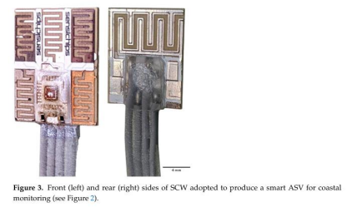

9.**Hybrid Aerial/Underwater Robotic System (HAUCS):**

The HAUCS framework combines aerial and underwater robots for comprehensive aquaculture monitoring. LoRa technology supports efficient communication, while machine learning predicts dissolved oxygen levels, improving scalability and reducing biofouling issues.

Validation through Real-World Deployment: Field tests on fish farms show the advantages of the HAUCS system in terms of cost-effectiveness, coverage, and the accuracy of environmental data.

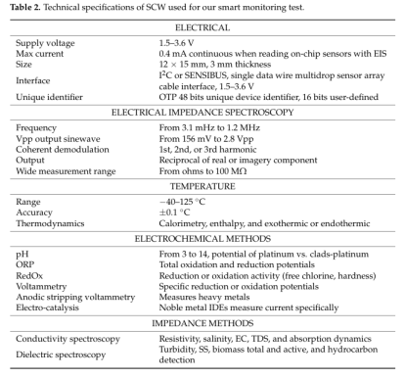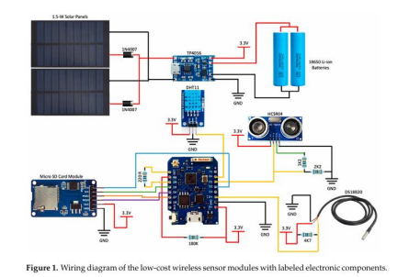

10.**Inventory Management for Perishable Goods**:

This system uses IoT sensors to monitor environmental conditions for perishable inventory, tracking items via RFID and barcodes. Machine learning models predict spoilage by analyzing historical and real-time data, optimizing storage conditions, and alerting for approaching expiration dates.

Architecture and Software: Developed with NodeJS and MongoDB, the system supports real-time tracking, alert notifications, and analytics on product degradation rates.

11.**Water Quality Monitoring with IoT for Fish Ponds**:

This Internet of Things-based Water Quality Monitoring System (WQMS) integrates wireless sensors (e.g., pH, ammonia sensors) to monitor fish ponds. Data is processed in real-time, enabling stakeholders to make informed decisions on water quality for aquaculture management.

Each methodology reflects an interdisciplinary approach, using advanced tools and frameworks to address environmental, agricultural, and industrial challenges, demonstrating the potential for scalable, sustainable solutions through technology integration.

