Tan Soon Jin
A0112213E

Intersex condition is a general term for a group of conditions where there exists a discrepancy between the sexual anatomy with a typical definitions of male or female[1]. This should not be confused with transsexualism where someone has an evident sex, but feels that he or she belongs to group of opposing sex[2]. Before we ask what causes intersex condition, it is important to understand the basis of genetics.

What are DNA, Gene and Chromosome? [3]

DNA(deoxyribonucleic acid) is a biomolecule that holds the recipe how a living organism is built.

Gene is essentially a segment of DNA transferred from parent to offspring that determines one's trait such as eye color, hair color or blood type.

Genes are packaged and organized into chromosome to prevent damage to DNA and fit into cells. Humans have 23 pairs of chromosomes, and among them, the X and Y chromosome are linked to a person's sex.

How are genes passed down from our parents ?
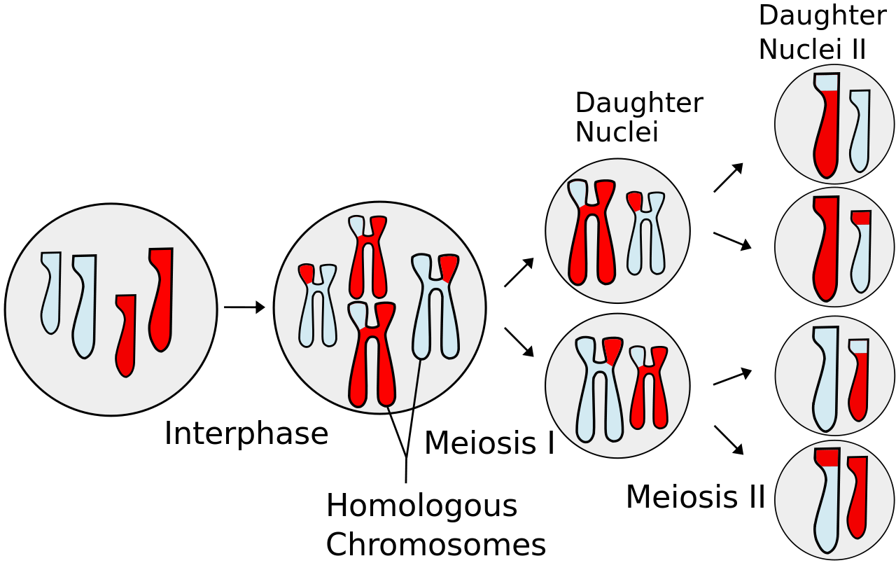Illustration 1: http://upload.wikimedia.org/wikipedia/commons/9/9a/Meiosis_Overview.svg

Meiosis
a pair of homologous chromosomes from father and mother undergoes cross-over to exchange genetic materials and undergoes two stages of cell division to produce sex cells with half number of chromosomes

How does chromosomes determine one's gender ?

Male normally has XY chromosomes while female will have XX chromosomes.

Classification of Intersex conditions[4]

a) Chromosomally intersexed - people who are missing a sex chromosome of having extra sex chromosome. This occurs when the chromosome pairs does not separate equally causing individuals with missing or extra chromosomes

b) Genetically intersexed – usually refers to individuals who have normal chromosomal makeup but a faulty gene on of the chromosome that may be caused by mutation

c) Physically intersexed – individuals with physical characteristic of both female and male. There

Though intersex condition is inborn; however, individuals with perfectly normal genitals for their gender may go unnoticed until puberty. They may encounter problem such as infertility or lack of secondary sexual characteristics.

Types of intersex conditions

A. Klinefelter syndrome (47 chromosomes, XXY)[7]
Cause: Extra Y chromosome in men.
Sign: Testes usually small and ejaculation contains no sperm. May experience breast development

B. Turner Syndrome (45 chromosomes, XO)
Cause: Missing X chromosome in female
Signs: Short stature, broad chest, low hairline, widely spaced nipple and infertility

C. Female with male-looking genitals(46 chromosomes, XX)
Cause: Congenital adrenal hyperplasia (CAH). A condition where lack of protein to produce cortisol and aldosterone causing higher production of male hormone. May lead to kidney problem.
Sigs: Male-looking genital on female

D. Female with extra X chromosome(47 chromosomes, XXX)
Cause: Extra X chromosome in female
Signs: Tall, shy and high incidence of dyslexia

FAQs

How do I determine sex assignment of individual ?[5]

It is advisable to avoid clinical surgery on the infant unless it is vital for survival of the infant. Certain criterion are to bet met such as prioritizing preservation of fertility, genital sensation and making sure the baby will be happy for the rest of his or her life. However, sex assignment could always be done when the infant has grown up and mature enough to choose his or her own sex.

Are individuals with intersex conditions unhealthy and needed to be treated ?

No, they are perfectly healthy and do not need to be treated unless the condition is life threatening

What are some advices for parents of children ? [6]

For infant who are identified at birth, it is recommended that parents delay registration of child's birth. Tests will be conducted to determine the cause of the condition and parents should consult with specialists about how to bring up the child.

References

1. http://www.isna.org/faq/what_is_intersex
2. http://en.wikipedia.org/wiki/Intersex
3. http://geneed.nlm.nih.gov/topic_subtopic.php?tid=15
4. http://www.hemingways.org/GIDinfo/intersex.htm
5. American Psychological Association, Answers to your questions about individuals with intersex conditions, 2006.
6. http://www.nhs.uk/Conditions/Disorders-Sex-Development/Pages/Introduction.aspx
7. http://www.isna.org/faq/conditions/klinefelter

Brochure No: 405

