**CRMS2Map documentation**

**Jin Ikeda**

**Last Modify 01/09/25**

CRMS2Map: Data analytical and mapping tools for the Louisiana Coastal Reference Monitoring System (CRMS)

Repository: <https://github.com/jinikeda/crms2map>

## **Datasets**

Available data list <https://cims.coastal.la.gov/monitoring-data/>

Bulk downloads: <https://cims.coastal.la.gov/FullTableExports.aspx>

CRMS data list

* Hydrographic Data (Continuous Hydrographic (Hourly), Discrete Hydrographic (Monthly)) using bulk download links
* Coastal Basin (GIS data -> Reference layers -> **Basins**)

Input/Basin_NAD83.shp (ten coastal domains defined by CPRA)

Input/Basin_NAD83_Dissolve.shp (merged single domain)

* Datum conversion for surface water elevation (**Geoid12B** after Oct 2, 2023. No more Geoid12A data are available)

<https://www.lacoast.gov/chart/Charting.aspx?laf=crms&tab=2>

## **Environment Setting**

Follow sections 1 to 3 in the Readme file: <https://github.com/jinikeda/crms2map>

## **CRMS2 Map package: Features and Workflow**

### ****1. Auto-Retrieve Hydrographic Data****

* **CRMS2Map continuous**:
  + Retrieves and subsets continuous hydrographic data (hourly).
  + **Estimated Time**: 10 – 20 minutes.
* **CRMS2Map discrete**:
  + Retrieves and subsets discrete hydrographic data (monthly).
  + **Estimated Time**: ~1 minute.

### ****2. Data Processing of Hydrographic Data****

* **CRMS2Map resample**:
  + Generates averaged datasets (hourly, daily, monthly, yearly) from continuous and discrete hydrographic data.
  + Processed datasets are saved in the “Input” folder.
  + Processed and output data are organized in their respective folders for easy access.
  + **Estimated Time**: ~3 minutes.

### ****3. Data Visualization of Hydrographic Data****

* **CRMS2Map plot**:
  + Creates time-series plots for the user’s specified period.
  + Includes (moving-averaged) datasets for:
    - Salinity [ppt]
    - Water level [m, NAVD88]
    - Percent time inundation/Hydro period [-]
    - Inundation depth [m]
  + **Station Specification**:
    - When the user wants to specify the station(s), of interest, update the station_list.txt file located in the parent folder.
  + **Estimated Time**: ~2 minutes.

option

--sdate State date for the data analysis (format: YYYY-MM-DD) [Default: "2008-01-01"]  
--edate End date for the data analysis (format: YYYY-MM-DD)[Default: "2024-12-31"]  
--staionfile Path to station list file <station_list.txt> (format: CRMSxxxx)[Default: None]  
--data_type Data type: hourly(H), daily(D), monthly(M), and yearly(Y)[Default: M]  
--save Save as a single (bundled) dataset and MA_datasets. This is time-consuming when the user uses high spatial datasets. [Default: True]  
--plotdata Plot original data (org) or moving average data (MA)[Default: MA]  
--specify_ma [Optional] The user can specify a central moving average window size in days. [Default: yearly averaged]

## **CRMS2Map Pytest**

### tests/test_CRMS_general_functions.py

* Test individual functions used in each submodule (Github Action automatically tests the CI/CD pipeline when changing the code).

## **Supplement Analysis** (folder: CRMS2Map/Supplement)

## **Datasets**

* **CRMS station coordinates**

CRMS_Long_Lat.csv

<https://www.lacoast.gov/crms_viewer/Map/CRMSViewer> -> Download Lat./Long.

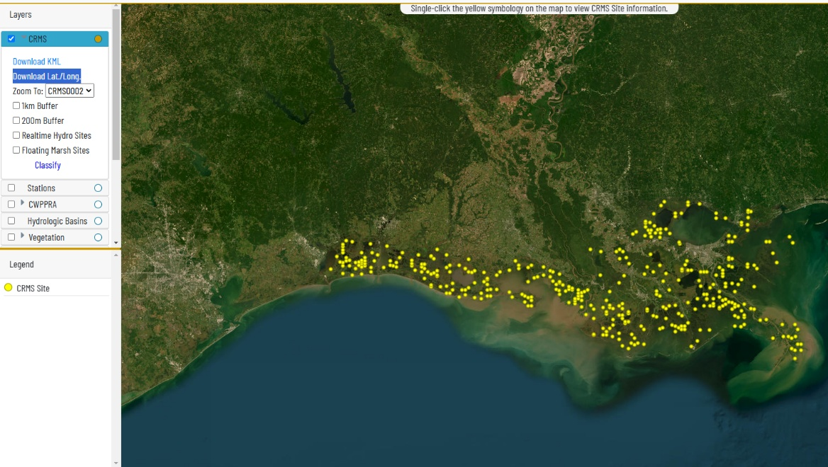

* **Marsh Vegetation**

(<https://cims.coastal.la.gov/FullTableExports.aspx> -> Full Table Exports - CRMS Data Only -> **Marsh Vegetation**)

Processed CRMS_Long_Lat.csv and CRMS_Marsh_Vegetation.csv to make dominant marsh vegetation types and the station’s coastal domains.

* Location: Data/CRMS_station_Basin_Community.shp
* **Station list for each variable** (Surface_salinity, water elevation, temperature, etc)
* Data/CRMS_stations_Surface_salinity.shp
* Data/CRMS_stations_Water_Elevation_to_Datum.shp
* Data/CRMS_stations_Water_Elevation_to_Marsh.shp
* Data/CRMS_stations_Water_Temp.shp
* **Median monthly climate drivers** (sea surface temperature, river flow, precipitation, winds) in Coastal Louisiana (Processed data)
* Locations: Data/MonthlySST.xlsx



Subdomain/community analysis:

* Data/AR_daily_discharge_since_1970.csv (daily Atchafalaya River discharge)
* Data/CS_discharge_since_2008.csv (daily Calcasieu River discharge)
* Data/Basin_total_prcp Monthly.xlsx (total precipitation in each basin)

For the detailed datasets list, please refer to Table2 on *“Tempo-spatial variations in water level and salinity in Louisiana coastal wetlands over 15 years”*

### ****1. Function of Monthly_analysis_practice.py****

* **Data Reading and Preparation**
  + **Read monthly continuous** and discrete hydrographic datasets.
* **Data Analysis**
  + **Generate 12-month moving average datasets.**
  + Examine short- (15 years) and long-term (over 40 years) trends for climate driver and CRMS data.
* Data Grouping
  + Grouped by subdomain and vegetation datasets.
* Data Visualization
  + Generates visualizations for subdomain and vegetation-specific datasets.
* Statistical Analysis
  + Analyzes correlations between subdomain/vegetation datasets and climate drivers.

**Outputs**:

* Plots for subdomains and vegetation datasets (e.g., Photo folder).
* Display/output statistical results (e.g., Sub_basin/Sub_marsh folders).

### ****2. Function of Bootstrap_Regression_analysis.py****

* **Multiple regression models**
  + **Automated bootstrap regression analysis using ordinal linear and random forest models.**
* Statistical Analysis
  + Evaluate the performance of models.

**Outputs**:

* Statistical results (e.g. bootstrap_Output folder).

### ****3. Function of Regression_analysis_plot.py****

* Data Visualization
  + Generates a time series of visualizations for each subdomain.
* Statistical Analysis
  + Generates a summary table of model performance for each subdomain.

**Outputs**:

* Plot a time series of model predictions and comparisons (Photo folder).
* Generate model performance and statistical results (bootstrap_Output folder).