# **Project Tasks Management**

Our team will follow SCRUM methodology and manage our tasks in Trello (<https://trello.com/b/Uha7qXGW/capstone-agile-sprint-board>)

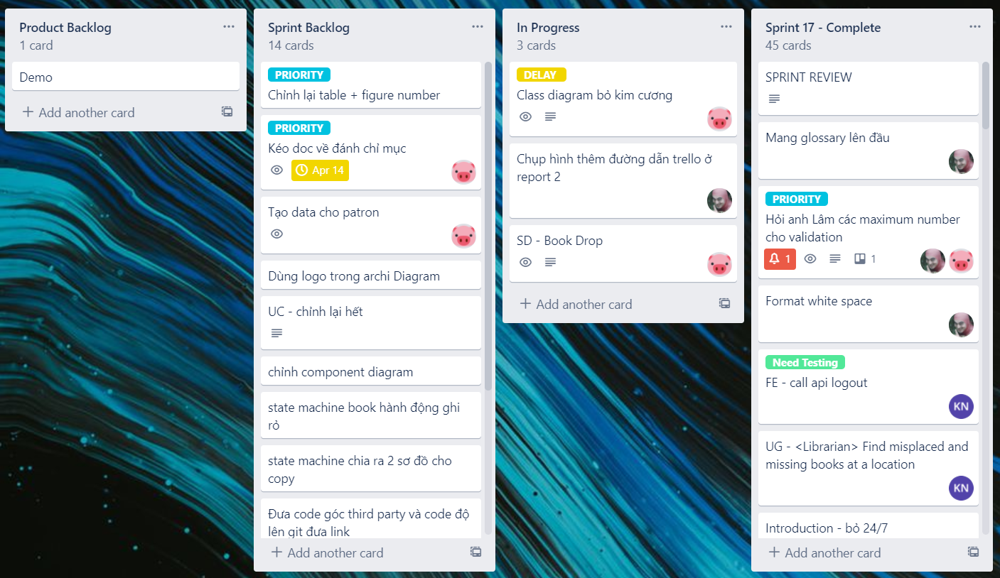

Some of our early tasks (from sprint 1 to sprint 7) were managed in Google Spreadsheet (<https://docs.google.com/spreadsheets/d/1TeyZk-06MU6EGz9Zln25RwDXYVGcFdLQ1_Zkl1PbBlk/edit?usp=sharing>)