CIS451

Linze Li, Jim Li

Final project report

NBA data analysis

1. Summary
2. ER-Diagram
3. Description of all the table
4. Conclusion
5. WebLink
6. Summary

We are going to make a database schema of NBA 2016-2017 regular season, containing 9 tables: team, player, player_performance, team_performance, game, award, award_granted, coach, injury. All data is going to be crawled from <http://stats.nba.com/>. We aimed at practicing our database manipulating skill as well as data crawling skill. We are also going to make a website that performs the functionality based on our database schema.

For basic functionality:

1. Click on a button to have the information of the team.
2. Input a team name to have the player info of this team.
3. Input name of a player’s name for his more info.
4. Input a team name to have the game info for this team within the season.
5. Input a team name to have the injury info of this team
6. Input a team name to have the award info of this team.

For advanced functionality:

1. Input two team names to have the game info between them
2. Input the value and the type of the stat to show the players with higher average of such stat.
3. Input two team names to have the game info between them
4. Input a jersey number to show the top 3 players in this jersey in terms of point per game
5. ER-Diagram

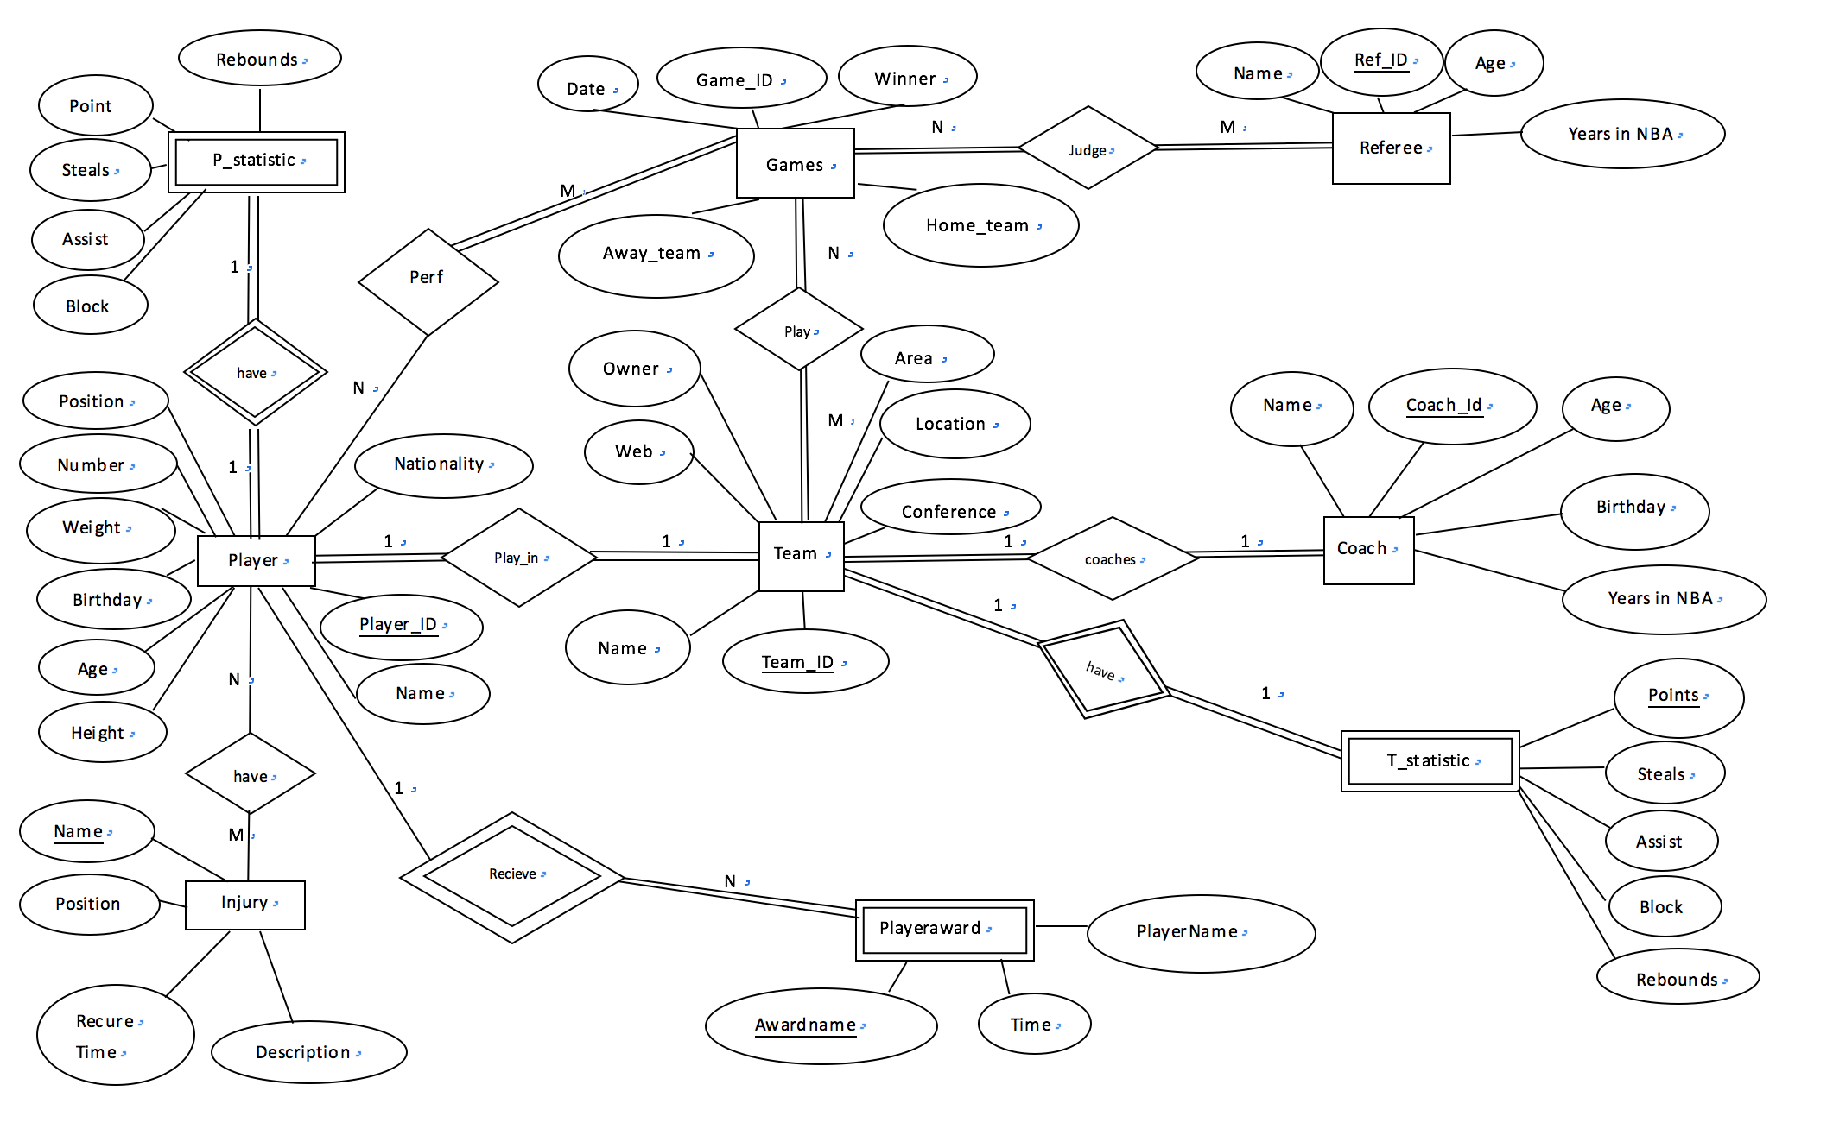

1. Description of all the table

TEAM_ID, COACH_ID, COACH_NAME, START_DATE, BIRTHDAY

In awards table, it has primary key "AWARD_ID", the id for each award, the name of each award "AWARD_NAME".

In awards_granted table, it is a relationship table, the table contain two foreign key "AWARD_ID" from award table & "PLAYER_ID" from player table.

In coach table, it comes with foreign key "TEAM_ID" from team table, and primary key "COACH_ID". And "COACH_NAME", "START_DATE" determine when the coach start to coach the team, "BIRTHDAY"

In game table, it comes with primary key "GAME_ID" for each game. and "Date", "Start (ET)" for the start time of each game. "Visitor_ID", "Visitor_PTS" is the visitor team's ID and points in this game, "Home_ID","Home_PTS" is the home team's ID and points in this game. "Notes" is whether this game has overtime.

INJURY_ID, TEAM_ID, PLAYER_ID, DATE, INJURY

In injury table, it comes with primary key "INJURY_ID", "TEAM_ID","PLAYER_ID",

"DATE", "INJURY" is the name of injury.

In player table, it comes with primary key "personId", "TEAM_ID","firstName","lastName", "weightPounds","heightFeet","heightInches","pos" is player's position in team,"jersey" is the jersey number for player,"playerUrl"

In player_performance table, it comes with primary key(PLAYER_ID),

"GP","MIN","FGM","FGA","FG_PCT","FG3M", "FG3A", "FG3_PCT", "FTM", "FTA", "FT_PCT", "OREB", "DREB", "REB", "AST", "STL", "BLK", "TOV", "PTS", "EFF"

those are the specific statistic for a player in 2016-2017 NBA season.

In team table, it comes with primary key "TEAM_ID","TEAM_NAME", "Owner", "Web", "Conference", "Arena", "Location", "Total_Salary"

those are specific infomation for the team in NBA.

In team_performance table, it comes with primary key "TEAM_ID", "GP", "W", "L", "W_PCT", "MIN", "FGM", "FGA", "FG_PCT", "FG3M", "FG3A", "FG3_PCT", "FTM", FTA, FT_PCT, "OREB", "DREB", "REB", "AST", "TOV", "STL", "BLK", "BLKA", "PF", PFD, PTS, PLUS_MINUS, "GP_RANK", "W_RANK", "L_RANK", "W_PCT_RANK", "MIN_RANK", FGM_RANK, FGA_RANK, "FG_PCT_RANK", "FG3M_RANK", "FG3A_RANK", "FG3_PCT_RANK", FTM_RANK, FTA_RANK, "FT_PCT_RANK", "OREB_RANK", "DREB_RANK", "REB_RANK", AST_RANK, TOV_RANK, STL_RANK, "BLK_RANK", "BLKA_RANK", "PF_RANK", "PFD_RANK", PTS_RANK, "PLUS_MINUS_RANK", "CFID" those are the specific statistic for a team in 2016-2017 NBA season.

1. Conclusion

It has been a happy time for two of us to make such a database based simple website, no only because we are both die hard fen of NBA, but also we learned much about how to use database for actual application. Database is such a useful tool for people to store and analysis data. If time permits, we might work on more fancy SQL queries to have a better understanding of every team and every player’s performance.

1. Link

<http://ix.cs.uoregon.edu/~linzeli/final/nba.html>

or

<http://ix.cs.uoregon.edu/~jinjiel/nba/nba.html>