|  |
| --- |
| Setup Guide |
| Google Cloud Platform Account Setup |

**HOW TO CREATE A GOOGLE CLOUD ACCOUNT?**

A GCP account can be created in the below four steps -

* Step 1 - Create a GMAIL account
* Step 2 - Use GMAIL account to log into GCP console
* Step 3 - Add credit card details to enable billing
* Step 4 - Create a project

# Step 1 - Create a GMAIL account

* Go to [https://accounts.google.com/signup/v2/webcreateaccount?flowName=GlifWebSignIn&flo wEntry=SignUp](https://accounts.google.com/signup/v2/webcreateaccount?flowName=GlifWebSignIn&amp;flowEntry=SignUp) to create a new gmail account
* You may also opt to use your existing Gmail account
* Fill in the details and click next

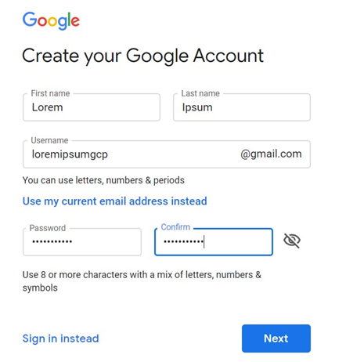

* Add your mobile number and verify using verification code
* Add details about your recovery address, data of birth and Gender
* Once account setup is complete - go to <https://mail.google.com/mail/u/0/>
* Login as your new account
* Click Next
* In the next page, click - Yes, I'm in
* In the next page, agree to the T&C

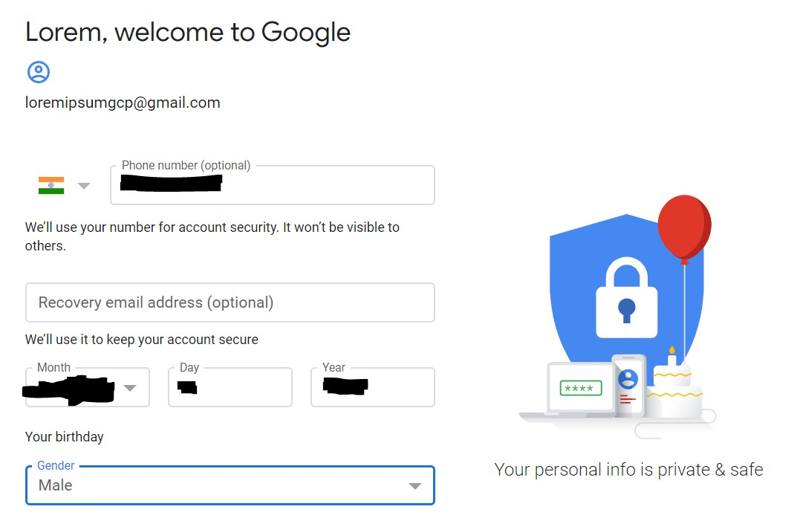

# Step 2 - Log in to GCP console

* On your browser (preferably chrome), navigate to [https://console.cloud.google.com](https://console.cloud.google.com/)

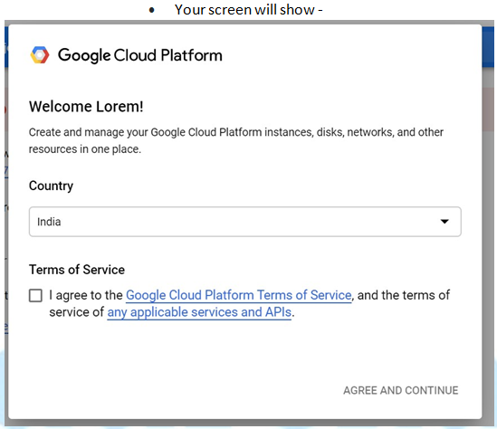

* Agree the terms and conditions and you now have a free tier account for GCP

# Step 3 - Enable Billing to receive $300 credits

* On top of your screen you will see the link to enable billing



* Click on the **Activate** Button to go to the next page
* In the next page - select your country and Agree to the T&C and click **Continue**

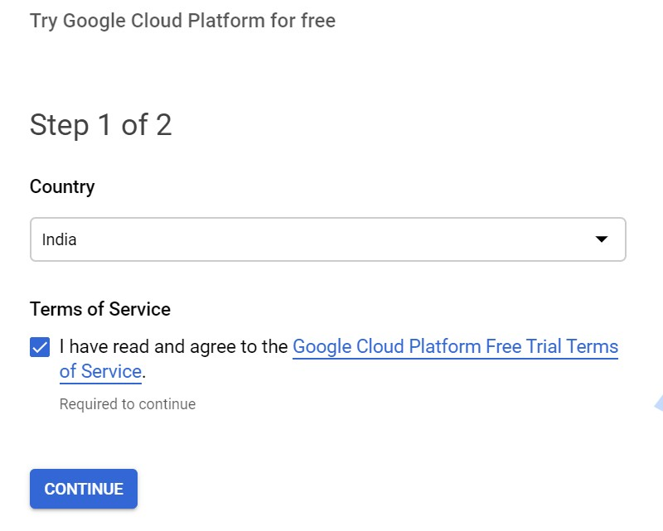

In the next page -

* Change account type to - **Individual**
* Select your Tax status type
* Add your Address
* Add details about your registered ID like SSN/PAN etc.
* Add credit card details

## **NOTE** - It is **YOUR** responsibility to ensure that you shut down your GCP resources so that you dont incur unnecessary charges. Google provides you with an evaluation credit of $300, upto which you will not be charged. Once you cross the limit of $300 Google will charge you for the resources that you utilize. All cloud providers has the **PAY AS YOU GO** model, which ensures that you are charged only for the resources that you are utilizing.

**NOTE** - Ensure that your card supports auto debit. I have seen a few instances where debit cards were **rejected** as they dont support auto debit

* Once done - click **Start My Free Trial**

# STEP 4 - Create a new project

* The top blue menu bar has an option of **Select a project**



* Click on **Select a project** dropdown
* By default a new project would be created

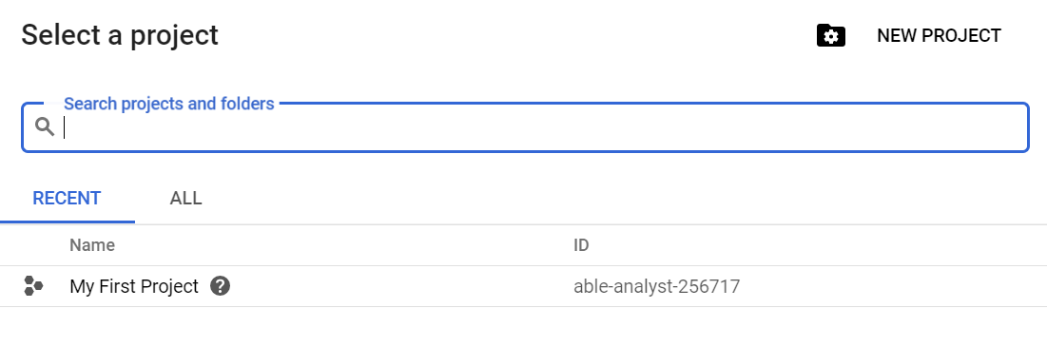

* Select the project **My first project** and you are good to go.

## **NOTE** - Google Cloud **Projects** provides a good way to bundle all your resources together. Which means that deleting the project entirely will delete all the resources inside it. This is really helpful when you dont remember what resources have been created and what resources are getting billed. Deleting the project completely will ensure that you are not billed for anything.