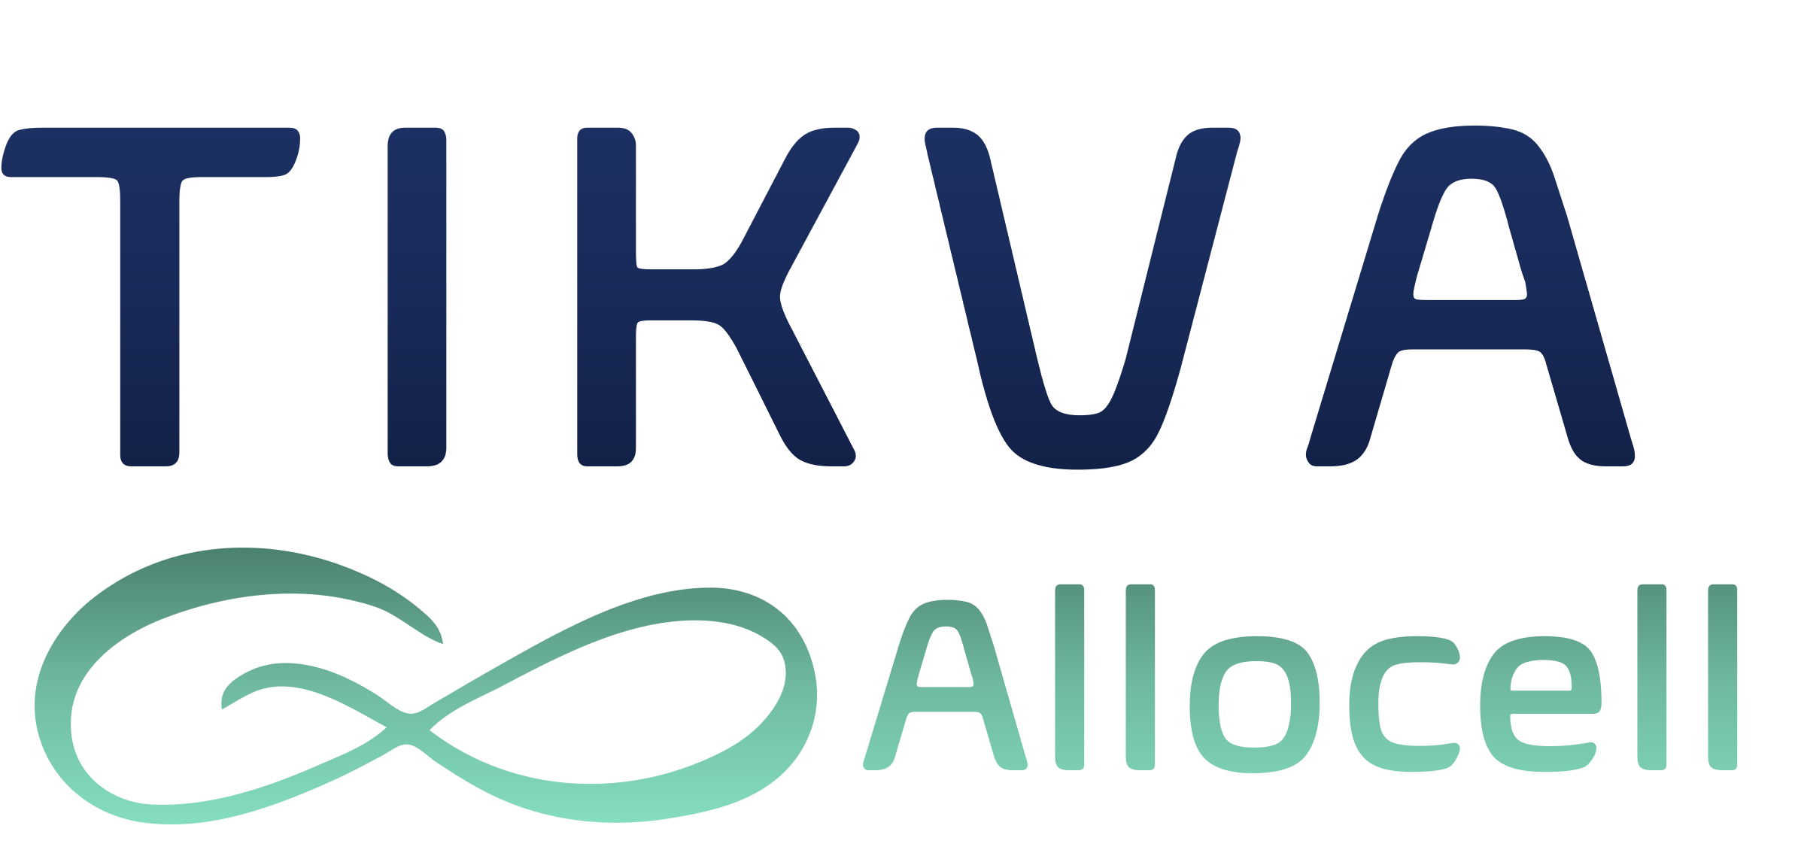
FORM-2025-0006-v01.00
SOP304
Version: 01.00
Approval Date: Not Approved
Effective Date: Not Set
Names | Signatures
Author  Admin Superuser | «DIGITAL_SIGNATURE»
Reviewer  Not Assigned | «DIGITAL_SIGNATURE»
Approver  Not Assigned | «DIGITAL_SIGNATURE»

- Purpose and Scope
This Quality Policy establishes the commitment and foundational principles of Tikva QC Lab for achieving and maintaining high standards of quality in all aspects of our internal pharmaceutical testing. Our purpose is to ensure that all testing of active pharmaceutical ingredients (APIs), in-process materials, intermediates, and finished drug products is performed with accuracy, reliability, and integrity. This commitment is critical to supporting internal research, development, and quality-driven decision-making, ensuring product quality, and safeguarding patient health.
This policy applies to all personnel, processes, and activities within the Quality Control (QC) laboratory. Its scope encompasses the lifecycle of a sample within our facility, from receipt, logging, and handling, through analysis and data generation, to the final review, reporting, and archival of all associated records. It governs every employee, from laboratory analysts and technicians to quality assurance personnel and senior management, ensuring a unified approach to quality.
- Policy Statement
Tikva QC Lab is dedicated to providing analytical testing that is accurate, impartial, and timely to support internal projects and stakeholders. We are committed to meeting the quality standards required for sound scientific and business decisions and ensuring our operations are guided by the principles of applicable national and international regulatory standards, including current Good Manufacturing Practices (cGMP) and Good Laboratory Practices (GLP). We operate with the understanding that our work impacts public health, and our goal is to contribute to the safety, efficacy, and quality of pharmaceutical products.
- Core Principles
Our commitment to quality is guided by the following core principles:
- Accuracy and Precision: We are dedicated to the scientific validity of our testing methods. We ensure that all results are accurate, precise, and reliable by using validated methods, qualified instruments, certified reference materials, and technically proficient analysts. We strive to understand and control analytical variability to deliver results of high confidence.
- Data Integrity: We uphold high standards of data integrity as a bedrock of our operations. We ensure that all data is attributable, legible, contemporaneously recorded, original, and accurate (ALCOA+). This includes the implementation of secure, validated electronic systems with audit trails and robust procedures to prevent data manipulation or loss, ensuring all results are trustworthy and defensible.
- Regulatory Guidance: We are committed to using relevant national and international regulatory standards, including those set forth by the FDA, EMA, and HSA, as a framework for best practices. We monitor the regulatory landscape to ensure our internal procedures align with current scientific and quality principles.
- Internal Stakeholder Focus: We strive to understand and meet the needs of our internal projects and stakeholders. We achieve this by providing reliable data, clear and consistent communication, dependable turnaround times, and expert scientific support. We aim to be a valued and integral partner in the product lifecycle.
- Continual Improvement: We are dedicated to the ongoing improvement of our processes, technologies, and the skills of our personnel to enhance the effectiveness of our Quality Management System (QMS). We foster a culture where improvement is driven by data analysis, risk assessment, trend analysis, and lessons learned from internal audits, investigations, and stakeholder feedback.
- Safety: We maintain a safe and healthy work environment for all our employees and visitors. We ensure that all laboratory operations are conducted with a focus on safety, including adherence to chemical hygiene plans, proper handling of hazardous materials, use of personal protective equipment (PPE), and comprehensive emergency preparedness.
- Key Quality Objectives
To fulfill our Quality Policy, we have established the following key, measurable objectives:
- To ensure all laboratory personnel are thoroughly trained and deemed competent in their assigned roles through a documented program of initial qualification, ongoing proficiency assessments, and regular refresher training.
- To maintain all laboratory equipment in a continuously calibrated and qualified state, suitable for its intended use, supported by preventative maintenance schedules and detailed service records.
- To ensure that all testing is conducted in accordance with scientifically sound, approved analytical methods, with any deviations being properly documented, investigated, and authorized.
- To thoroughly investigate and resolve any out-of-specification (OOS) or unexpected results, deviations, or non-conformances in a timely and scientifically sound manner, including root cause analysis and the implementation of effective Corrective and Preventive Actions (CAPA).
- To maintain a robust, controlled documentation system that ensures the traceability, integrity, and security of all data and records, from raw data to final reports.
- To achieve and maintain a high level of internal stakeholder satisfaction, measured through metrics such as on-time delivery of results, data reliability, and formal feedback mechanisms.
- To conduct regular internal audits and formal management reviews to systematically assess the ongoing suitability, adequacy, and effectiveness of our QMS, driving actionable improvements.
- Regulatory Guidance
Tikva QC Lab is committed to operating in a manner that is informed and guided by applicable best practices. Our QMS is designed to align with the principles and guidance of:
- Current Good Manufacturing Practices (cGMP) as defined in 21 CFR Parts 210 and 211, with a specific focus on Subpart I (Laboratory Controls) and Subpart J (Records and Reports).
- Good Laboratory Practices (GLP) for nonclinical laboratory studies, ensuring the quality and integrity of safety data.
- ISO/IEC 17025 "General requirements for the competence of testing and calibration laboratories," as a model for demonstrating technical competence and generating technically valid results (if applicable).
- Guidelines from the International Council for Harmonisation (ICH), including but not limited to Q2 (Analytical Validation), Q7 (Good Manufacturing Practice for APIs), and Q10 (Pharmaceutical Quality System).
- Personnel
We recognize that our personnel are our most valuable asset and are essential to maintaining quality. We are committed to:
- Recruiting and retaining qualified, experienced, and ethically-minded analysts and support staff.
- Providing comprehensive and continuous training on quality principles, data integrity, safety, ethics, and specific standard operating procedures (SOPs) to ensure technical competence and an understanding of our QMS.
- Empowering all employees with the responsibility and authority to identify and report quality issues, fostering a culture of personal accountability and quality ownership.
- Equipment, Facilities, and Materials
We are committed to providing the necessary resources to support our quality objectives. This includes:
- Maintaining clean, controlled, and suitable laboratory facilities with appropriate environmental monitoring and a logical workflow designed to prevent cross-contamination and mix-ups.
- Ensuring that all analytical instruments and equipment are properly qualified (IQ/OQ/PQ), calibrated, and maintained according to a defined schedule, with all activities documented in a central, auditable system.
- Using approved, traceable, and properly stored reference standards, reagents, and materials from qualified suppliers to ensure the integrity of our analytical work.
- Continual Improvement
Tikva QC Lab is committed to a culture of continual improvement. We will regularly review our quality policy, objectives, and processes to identify opportunities for enhancement. This is achieved through Quality Risk Management (QRM), analysis of quality metrics and Key Performance Indicators (KPIs), and by using the findings from internal audits and assessments as opportunities for growth.
- Responsibilities
The overall responsibility for the implementation of this Quality Policy rests with the senior management of Tikva QC Lab. Management is committed to providing leadership and necessary resources for quality. However, quality is the shared responsibility of every employee. Each individual is responsible for understanding and adhering to the principles and objectives outlined in this policy in their daily work, thereby ensuring the integrity of our data and processes.
Approved by:
_________________________
[Name], Laboratory Director
_________________________
[Name], Quality Assurance Manager

[{'version': 'v01.00', 'date': '12/03/2025', 'author': 'Admin Superuser', 'status': 'Draft', 'comments': 'Initial version'}]

