Some explanation on the Corpus
------To submit to Prof. Choi Key-Sun

The origin of the Corpus
- About 20,000 bilingual sentences are purchased from the department of foreign language and literature of TsingHua University.
- About 10,000 bilingual sentences are purchased from a Chinese Press.
- About 10,000 bilingual sentences are obtained from the electronic dictionary <<Oxford English-Chinese Dictionary>> (Taiwan Version)
- About 20,000 bilingual sentences are obtained from the publication, most of which are about the trade domain field.

The Statistical Data of the Corpus
- The total number of the bilingual sentences = 61599.
- The total number of Chinese Token (Words) = 590564.
- The average length = 9.587 words /Per Sentence.
- The sentences distribution according to the length are described as follows:

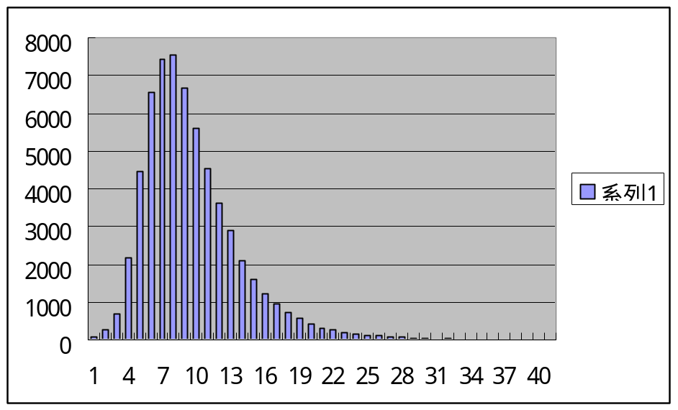

1:71 2:270 3:673 4:2190 5:4462 6:6559 7:7440 8:7556 9:6673
10:5583 11:4520 12:3625 13:2896 14:2113 15:1612 16:1202 17:939 18:728
19:562 20:423 21:319 22:252 23:202 24:168 25:113 26:97 27:68
28:74 29:47 30:36 31:18 32:26 33:18 34:10 35:7 36:13
37:3 38:3 39:9 40:12 41:2 43:2 46:2 56:1

