**WA#2: “Online Courses Fail Those Who Need Help”**

1. Before reading, please freewrite for six minutes in your notebook. Do not worry about grammar or spelling. Write freely. Your writing will not be graded. What is your opinion of online classes? Have you ever taken an online class? If so, was it worthwhile or not? Do you know anyone who has taken an online class? What was his experience?
2. Read the article one time through without stopping. Underline any vocabulary words you are unsure of.
3. Choose seven academic vocabulary words from the list below. Make a vocabulary card for each word. Do the same for three of the vocabulary words you underlined.
4. Re-read the article carefully and thoroughly. Take thoughtful notes in the margins. In the left margin, summarize the main idea. In the right margin, write your reaction to the idea. Make it personal. How does the idea make you feel? Do you have a similar experience? What is it? Do you agree with the idea? Why or why not? What questions do you have?
5. Be prepared to discuss the article in class and share your reactions and ideas about the article. We will discuss in small groups and as an entire class.

**Academic Vocabulary Words**

Precisely supplement resource achievement

Require regulate consequence subsequent

Conduct random expand disproportionately

Site version assessment approach

Ultimately option

[Economic View](https://www.nytimes.com/column/economic-view)

# Online Courses Are Harming the Students Who Need the Most Help

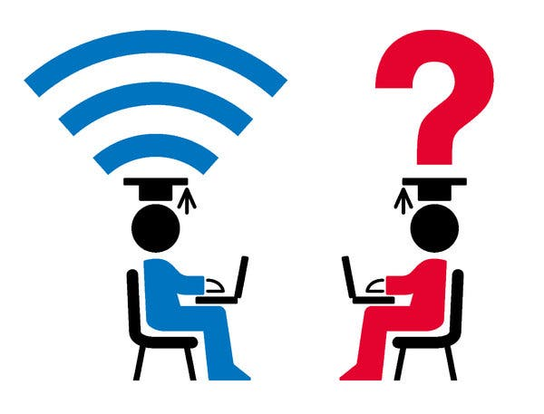

By Susan Dynarski

* Jan. 19, 2018

A single teacher can reach thousands of students in an online course, opening up a world of knowledge to anyone with an internet connection. This limitless reach also offers substantial benefits for school districts that need to save money, by reducing the number of teachers.

But in high schools and colleges, there is [mounting evidence](https://www.brookings.edu/research/who-should-take-online-courses/) that the growth of online education is hurting a critical group: the less proficient students who are precisely those most in need of skilled classroom teachers.

Online courses can be broken down into several categories, and some are more effective than others.

In “blended” courses, for example, students don’t do their work only online: They also spend time in a classroom with a flesh-and-blood teacher. [Research suggests](https://www.nber.org/papers/w23744) that students — at nearly all levels of achievement — do just as well in these blended classes as they do in traditional classrooms. In this model, online resources supplement traditional instruction but don’t replace it.

In the fully online model, on the other hand, a student may never be in the same room with an instructor. This category is the main problem. It is where less proficient students tend to run into trouble. After all, taking a class without a teacher requires high levels of self-motivation, self-regulation and organization. Yet in high schools across the country, students who are struggling in traditional classrooms are increasingly steered into online courses.

For example, in so-called credit recovery programs, many students who have flunked a course in an old-fashioned classroom retake the class online. The negative consequences may not be obvious at first, because the [pass rates in these courses](http://www.slate.com/articles/news_and_politics/schooled/2017/05/u_s_high_schools_may_be_over_relying_on_online_credit_recovery_to_boost.html) are very high and students who take them tend to graduate from high school instead of flunking out. What could be wrong with that?

But there is something wrong with it. In reality, students who complete these courses tend to do quite poorly on subsequent tests of academic knowledge. This suggests that these online recovery courses often give students an easy passing grade without teaching them very much.

Consider a [study conducted in the Chicago high schools](http://www.tandfonline.com/doi/abs/10.1080/19345747.2016.1168500?journalCode=uree20&). Students who had failed algebra were randomly assigned either to online or to face-to-face recovery courses. The results were clear: Students in the online algebra courses learned much less than those who worked with a teacher in a classroom.

Online courses have many real benefits, of course. They can help high achievers in need of more advanced coursework than their districts provide through other means. This is especially true in small, rural districts that offer few specialized, traditional courses for students working ahead of their grades.

A study in Maine and Vermont examined the effect of online courses on eighth graders with strong math skills in schools that didn’t offer face-to-face algebra classes. Students were randomly assigned either to online algebra or to the less challenging, standard math offered in traditional classes.

Both groups of students were tested at the end of the school year. The online algebra students [did substantially better](https://ies.ed.gov/ncee/edlabs/regions/northeast/pdf/REL_20124021.pdf) than their counterparts in standard classrooms. They were also twice as likely to complete advanced math later in high school.

In colleges, especially in nonselective and for-profit schools, online education has expanded rapidly, too, with similar effects. These schools disproportionately enroll low-income students who are often the first in their families to attend college. Such students tend to drop out of college at very high rates. Students with weak preparation don’t fare well in online college classes, as [recent research](https://www.aeaweb.org/articles?id=10.1257/aer.20151193) by professors at Harvard and Stanford shows.

These scholars examined the performance of hundreds of thousands of students at DeVry University, a large for-profit college with sites across the country. DeVry offers online and face-to-face versions of all its courses, using the same textbooks, assessments, assignments and lecture materials in each format. Even though the courses are seemingly identical, the students who enroll online do substantially worse.

The effects are lasting, with online students more likely to drop out of college altogether. [Hardest hit](https://www.brookings.edu/wp-content/uploads/2017/06/ccf_20170609_loeb_evidence_speaks1.pdf) are those who entered the online class with low grades. Work by [researchers](https://www.brookings.edu/research/a-silver-lining-for-online-higher-education/) in many other colleges concurs with the DeVry findings: The weakest students are hurt most by the online format.

For those with strong academic skills, by contrast, online learning can open up amazing opportunities.

The Massachusetts Institute of Technology offers a set of free, online courses in the [economics of developing countries](https://micromasters.mit.edu/dedp/). Students who perform well in these classes can apply for a face-to-face master’s program in economics at M.I.T. In fact, the online courses are the sole route into this special degree program. With online credit, students need to spend only one semester in Cambridge to graduate.

The M.I.T. approach reverses the high school model in which students who fail in a face-to-face class are shifted into a more challenging online format. In M.I.T.’s program, students must first demonstrate that they can tough it out in an online class. Only then are they admitted to a rigorous, face-to-face master’s program.

Online education is still in its youth. Many approaches are possible, and some may ultimately benefit students with deep and diverse needs. As of now, however, the evidence is clear. For advanced learners, online classes are a terrific option, but academically challenged students need a classroom with a teacher’s support.

Susan Dynarski is a professor of education, public policy and economics at the University of Michigan. Follow her on Twitter: [@dynarski](https://twitter.com/dynarski).

A version of this article appears in print on Jan. 20, 2018, Section BU, Page 3 of the New York edition with the headline: Online Courses Fail Those Who Need Help.

<https://www.nytimes.com/2018/01/19/business/online-courses-are-harming-the-students-who-need-the-most-help.html>