**SOFTWARE DEVELOPMENT LIFE CYCLE**

Software Development Life Cycle contains six phases

1. Requirement Phase (Planning)

2. Analysis Phase

3. Design Phase

4. Coding Phase

5. Testing Phase

6. Maintenance Phase

**PLANNING PHASE – REQUIREMENTS GATHERING**

**Identification of the system for development**

* **Define the project**

Online Grocery Shopping – The project holds an online grocery store aiming for customers to purchase and order groceries online. This is useful for clients who don’t have time and won’t be able to physically buy items at the store thus also serves to people with disability.

* **Identity business cases, and concepts**

The system will pull provide items online anytime as well as deliver purchases door-to-door with specific delivery schedules. Each item has product description, stock availability, prices, ingredients and other related information. The order-buy-deliver process is on a global scale with options of availing product delivery or not.

* **Risks and Solutions - Define at least 1 technical, and 1 non-technical risks and solutions**

**Risks:**

* Scope creep – frequent changing of project scopes into something completely different from the initial plan. It could result to miss project deadlines and extend project timeframes.
* Buyer non-involvement – the success of project depends on how the buyer participates and accepts in using it to purchase products online. Without their partaking, all the effort, time, costs incurred will be useless as the system will be inoperable.

**Solutions:**

* Documenting the details of your project
* Projects rarely move from start to end without having some setbacks. Developing a backup plan in place in the initial planning stage is a good preparation in case few hiccups/glitches from clients will occur. Determining who’s responsible for revising and approving requested modifications or additions, how long timelines these can be extended, how many individuals needed for this request, and the cost associated with extra work.
* Initiate a kick-off meeting and communicate clearly with teams and clients
* When a client requests with additional changes, start by reminding them what is initial agreed scope of work, and then present them with possible options to choose.
* Training in the use of the new system and hear user complaints and suggestions
* Allowing the users to have sufficient time to explore and experiment with the new system
* Launching user support services for easily accommodate user’s needs corollary to the use of new system
* Extensive dissemination and good marketing strategy to make the system known to people.

**Technical approaches**

Leading software – WordPress

Benefits of using the WordPress Platform:

* Plugins extend functionality and user-friendly especially for beginners
* Offers variety of theme designs, mobile responsive and have a built-in blog feature that can be accessed from any device anytime.
* Global WordPress-loving communities offer support in outreaching to users, promote the growth of co-WordPress users.

Benefits of using CMS system:

* Allows multiple user – permits numerous people to input data about their items and CMS easily manage roles and permissions for all these users so that only those with rightful access could publish content and make it live.
* Improves site maintenance – updating changes would be easy and adding functionality is possible without breaking the site.
* Simple design changes – any modifications are easy because of the existence of administrative dashboard that will automatically broadcast to the entire site.

**Security:**

* Widespread community or developer that assist in WordPress to update functions or add more features.
* Eliminate Attack Vectors means that permit only inbound traffic to the web server on the ports that are required for the CMS. Also, limiting access to CMS to users on main network or VPN.
* Numerous logins with stern access and permissions are possible in CMS.

Buyer Login: The buyer views all the products available and may place order, select delivery options and payment online.

Admin Login: For the administrator or management who may delete fake or unwanted ads, manage bidder and seller access. Also, uploads a product up ready for selling.

**Outcomes:**

* Project in control - With CMS, the web developer is in control with the content, security, has the ability to allocate tasks, and to check improvement at any time.
* Good manage content – Menus, links, announcements will update automatically, in which the clients have continuous remarkable experience in using the site.

**ANALYSIS PHASE**

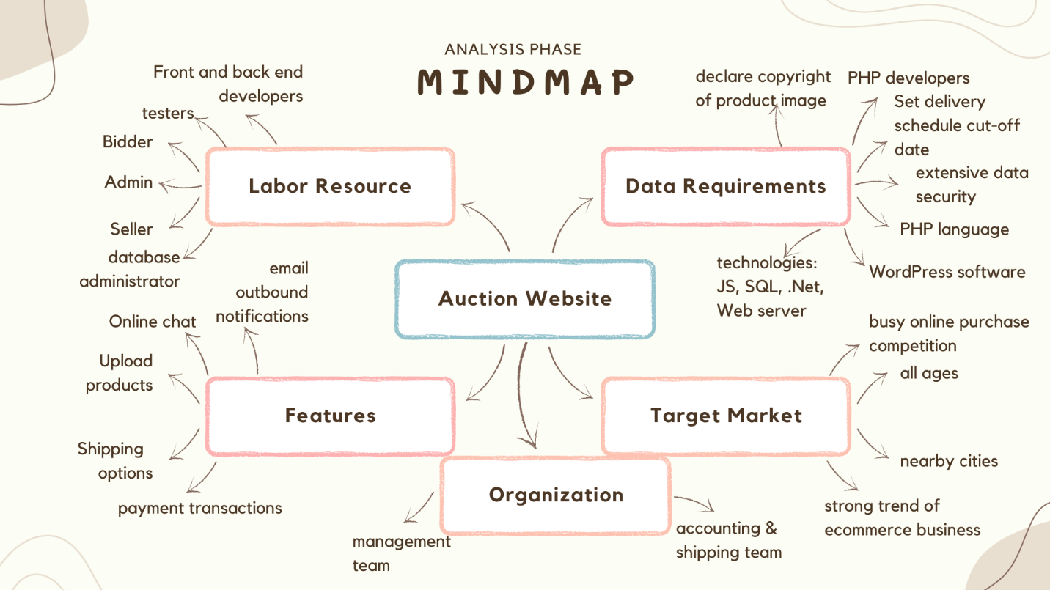

**Feasibility assessment**

* Language and labor resources - The programming language will be used in developing the auction website is PHP language. There are numerous PHP developers in the city so hiring labor resources with work experience is feasible. Also, PHP language has been taught by schools hence, new graduates are welcome to join the workforce.
* Technical – WordPress software
* Financial – estimated budget for resources incurred such as software, labor, facilities and overhead costs
* Market – consistent growth of ecommerce business especially when pandemic struck globally. During this time, online transactions have been the best choice for people to safely purchase items without touching nor evaluating it firsthand.
* Legality – declare copyright of images as much as possible
* Organization – There would be a group of people in charge for operational management, shipping, and accounting to create a smooth process of incoming orders until delivery.

**Technology Selection**

* PHP
* JavaScript
* .Net
* MySQL or MS SQL
* Web Server
* WordPress

**Resource Plan**

* Database administrator
* Lead admin
* Front-end developers
* Back-end developers

**DESIGN PHASE**

**System Architecture:**

Bluehost will be used as a hosting solution and this has been considered best web hosting for WordPress. It comes with free SSL certificate, malware detection, 1-year free domain and 24/7 support. Moreover, the monthly cost is cheaper compared to other web hosting services. Plus-plan will be availed with CA $6.89 as of 4th of June 2022 with following benefits:

|  |  |
| --- | --- |
| PLUS PLAN | |
| # of websites | **Unlimited** |
| Website space | **unmetered** |
| bandwidth | **unmetered** |
| Performance | **Standard** |
| SSL Certificate | **free** |
| Included domains | **1** |
| Parked domains | **unlimited** |
| Sub domains | **unlimited** |
| Email accounts* | **unlimited** |
| Email storage | **unlimited** |

*Unlimited email accounts as this online supermarket ordering website has been expecting multiple users/buyers.

**Website requirements:**

Below are the recognized requirements for the online supermarket ordering website

|  |  |
| --- | --- |
| Website Requirements | |
| Content | **Functionality** |
| * *About the website* * *Online support chat* * *Product categories menu* * *Images of all products* * *Display of quantity of stocks available* * *Add to cart display* * *Delivery schedules* | * *User Sign in page, home and account page* * *Adding to shopping cart feature with totals* * *Accepts card payments* * *Delivery costs* * *Display of all products with stock availability* * *Daily sale products* * *Promos and discounts announcements* * *Order status* |

**Complete detail of interface:**

Website User Interface Structure Color Palette

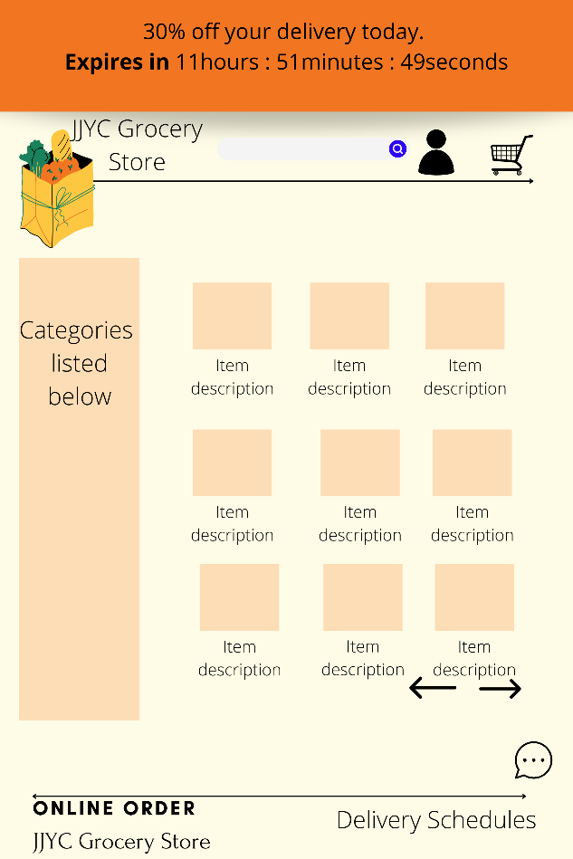

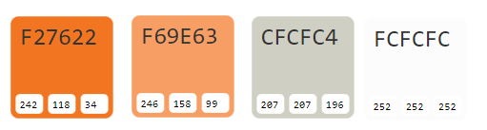

**Dependencies:**

|  |  |
| --- | --- |
| Plugins | Templates |
| WooCommerce   * various Grocery-Store templates to choose from. There are simplistic design, intuitive layout, and several customization options available to design the website. * Shop theme v.1.02 by DesignPromote will be used in this project   Smush   * WordPress plugin that optimizes images while keeping its quality. * Easy to use, upload and tested as number one for speed and quality   Yoast SEO   * Improves website’s rankings on search engines through enhancing the site’s contents and keywords for easy search look-up. * The free version has a lot of tools in helping the site to be searched effectively.   Duplicator   * Free and prevailing plugin that enables the user to create a full copy of the WordPress website, contents, styling, and even database. * Groups the website’s files into a single package and hence, used in migrating the entire site to a new host, domain or staging site. | <https://getthe.me/wp/shop/>  Ready to use website theme for shops or other type of business. Use featured images or page titles to list pages (not posts) on the front page. The theme is derived from Twenty Twelve. |

**CODING PHASE**

**Roles:**

* Design Team handles the overall features of the website. Works with developers, database administrator, clients and project manager to capture the needs and desires in criteria documents/contract documents. The team identifies business and user goals in the early stages hence building the vision and website design as planned and agreed.
* Developers are responsible for developing and implementing a website application with quality coding practices and output to best deliver client’s expectations and objectives. They made the website fully functional similarly maintaining and upgrading existing websites.

* Project Manager is accountable in handling changes of scope and project schedule, creates good quality of process, controls, initiating countermeasures and budget as project is being developed. Also, managing possible risks of unpredicted situations that hinders the stream of development cycle thus addressing probable strategic responses thereby creating a risk response plan.

**Check-in:**

A server will be used to transfer files from local machine to centralized model, where updated codes are in place. Backups, builds, permissions and other restrictions are monitored in the server. Database is widely used to hold data from the users.

**Check-out:**

The downloading of files from the repository to the client’s user machine will be aided through the support of database and server. They provide and transports data requested from the local machine to be readily used by the users.

**TESTING PHASE**

**Roles:**

* Test Engineer primarily focuses on designing and implementing test procedures, executes and logs test results, and document problems encountered against performance metrics during the testing phase to ensure no repetitive errors occur and website works as intended. They complete website specifications before deploying its application to the public. Manual or automated software tool is often used during debugging stage.
* Project Manager determines the needs or conditions to meet for a website expectation. Manages the test bugs discovered during the testing phase and create a timeline to accomplish solving and retesting these bugs. This cycle is repetitive until minimal errors are captured in the project.

**MAINTENANCE PHASE**

**DELIVERY AND MAINTENANCE’S PHASE:**

* The updated website will be built and compiled in a folder to transfer in the live environment for the clients to test and review if the website’s on point on their need.
* The team will test, repair and fix the website both in test and production environment to ensure that no bugs as much as possible.
* If the build is deployed in production environment, then the company will conclude that the project delivered to the client properly
* Once the project is delivered, the maintenance phase of the project will be started.

**MAINTENANCE PHASE**

* Once the project got delivered to the client and it is deployed in live environment the maintenances of the project will be started
* Maintenance depends on the agreement between two parties usually semi-annual or yearly maintenance checking.
* This stage occurs introducing new features to incorporate in the existing website.
* Upgrading the application to the newer versions of Software and plugins that were used in developing the application.
* Bugs are reported from the clients when they find something odd. Mails with comments, issues and bugs are delivered to the company and is expected to provide solutions or modifications as deem necessary within 12 to 24 hrs.
* As long has the project continue to meet the needs and that it still performing as per specification mentioned in the earlier phases, it would be kept running in the production environment.