RIS RStudio Workshop Instructions

Step 1: Access the RIS server via ssh
- Using your WUSTL key, login to the RIS server via terminal using the following command:
  - ssh wustlkey@compute1-client-1.ris.wustl.edu
    - ex. ssh kevin.boyer@compute1-client-1.ris.wustl.edu
- You will be prompted to enter your password, which will be the same as your WUSTL key password.
Step 2: Creating R profile
- Once logged in, you should be in your home directory. You can check this using the command “pwd”, which should return something like the image below.
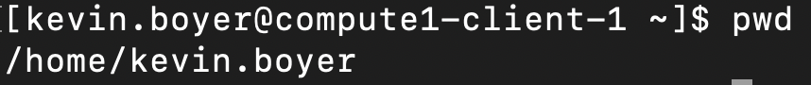
- If you are not in your home directory for some reason, you can change your directory using the command “cd”. The following command will take you to your home directory: cd ~
- Create and edit a new R profile file using the command: vim .Rprofile
  - This will open an empty file which you can paste the following code to: (you may need to press “i” in order to insert text to it.)
vals <- paste('/storage1/fs1/workshops/Active/BIO5488/R_libraries/',paste(R.version$major,R.version$minor,sep="."),sep="")
for (devlib in vals) {
if (!file.exists(devlib))
dir.create(devlib)
x <- .libPaths()
x <- .libPaths(c(devlib,x))
}
rm(x,vals)
  - After pasting the above code, you can save and exit this file by typing “:x” and pressing the enter button
Step 3: Access RStudio through the Open On Demand Platform
- Login (if necessary) using your WUSTL key to Open On Demand here: http://ood.ris.wustl.edu/
- Under “Interactive Apps” dropdown menu, select Rstudio. You should see the below screen:
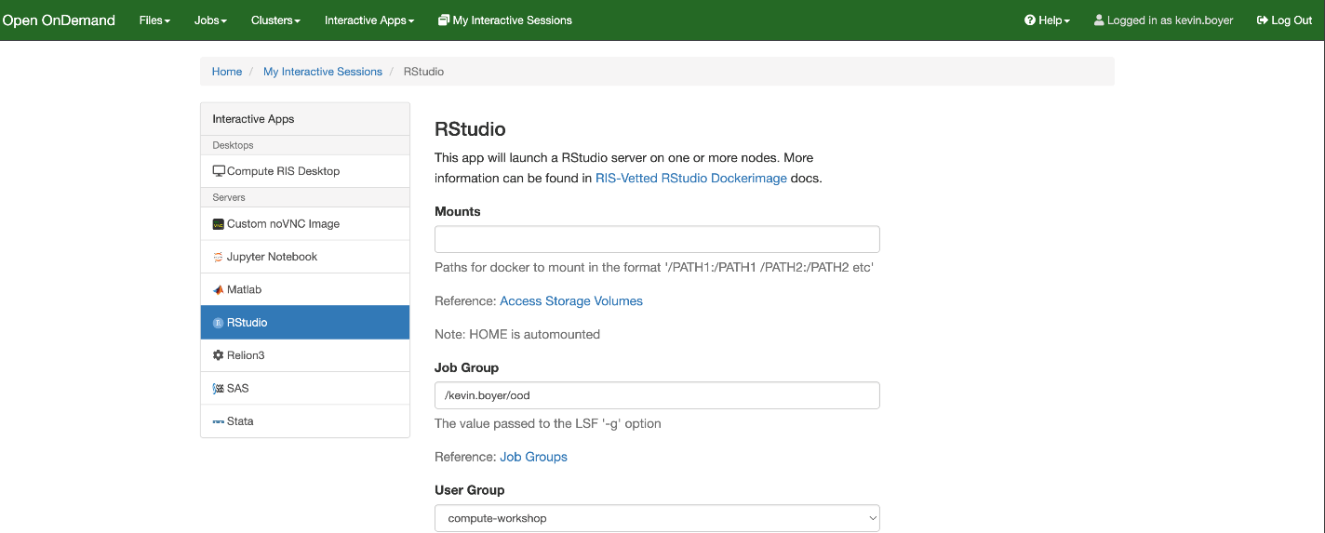
- In the “Mounts” section enter the path to the class directory:
  - /storage1/fs1/workshops/Active/BIO5488:/storage1/fs1/workshops/Active/BIO5488
- In the “Memory” section, enter “4” to request 4GB of memory for this project
- In the “Number of hours” section, select how long you would like the session to stay active
- Leave all other values empty or with their defaults.
- Press Launch
  - Your session will be queued, and you will be brought to this page until it is ready to launch 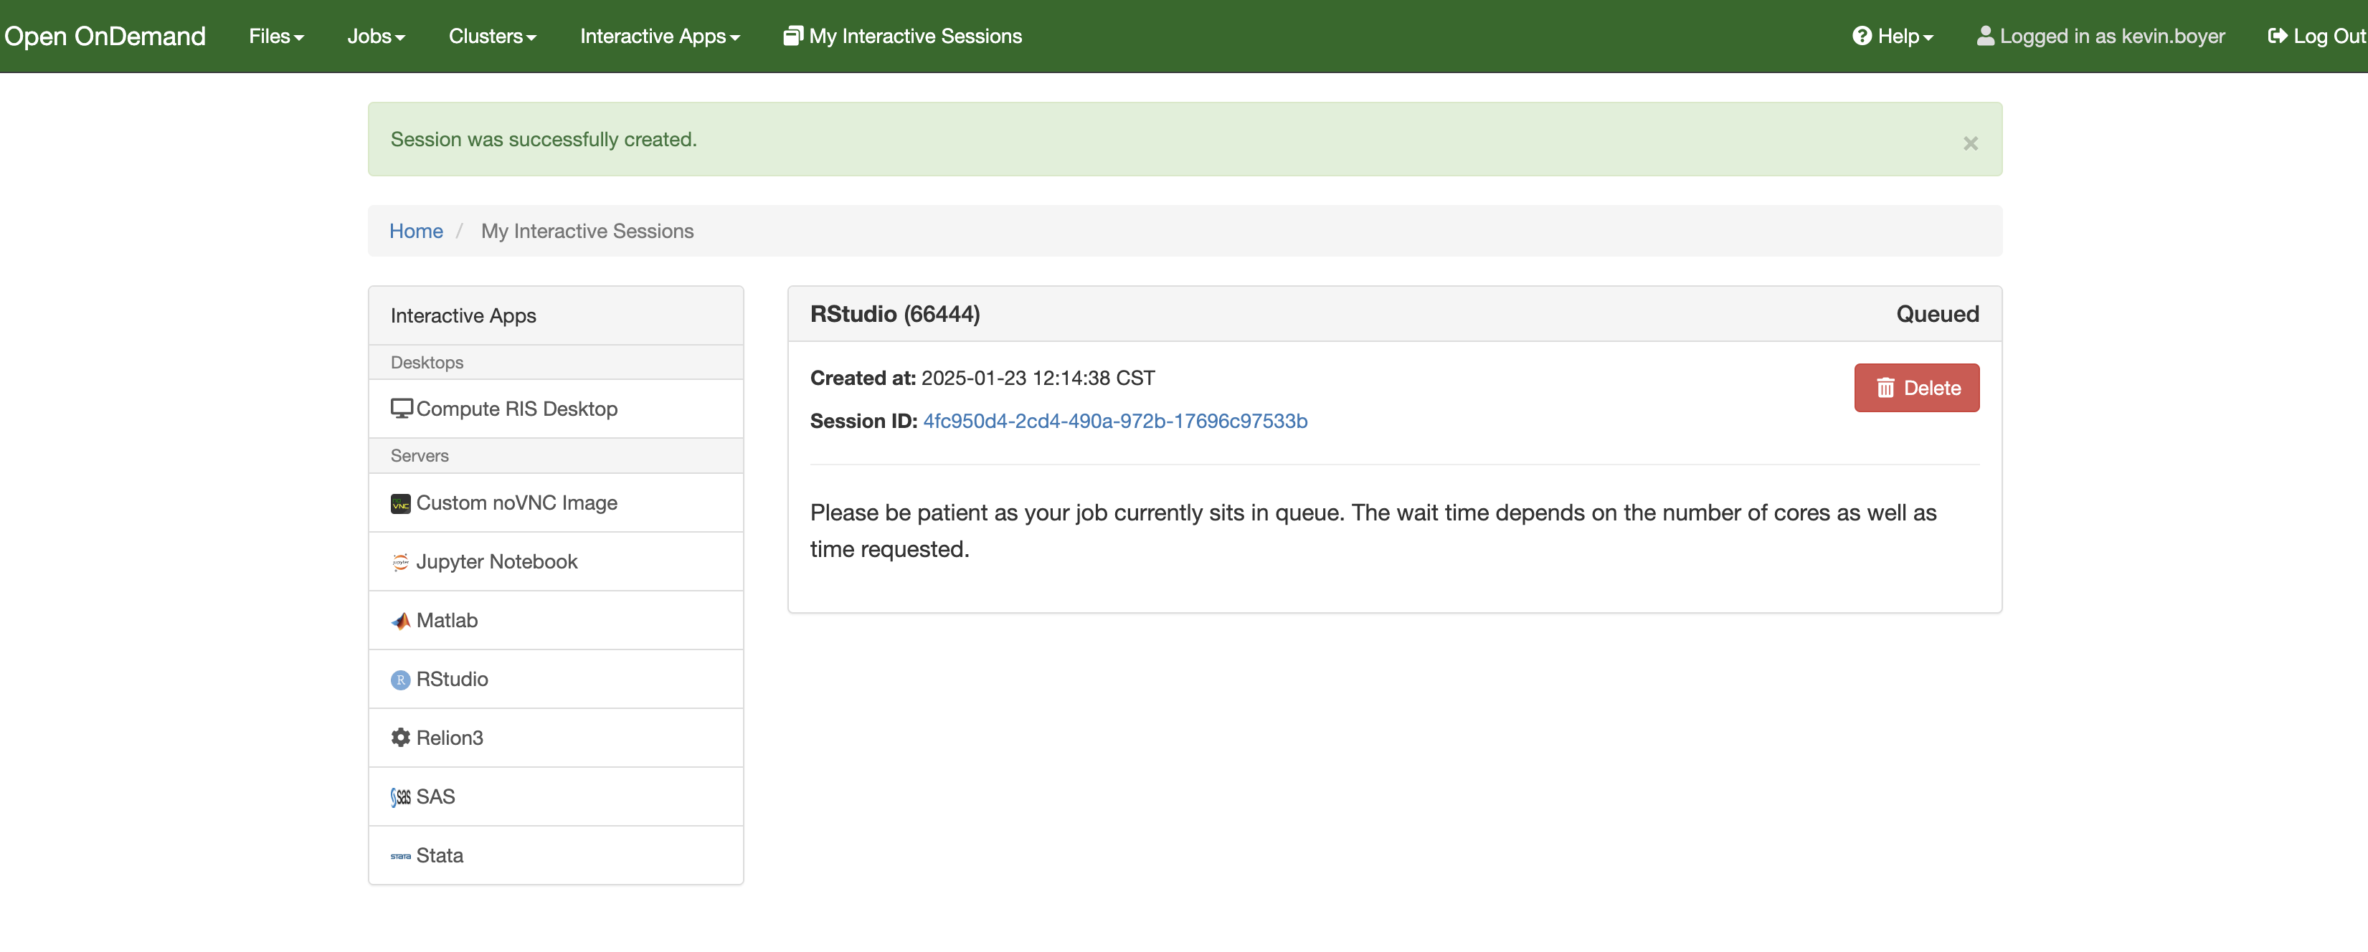
- When the session is ready, a blue button will appear which says “Connect to RStudio Server”. Clicking this will open the RStudio session.
Step 4: Load the script file Bio5488_Homework_RNA_seq.Rmd
Set your working directory by changing the path to your homework directory in the following line of code:
setwd("/home/gzhao/Bio5488_Homework_RNA_seq")

Step 5: Load the necessary packages by following the lines of code in the template script. If a package is not available you can install it by using the following command or search it up on how to install. Most of the libraries used are easy to install.
- Most packages can be installed using the command “install.packages()”
  - Ex install.packages(“Seurat”)
- Once installed, packages can be loaded using the command “library()”
  - Ex library(“Seurat”)

- To install DESeq2, which is required for the differentially expressed gene analysis:
if (!require("BiocManager", quietly = TRUE))
install.packages("BiocManager")

BiocManager::install("DESeq2")

