Untitled

Jin Lin

2019年1月15日

# R Markdown

This is an R Markdown document. Markdown is a simple formatting syntax for authoring HTML, PDF, and MS Word documents. For more details on using R Markdown see <http://rmarkdown.rstudio.com>.

When you click the **Knit** button a document will be generated that includes both content as well as the output of any embedded R code chunks within the document. You can embed an R code chunk like this:

summary(cars)

## speed dist   
## Min. : 4.0 Min. : 2.00   
## 1st Qu.:12.0 1st Qu.: 26.00   
## Median :15.0 Median : 36.00   
## Mean :15.4 Mean : 42.98   
## 3rd Qu.:19.0 3rd Qu.: 56.00   
## Max. :25.0 Max. :120.00

## Including Plots

You can also embed plots, for example:

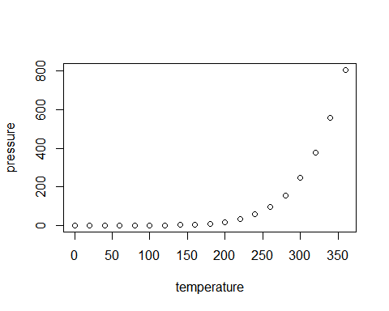

Note that the echo = FALSE parameter was added to the code chunk to prevent printing of the R code that generated the plot.

### 三级标题

Bollerslev(1986)运用GARCH模型对短期利率波动进行估计得到了 较好的效果，此模型能够有效克服金融时间序列数据的高峰厚尾与波动集群的特性[1]。

吴冠、杨琪(2011)研究表明GARCH模型对拟合拆借利率的波动特征有 较好的效果[2]。

#### 四级标题

##### 五级标题

# 第二个一级标题

## 二级标题

## 第二个二级标题

### 三级标题

### 三级标题

### 三级标题

# 参考文献

[1] BOLLERSLEV T. Generalized autoregressive conditional heteroskedasticity[J]. Eeri Research Paper, 1986, 31(3): 307–327.

[2] 吴冠, 杨琪. 我国银行间债券市场回购利率波动性的拟合分析[J]. 金融经济, 2011(8): 98–99.