Assigned Task |

use Python with a regex module to pull out values

My ask is that they pull out any **port** values that they see and are able to

Expressions |

port 11332 - Regex expression r'port [0-9]{5}'

Port: 19778 - Regex expression r'Port: [0-9]{5}'

s_port:"60641" - Regex expression r's[_]port:"[0-9]{5}"'

Code shell |

Imports

Variables

Loops

Callback function

Code |

import re

regex1 = r'port [0-9]{5}'

regex2 = r'Port: [0-9]{5}'

regex3 = r's[_]port:"[0-9]{5}"'

from multiprocessing import Process

import sys

def port1():

  with open ('failed_passwd.txt', 'r') as infile:

    ports = infile.read()

    results = print(re.findall(regex1,ports))

def port2():

  with open ('failed_passwd.txt', 'r') as infile:

    ports = infile.read()

    results = print(re.findall(regex2,ports))

def port3():

  with open ('failed_passwd.txt', 'r') as infile:

    ports = infile.read()

    results = print(re.findall(regex3,ports))

if __name__=='__main__':

  p1 = Process(target = port1)

  p1.start()

  p2 = Process(target = port2)

  p2.start()

  p3 = Process(target = port3)

  p3.start()

Result |

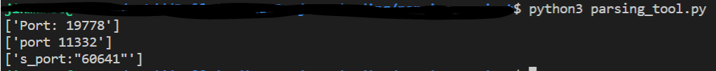

Refactor |

import re

regex1 = r's[_]port:"[0-9]{5}"|port [0-9]{5}|Port: [0-9]{5}'

  with open ('failed_passwd.txt', 'r') as infile:

    ports = infile.read()

    results = print(re.findall(regex1,ports))

Result |

