1. **Introduction**
   1. **Objectives**
2. Learn how to use UT60A multimeter for measurements of voltage, current, and resistance.
3. Learn to build circuits on a solderless prototype board.
4. Verify the basic circuit laws –KCL, KVL, and Ohm’s laws from measurements of currents and voltages.
5. Measure the current-voltage characteristics of a 50Ω resistor. From the results  
   of measurements, draw the conclusion on whether they obey Ohm’s law.
6. Build an LED circuit on a protoboard and learn about non-ohmic circuit components, which do not obey Ohm’s law.
   1. **Apparatus & Theoretical Background**
7. Multimeter

A multimeter is able to work as a voltmeter to measure voltages, as an ammeter to measure currents, or as an ohmmeter to measure resistances. Every multimeter has two terminals for the two cables that ensure electrical connections to the two nodes. The black cable should be connected to ground, the ground port is labeled COM on the multimeter. The red cable should be connected to HzVΩ port for voltage or resistance measurements, 10A MAX port for current measurements, or μAmA port for small current measurements.

The voltmeter has its own internal resistance, which is usually very high. For an ideal voltmeter the input resistance is infinitely large. In real instruments the internal resistance usually exceeds 1MΩ. When we measure VAB the voltmeter’s internal resistance is connected in parallel with all circuit elements between these two terminals. Note that you do not have to change anything in your circuit to measure voltage: just connect the multimeter to the nodes of interest.

To measure the current that flows through a branch of your circuit we should make this current flow through the multimeter. Note that in order to measure the current we have to interrupt the circuit: the diagram below shows that instead of one node we work with two nodes A1 and A2.

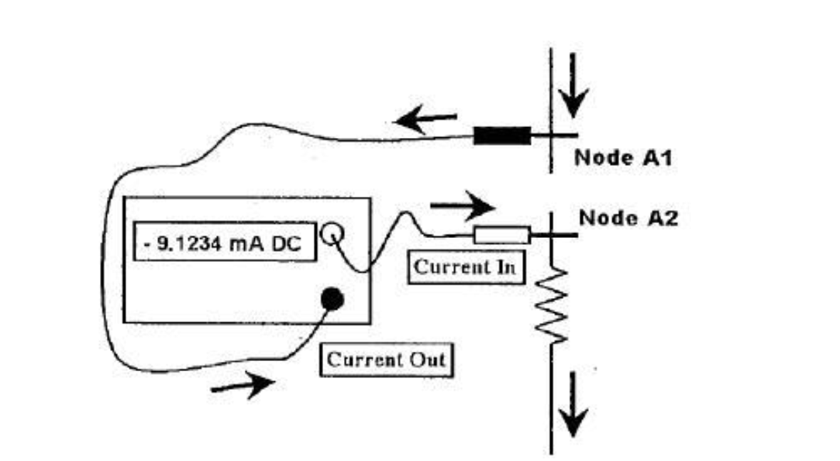

The circuits is broken at the point where we measure the current and the ammeter bridges the gap. The internal resistance of an ammeter is very low, say, 1Ω or less.

To measure the resistance, we simply connect it to the two terminals of the multimeter, and read the resistance from the display. **Remember:** you must disconnect the resistor from your circuit before measuring the resistance! Otherwise, you will not obtain the correct reading of resistance.

1. DC source

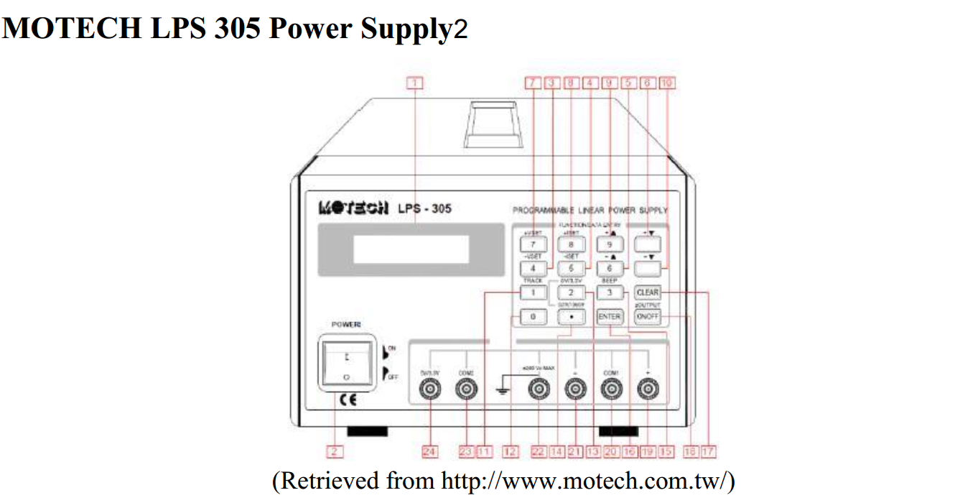

1. When you press the +Vset, or -Vset, the output selected (+output or –output) and the present setting for that function will be displayed. You can change setting using the numeric entry keys. Pressing the number keys will cause the present numeric setting to become blank and be replaced with the new numbers on the display. Pressing the ENTER key will enter the values displayed.
2. The selected output channel can be turned on and off from the front panel. The output on/off key toggles both the +output and –output on and off simultaneously.
3. Remember to turn off the output when no measurements are being undertaken.

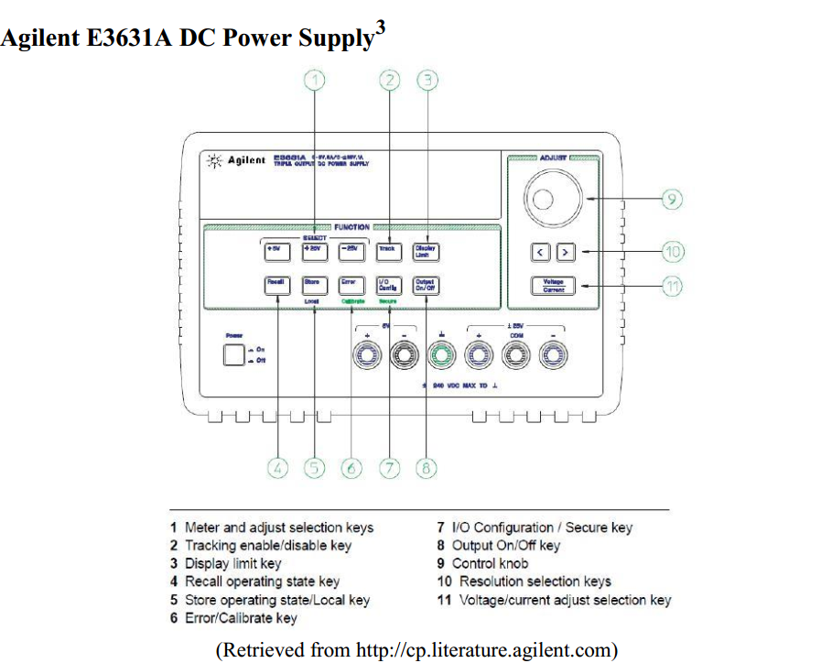

To set up the power supply for constant voltage (CV) operation, proceed as follows.

1. Connect a load to the desired output terminals with power-off.
2. Press to turn on the power supply. The power supply will go into the power-on / reset state; all outputs are disabled (the OFF annunciator turns on); the display is selected for the +6V supply (the +6V annunciator turns on); and the knob is selected for voltage control.
3. Adjust the knob for the desired output voltage. Set the knob for voltage control. The second digit of the voltmeter will be blinking. Adjust the knob to the desired output voltage.
4. Protoboards

In this lab and all the future labs, you will connect resistors, LEDs and other components to each other on a circuit board. Circuits boards are also called “protoboards”, because they are used for prototyping the circuits. Another name is “breadboard”, because in old times circuits were indeed built on wooden breadboards. The main idea is to build the citcuit without solderingevery connection thus the long generic name is *solderless prototyping boards.*A prototyping board used in the lab consists of several plastic blocks. These plastic blocks are mounted on a metal plate along with terminal (blind) posts.  
Each plastic block has many holes, into which you insert wires, plug in resistors, op amps, and other circuit components. Inside the plastic block, themetal clips snugly hold your wires, resistors, etc., and ensure electric connections between circuit components.

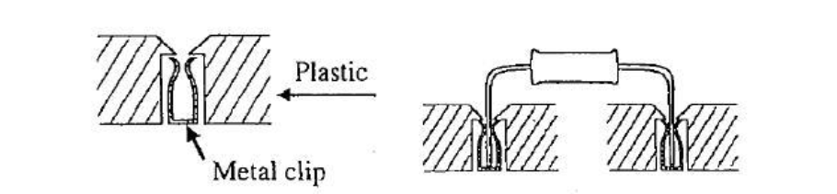

These metal clips hidden under the plastic create nodes on the protoboard, to which you connect your circuit components.  
Connections under the plastic are different for the wide and narrow blocks.

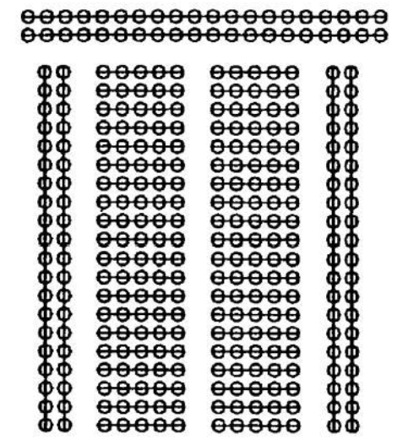

Straight lines on the diagram above show the metal clips that connect holes under the plastic. Remember how the holes are connected into nodes on a circuit board. Many students’ mistakes in the lab are due to forgetfulness of how the nodes are organized.

1. Semiconductor diodes

The simplest semiconductor device is a diode. Its circuit symbol looks like an arrow because the diode allows the current flow only in the direction of that arrow. If > (which is called direct bias) the conductor will conduct. If < (which is called reverse bias) the conductor will not conduct. Thus a diode is not an Ohmic resistor.

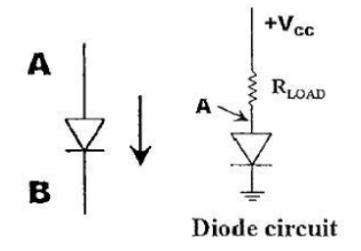

Moreover, even under direct bias the resistance of a diode does not remain constant. At small values of the voltage difference - the current through the diode is very small, because its resistance is large. The diode’s resistance abruptly changes as soon as the direct bias voltage across the diode reaches the threshold value, which is called the turn-on voltage and equals about 0.5 to 0.7V for many diodes. Above this voltage the current through the diode rapidly increases and becomes practically independent of the voltage. The diode resistance becomes so small that in real circuits the diodes have to be protected from high currents that may damage them. A load resistor (50Ω in this lab) connected in series with the diode ensures the simplest protection. Lightemitting diodes emit light (visible or infrared) when the direct current becomes large enough. The LED, which you will use in this lab, has the turn-on voltage of about 1.6V.

1. **Measurement Procedures**
   1. **Voltage, Current & Resistance Measurement**
2. Use the multimeter to measure the resistance R1 labeled 100Ω directly and record the result.
3. Connect the resistance R1 = 100Ω with the power supply and set the voltage 3V.
4. Use the multimeter to measure the Voltage (m) across the resistor and compare it with the Voltage (s) shown on the power supply.
5. Use the multimeter to measure the Current (m) through the resistor and compare it with the Current (s) shown on the power supply.
   1. **Voltage Division & Current Division**
6. Before measurement, measure the actual resistances of the two resistors you are using in this section.
7. Connect the R1 = 100Ω and R2 = 50Ω in series and in parallel, respectively.
8. Use the multimeter to measure the voltage across the R1, R2 and the power supply, and think about the relationship among the three voltages.
9. Use the multimeter to measure the current through R1, R2 and the power supply, and think about the relationship among the three currents.
10. Compare the result with what you expect.
    1. **Ohm’s Law**
11. Measure the resistance of R = 50Ωand record the result.
12. Connect the R with the power supply.
13. Set the voltage outputs and record the corresponding currents.
14. Sketch the voltage-current characteristic curve of the resistor.
    1. **Non-ohmic LED**
15. Connect the resistor R = 50Ωand the LED in series with the power supply.
16. Change the voltage output and record the corresponding current.
17. You need to design the proper step of voltages to get the voltage-current characteristic of the non-ohmic device.
18. **Results & Discussion**
    1. **Voltage, Current & Resistance Measurement**

|  |  |  |  |
| --- | --- | --- | --- |
| **Resistance[**Ω] | **99.7** |  |  |
| **Voltage(m)[V]** | **2.977** | **Voltage(s)[V]** | **2.99** |
| **Current(m)[A]** | **0.029** | **Current(s)[A]** | **0.0295** |

Table 1. Measurement of voltage current and resistance.

The resistance and its voltage and current are measured and the values is shown on the table 1. The relative error of resistance is

* 1. **Voltage Division & Current Division**

|  |  |  |  |  |  |  |  |
| --- | --- | --- | --- | --- | --- | --- | --- |
| Resistance R1[Ω] | | 99.7 | | Resistance R2[Ω] | | 54.3 | |
|  | Voltage | | Division | | Current | | Division |
|  | Current[A] | | Voltage[V] | | Current[A] | | Voltage[V] |
| Total | 0.019 | | 2.978 | | 0.087 | | 2.99 |
| R1 | 0.019 | | 1.965 | | 0.029 | | 2.970 |
| R2 | 0.019 | | 1.010 | | 0.058 | | 2.970 |

Table2. Voltage Division and Current Division

The result is presented in the table2. From table 2, we can find that the results match the KCL and KVL theorem.

* 1. **Ohm’s Law**

|  |  |
| --- | --- |
| Resistance[Ω] | 54.3 |
| Voltage[V] | Current[A] |
| 0.5 | 0.009 |
| 1.0 | 0.018 |
| 1.5 | 0.028 |
| 2.0 | 0.038 |
| 3.0 | 0.057 |
| 4.0 | 0.078 |
| 5.0 | 0.098 |

Table 3.Ohm’s Law

The relationship between the voltage and the current is presented on the table 3. And we can use Matlab to fit the data.

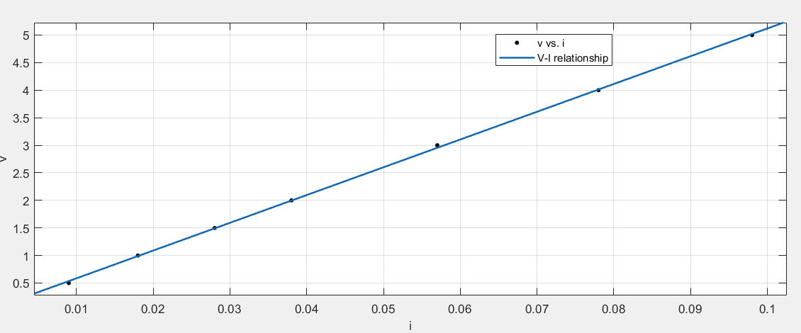

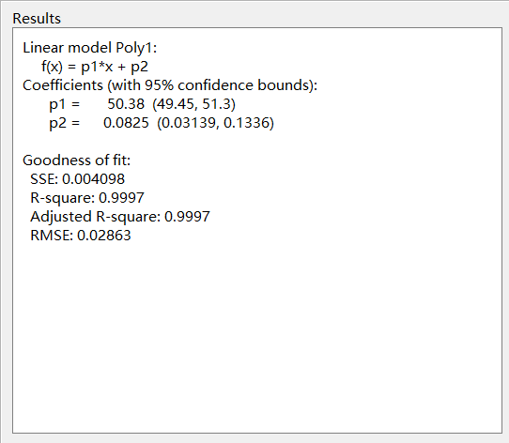

The R-square is 0.997 which is very close to 1. Therefore, the resister obeys the Ohm’s law.

* 1. **Non-ohmic LED**

|  |  |
| --- | --- |
| Voltage[V] | Current[A] |
| 0.40 | 0.000 |
| 1.58 | 0.000 |
| 1.90 | 0.008 |
| 2.025 | 0.030 |
| 2.069 | 0.045 |
| 2.083 | 0.056 |

Table 4.Semiconductor diodes

The voltage and the current are presented on the table 4. And their relationship will presented in the following figure.

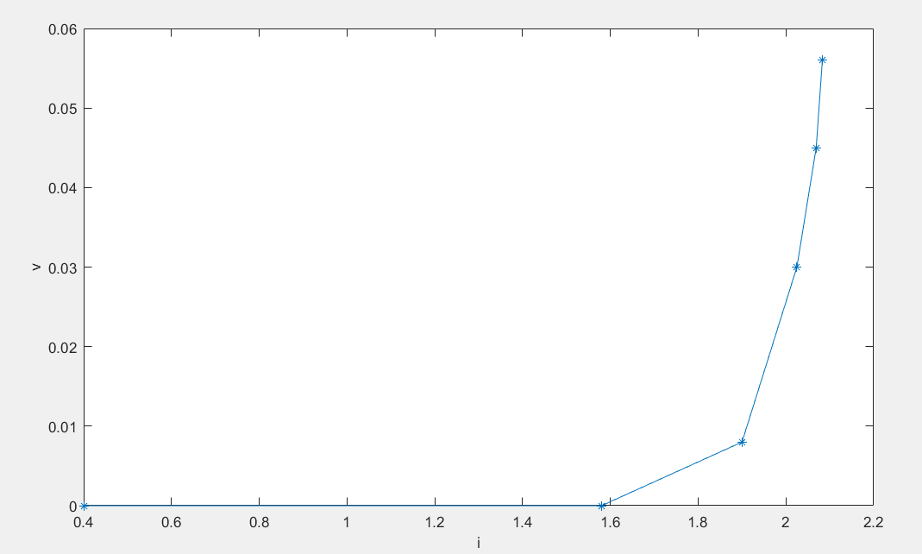

We can see that this graph is quite similar to the expectation of the theoretical model, and the turn-on voltage is 1.58V which is very close to 1.6V as expected.

1. **Conclusions**

From this experiment, we successfully measured the resistance and verified the KCL and KVL theorem. We also used matlab to draw a fitting curve to verify the Ohm’s law and sketched the voltage-current figure for LED. The uncertainty of all the data is not very big and the graphs are quite similar to the model as expected. This is a quite successful experiment.

However, there still exists some error and I think that there are some reasons about that. First, We all know that the multimeter is not absolutely correct, therefore, when we are testing the resistance, voltage and current, it seems to be impossible to have an absolutely correct value. Next, the breadboard also has resistance and it is just a tiny capacitor. Therefore, when I was testing the current and voltage on voltage division and current division, it is hard for me to have an answer with no error. Third, the wire also has resistance, and it can be regarded as a passive element. Therefore, it will also make some errors.

From this experiment, we learn how to UT60A to measure the resistance, voltage and current. We learn to build circuit with breadboard and verify the KCL and KVL laws. We also test the relationship between the voltage and current on a resistance and a LED. They are all very useful and I think that if we can use a better multimeter, we can have a more accurate value of the result.