Code:1 sum of elements in an array

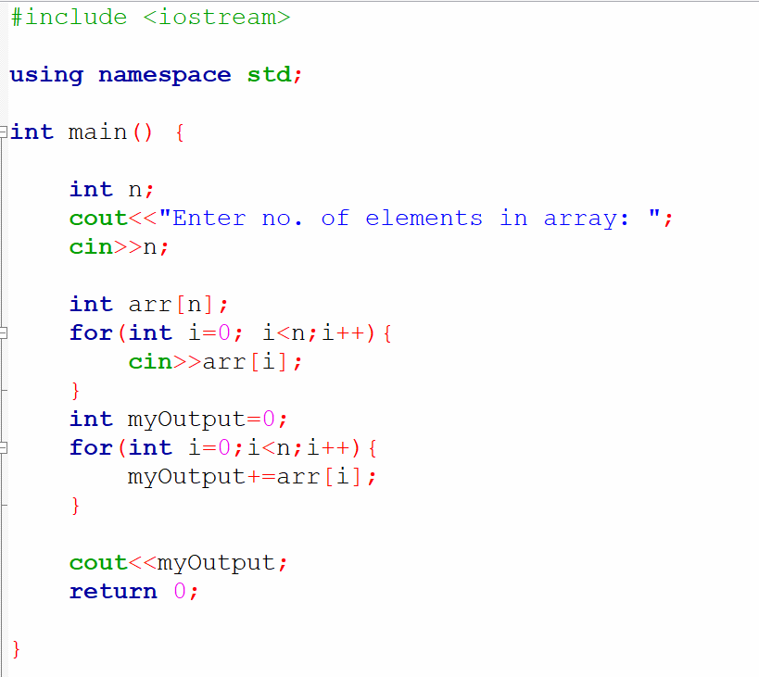

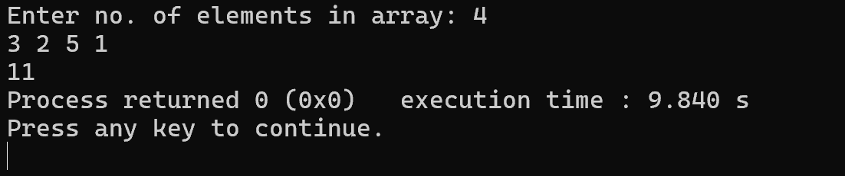

Searching Algorithms in Arrays:

1. Linear Search : In linear search, we iterate over all the elements of the array and check if the current element is equal to the target element. If we find any element to be equal to the target element, then return the index of the current element, otherwise, if no element is equal to the target element, then return -1 as the element is not found.

Linear search is also known as sequential search.

Time complexity for this is O(n).

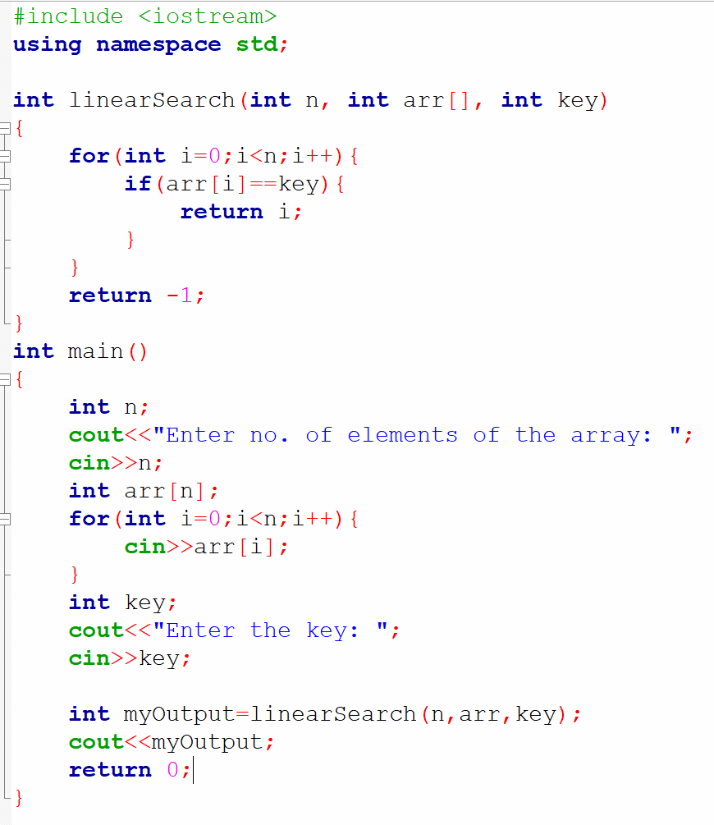

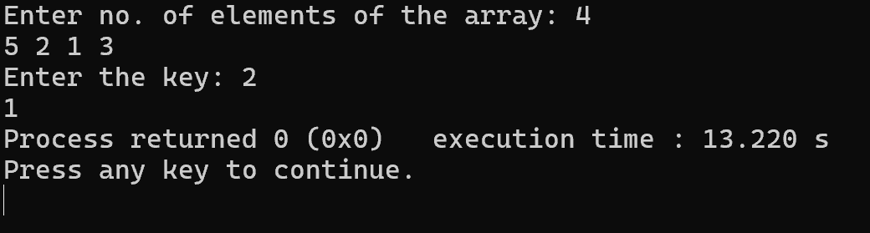

1. Binary Search: It is searching algorithm used in a sorted array by repeatedly dividing the search interval in half. The Idea of binary search is to use the information that the array is sorted and reduce the time complexity to O(log n) where n is the number of elements of the array.

