**INSERTING ELEMENT IN THE BEGINNING**

Inserting an element at the beginning of an array involves shifting all existing elements one position to the right to create an empty space for the new element at index 0.

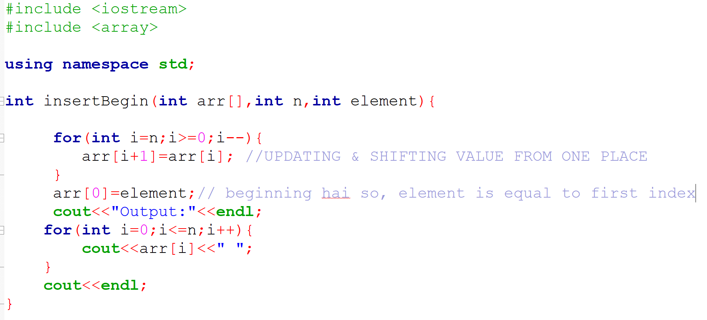

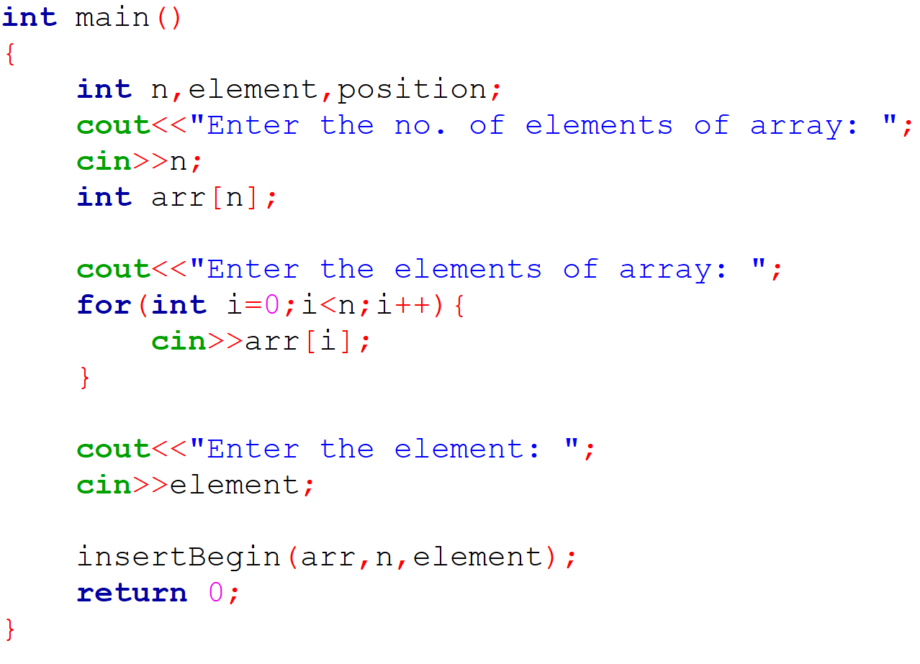

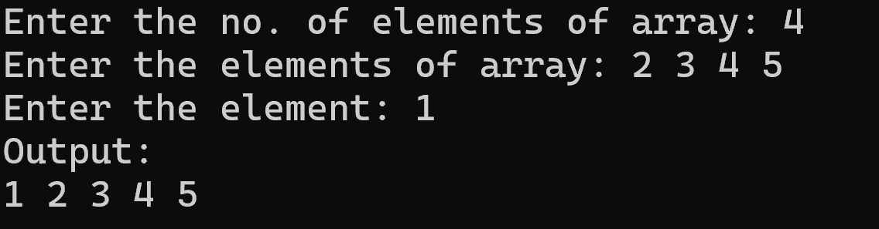

**INSERTING ELEMENT IN THE END:**

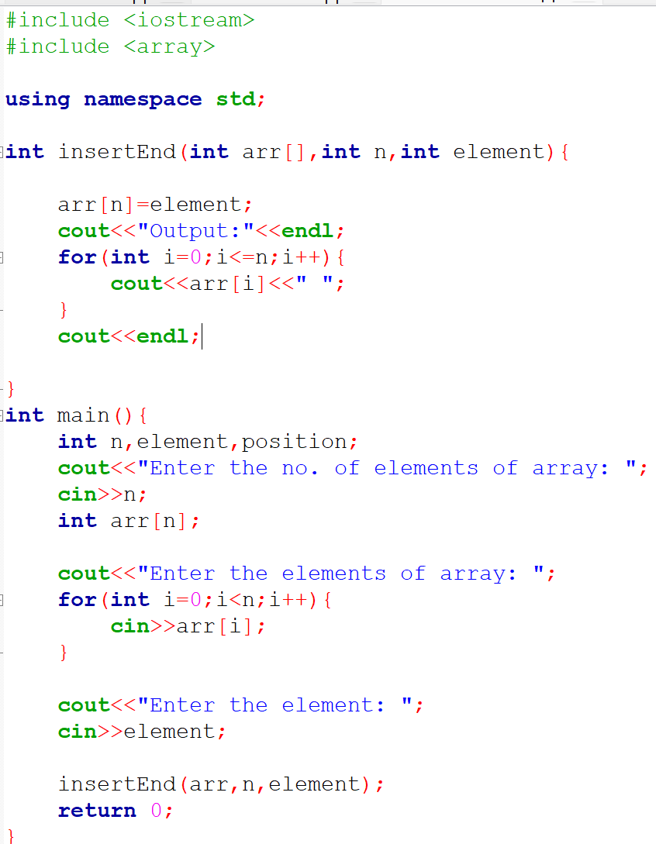

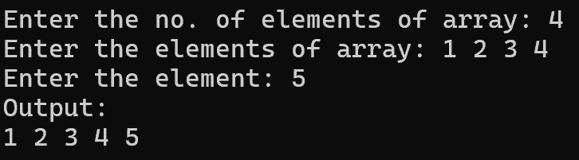

**INSERTING ELEMENT AT ANY INDEX:**



