Instruction Document

Jinqing Xu

* Part 1: Instruction for experiments
* **Step one: Connecting laptop to the internment**  
  Choose wpa.mcgill.ca and log in with the McGill account.

**What if problems occur:**

Since the ip address of this laptop is fixed, if there is a message that 'there is another device using the ip address (142.157.179.209)' , you need to change the ip address.( Shown in the figure below)

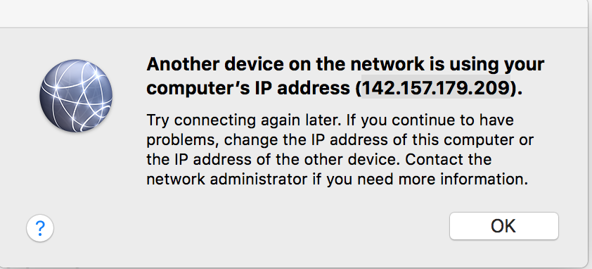

Go to the tips section ‘How to solve the problem of conflict ip address’

to find the solution.

* **Step two: Do the precision experiment**

1. Run the precision experiment app and enter 88XX as pid.
2. Then run the leap motion program and enter 88XX (the same as in 1.) as pid.
3. Do some warm up for at least 5 seconds. Warm up means put your whole right hand in front of leap motion and move up, down, right and left.
4. Click on Yes on the tablet.
5. Use your finger to touch the center of the crosshair and fix your finger there. If you hear the counting voice of ‘1,2,3’, you have already selected the center.
6. Then move your finger along the horizontal line towards right slowly. You cannot move too far away from the center in case that the leap motion will miss your finger.
7. Lift up your finger.
8. Remember that after you have selected the target, you only have one chance to move your finger along the horizon line. That means after you lift up, you need to go to 9. and never redo 6.
9. Use your finger to touch the center of the crosshair and fix your finger there. If you hear the counting voice of ‘1,2,3’, you have already selected the center.
10. The move your finger along the vertical line towards up slowly. You cannot move too far away from the center in case that the leap motion will miss your finger.
11. Lift up tour finger.
12. Stop the leap motion program.

* **Step three: The crosshair experiment**

1. Run the crosshair experiment app and enter 88XX (the same as in step one) as pid.
2. Then run the leap motion program and enter 88XX as pid.
3. Do some warm up for at least 5 seconds.
4. Click on Yes on the tablet.
5. Use your finger to touch the center of the crosshair and fix your finger there. If you hear the counting voice of ‘1,2,3’, you have already selected the center. But if you hear some alarm sound, that means you fail to select the center or your finger had moved to be away from the center. You need to try again in this case.
6. Lift up your finger.
7. Run the python program processCrossHairData.py to calculate the average x, y and z. No input is needed. The output will be ‘Average_X_Y_Z_Of_CrossHair_Experiment.csv’ which is in the folder ‘/Leap Accuracy/CrossHair Data’.

* **Step three: Do the target select experiment**

1. Run the target selection app.
2. Enter pid (101-199 means old adults and 201-299 means young adults.)
3. Reading instructions.
4. Do some warm up for at least 5 seconds.
5. Click on Yes on the tablet.
6. Press start button, then try to select the target. If it’s selected, some sounds like BING will occur. Participants need to try until they have successfully selected the target.
7. After one block, touch the screen anywhere to begin the next block.
8. Stop the leap motion program.

* **Step four: Run the python program for data analysis and data visualization.**

1. Send the android data and detailed data through email.
2. Download them in the laptop and put them in the folder of that pid.
3. Run login, that program will scan all the data to do analysis and draw plots.

* Part 2: Small tips
* **How to change path in python program**  
  1. Open GlobalVariables.py

2. Change path header to your workspace

* **how to change path in leap motion program**  
    
  1. Open LeapLogin.java

2. Change writePath to your workspace

3. Please ensure the writePath is the same as pathHeader

4. You can delete all the individual folders like ‘PID_XXX’, but you cannot delete the outer folder like ‘Experiment Data’.

* **What if the android program suddenly stops in the block 0**  
  it's probably because of the network  
    
  The solution

1. check if both laptop and tablet are online

2. check if the server of GetTime has been started

3. if you have already checked 1. and 2. but the program still suddenly stops, you can just restart the whole program.

* **How to judge whether there are wrong trials in one experiment**  
  The simplest way is to check the size of split data, if its size is less than 5KB, probably sometimes the leap motion fail to track the finger trace.

The python program will also print the pid, block and trial of wrong data.

Also, those wrong trial will not be included in the result.

* **How to solve the problem of conflict ip address**

1. Choose the system preference and enter the Network setting.

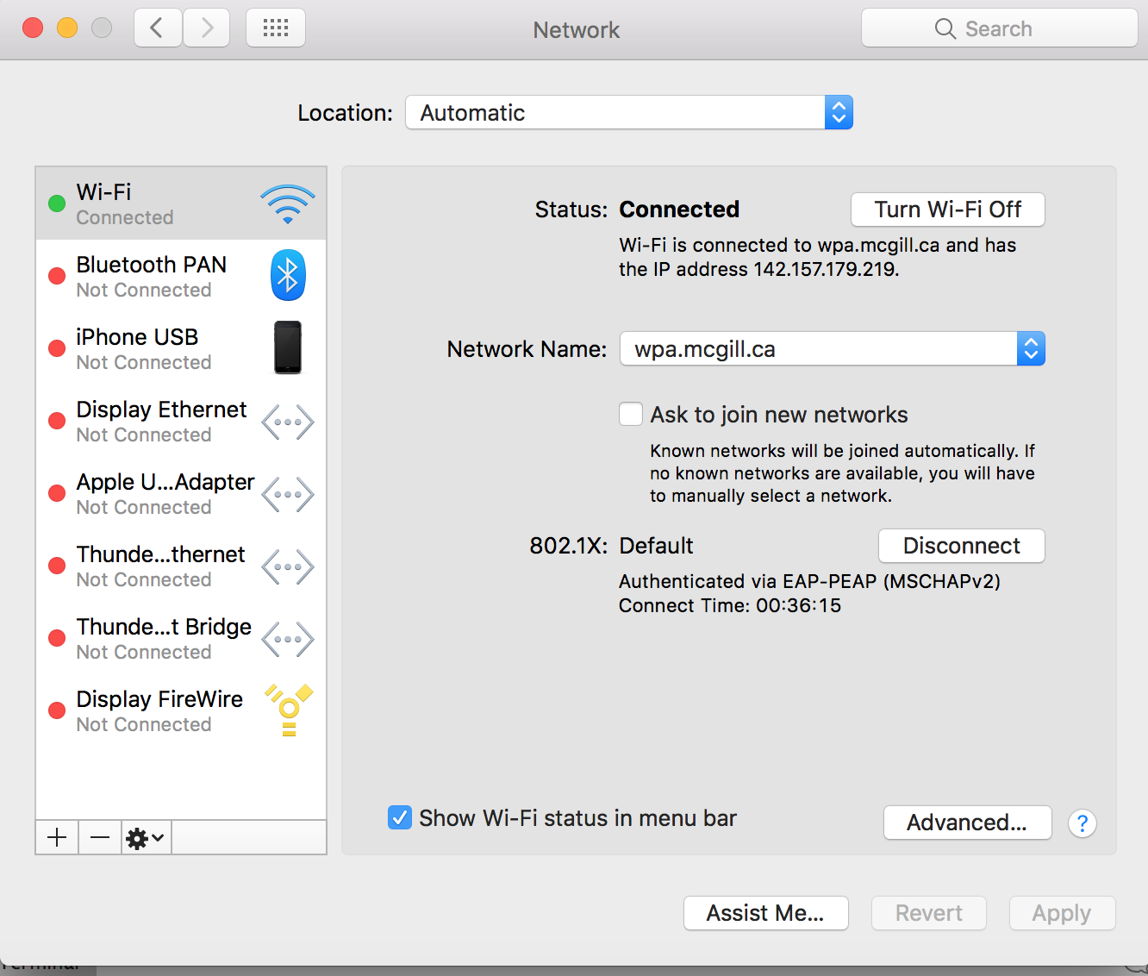

1. Choose Advanced, then choose TCP/IP to change the IPv4 Address.

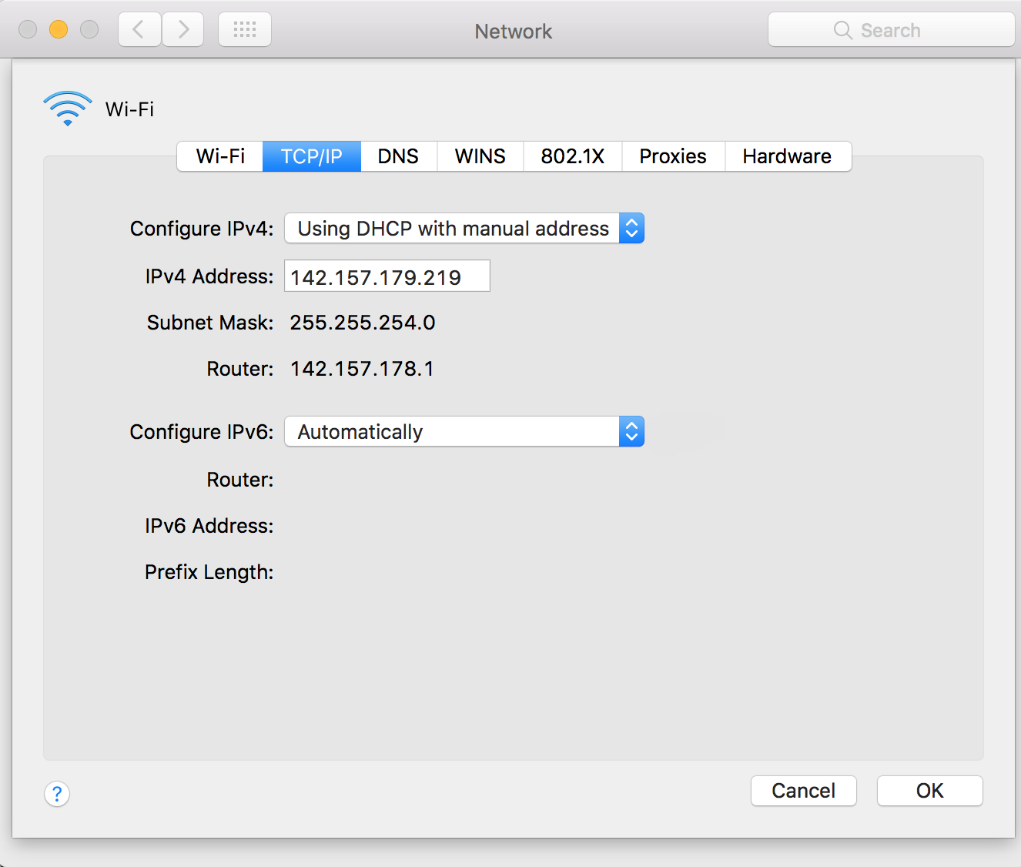

After that, you need to change the ip address in TargetSelect Android Program, too.

Open the project ‘Experiment SoftWare’ in android studio, then open TwoDFittsTask file. Change ipAddress to the one you have set on the laptop.



Also, open the TwoDCalibTask file in Precision Experiment and Crosshair Experiment, and change the ipAddress, too. (it is also at the beginning of the activity)

