实验1：

class CPU{

public:

CPU():rank(P1) , frequency(0) , voltage(0){cout << "调用默认构造函数..." << endl ;} ;

CPU(int c):rank(P1) , frequency(c) , voltage(c){cout << "调用构造函数..." << endl ;} ;

void run() ;

void stop() ;

enum CPU_Rank{P1 = 1 , P2 , P3 , P4 , P5 , P6 , P7};

~CPU(){cout << "调用析构函数..." << endl ;};

private:

CPU_Rank rank ;

int frequency ;

float voltage ;

};

int main(){

CPU c1 , c2(0);

return 0 ;}

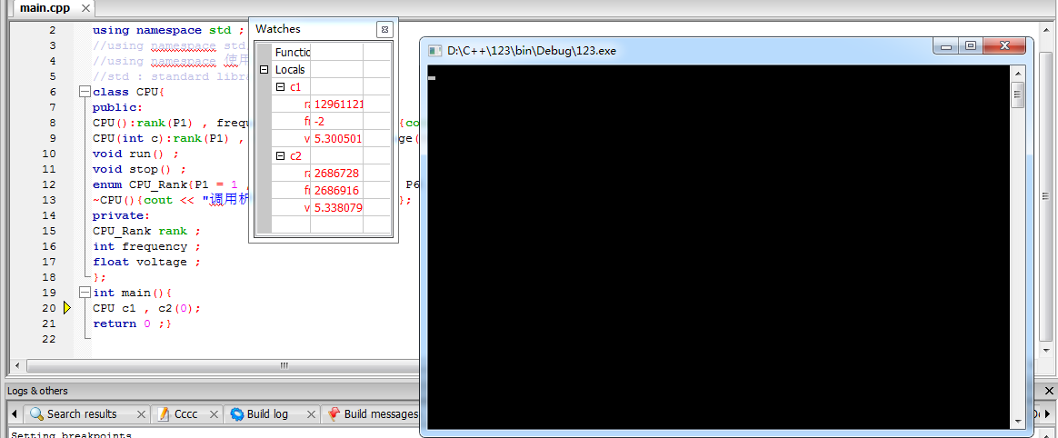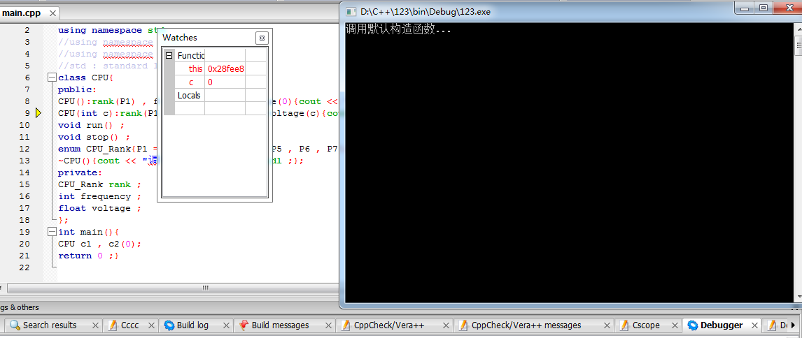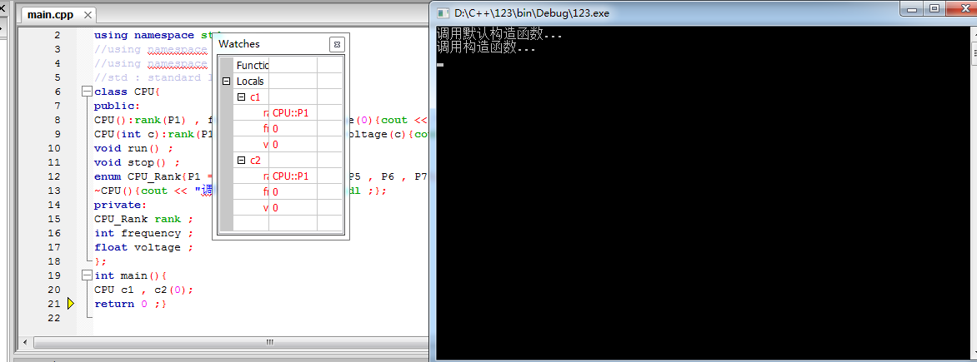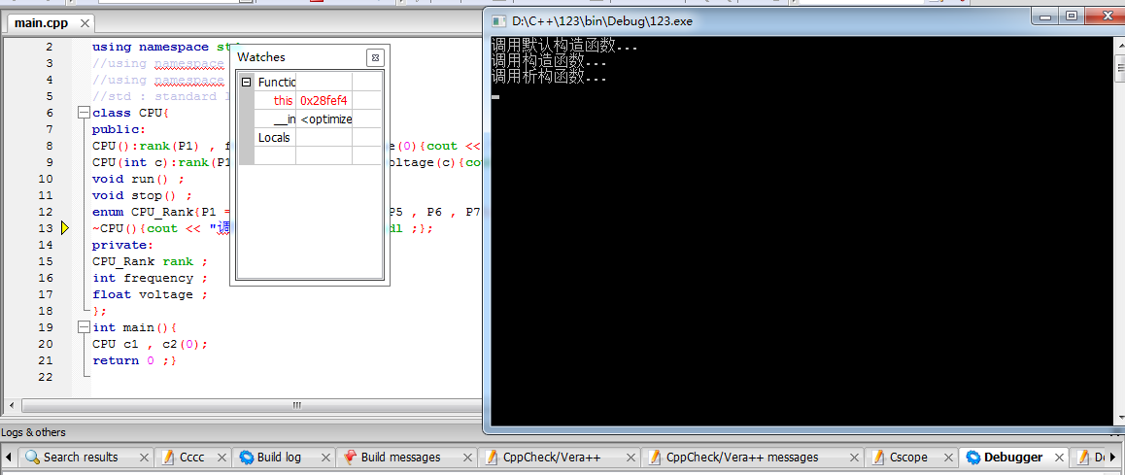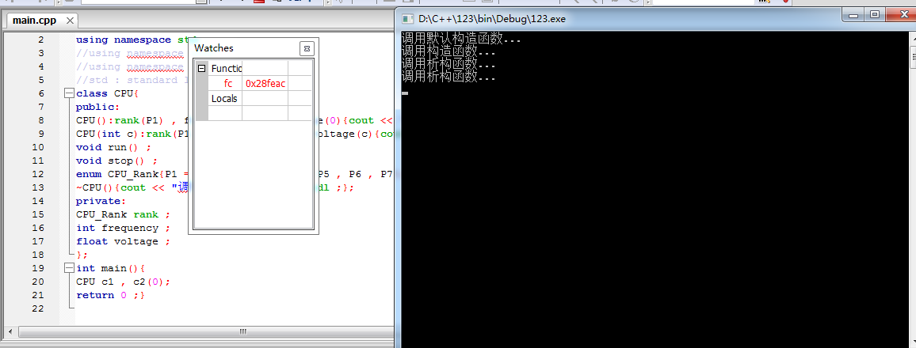

实验2：

class CPU{};

class RAM{};

class CDROM{};

class Computer{

public:

void run() ;

void stop() ;

private:

CPU cpu ;

RAM ram ;

CDROM cdrom ;

};

int main(){

Computer c ;

return 0 ;

}

实验3：

（1）

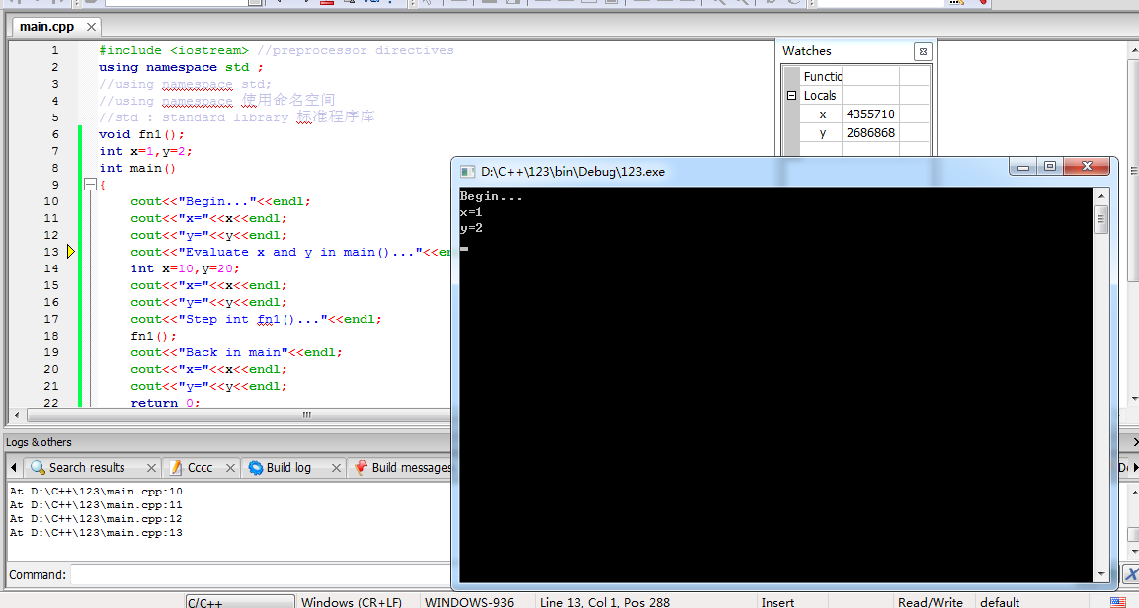 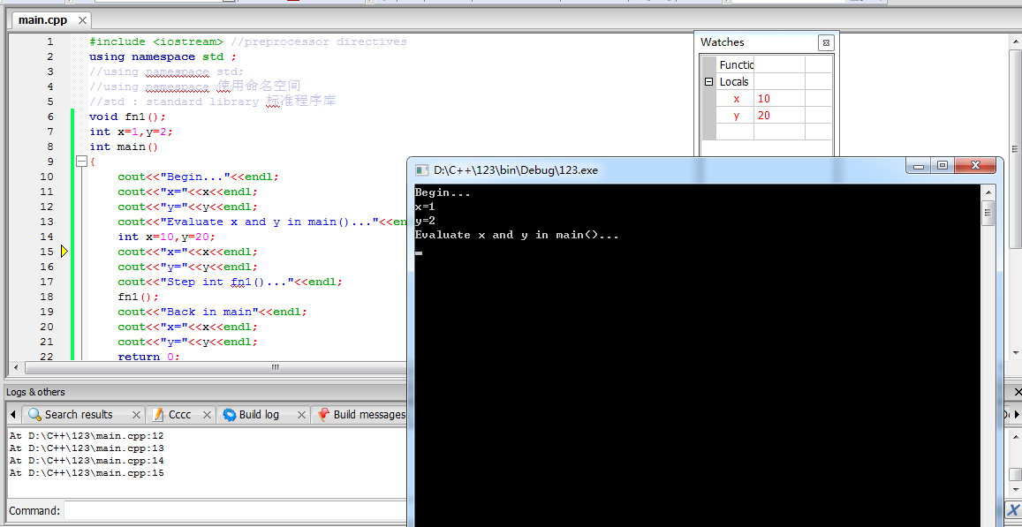 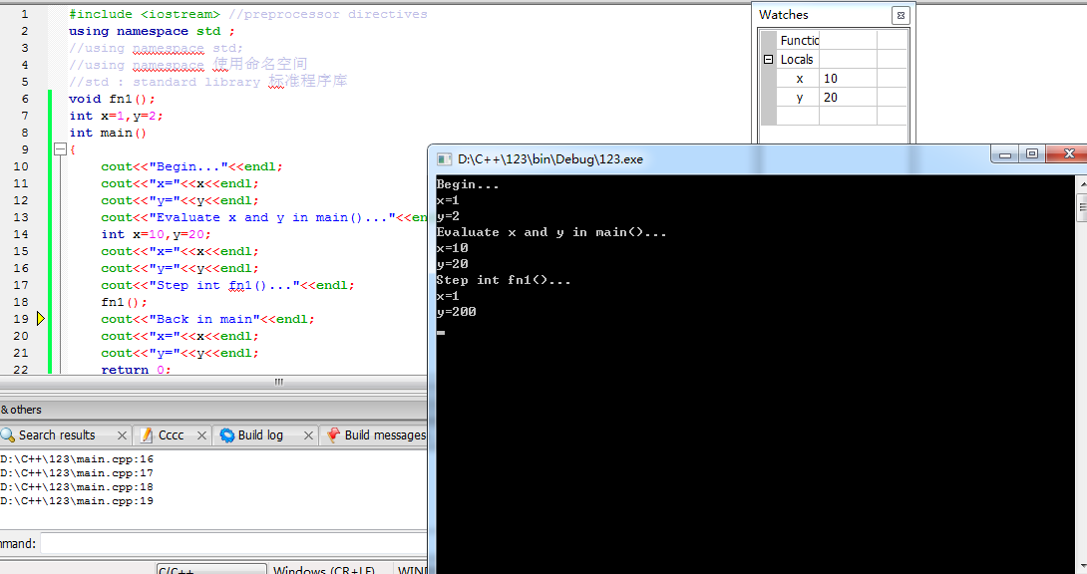 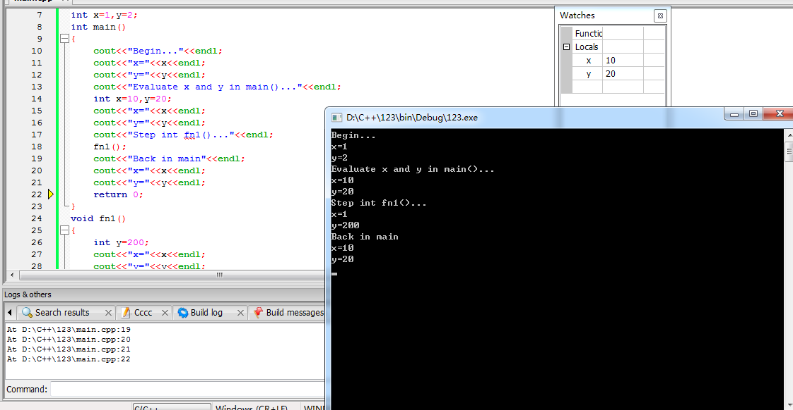

（2）

//client.h

#ifndef CLIENT_H_INCLUDED

#define CLIENT_H_INCLUDED

class Client{

static char ServerName ;

static int ClientNum ;

public:

static void ChangeServerName(char name) ;

static int getClientNum() ;

};

#endif // CLIENT_H_INCLUDED

//client.cpp

#include "client.h"

void Client::ChangeServerName(char name){

Client::ServerName = name ;

}

int Client::getClientNum(){

return Client::ClientNum ;

}

//lab5_2.cpp

#include <iostream>

#include "client.h"

using namespace std ;

int Client::ClientNum = 0 ;

char Client::ServerName = 'a' ;

int main(){

Client c1 ;

c1.ChangeServerName('B') ;

cout << c1.getClientNum() << endl ;

}

