实验报告

实验一：#include<iostream>

using namespace std;

enum CPU_Rank{p1=1,p2,p3,p4,p5,p6,p7};

class CPU{

public:

CPU(CPU_Rank crank,int cfrequency,float cvoltage);

void run(){cout<<"start the CPU"<<endl;

cout<<"rank = "<<rank<<endl;

cout<<"frequency = "<<frequency<<" MHz"<<endl;

cout<<"voltage = "<<voltage<<endl;};

void stop(){cout<<"stop the CPU"<<endl;};

~CPU(){cout<<"clear"<<endl;};

private:

CPU_Rank rank;

int frequency;

float voltage;

};

CPU::CPU(CPU_Rank crank,int cfrequency,float cvoltage):rank(crank),frequency(cfrequency),voltage(cvoltage){

cout<<"calling the copy constructor of CPU"<<endl;

}

int main(){

CPU myCPU(p2,2,3);

myCPU.run() ;

myCPU.stop() ;

return 0;

}

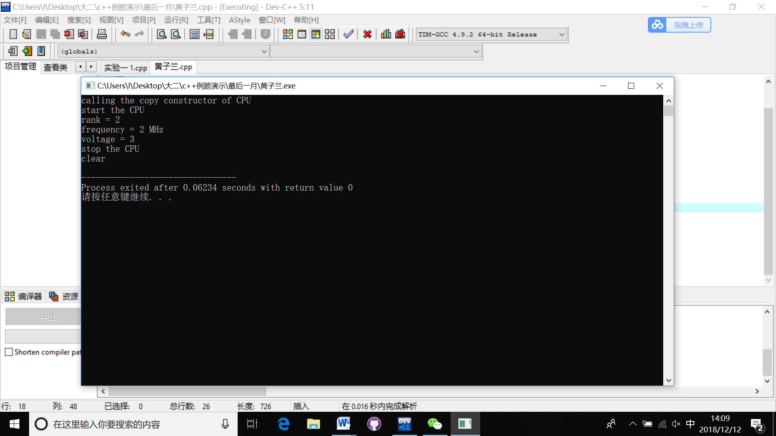

实验二：

#include<iostream>

using namespace std;

enum CPU_Rank{p1=1,p2,p3,p4,p5,p6,p7};

class CPU{

public:

CPU(CPU_Rank crank,int cfrequency,float cvoltage){

rank=crank;

frequency=cfrequency;

voltage=cvoltage;

cout<<"calling the constructor of CPU"<<endl;}

void run();

void stop(){cout<<"stop the CPU"<<endl;};

~CPU(){cout<<"clear the cpu"<<endl;};

private:

CPU_Rank rank;

int frequency;

float voltage;

};

void CPU::run()

{cout<<"start the CPU"<<endl;

cout<<"rank = "<<rank<<endl;

cout<<"frequency = "<<frequency<<" MHz"<<endl;

cout<<"voltage = "<<voltage<<endl;

}

class RAM{

public:

RAM(int cr){

r=cr;

cout<<"calling the constructor of RAM "<<endl;}

void RAM1(){cout<<"r="<<r<<endl;}

~RAM(){cout<<"clear the ram "<<endl;}

private:

int r;

};

class CDROM{

public:

CDROM(int ccdrom){

cdrom=ccdrom;

cout<<"calling the constructor of CDROM"<<endl;};

void CDROM1(){cout<<"cdrom="<<cdrom<<endl;}

~CDROM(){cout<<"clear the cdrom "<<endl;}

private:

int cdrom;

};

class Computer{

public:

Computer(CPU ccpu,RAM cram,CDROM ccdrom):cpu(ccpu),ram(cram),cdrom(ccdrom){

cout<<"calling the constructor of computer "<<endl;

};

void run();

void stop(){cout<<"stop the computer"<<endl;};

~Computer(){cout<<"clear the computer"<<endl;};

private:

CPU cpu;

RAM ram;

CDROM cdrom;

};

void Computer::run() {

cout<<"start the computer"<<endl;

cpu.run() ;

cpu.stop() ;

ram.RAM1() ;

cdrom.CDROM1() ;

}

int main(){

CPU mycpu(p1,2,3.4);

RAM myram(6);

CDROM mycdrom(8);

Computer mycomputer(mycpu,myram,mycdrom);

mycomputer.run() ;

mycomputer.stop();

return 0;

}

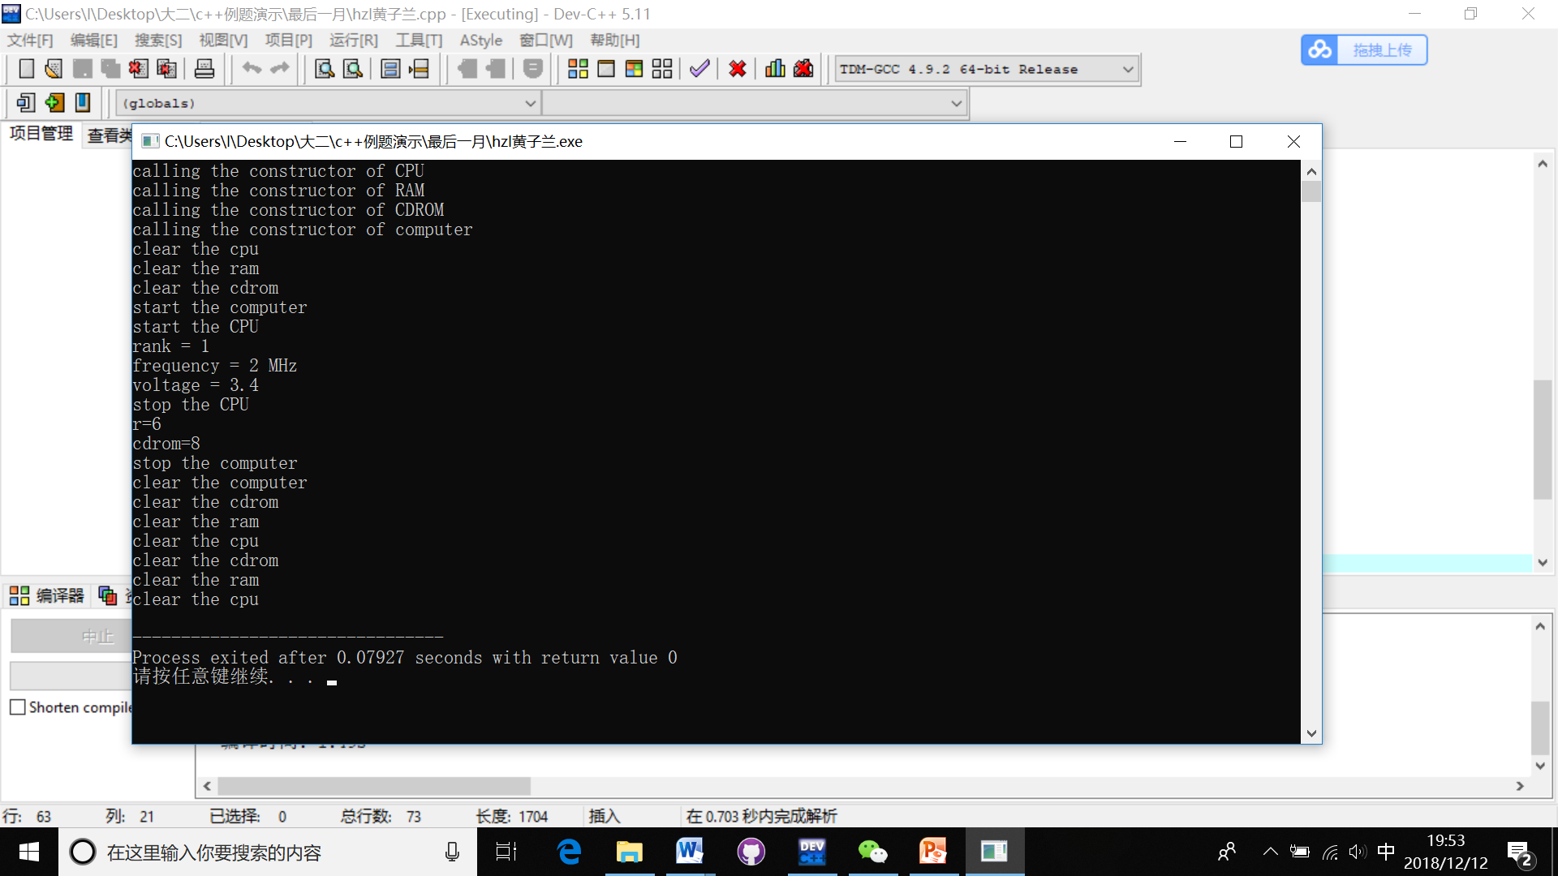

实验三

1.结果和分析：

Begin...

x=1

y=2//全局变量

Evaluate x and y in main()...

x=10

y=20//局部变量

Step int fn1()...

x=1//函数体内只能看到全局变量

y=200//同名覆盖

Back in main

x=10

y=20//局部变量

2.代码：

//client.h

#ifndef _CLIENT_H_

#define _CLIENT_H_

#include <string>

class Client {

private:std::string name;

int number;

char sex;

int age;

int tel;

static int count;

public:Client(std::string na, int nu, char s, int a, int t);

void show();

void getsex();

static int showcount();

};

#endif

//client.cpp

#include"client.h"

#include <iostream>

#include<string>

using namespace std;

int Client::count = 0;

Client::Client(std::string na, int nu, char s, int a, int t) :name(na), number(nu), sex(s), age(a), tel(t)

{

cout << "dear " << name << " ,welcome to our company!" << endl; count++;

};

void Client::getsex() {

if (sex == 'f')cout << "female";

else cout << "male";

}

void Client::show() {

cout << "this is your information: " << endl;

cout << "name:" << name << " number:" << number << " sex:";

getsex();

cout << " age:" << age << " tel:" << tel << endl;

};

int Client::showcount() {

return count;

};

//c_.cpp

#include "client.h"

#include"client.cpp"

#include<iostream>

#include<string>

using namespace std;

int main() {

Client i(ming, 1, f, 19, 82901129);

i.show();

Client she(yue, 2, f, 19, 23498500);

she.show();

Client he(huo, 3, m, 18, 23983123);

he.show();

Client it(lulu, 4, m, 20, 23881039);

it.show();

cout << "we have " << Client::showcount() << " clients." << endl;

return 0;

}

结果：

dear ming ,welcome to our company!

this is your information:

name:ming number:1 sex:female age:19 tel:82901129

dear yue ,welcome to our company!

this is your information:

name:yue number:2 sex:female age:19 tel:23498500

dear huo ,welcome to our company!

this is your information:

name:huo number:3 sex:male age:18 tel:23983123

dear lulu ,welcome to our company!

this is your information:

name:lulu number:4 sex:male age:20 tel:23881039

we have 4 clients.//静态函数成员