# Read Me

## Open Cube.TemperatureConverter.sln with Visual Studio 2017

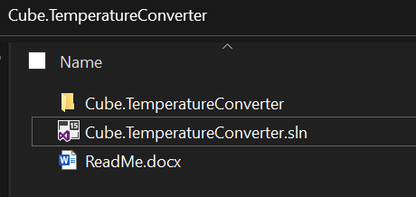

## Click on IIS Express

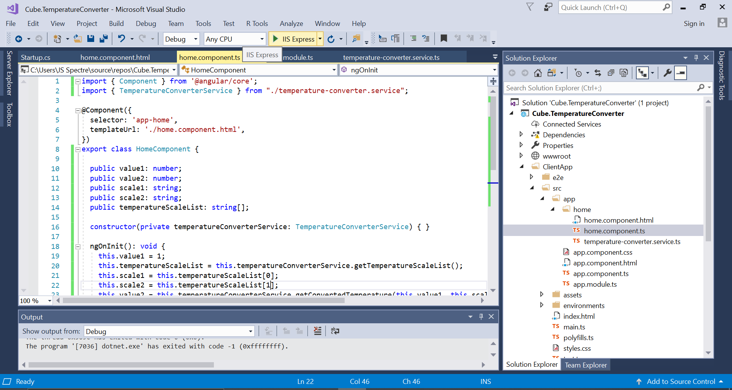

## Click on “No”, if the below dialogue pop up

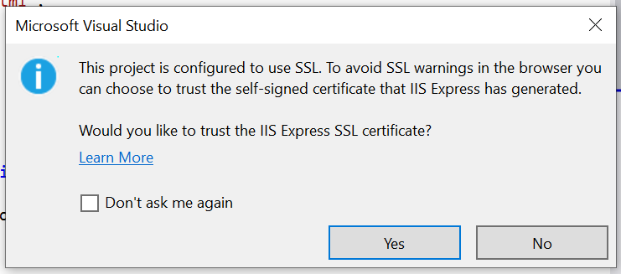

And proceed to view page if blocked.

## This opens the Temperature Converter app

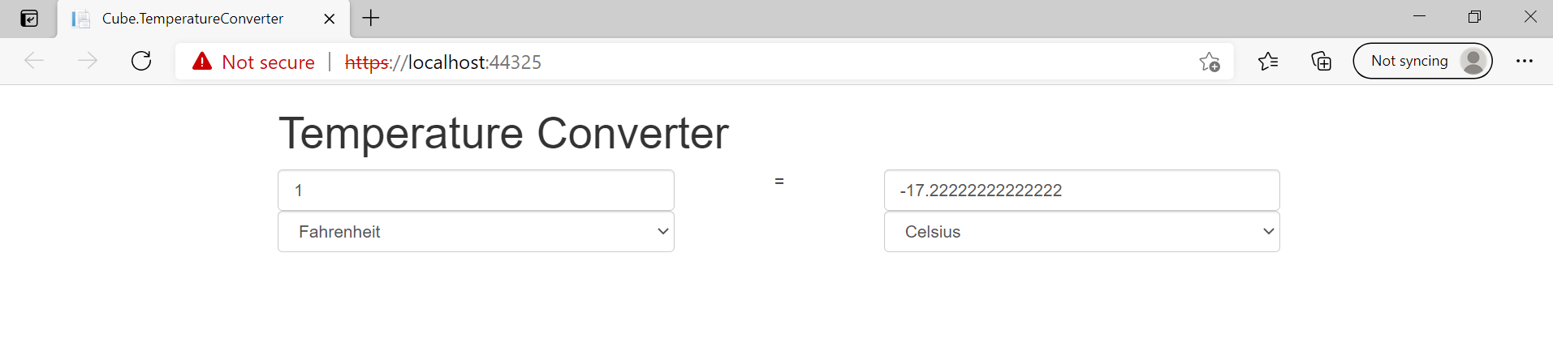

## Type in Value, change scale to view conversion

2nd textbox value is updated on change of any fields other than 2nd textbox.

On change of 2nd textbox value, first text box value is updated.