CIT360

Portfolio #5 (Week5)

02/20/2016

Jinseong Jeong

**MVC: Model-View-Controller**

MVC is a software architectural pattern mostly for implementing user interface on computers. It divides a given software application into three interconnected parts, so as to separate internal representations of information from the ways that information is presented to or accepted from the user.

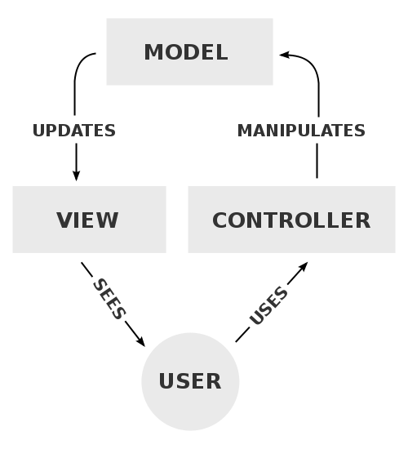

A typical collaboration of the MVC components

Here is the example of MVC Code:

<https://github.com/jinseongv/homework/blob/master/JavaMvcModel.java>

The code can be explained in the following few stages:

1. First of all is the declaration of the package in which this class exists.

JavaMVCModels is the package which would contain the class file.

1. The class name and the file name is similar.
2. The class contains two methods, one to extract the data and one to save the data from the user.

**Application Controller Pattern – Core J2EE Patterns**

**Problem**

You want to centralize and modularize action and view management.

**Forces**

* You want to reuse action and view-management code.
* You want to improve request-handling extensibility, such as adding use case functionality to an application incrementally.
* You want to improve code modularity and maintainability, making it easier to extend the application and easier to test discrete parts of your request-handling code independent of a web container.

**Solution**

Use an Application Controller to centralize retrieval and invocation of request-processing components, such as commands and views.

Here is Class Diagram

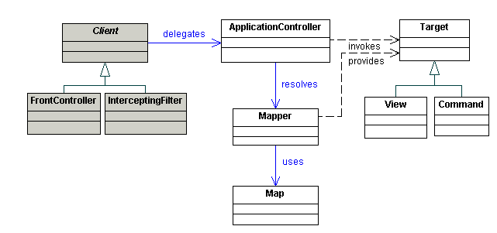

**Client and Server Sockets and their I/O Streams**

Although most programmers probably do network programming using a nice library with high-level application protocol (such as HTTP) support built-in, it's still useful to have an understanding of how to code at the socket level. Here are a few complete examples you can compile and run.

DateServer:

<https://github.com/jinseongv/homework/blob/master/DateServer.java>

DateClinet:

<https://github.com/jinseongv/homework/blob/master/DateClient.java>