CIT360

Portfolio #6 (Week6)

02/27/2016

Jinseong Jeong

**UML Diagrams?**

The Unified Modeling Language is a general purpose, developmental, modeling language in the field of software engineering that is intended to provide a standard way to visualize the design of a system.

**Use Case Diagram**

Purpose:

The purpose of use case diagram is to capture the dynamic aspect of a system. But this definition is too generic to describe the purpose.

How to draw Use Case Diagram?

Use case diagrams are considered for high level requirement analysis of a system. So when the requirements of a system are analyzed the functionalities are captured in use cases.

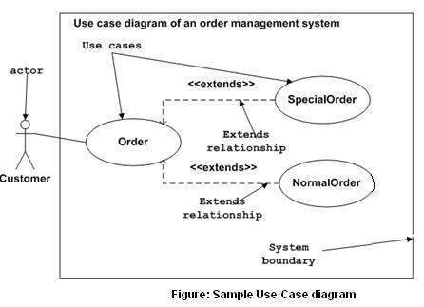

**Use Class diagram**

Purpose:

The purpose of the class diagram is to model the static view of an application. The class diagrams are the only diagrams, which can be directly mapped with object, oriented languages and thus widely used at the time of construction.

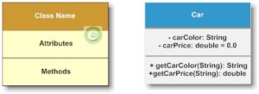

Example:

<https://github.com/jinseongv/homework/blob/master/ClassDiagram.java>

**Use State Diagrams?**

A state diagram, also called a state machine diagram or statechart diagram, is an illustration of the states an object can attain as well as the transitions between those states in the Unified Modeling Language (UML).

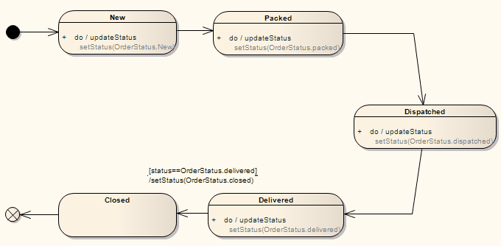

Example: <https://github.com/jinseongv/homework/blob/master/StateDiagram.java>