CIT360

Portfolio #7 (Week7)

03/05/2016

Jinseong Jeong

**Use Case Document?**

A use case diagram at its simplest is a representation of a user's interaction with the system that shows the relationship between the user and the different use cases in which the user is involved. A use case diagram can identify the different types of users of a system and the different use cases and will often be accompanied by other types of diagrams as well.

Purpose:

The purpose of use case diagram is to capture the dynamic aspect of a system. But this definition is too generic to describe the purpose.

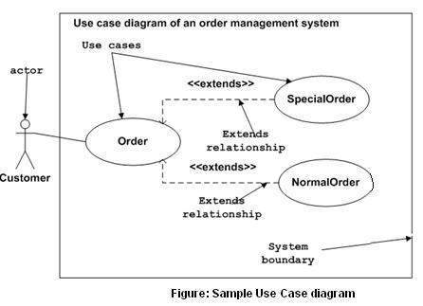

Example of Case diagram by using Java code:

<https://github.com/jinseongv/homework/blob/master/CaseDiagram.java>

**Sequence Diagram?**

The Sequence Diagram models the collaboration of objects based on a time sequence. It shows how the objects interact with others in a particular scenario of a use case. With the advanced visual modeling capability, you can create complex sequence diagram in few clicks. Besides, Visual Paradigm can generate sequence diagram from the flow of events, which you have defined in the use case description.

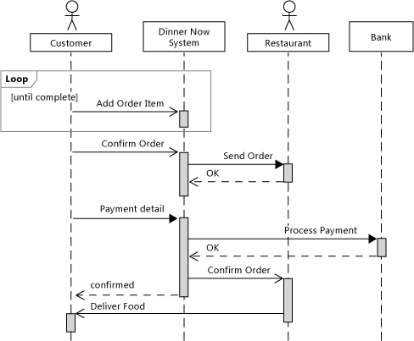

Example of sequence diagram with Java code:

<https://github.com/jinseongv/homework/blob/master/SequenceDiagram.java>

**System Test Diagram (Activity Diagram)?**

Activity diagram is another important diagram in UML to describe dynamic aspects of the system. Activity diagram is basically a flow chart to represent the flow form one activity to another activity. The activity can be described as an operation of the system.

Purpose:

The basic purposes of activity diagrams are similar to other four diagrams. It captures the dynamic behavior of the system. Other four diagrams are used to show the message flow from one object to another but activity diagram is used to show message flow from one activity to another.

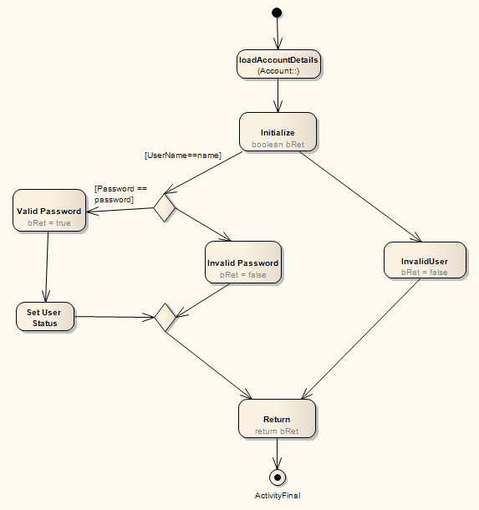

Example of Activity Diagram by using Java code:

<https://github.com/jinseongv/homework/blob/master/SystemTestDiagram.java>