**Atomic scale simulation-HW1- Jinsheng Wang (Netid: jwang278) 09/01/16**

**Dataset 1:**

Initial cutoff and end cutoff

1. mean value = 1.18567053
2. standard error of mean = 0.01328956
3. standard deviation = 0.40121770

end cutoff = 500

1. standard error of mean = 0.01776798. in fact, the standard error of the mean increased.
2. standard deviation = 0.40370873. it also increased.
3. when we set the initial cutoff from 0 to 500, I guess these two values above would become bigger since there would be less data points available. Set the initial cutoff as 0, 100, 200, 300, 400 I found that generally this guess above is right.

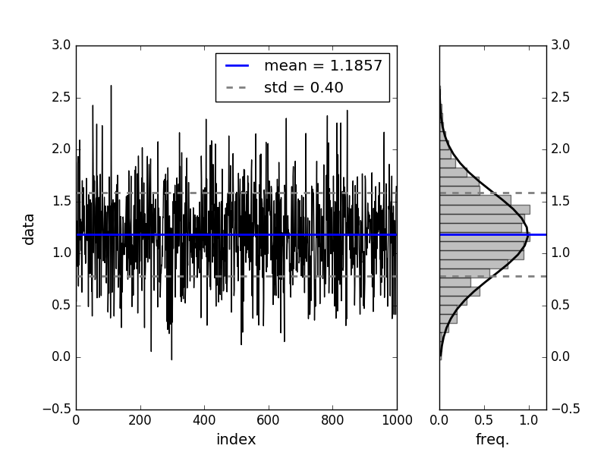

**Dataset2:**

This data has correlation:

1. autocorrelation time = 19.73551276
2. without autocorrelation, stderr of mean = 0.00325914
3. with autocorrelation, stderr of mean = 0.01447864

as we can see that without considering autocorrelation time, we will under estimate the standard error of mean, which is bad for sure.

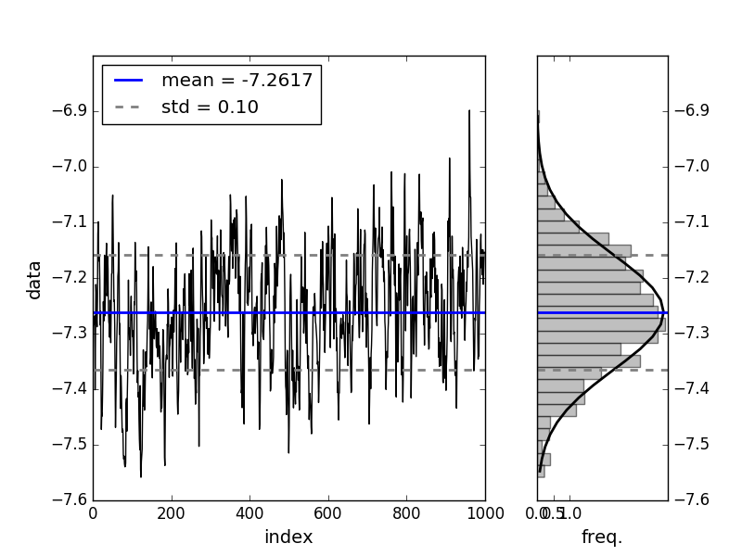

**Dataset3:**

1. when initial cutoff = 0, mean = -7.65069908, error = 0.02808983
2. the initial cutoff should be around 50 which can be seen from the below trace figure.

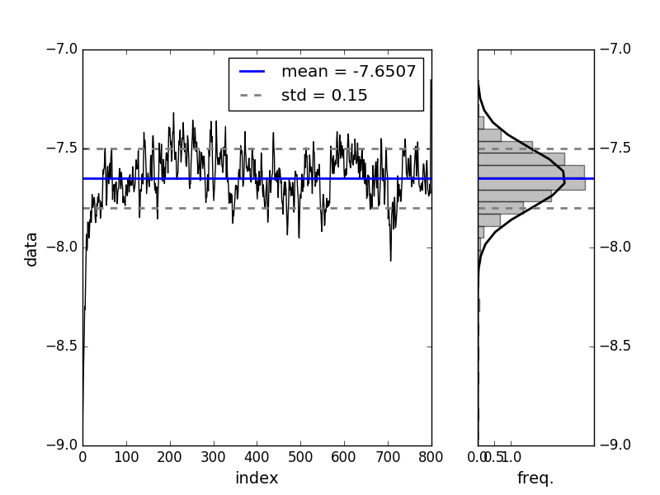

1. with initial cutoff as 50, mean = -7.63212793, error = 0.02022860
2. this mean difference between for part 1 and part 3 is not significant since we only chunk off first 50 data points, but the overall number for dataset3 is 800. However, the error for mean changed obviously, which showed big difference here.

**Dataset4:**

1. the mean should end up to 0 since the integral function for mean is odd and the limit is from negative infinity to positive infinity, thus we found mean = 0. As for the variance, when x goes to infinity, we find that the main integral part is $2b\int_{0}^{∞}{\frac{1}{x^{0.2}}dx→∞}$. Thus while the mean is zero, the variance goes to infinity.

A. the results of dataset4

|  |  |  |
| --- | --- | --- |
|  | mean | Sigma of mean |
| 0-1000 | 0.09051580 | 0.14145010 |
| 0-2000 | 0.15604591 | 0.10502587 |
| 0-3000 | 0.27216578 | 0.55969189 |
| 0-4000 | 0.23656340 | 0.42006410 |
| 0-5000 | 0.23988027 | 0.33666089 |

As we see from the table, the mean above seems to converge to 0.24 or so, but there is no sign of convergence for sigma of mean, which can be best illustrated by the trace profile below: the trace illustrated huge fluctuation.

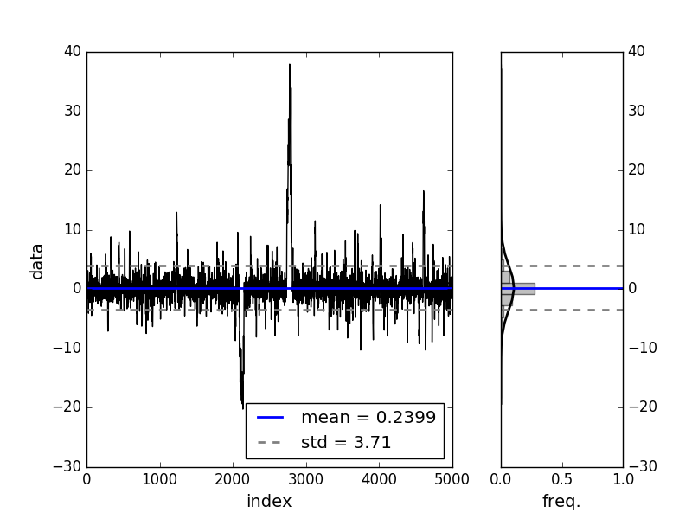

B. the results of dataset1

|  |  |  |
| --- | --- | --- |
|  | mean | Sigma of mean |
| 0-200 | 1.19083389 | 0.02922432 |
| 0-400 | 1.18005460 | 0.01966988 |
| 0-600 | 1.19290580 | 0.01611731 |
| 0-800 | 1.18740258 | 0.01629484 |
| 0-1000 | 1.18567053 | 0.01328956 |

We see clear convergence of both mean and its sigma for dataset1.

C the results of dataset2

|  |  |  |
| --- | --- | --- |
|  | mean | Sigma of mean |
| 0-200 | -7.32009496 | 0.02193282 |
| 0-400 | -7.28524602 | 0.02752463 |
| 0-600 | -7.28223970 | 0.01956533 |
| 0-800 | -7.27155575 | 0.01703991 |
| 0-1000 | -7.26167576 | 0.01447864 |

We also see clear convergence of mean and its sigma for dataset1.

**Comparison of datasets:**

1. see the table below:

|  |  |  |  |
| --- | --- | --- | --- |
|  | mean | Variance $\left(σ\right)$ | Error of mean |
| A | 1.25333333 | 0.15769168 | 0.06437736 |
| B | 1.35166667 | 0.16509593 | 0.06740013 |

Difference C =B-A= 1.35166667- 1.25333333 = 0.09833333. Estimate error of the difference error of difference = $\sqrt{{0.06437736}^{2}+{0.06740013}^{2}}=0.09320526$, variance of difference = $\sqrt{{0.15769168}^{2}+{0.16509593}^{2}}=0.22830537$

$$t=\frac{x-μ}{σ}=\frac{0.09833333}{0.09320526}=1.055$$

go to the Normal Standard Probability Distribution Table and find P(0,1.055)=0.354, so P(-1.055,1.055)=0.71. Thus we probe the possibility of two runs drawn from different runs is 0.71.

1. combined dataset

|  |  |  |
| --- | --- | --- |
|  | mean | Error of mean |
| combined | 1.30250000 | 0.04684153 |

**Biased from unequilibrated data:**

1:

$$m=\frac{m_{1}t_{1}+m_{2}(t_{2}-t_{1})}{t_{2}}$$

$$ε=m-m_{2}=\left(m_{1}-m_{2}\right)\frac{t_{1}}{t_{2}}=\frac{∆}{λ}$$

2:

$$σ^{2}=\frac{∆^{2}}{λ}-\frac{∆^{2}}{λ^{2}}+\frac{σ_{1}^{2}}{λ}+(1-\frac{1}{λ})σ_{2}^{2}$$

(deduction process is on my own draft paper, too long, not shown here.)

3: standard error = $σ=\sqrt{\frac{κ_{2}}{N_{eff}}}$ where $κ_{2}$ is variance and $N_{eff}=\frac{N}{correlation time T}$

so we have:

$$ε=m-m_{2}=\frac{∆}{λ}=\sqrt{\frac{σ^{2}}{\frac{t_{2}}{T}}}=\sqrt{\frac{\left(\frac{∆^{2}}{λ}-\frac{∆^{2}}{λ^{2}}+\frac{σ_{1}^{2}}{λ}+(1-\frac{1}{λ})σ_{2}^{2}\right)T}{t_{2}}}$$

for $λ≫1$, so we have:

$$\frac{∆}{λ}=\sqrt{\frac{σ_{2}^{2}T}{t_{2}}}$$

and finally

$$t_{2}=\frac{∆^{2}{t_{1}}^{2}}{σ_{2}^{2}T}$$

3:

when T=1 and $t_{1}=100$, and from the figure we get that $\frac{∆}{σ_{2}}≈6.75$. with all these values the calculation gives

$$t_{2}=4.6×{10}^{5}$$